Australian Capital Territory
Voluntary Assisted Dying (Supplier and Disposer) Approval 2025 (No 1)
Notifiable instrument NI2025–569
made under the
Voluntary Assisted Dying Act 2025, section 57 (Approved suppliers and disposers)

1 Name of instrument
This instrument is the Voluntary Assisted Dying (Supplier and Disposer) Approval 2025 (No 1).
2 Commencement
  - This instrument commences on the day after its notification day.
  - The Legislation Act 2001, section 81 (6) applies to this instrument.
Note: The Legislation Act 2001, s 81 provides for the exercise of a power given by a law if the law, or amending law, has been notified but has not yet commenced.
3 Approval
I approve the pharmacists working in the ACT Voluntary Assisted Dying Pharmacy Service to supply and dispose of an approved substance.

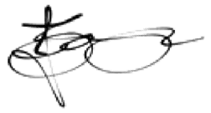
Janet Zagari
Delegate of Director-General Health and Community Services Directorate
13 October 2025

