Australian Capital Territory
Planning (Molonglo Valley District) Technical Specifications 2025 (No 2)
Notifiable instrument NI2025–596
made under the
Planning Act 2023, s 51 (Technical specifications)

1 Name of instrument
This instrument is the Planning (Molonglo Valley District) Technical Specifications 2025 (No 2).
2 Commencement
This instrument commences on the day after its notification day.
3 Technical specifications
I make the technical specifications at schedule 1.
4 Revocation
This instrument revokes the Planning (Molonglo Valley District) Technical Specifications 2025 (No 1) (NI2025-118).

George Cilliers
Chief Planner
24 October 2025


Inner
Schedule 1

Table of Contents
Table of Contents 2
Molonglo Valley District planning technical specifications 5
1. Coombs 6
Bushfire requirements 6
Figure 1 Coombs – Bushfire Provisions 6
Figure 2 Coombs - Bushfire Provisions 7
Figure 3 Coombs – Noise Provisions 8
Figure 4 Coombs – Noise and Bushfire Provisions 9
2. Denman Prospect 10
Vehicle access 10
Private open space 10
Principle private open space 10
Landscaping – open space 10
Visual corridor 10
Building heights 10
Setbacks 10
Habitable rooms 10
Garages/Carports 10
Gates 10
Fencing – general 10
Fencing and courtyard walls– to open space 11
Parking 11
Pedestrian access 11
Development provisions 11
Figure 5 Denman Prospect – Ongoing Provisions 12
Figure 6 Denman Prospect – Ongoing Provisions 13
Figure 7 Denman Prospect – Ongoing Provisions 14
Figure 8 Denman Prospect – Ongoing Provisions 15
Figure 9 Denman Prospect – Ongoing Provisions 16
Figure 10 Denman Prospect – Ongoing Provisions 17
Figure 11 Denman Prospect – Ongoing Provisions 18
Figure 12 Denman Prospect – Ongoing Provisions 19
Figure 13 Denman Prospect – Ongoing Provisions 20
Figure 14 Denman Prospect – Ongoing Provisions 21
Figure 15 Denman Prospect – Ongoing Provisions 22
Figure 16 Denman Prospect – Ongoing Provisions 23
Figure 17 Denman Prospect – Ongoing Provisions 24
Figure 18 Denman Prospect – Ongoing Provisions 25
Figure 19 Denman Prospect – Ongoing Provisions 26
Figure 20 Denman Prospect – Ongoing Provisions 27
Figure 21 Denman Prospect – Ongoing Provisions 28
Figure 22 Denman Prospect – Ongoing Provisions 29
Figure 23 Denman Prospect – Ongoing Provisions 30
Figure 24 Denman Prospect – Ongoing Provisions 31
Figure 25 Denman Prospect – Ongoing Provisions 32
Figure 26 Denman Prospect – Ongoing Provisions 33
3. Molonglo 34
Assessment Outcome 1 34
Assessment Outcome 2 34
Light Spill 34
Assessment Outcome 3 34
Building Heights 34
Assessment Outcome 4 34
Assessment Outcome 5 35
Assessment Outcome 6 35
Assessment Outcome 7 35
Assessment Outcome 8 35
Assessment Outcome 9 35
Figure 26A – Molonglo Valley – Town Centre and surrounds – Building Heights 36
Figure 26B – Molonglo Valley – Town Centre and surrounds – Building Heights 37
4. Whitlam 38
Assessment Outcome 10 38
Noise 38
Vehicle access 38
Courtyard walls 39
Building heights 39
Setbacks 39
Habitable rooms 39
Garage doors and carports 39
Finished floor level 39
Acoustic protection 39
Bushfire asset protection zone 40
Development requirements 40
Figure 27 Whitlam – Ongoing Provisions 41
Figure 28 Whitlam – Ongoing Provisions 42
Figure 29 Whitlam – Ongoing Provisions 43
Figure 30 Whitlam – Ongoing Provisions 44
Figure 31 Whitlam – Ongoing Provisions 45
Figure 32 Whitlam – Ongoing Provisions 46
Figure 33 Whitlam – Ongoing Provisions 47
Figure 34 Whitlam – Ongoing Provisions 48
Figure 35 Whitlam – Ongoing Provisions 49
Figure 35A Whitlam – Ongoing Provisions 50
Figure 36 Whitlam – Ongoing Provisions (Elevation of Courtyard Wall) 51
Figure 37 Whitlam – Ongoing Provisions 52
Figure 38 Whitlam – Ongoing Provisions 53
Figure 39 Whitlam – Ongoing Provisions 54
Figure 40 Whitlam – Ongoing Provisions 55
Figure 41 Whitlam – Ongoing Provisions 56
Figure 42 Whitlam – Ongoing Provisions 57
Figure 43 Whitlam – Ongoing Provisions 58
Figure 44 Whitlam – Ongoing Provisions 59
5. Wright 60

Molonglo Valley District planning technical specifications
The primary assessment consideration for a development application is the assessment outcomes in the Territory Plan. In demonstrating compliance with the assessment outcomes, consideration may be given to the relevant planning technical specifications which may serve as a benchmark. While all assessment outcomes are to be met, not all outcomes are covered by a specification.
Planning technical specifications are used as a possible solution or to provide guidance for identified aspects of a development proposal. The specifications may also be used as a reference or benchmark in the preparation and assessment of development proposals to demonstrate compliance with the assessment outcomes, and the Territory Plan.
Where a proposed development complies with a relevant provision in the planning technical specifications and the development comprehensively addresses the assessment outcome, further assessment regarding those specific provisions will not be required.
The specifications in the Molonglo Valley District Specifications can be used to demonstrate compliance with the assessment outcomes in the Molonglo Valley District Policy or the relevant zone policy. Where there is a specific assessment outcome in the Molonglo Valley District Policy, this takes precedence over the equivalent outcome in the zone policy. Where there is no specific assessment outcome in the Molonglo Valley District Policy, the specification can be used to demonstrate compliance with the assessment outcomes in the zone policy.
The Territory Planning Authority may consider advice or written support from a referral entity to demonstrate compliance with a relevant assessment outcome. Where endorsement from an entity is noted as a planning specification, entity referral may be required.
Consistent with the Molonglo Valley District Policy, this Molonglo Valley District Specifications comprises specifications for specific localities, structured according to the localities.
These specifications will only apply to the specific sites or locations they refer to and should be used in conjunction with the relevant district policy, i.e., Part D5: Molonglo Valley District Policy.

Coombs
The following specifications provide possible solutions that should be considered in planning, placing, designing and using buildings and structures for proposed development in Coombs:
Assessment Outcome | Refer to zone assessment outcome
Specification
Bushfire requirements | - Development complies with the specified bushfire attack level construction requirements and noise provisions, in accordance with Figure 1, Figure 2, Figure 3 and Figure 4.

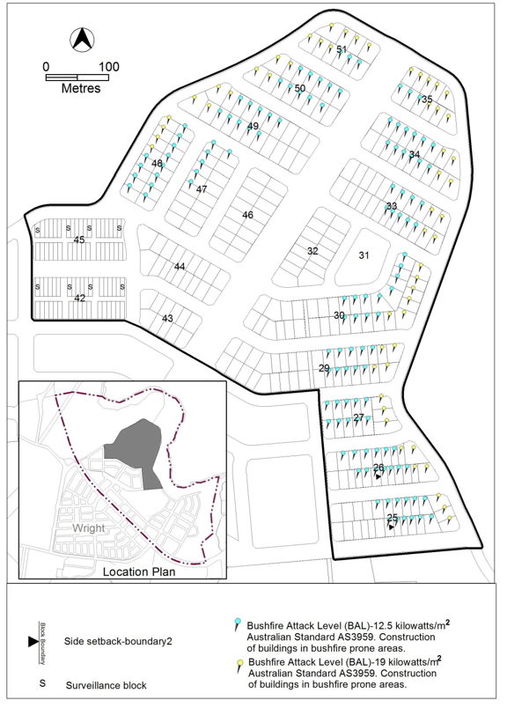
Figure 1 Coombs – Bushfire Provisions

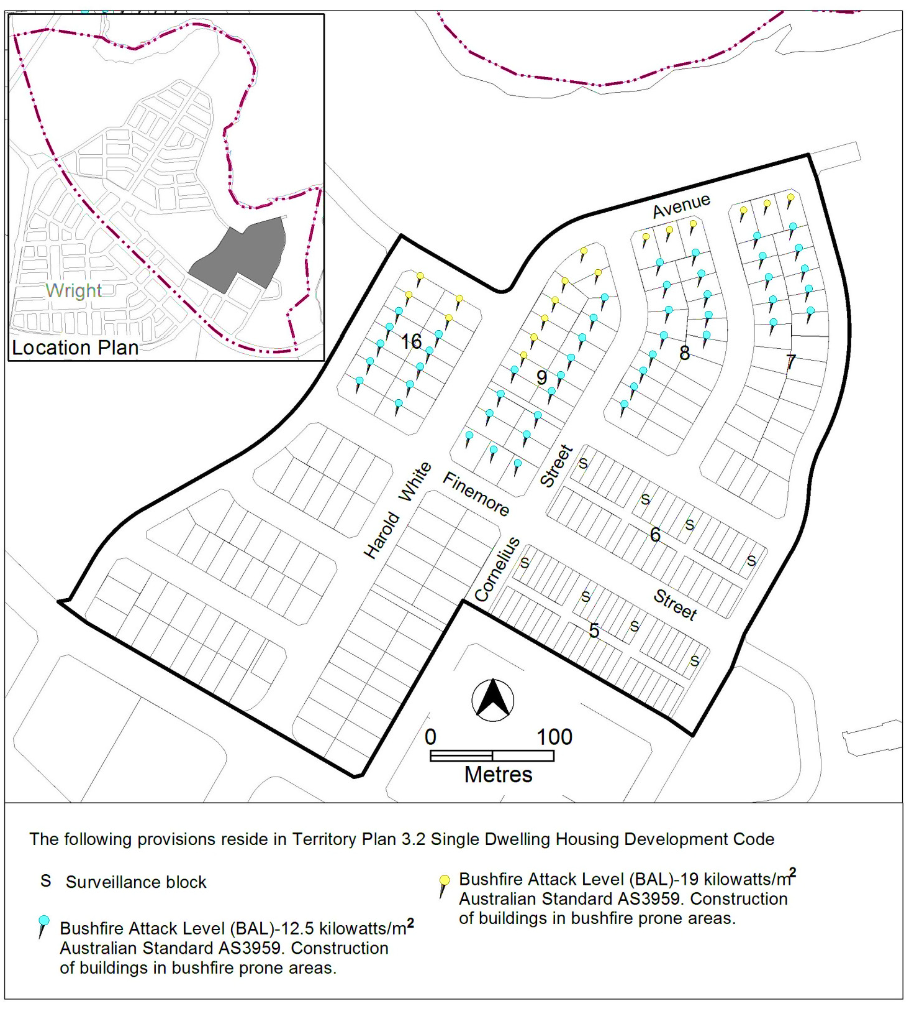
Figure 2 Coombs - Bushfire Provisions

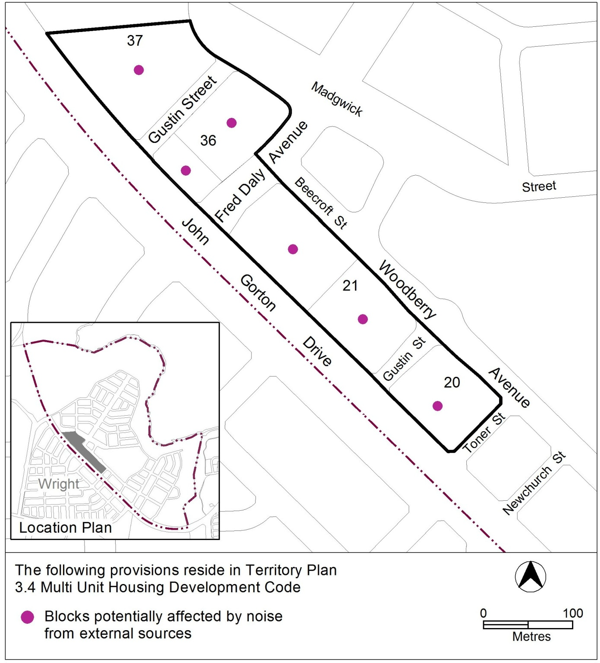
Figure 3 Coombs – Noise Provisions

Figure 4 Coombs – Noise and Bushfire Provisions
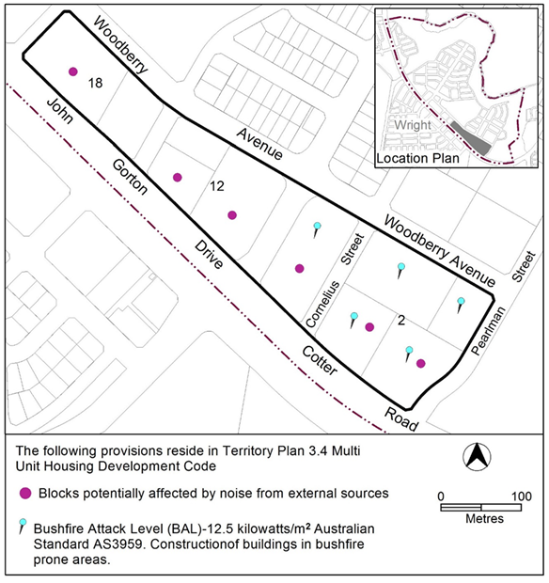

Denman Prospect
The following specifications provide possible solutions that should be considered in planning, placing, designing and using buildings and structures for proposed development in Denman Prospect:
Assessment Outcome | Refer to zone assessment outcomes
Specification
Vehicle access | - No vehicle access is provided from frontages as indicated on Figure 6, Figure 7, Figure 8, Figure 9, Figure 11, Figure 12 and Figure 13.
Private open space | - For blocks in Figure 6, the level of private open space is not lower than 1m below the front boundary level for a depth of 3m from the front boundary to the open space. Maximum length of wall at zero setback is limited to length of the adjoining dwelling party wall.
Principle private open space | - For nominated blocks in Figure 15 and Figure 16, alternate principle private open space (PPOS) is permitted above the garage. All other PPOS requirements apply as per the relevant Territory Plan code.
Landscaping – open space | - For blocks in Figure 7:  - Identified areas are maintained as a landscape zone.  - Commercial uses adjacent to the landscape zone are activated.  - Pedestrian access is facilitated at the corner of Marie Little Crescent and Greenwood Street, providing an accessible connection to Section 76; and from Section 72 across Marie Little Crescent providing an accessible connection to Section 73.
Visual corridor | - Buildings must be setback to achieve a visual corridor through nominated block as shown in Figure 14 and Figure 16.
Building heights | - The minimum and maximum number of storeys is nominated in Figure 10, Figure 11, Figure 12, Figure 13, Figure 14, Figure 15 and Figure 16
Setbacks | - For blocks in Figure 10, Figure 11, Figure 12, Figure 13, Figure 14, Figure 15 and Figure 16, the minimum boundary setbacks to floor levels are nominated.
Habitable rooms | - Blocks identified in Figure 11, Figure 12, Figure 14 and Figure 16 are to provide habitable rooms that overlook both front boundaries.
Garages/Carports | - For blocks in Figures 5, Figure 6, Figure 10, Figure 11, Figure 12, Figure 13, Figure 14, Figure 15 and Figure 16, the minimum side boundary setback to garage / carport is as nominated and the maximum length of the wall is 8m.  - For nominated blocks in Figure 15 and Figure 16, the minimum side boundary setback to the garage is specified.  - For nominated blocks in Figure 15 and Figure 16, the garage opening may exceed 50% if building façade width. Upper floor must provide building articulation.
Gates | - For blocks in Figure 5, Figure 6, Figure 7, Figure 8, Figure 9 and Figure 10 boundaries to open space must provide at least one gate access.
Fencing – general | - Blocks fronting open space identified in Figure 26 provide transparent type fencing with maximum height of 1.2m.  - For blocks identified in Figure 11 and Figure 15, no fencing permitted to nominated front boundaries. Landscape treatment only. Where a multi-unit site fronts open space, landscape treatment provides an effective vehicle barrier.
Fencing and courtyard walls– to open space | - For blocks addressing open space in Figure 11, Figure 12, Figure 13, Figure 14 and Figure 16, fences are not permitted on nominated front boundaries, however, courtyard walls are permitted and are to be:  - Constructed only of brick, block or stonework, any which may be combined with feature panels.  - Maximum height of 1.8m.  - Located on the block boundary or in a location setback from the block boundary as required to permit access by service authorities.
Parking | - For blocks identified in Figure 6, Figure 7, Figure 8, Figure 9, Figure 11, Figure 12, Figure 13, Figure 14, Figure 15 and Figure 16, all visitor parking requirements are to be provided within the block.
Pedestrian access | - For blocks identified in Figure 11, Figure 12, Figure 13, Figure 14, Figure 15 and Figure 16, pedestrian access must be provided on all nominated boundaries. Where a multi-unit exceeds 10 dwellings, multiple entries must be provided.
Development provisions | - Development complies with the specifications identified in Figure 17, Figure 18, Figure 19, Figure 20, Figure 21, Figure 22, Figure 23, Figure 24, and Figure 25.  Note: Blocks identified as being subject to mid-sized block provisions are from 500m² or greater, but less than 550m².

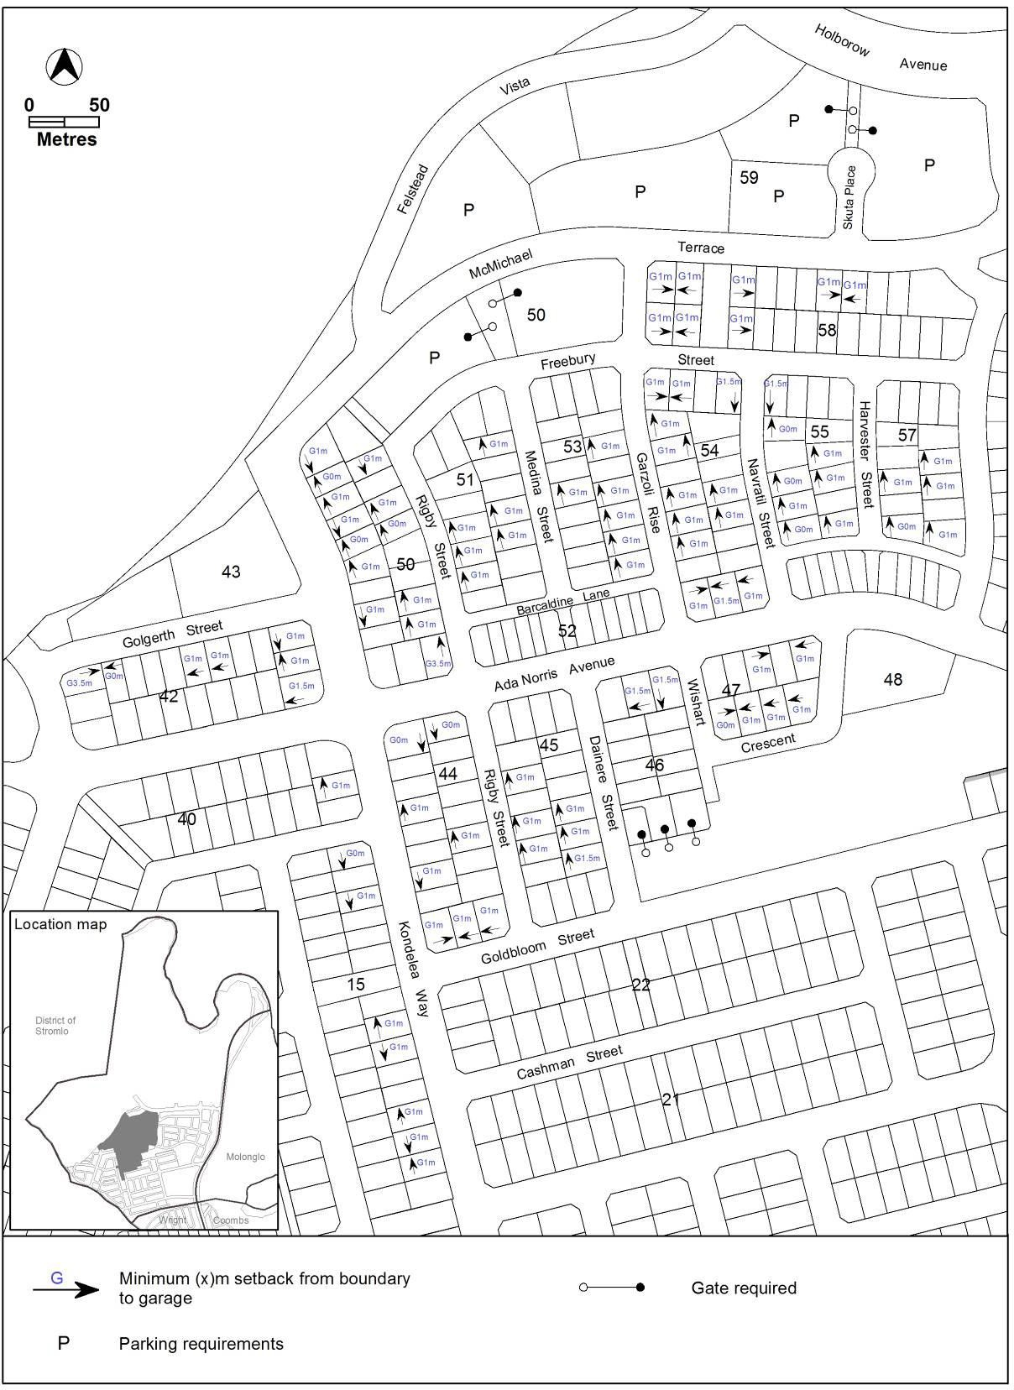
Figure 5 Denman Prospect – Ongoing Provisions

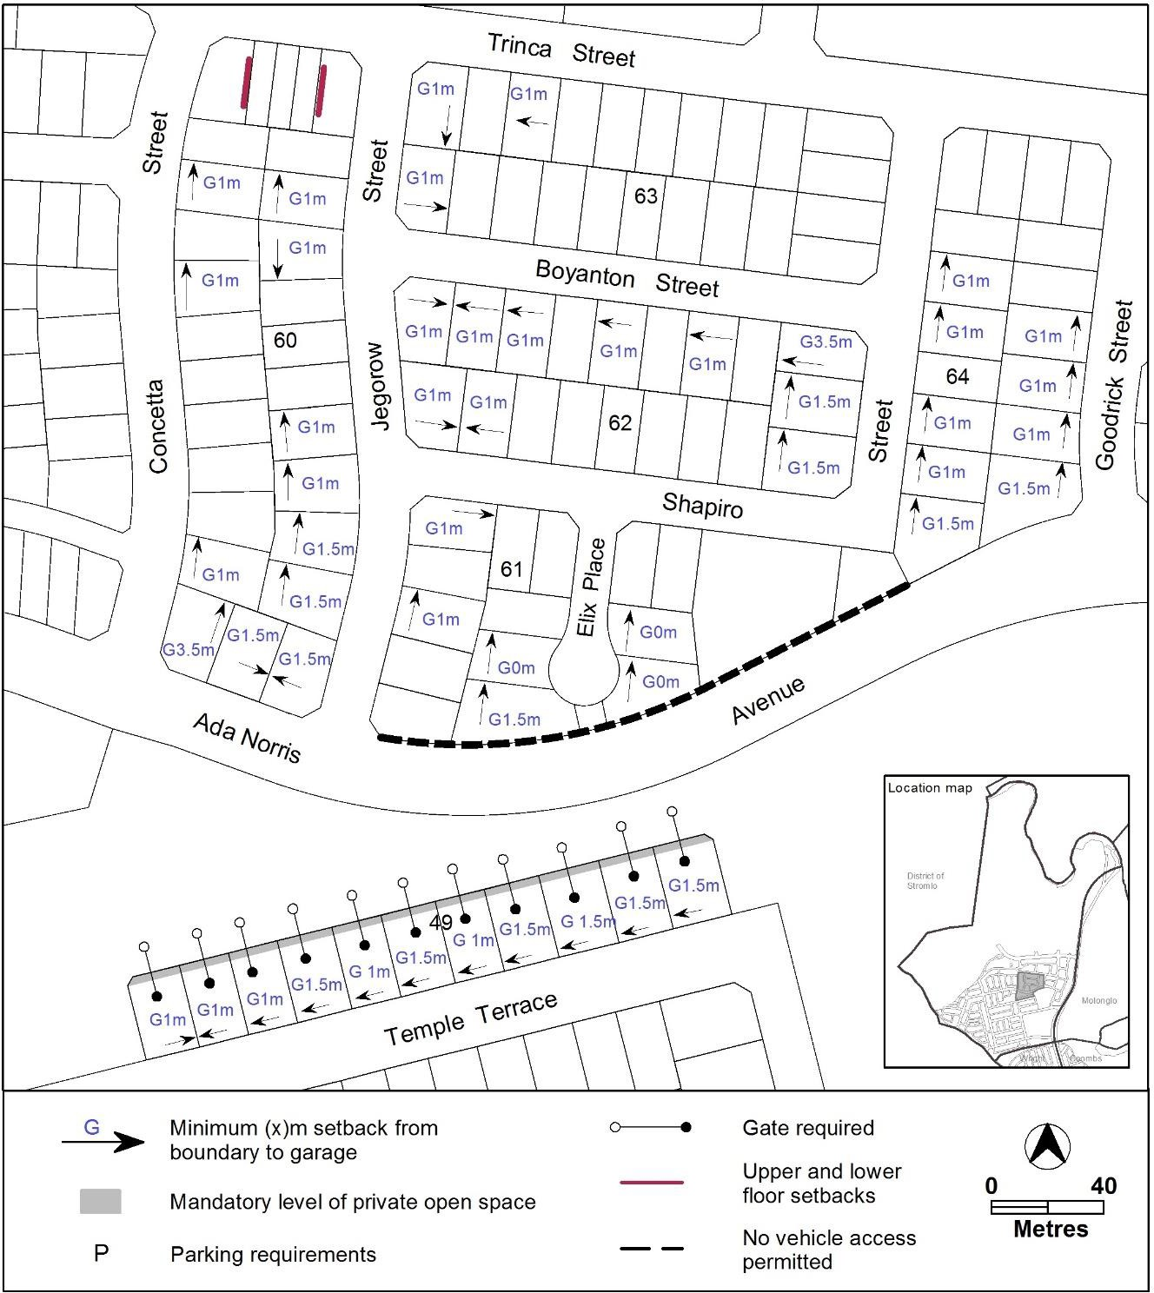
Figure 6 Denman Prospect – Ongoing Provisions

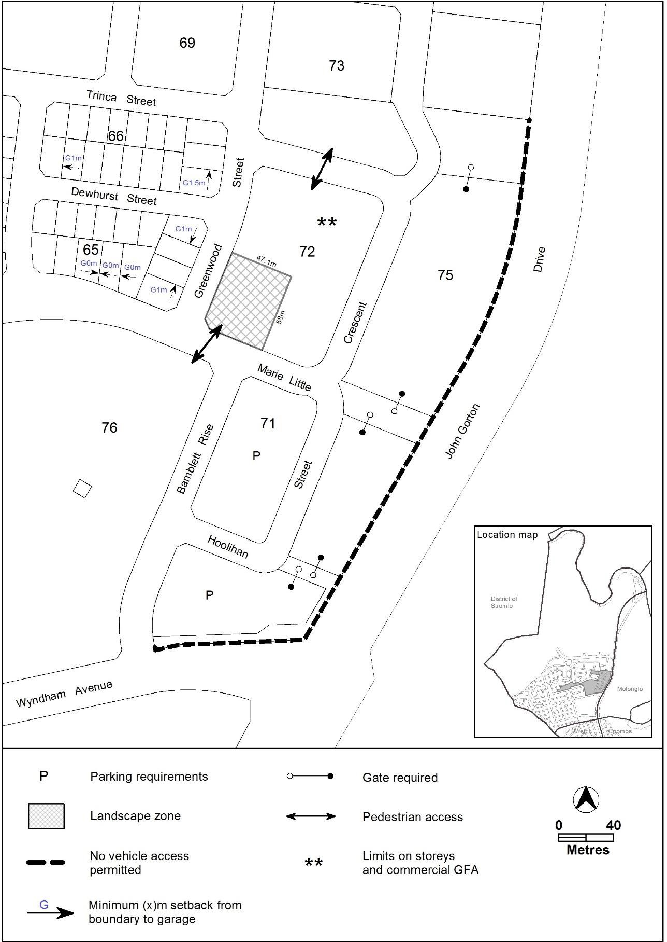
Figure 7 Denman Prospect – Ongoing Provisions

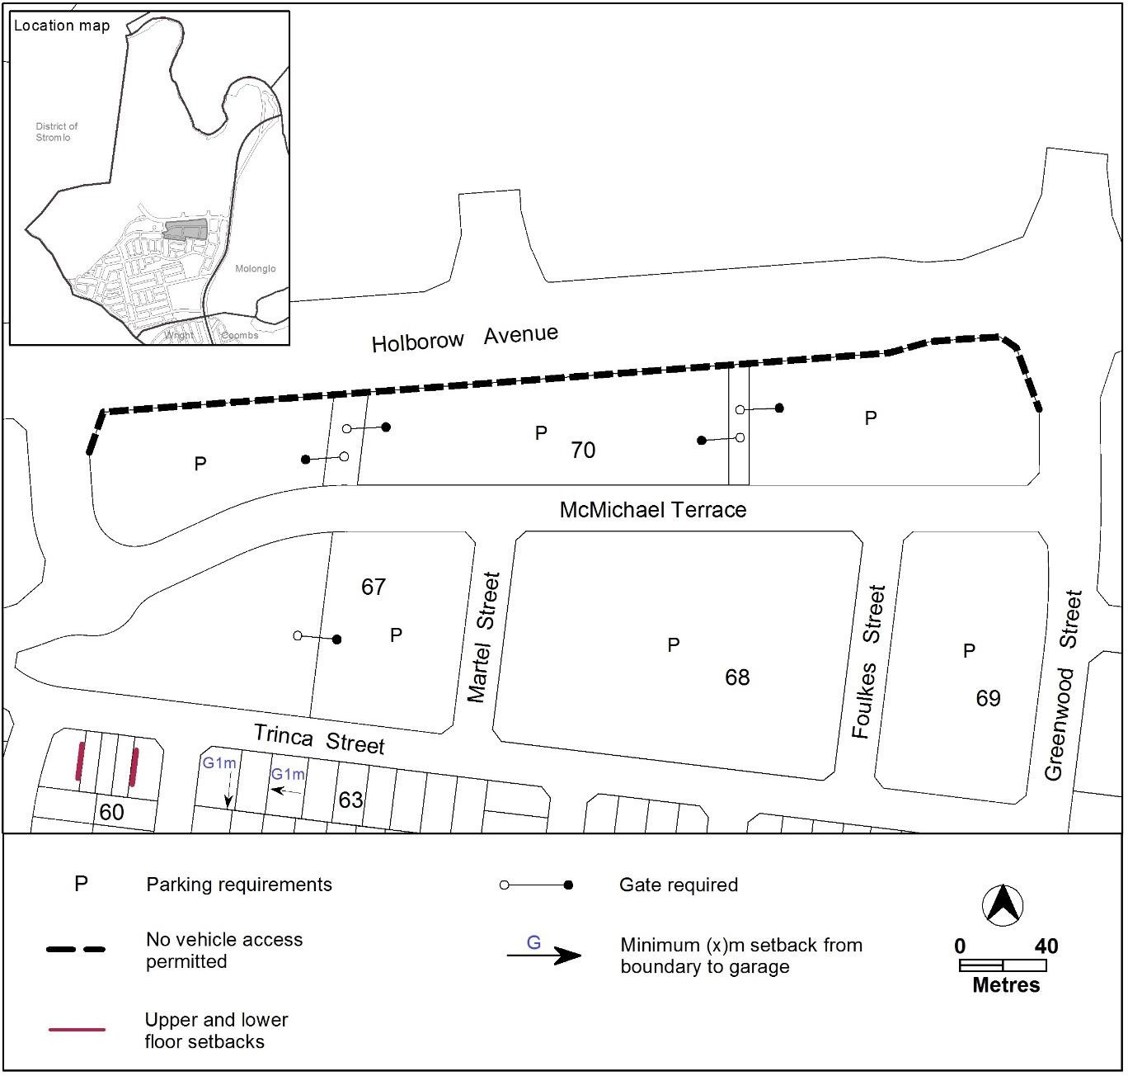
Figure 8 Denman Prospect – Ongoing Provisions

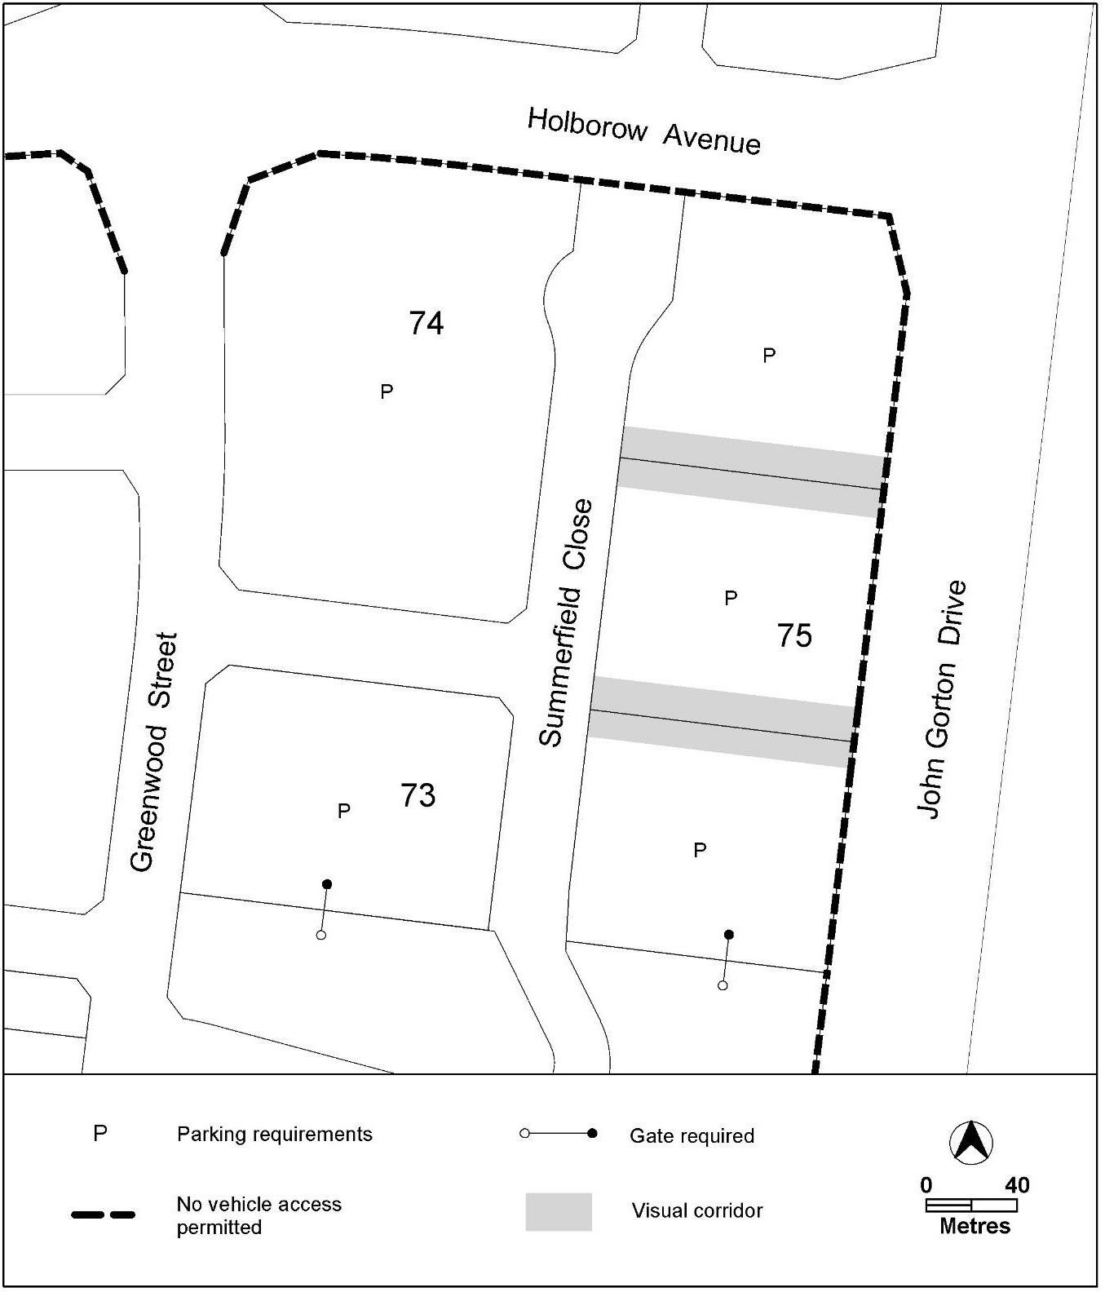
Figure 9 Denman Prospect – Ongoing Provisions

Figure 10 Denman Prospect – Ongoing Provisions
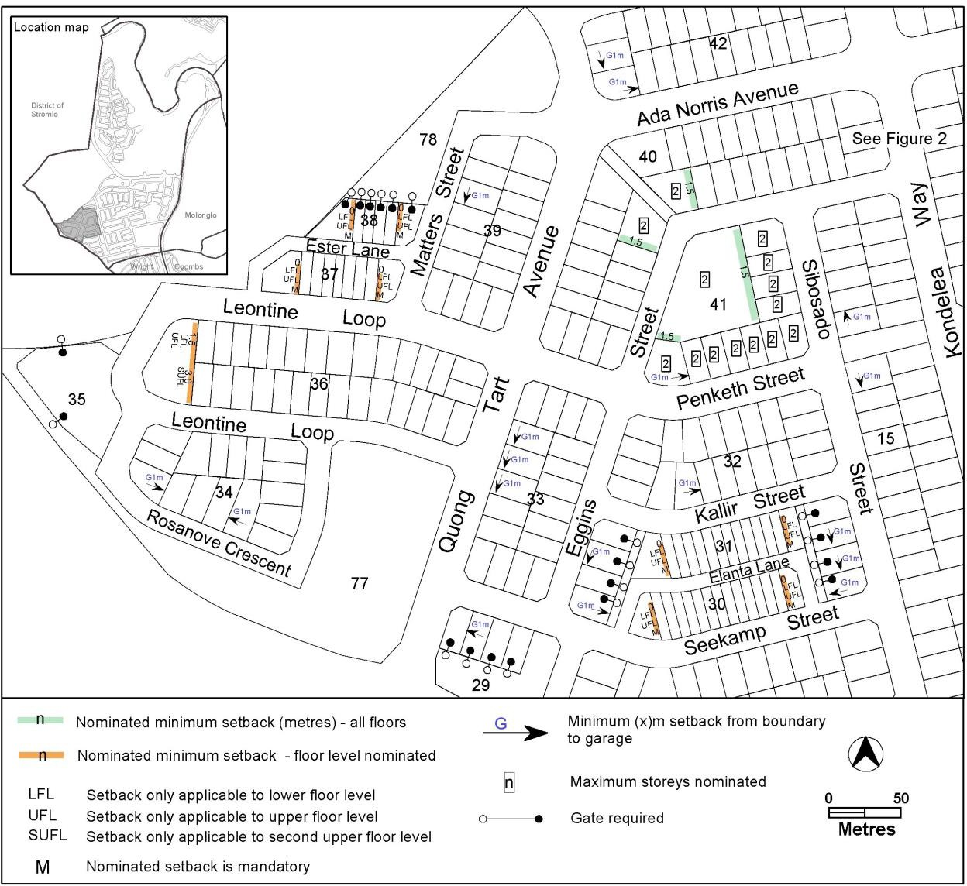

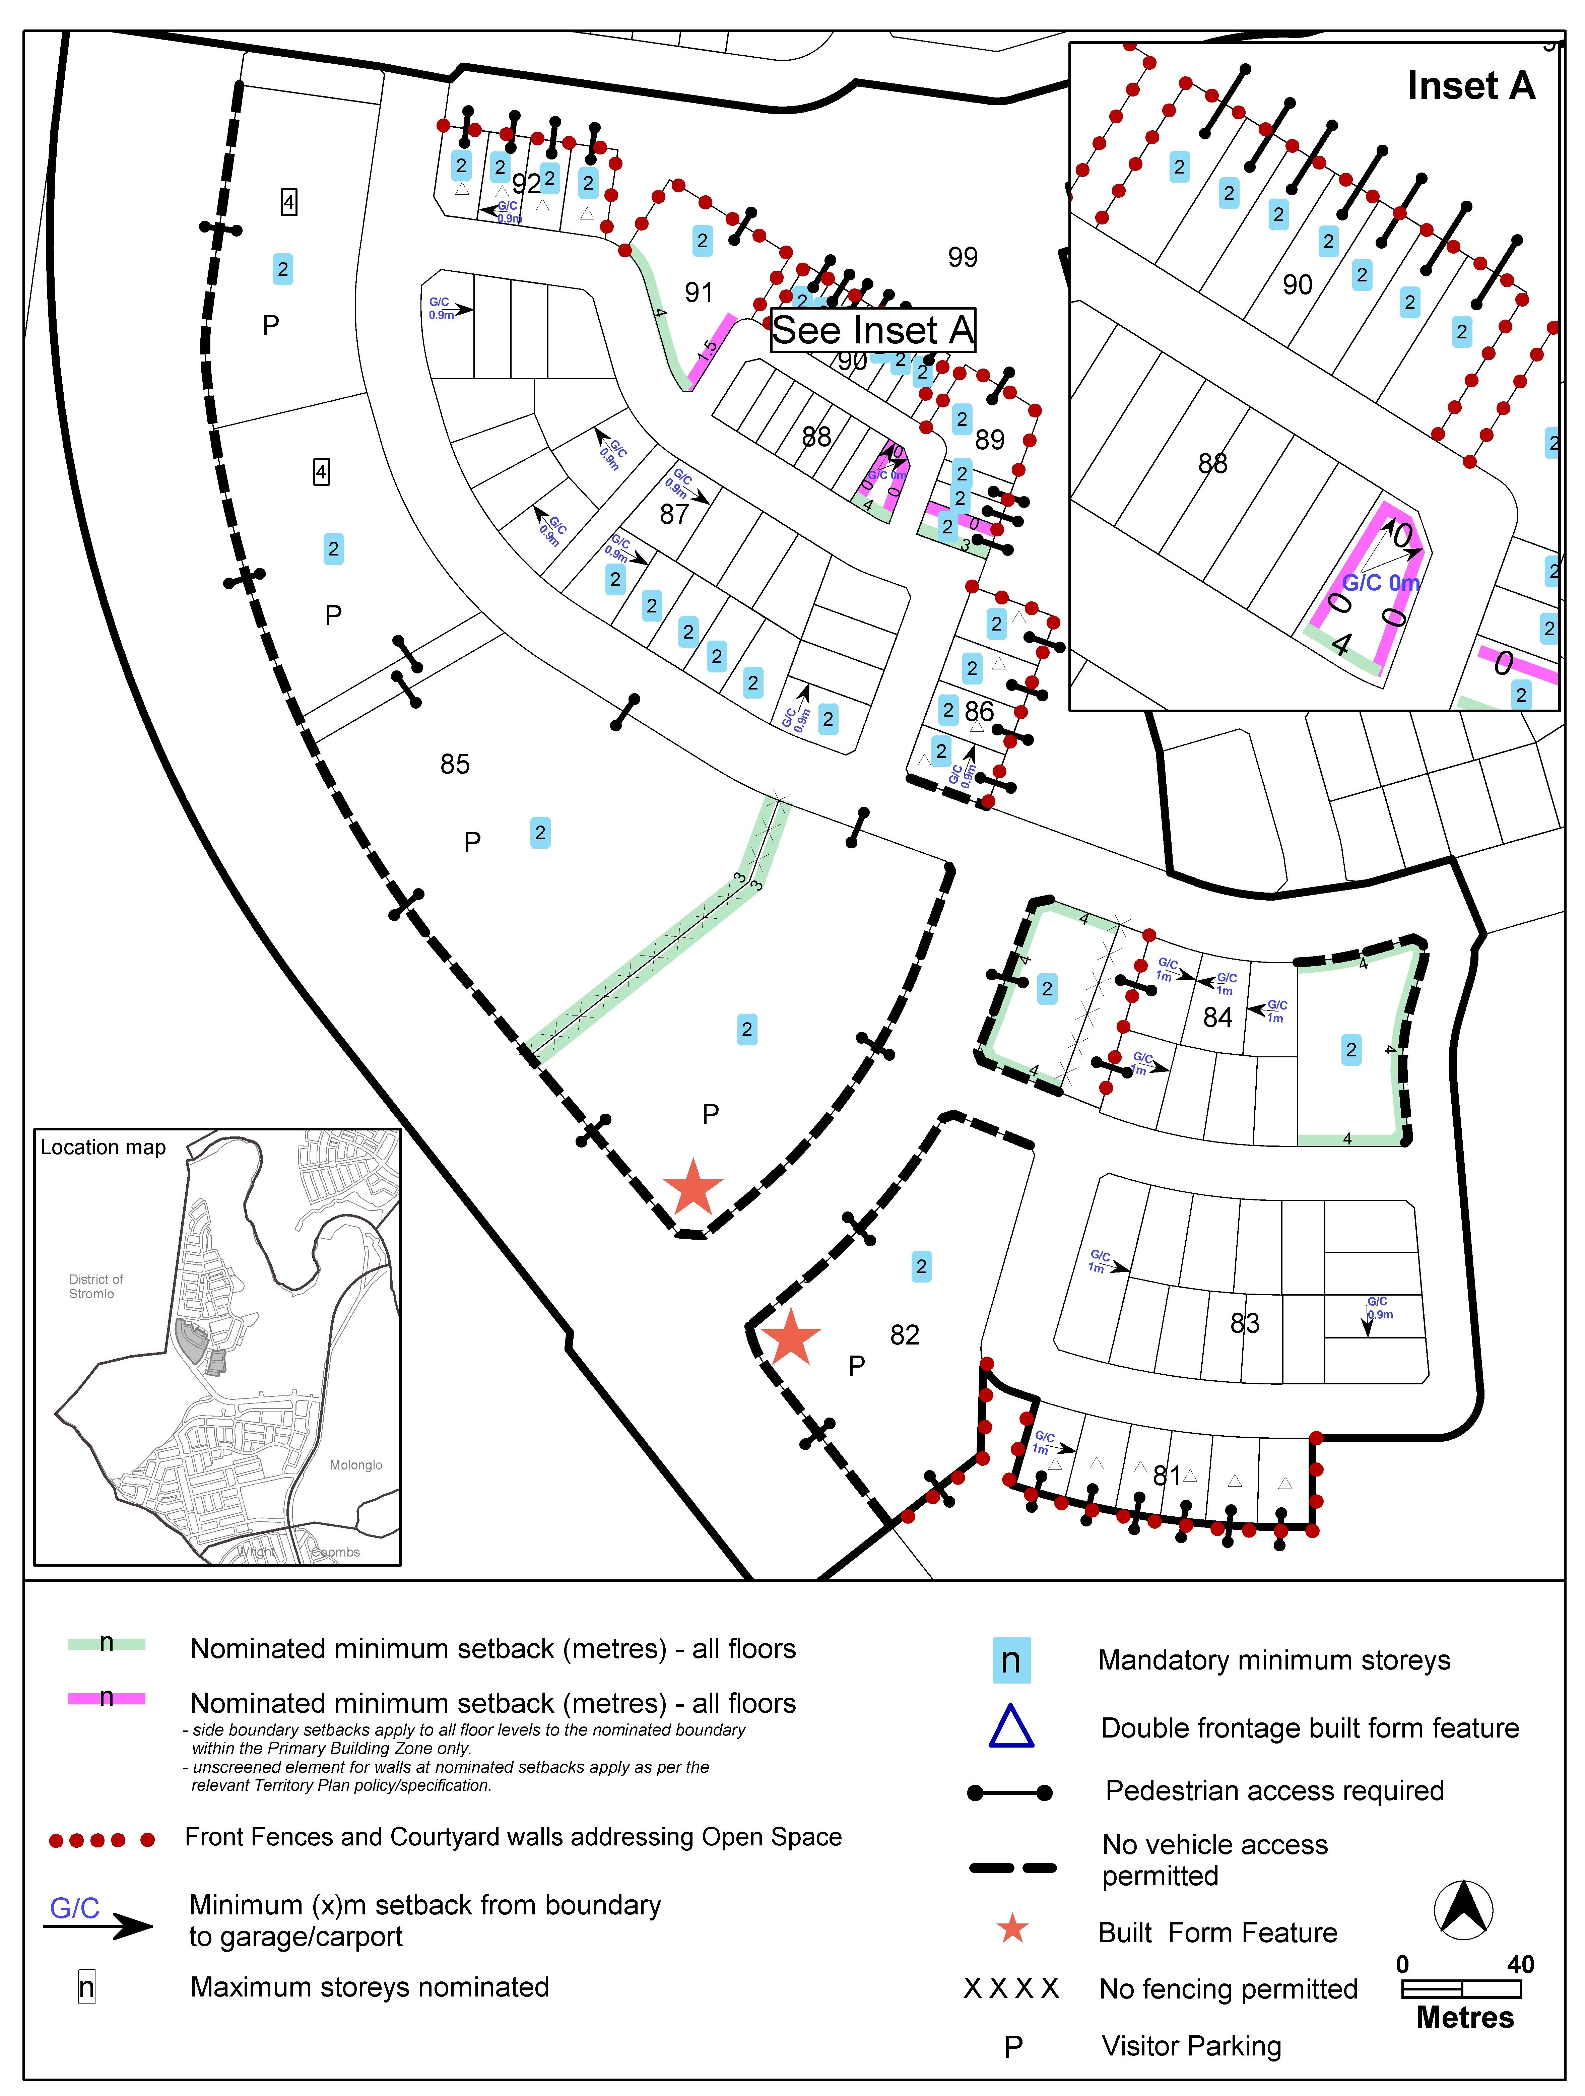
Figure 11 Denman Prospect – Ongoing Provisions

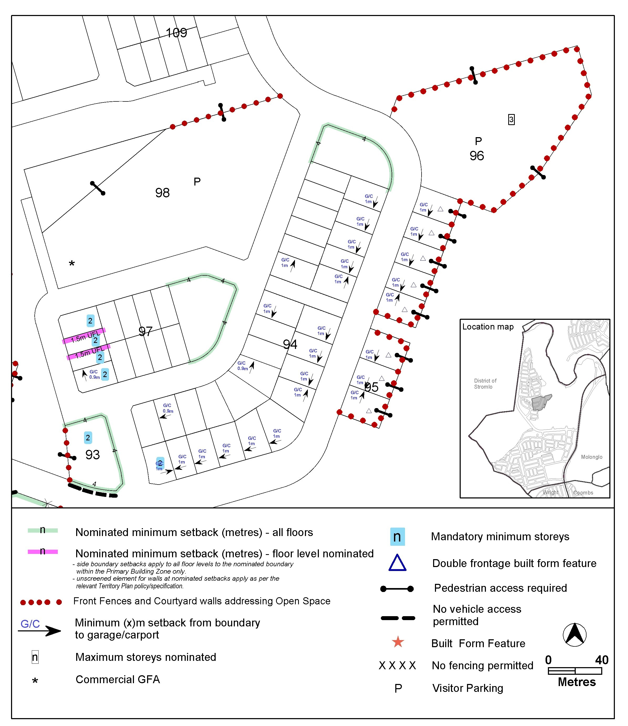
Figure 12 Denman Prospect – Ongoing Provisions

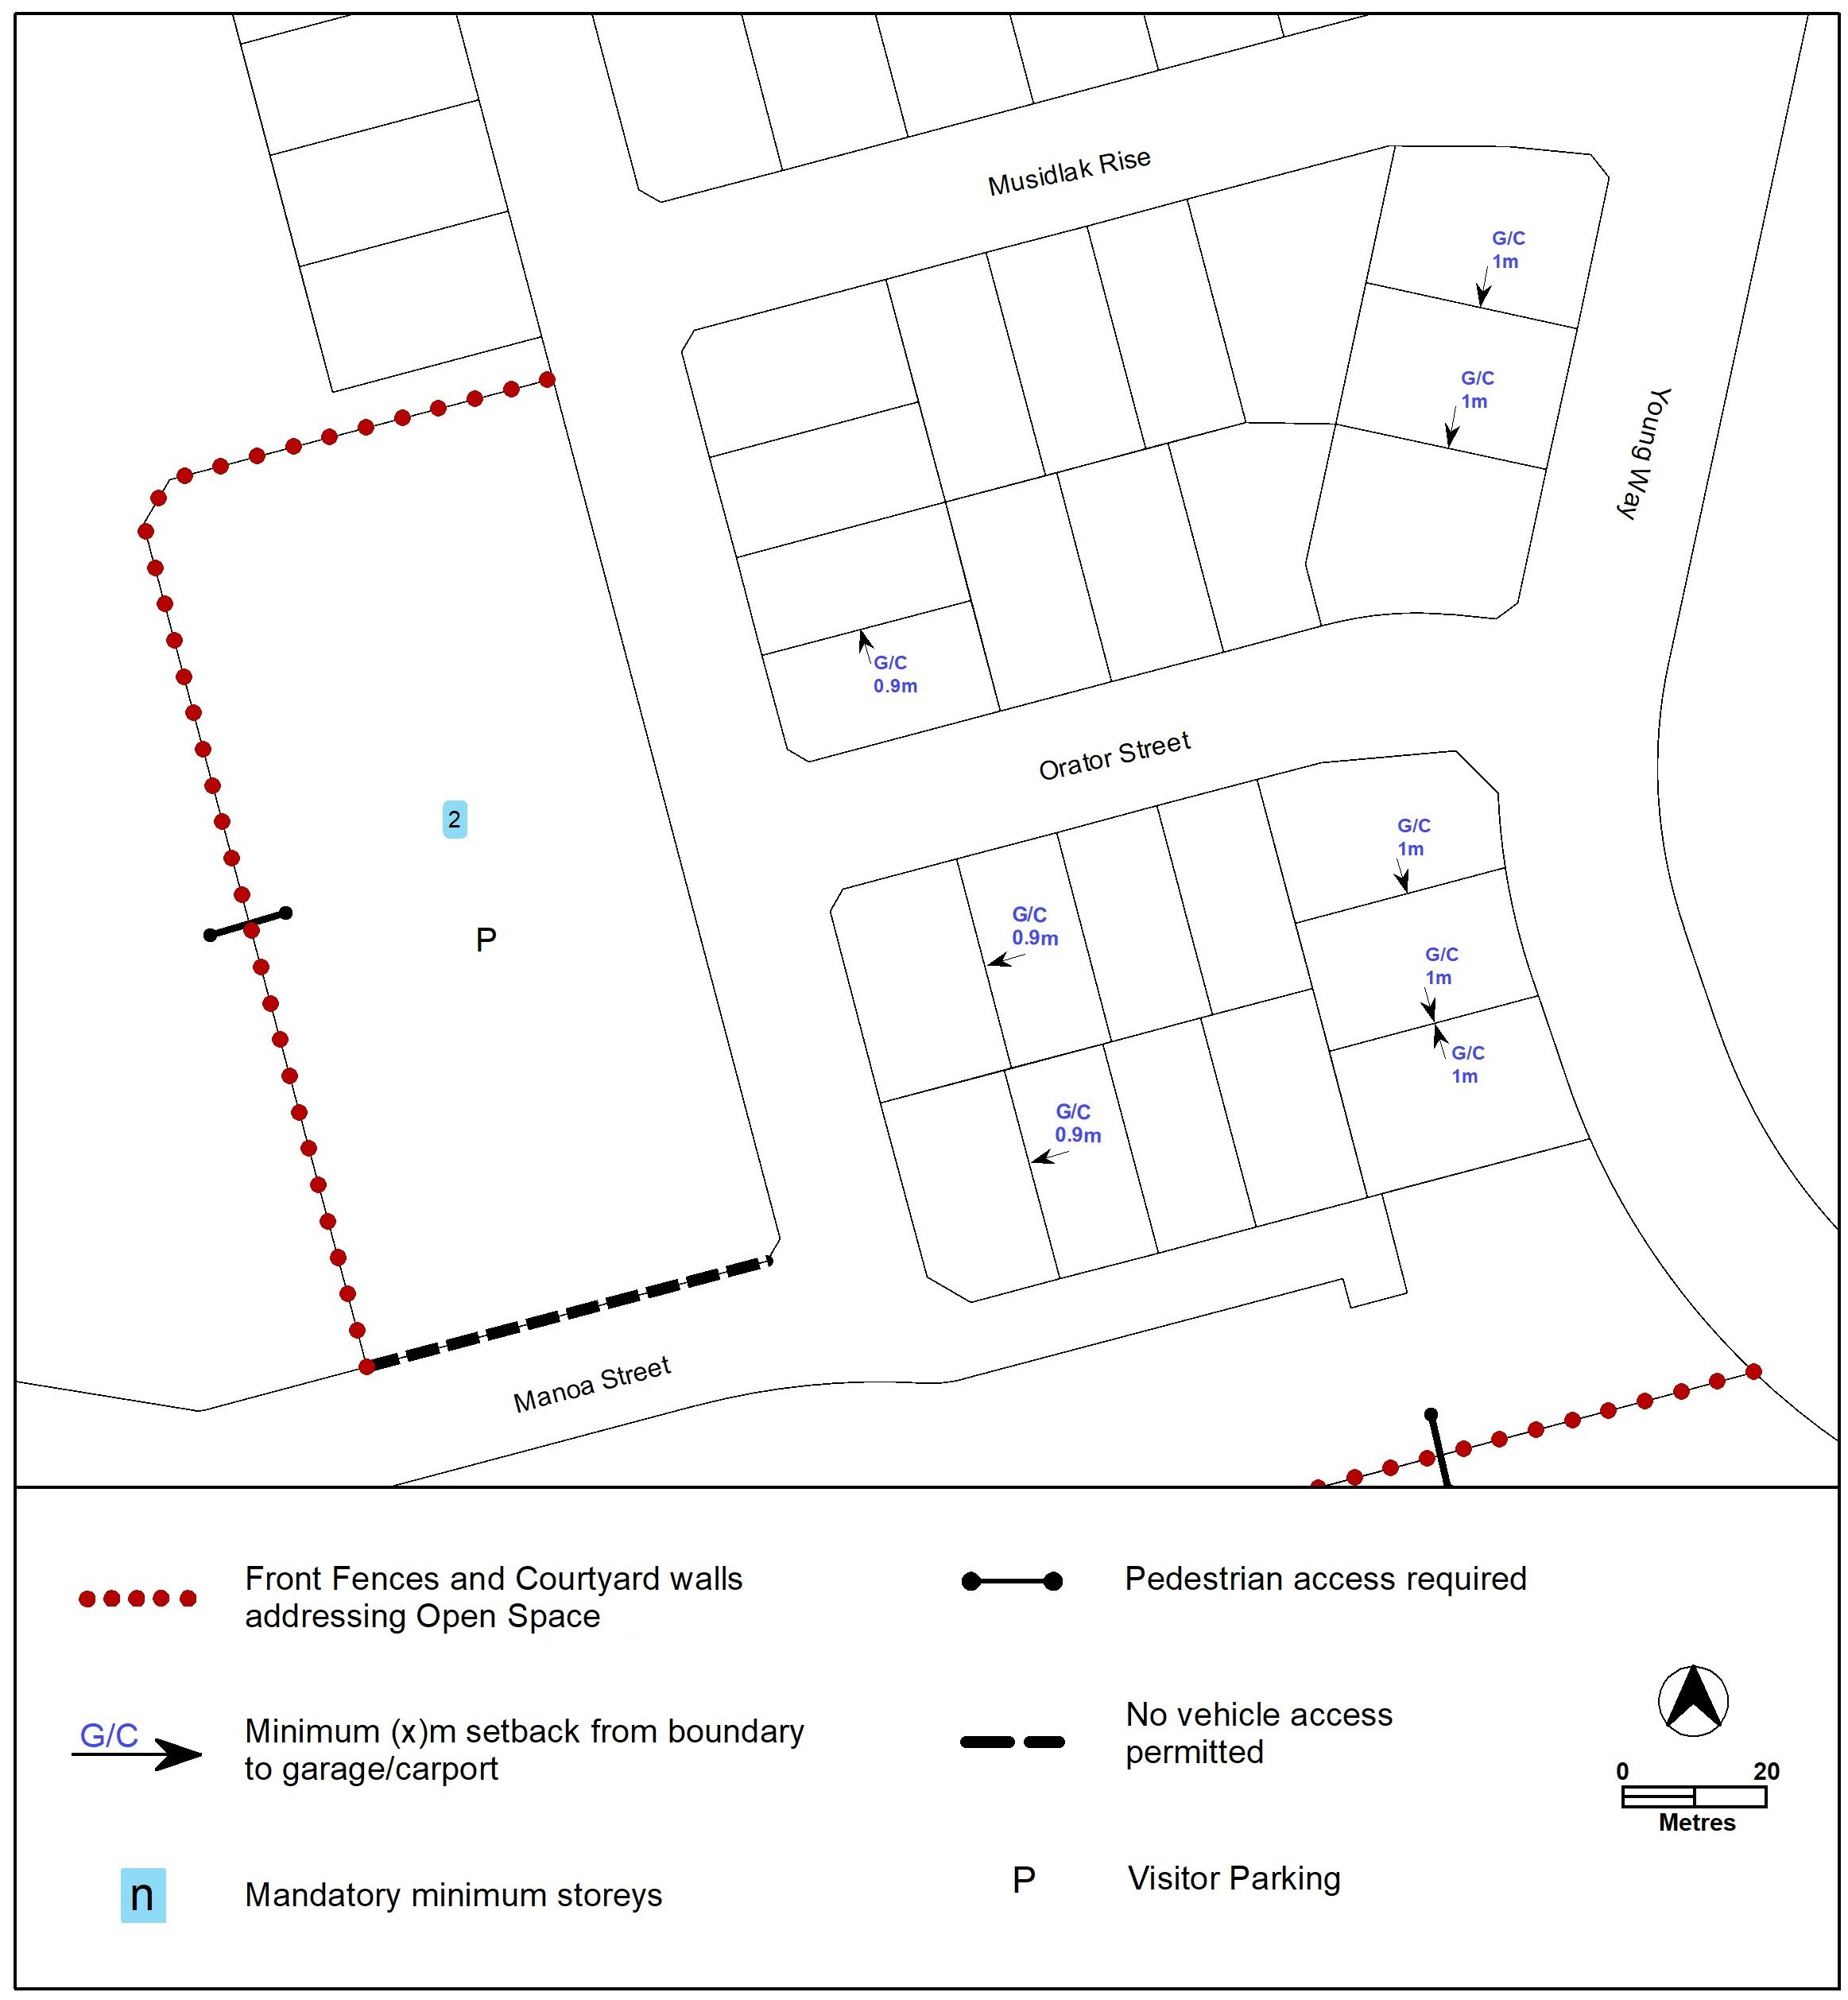
Figure 13 Denman Prospect – Ongoing Provisions

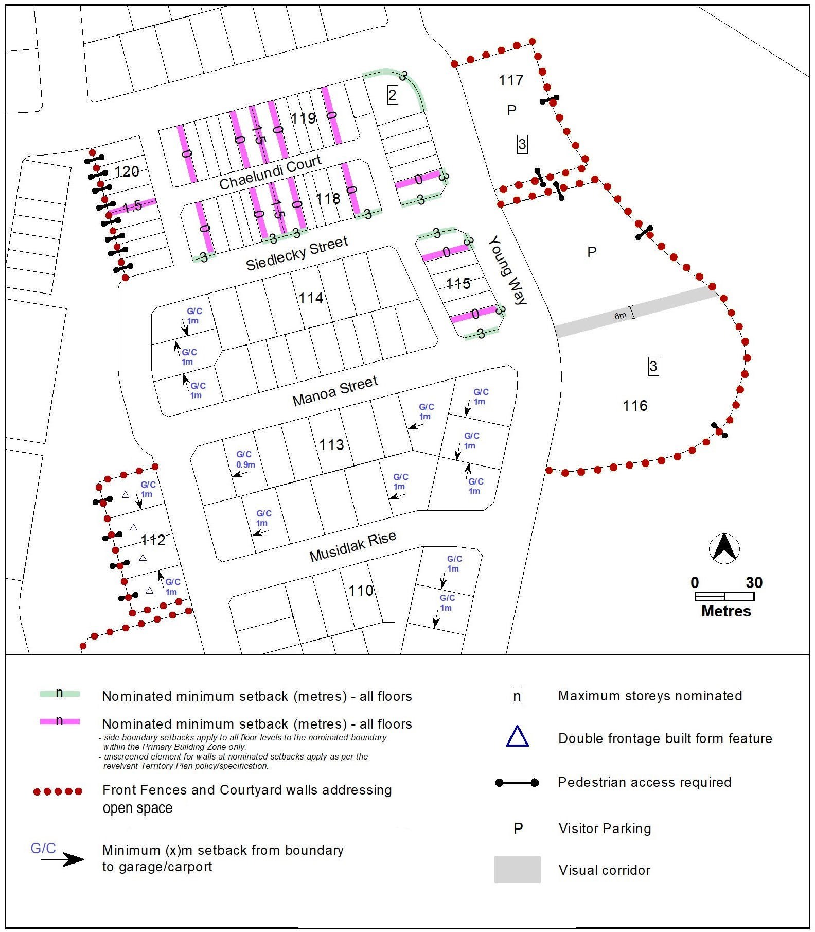
Figure 14 Denman Prospect – Ongoing Provisions

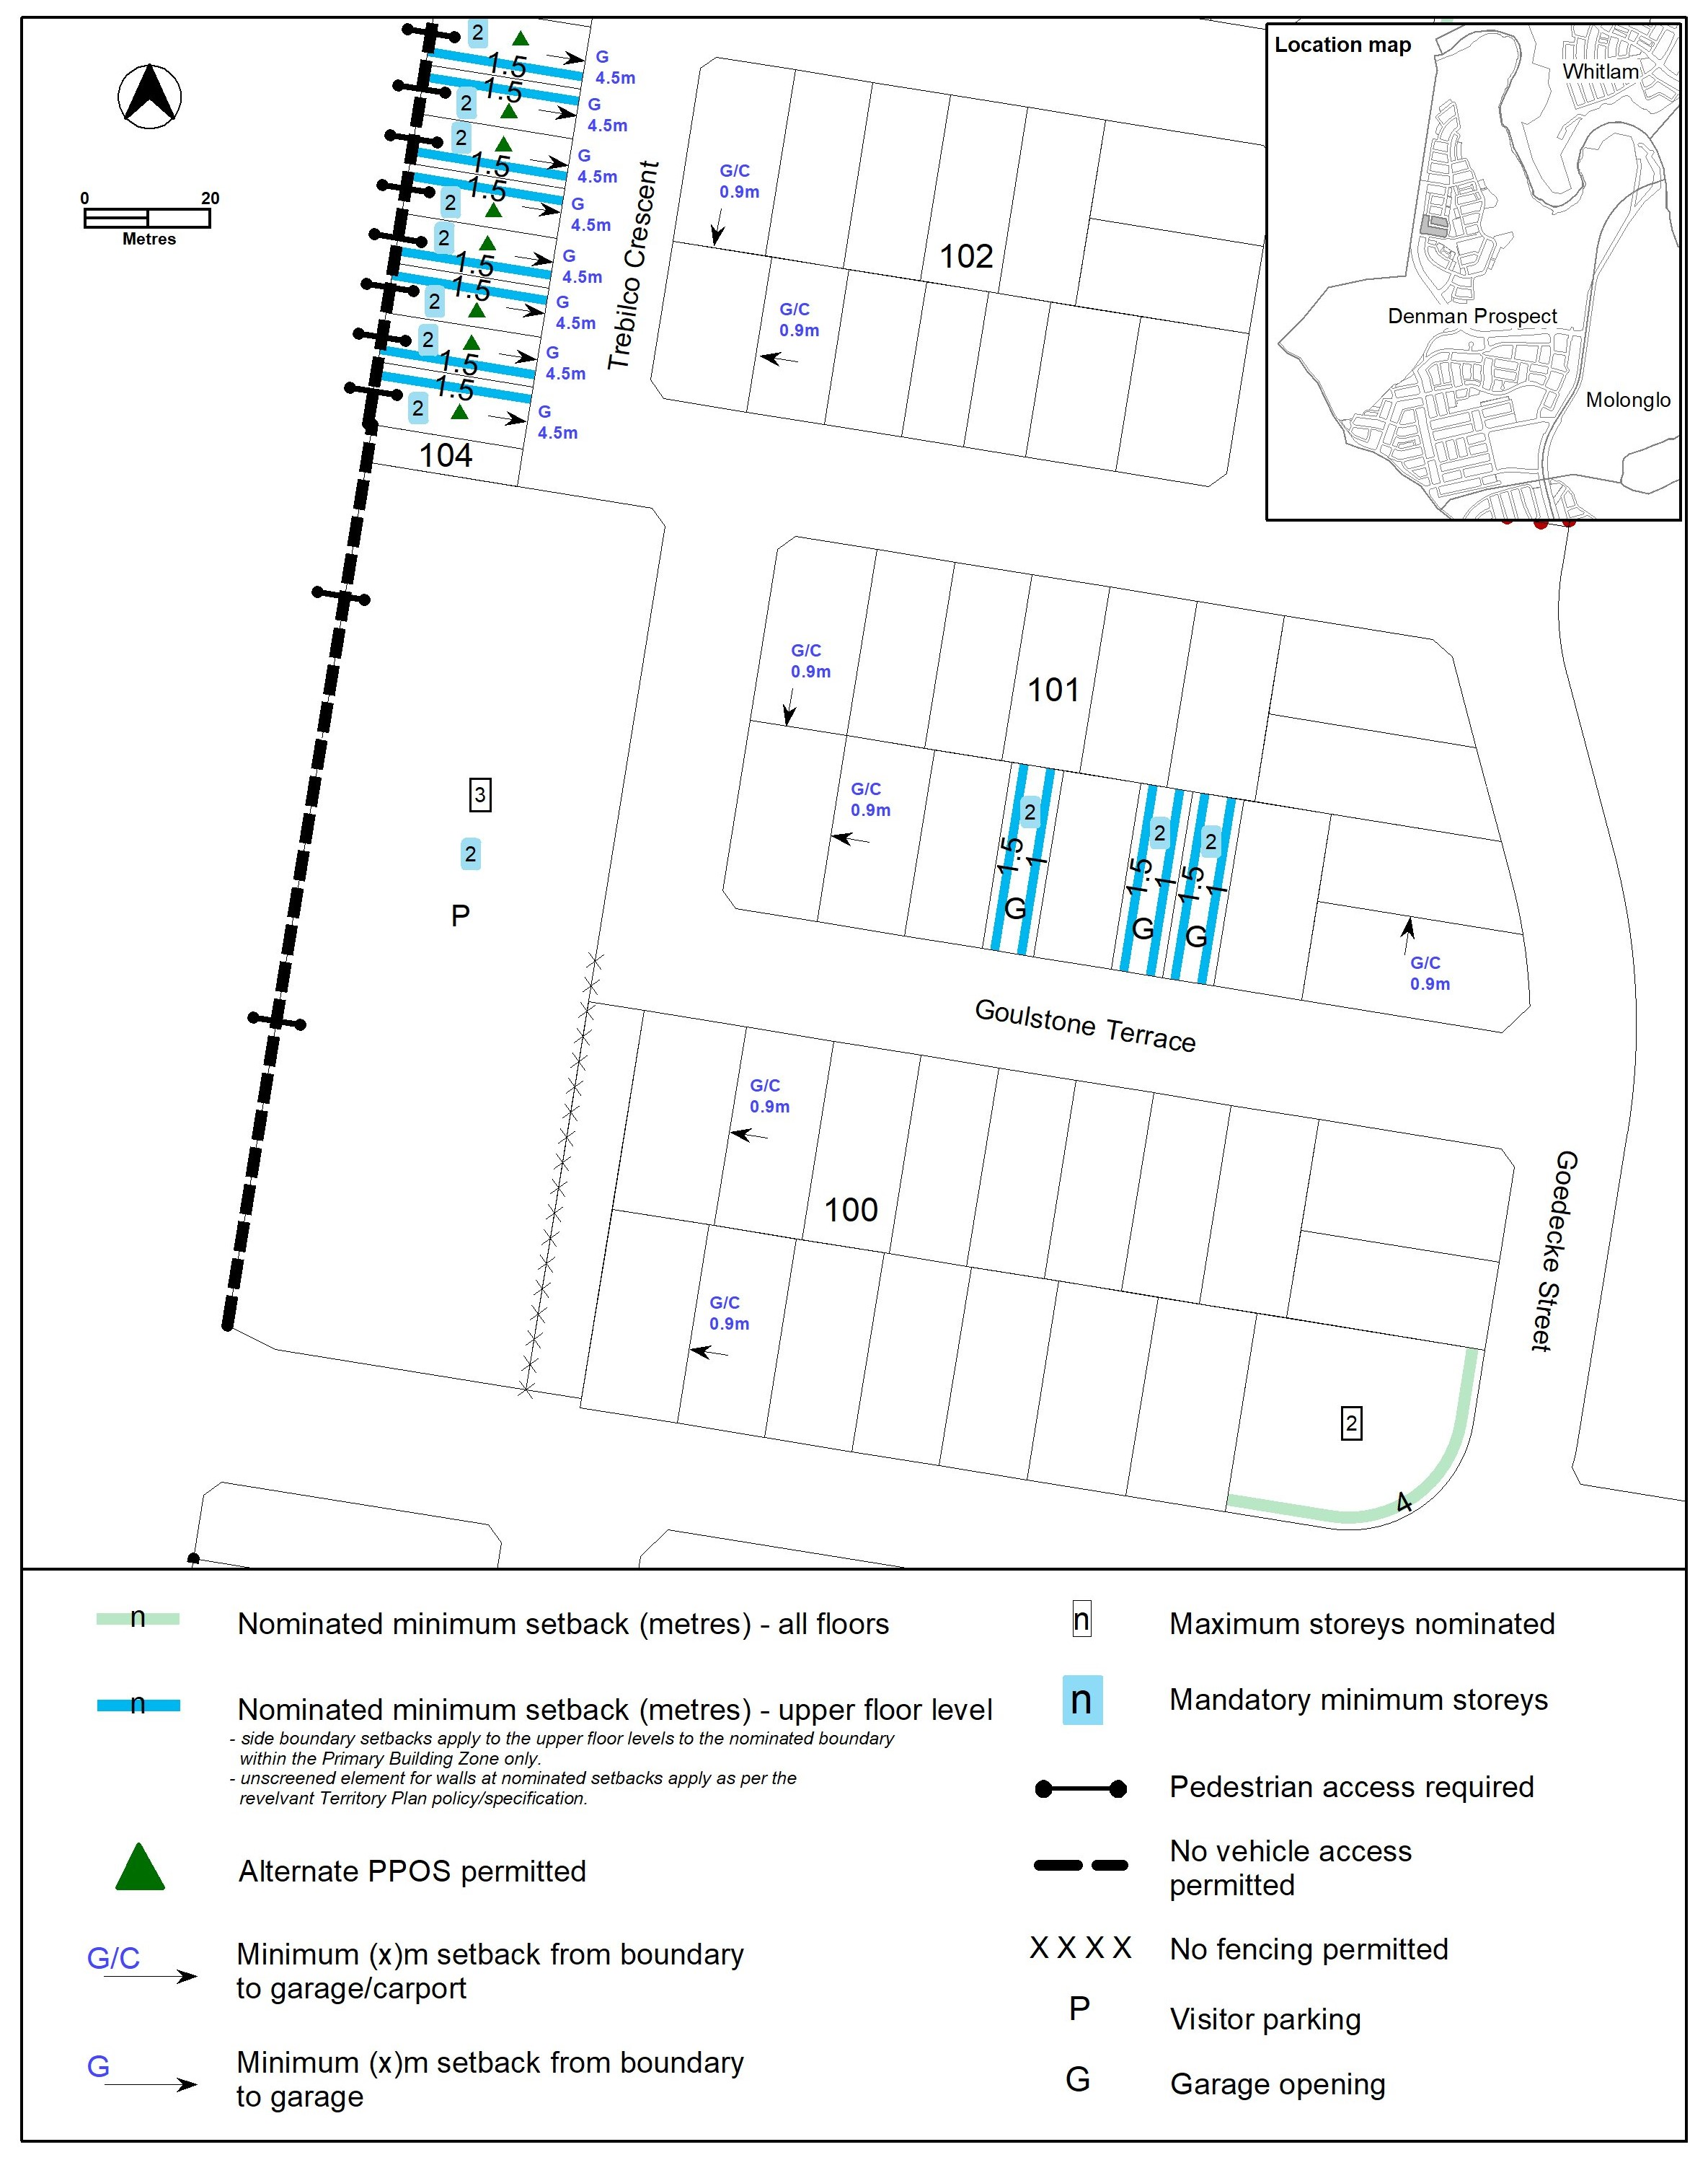
Figure 15 Denman Prospect – Ongoing Provisions

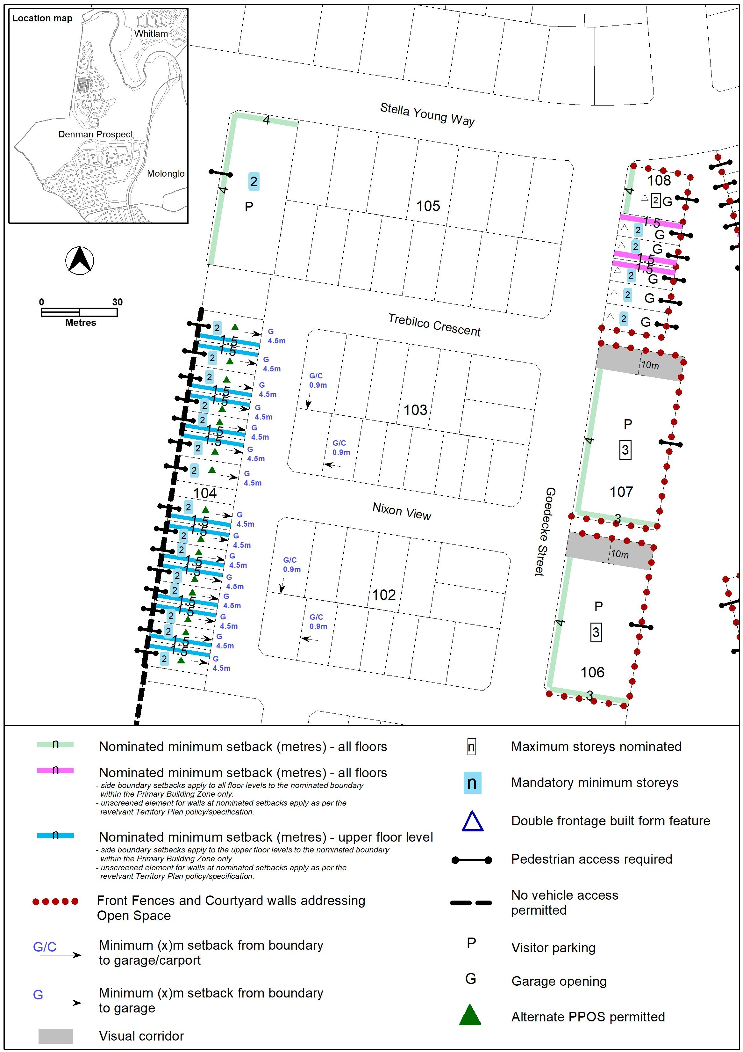
Figure 16 Denman Prospect – Ongoing Provisions

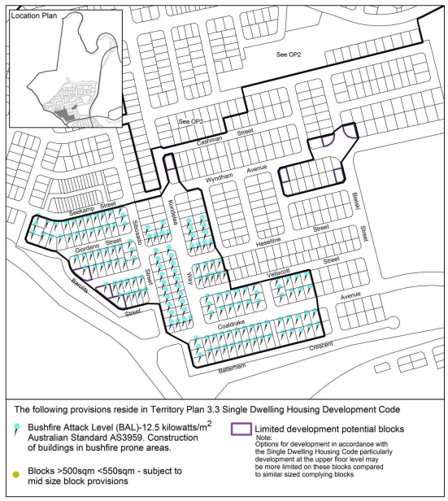
Figure 17 Denman Prospect – Ongoing Provisions
Options for development, particularly development at the upper floor level may be more limited on these blocks.

Options for development, particularly development at the upper floor level may be more limited on these blocks.

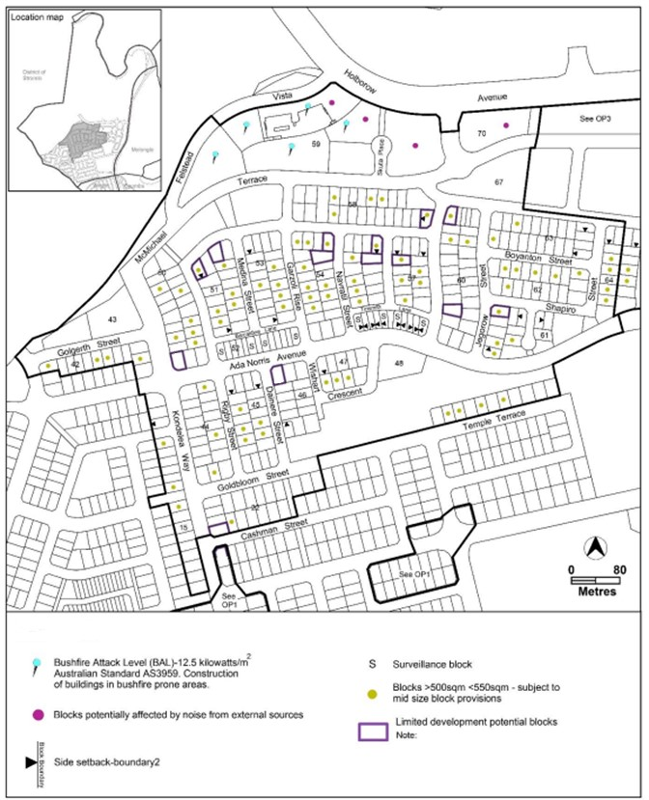
Figure 18 Denman Prospect – Ongoing Provisions
Options for development, particularly development at the upper floor level may be more limited on these blocks.

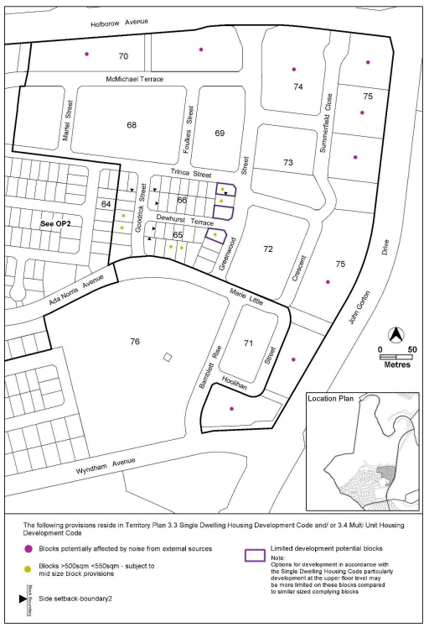
Figure 19 Denman Prospect – Ongoing Provisions
Options for development, particularly development at the upper floor level may be more limited on these blocks.

Options for development, particularly development at the upper floor level may be more limited on these blocks.

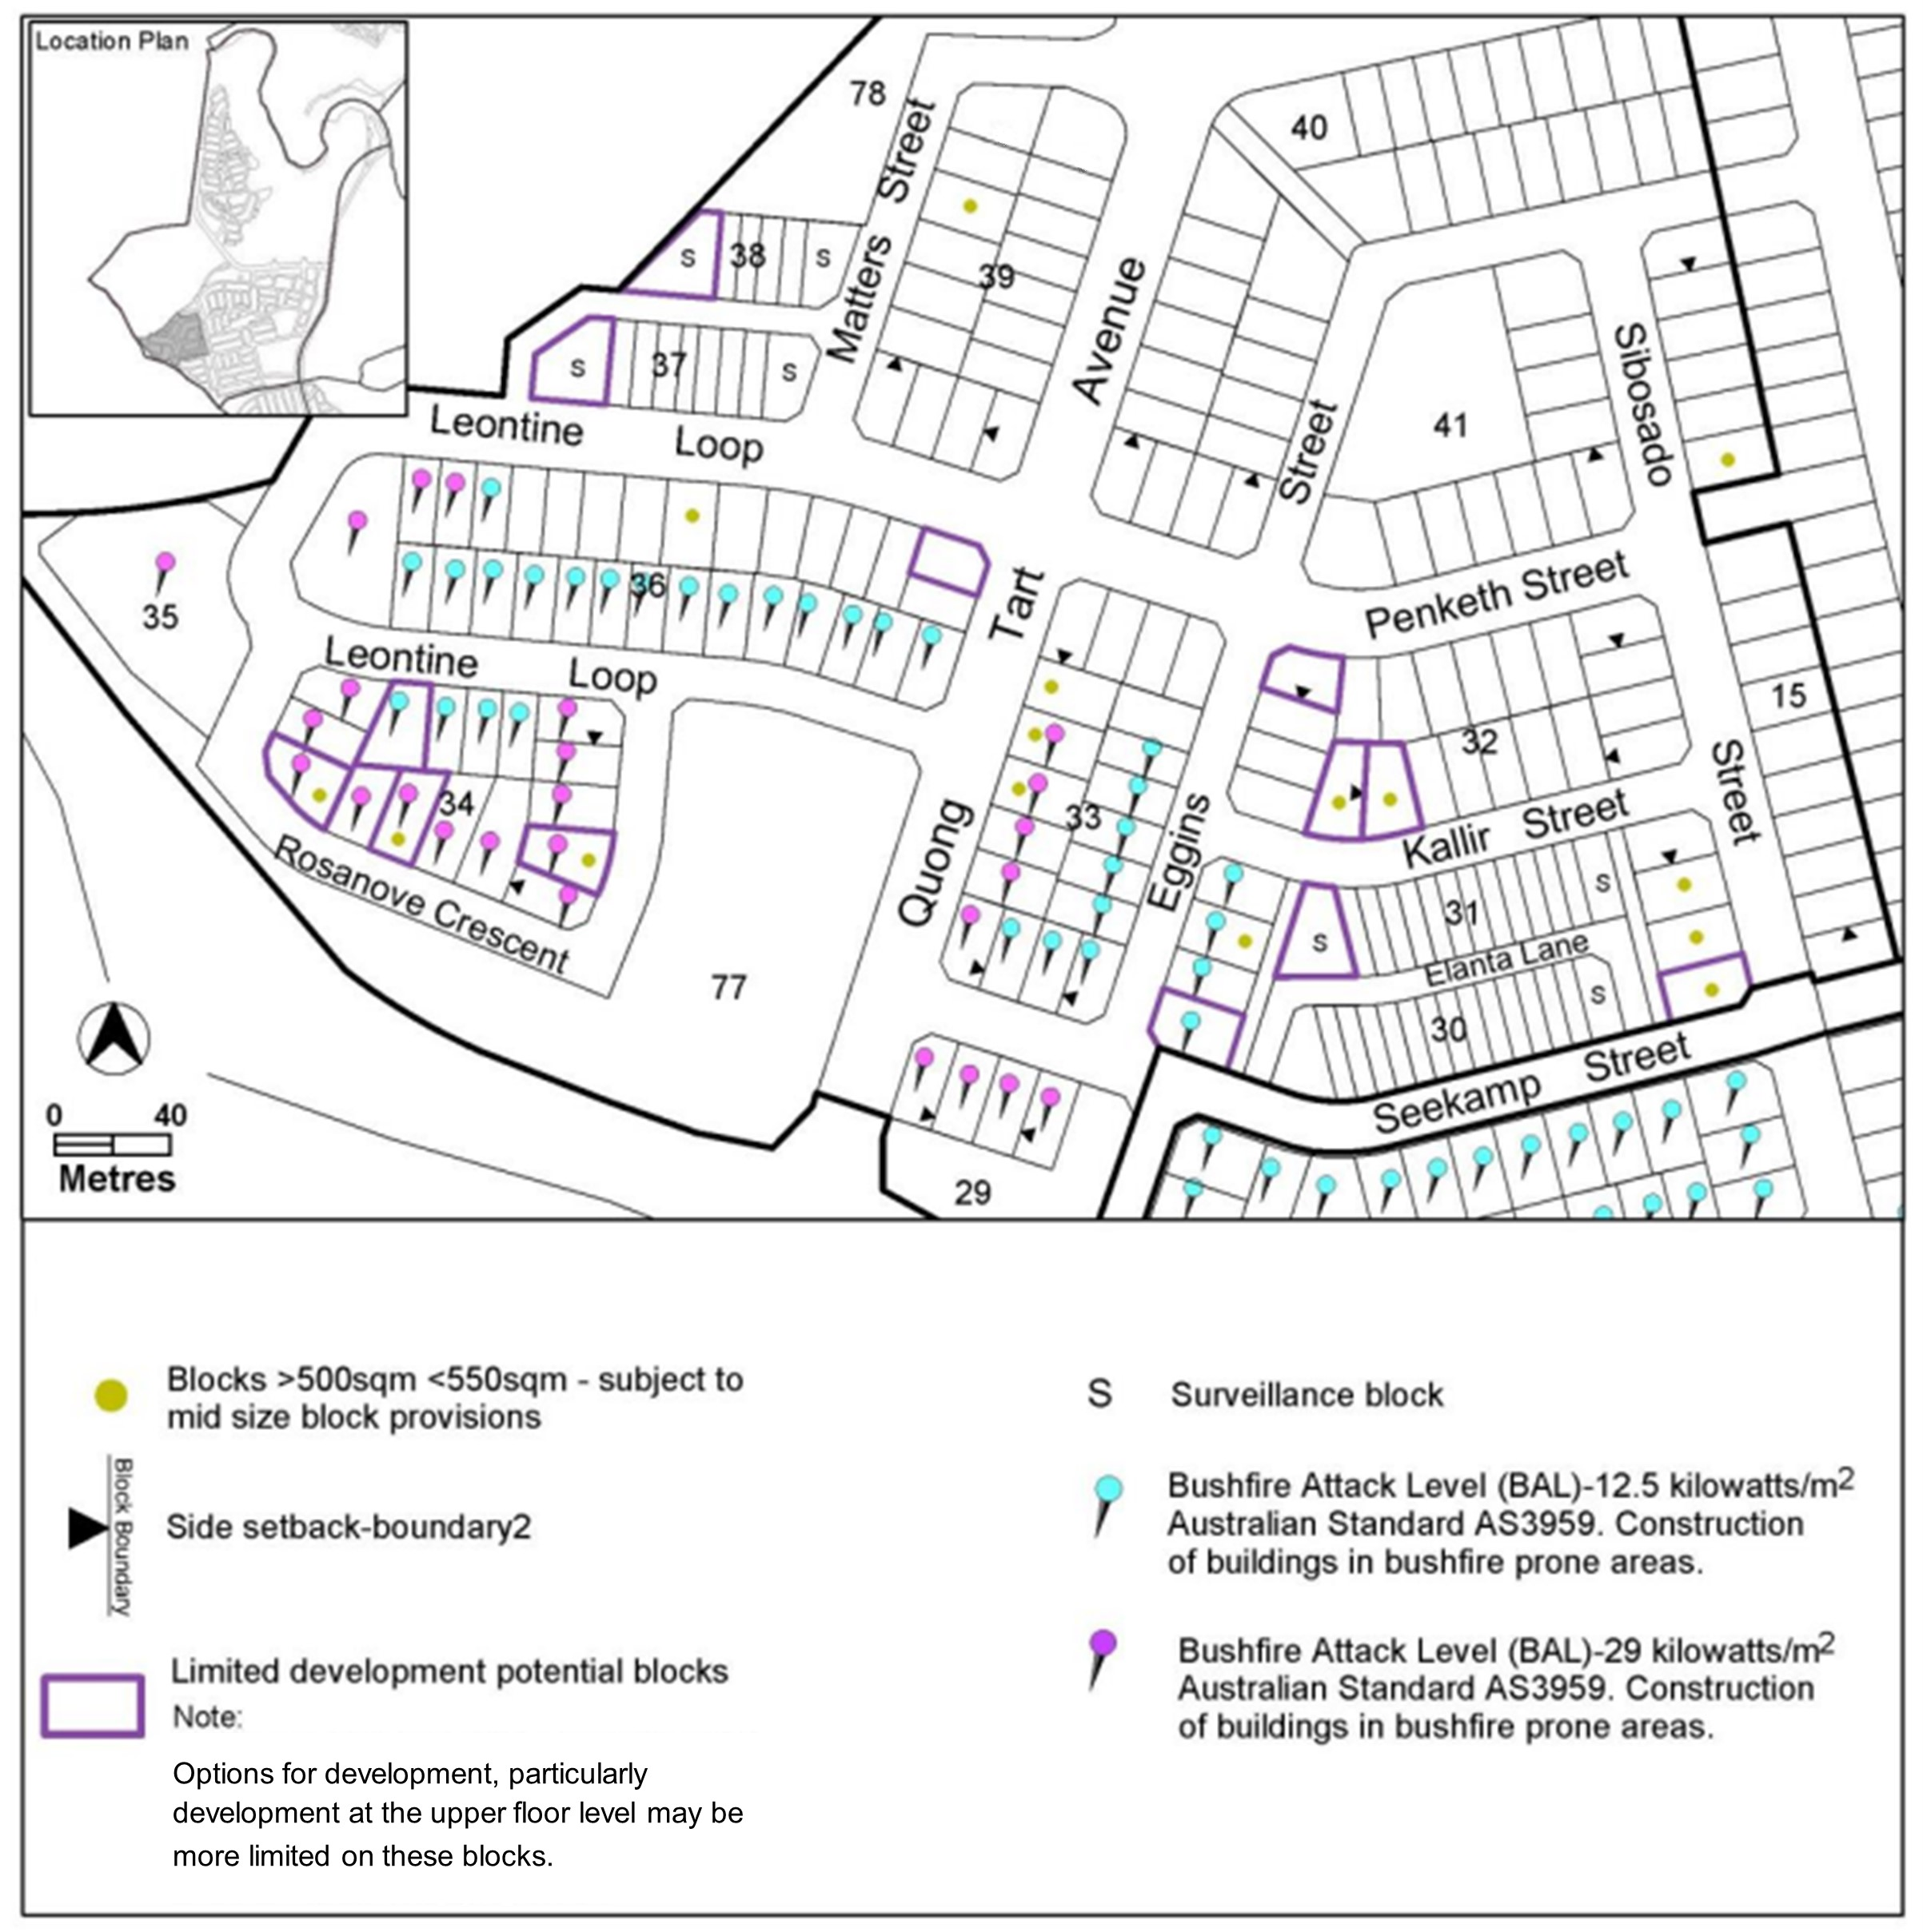
Figure 20 Denman Prospect – Ongoing Provisions

Figure 21 Denman Prospect – Ongoing Provisions
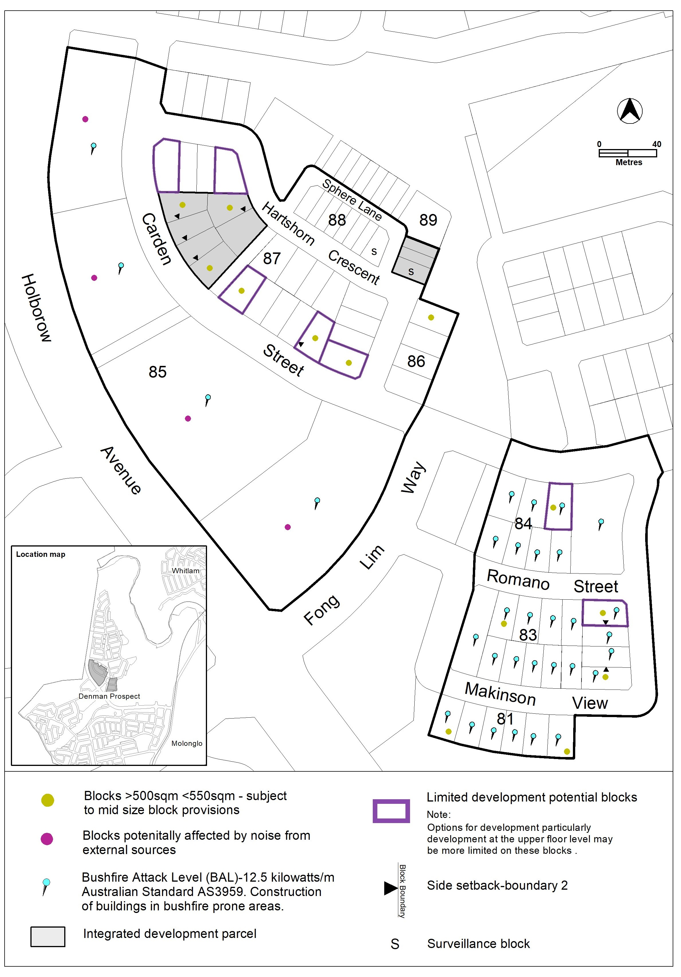

Figure 22 Denman Prospect – Ongoing Provisions
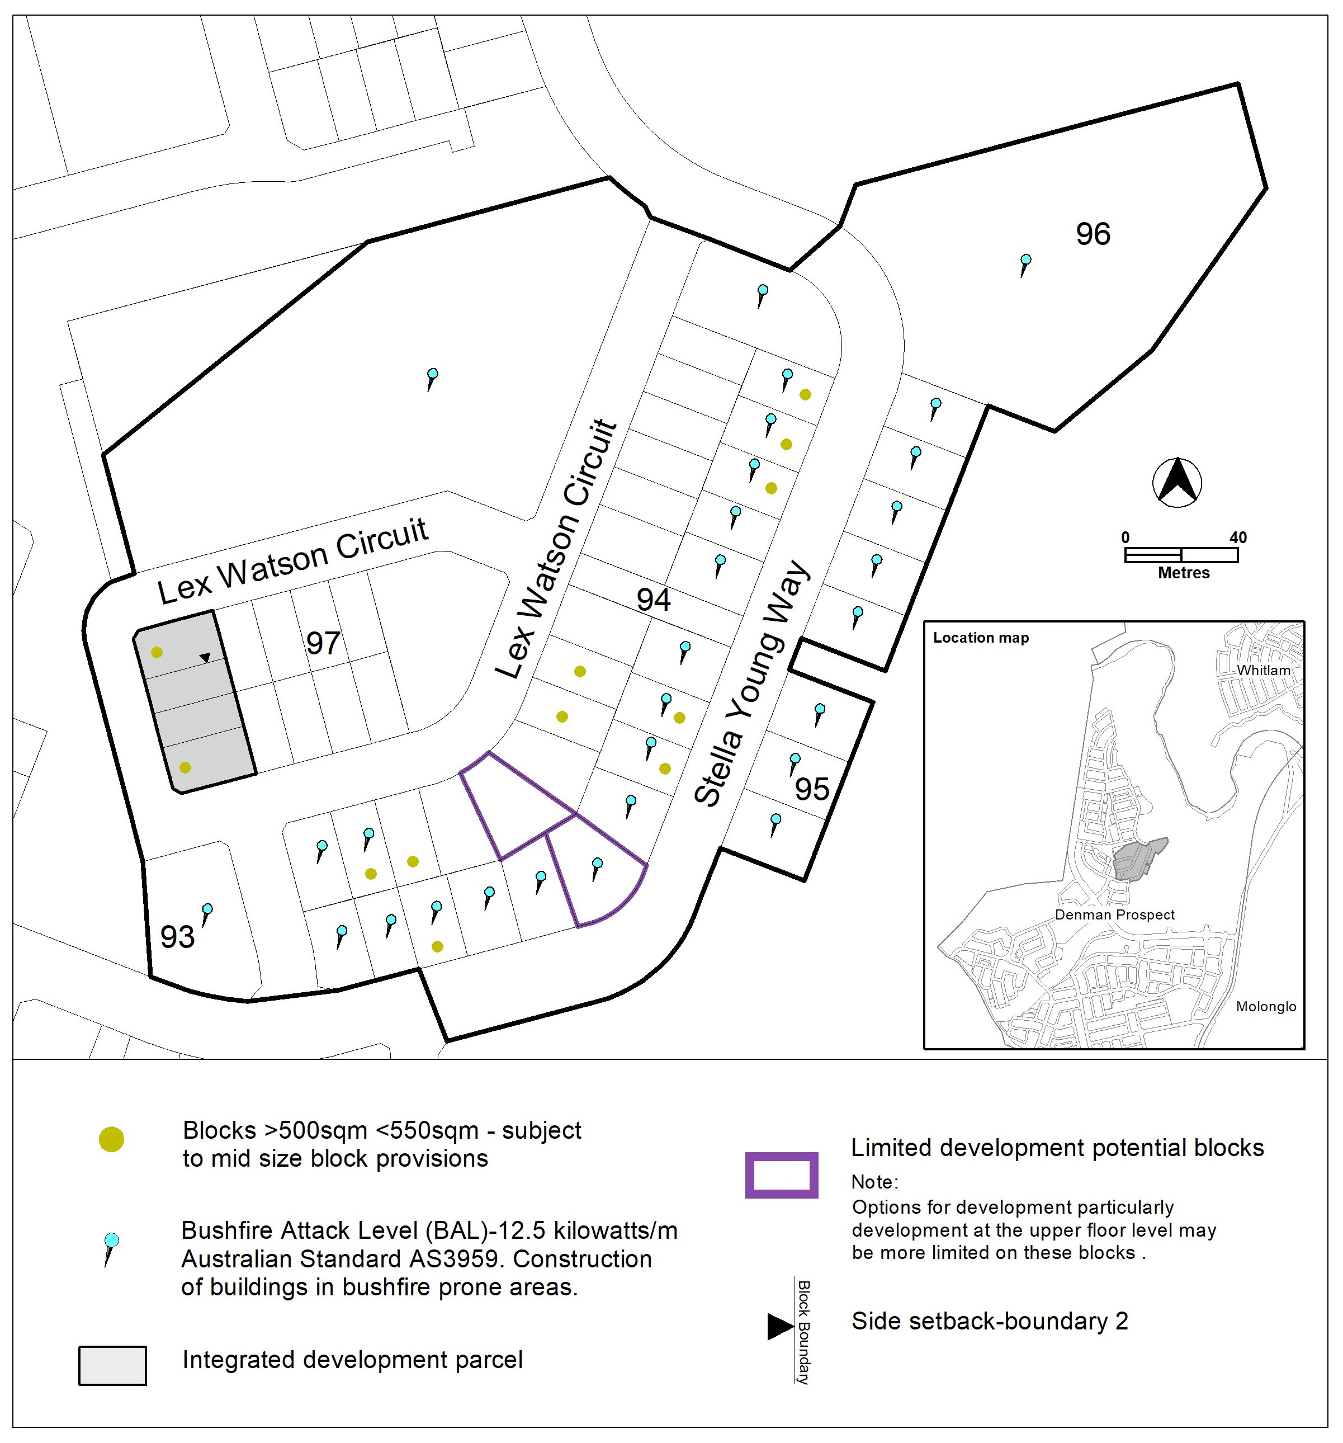

Figure 23 Denman Prospect – Ongoing Provisions
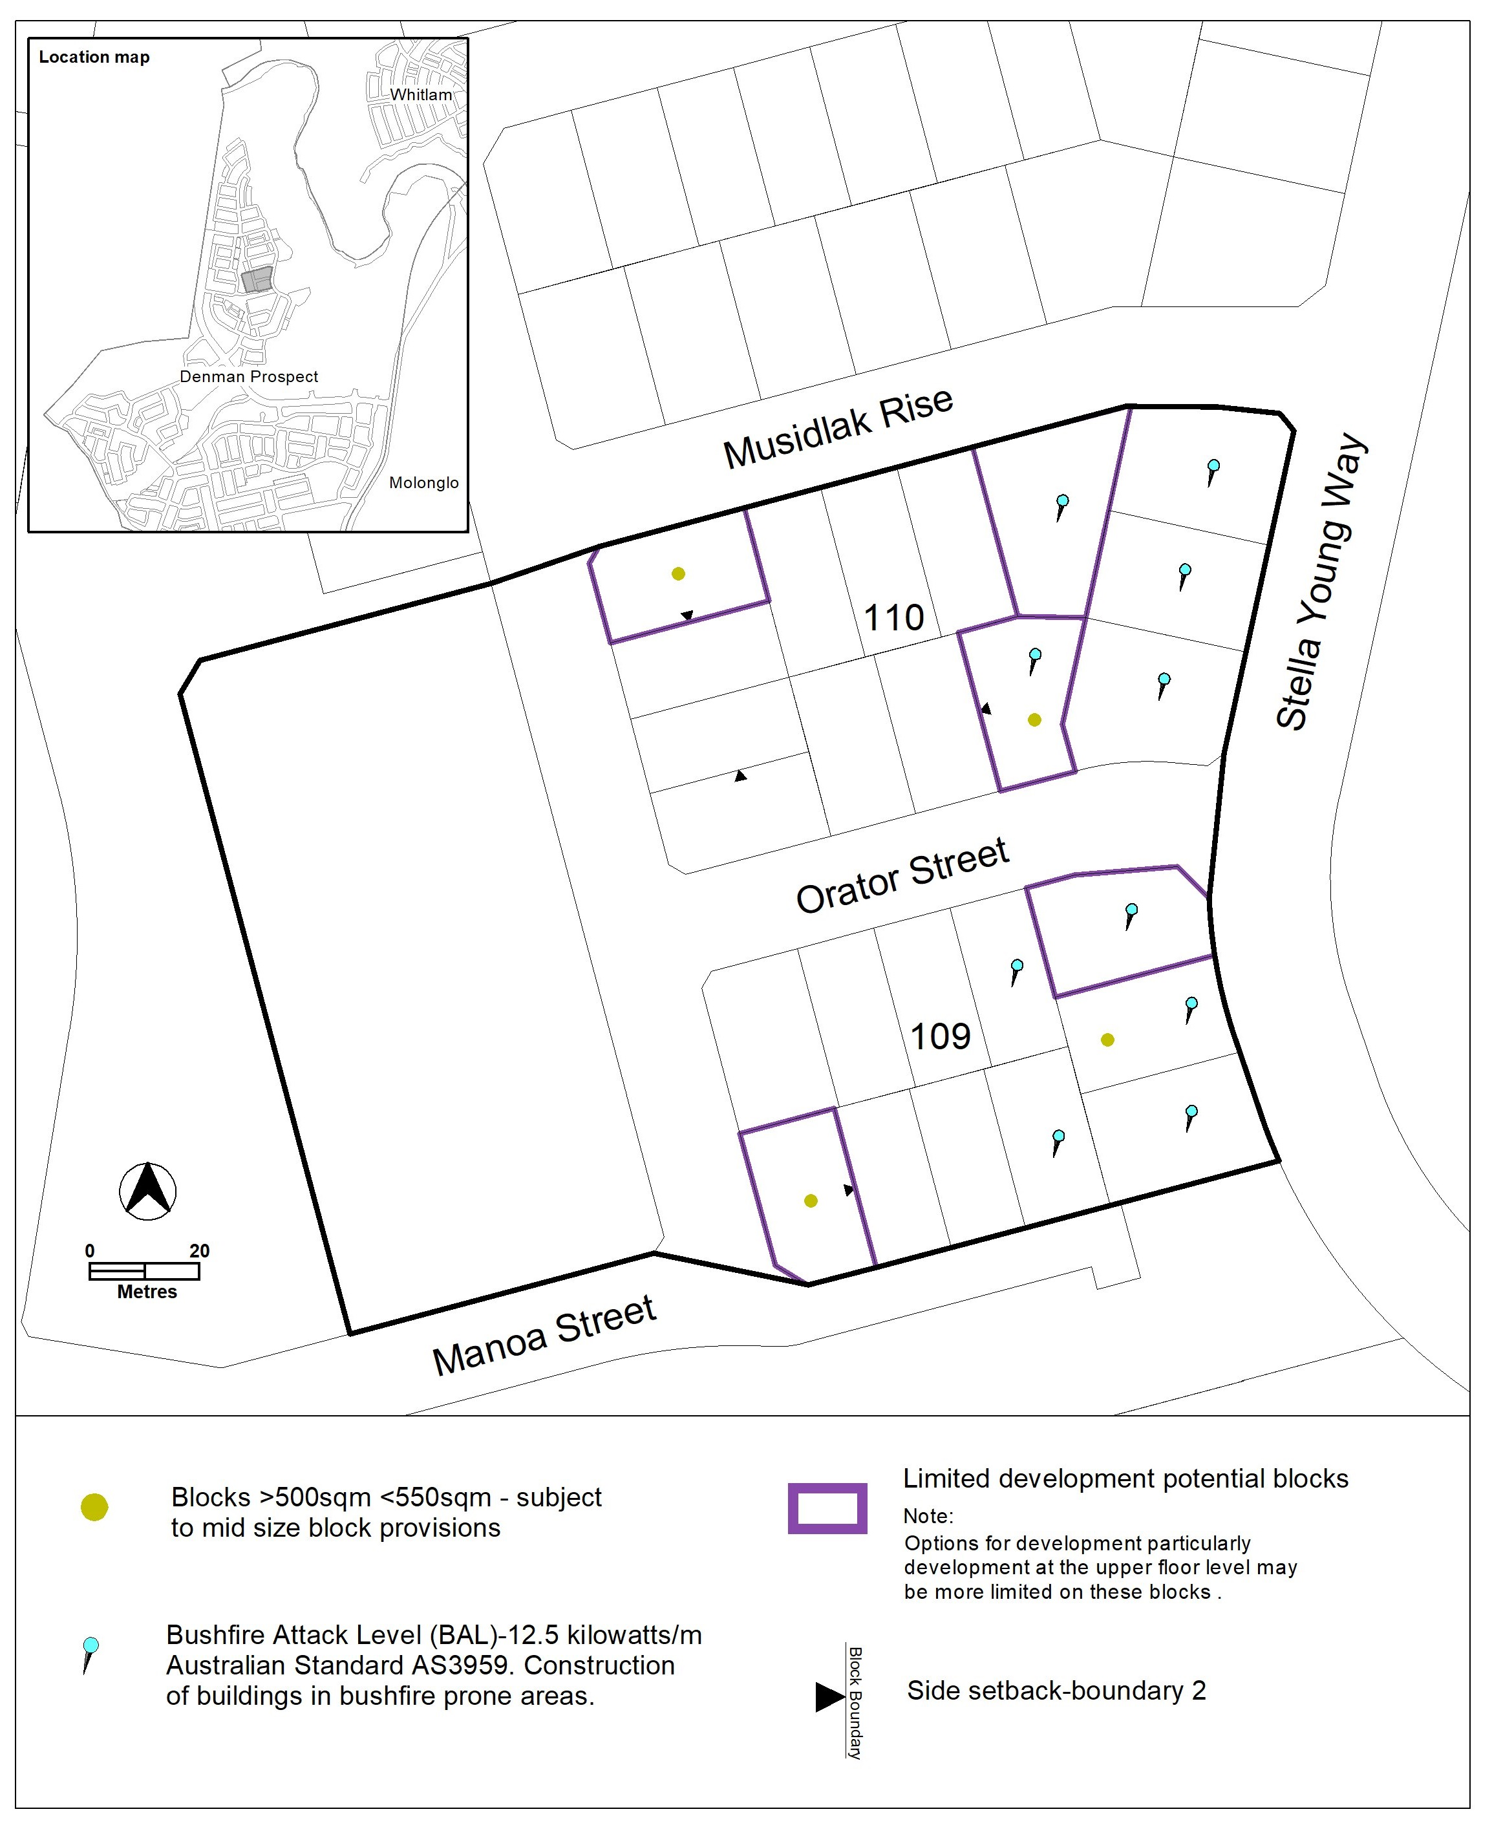

Figure 24 Denman Prospect – Ongoing Provisions
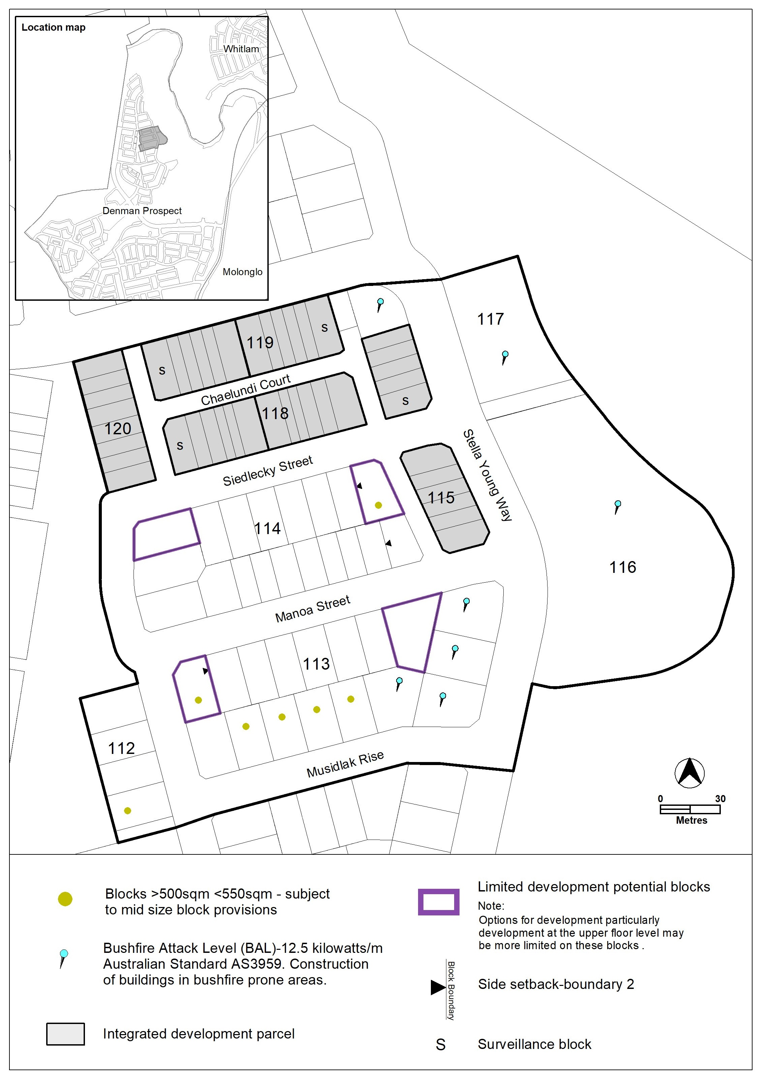

Figure 25 Denman Prospect – Ongoing Provisions
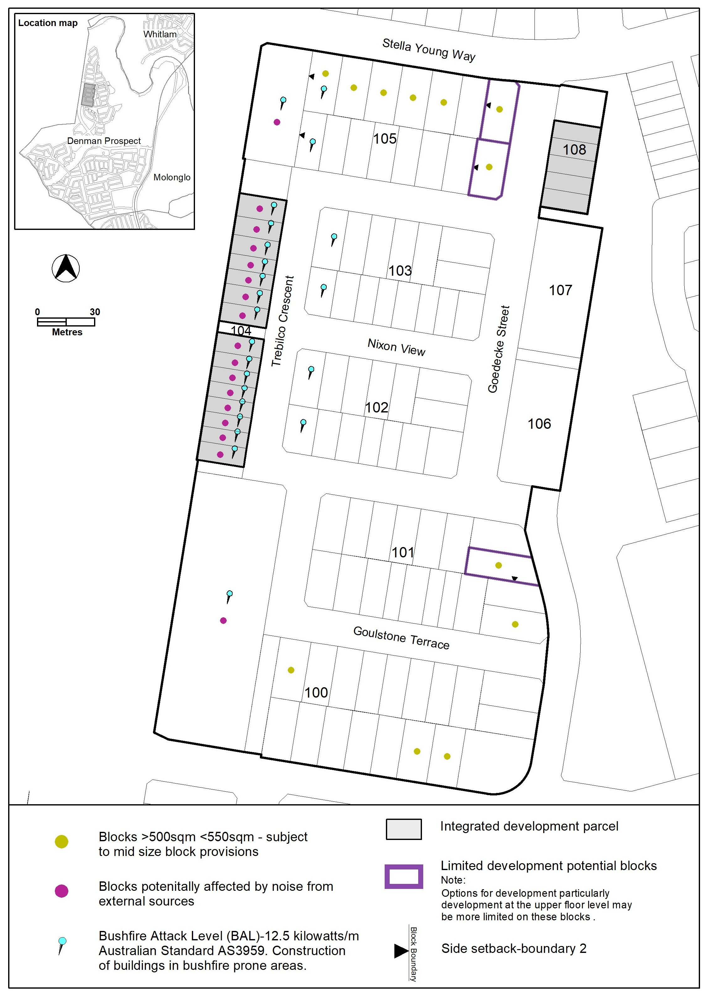

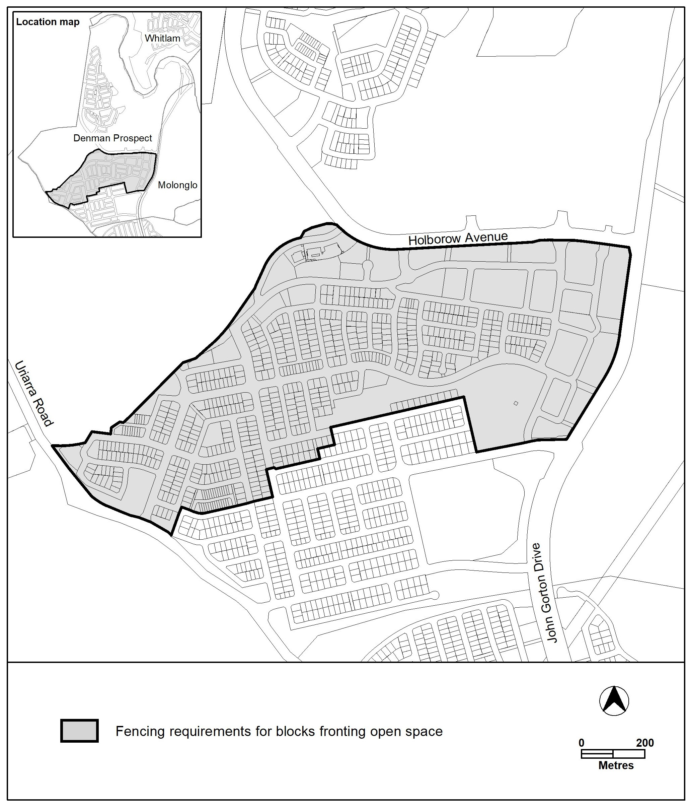
Figure 26 Denman Prospect – Ongoing Provisions

Molonglo
The following specifications provide possible solutions that should be considered in planning, placing, designing and using buildings and structures for proposed development in Molonglo:
Assessment Outcome 1 | The landscape setting and values of Molonglo will be recognised and incorporated into the urban design of the future urban area. Boundary hills and significant internal ridges within the urban fabric will be excluded from inappropriate development.
No applicable specification for this assessment outcome. Application must respond to the assessment outcome.

Assessment Outcome 2 | Upward light spill will be minimised in recognition of its proximity to the Mount Stromlo Observatory.
Specification
Light Spill | - Upward light spill will be minimised by:  - Planting dense evergreen trees between the Mount Stromlo Observatory and urban areas.  - Minimise reflective ground surfaces.  - Applying the relevant Australian Standards such as AS/NZS 1158 (Road Lighting), AS 4282 (Obtrusive Effects of Outdoor Lighting), and AS2560 (Sports Lighting).  - Applying light-sensitive practices to sportsground including the use of cut-off lighting and limiting hours of operation.  - Minimising light spill from outdoor lighting systems, including advertising structures.

Assessment Outcome 3 | Varied building heights, with taller buildings having slender footprints, encourages built form that responds to existing topography and the natural environment, and generally provides a gradual transition in height and scale, from lower buildings in the suburban areas to the tallest buildings in the Core zone. A variety of heights are provided across the Town Centre and surrounds to create architecturally interesting streetscapes and provide views to the river corridor and broader landscape.
Specification
Building Heights | - A range of building heights, including maximum building heights are indicated in Figure 26A and 26B.  - In the area shown on Figure 26A as hatched, one building up to 29 metres (approximately 8 storeys) is permitted where building design contributes to a safe and interesting streetscape.  - Taller buildings are to be carefully distributed at key locations which may include corners and sites adjacent to park or plaza frontages.  Note: Plant room that is set back a minimum of 3m from the building façade of the floor immediately below, and screening and other non-gross floor area rooftop architectural features are excluded from the building height.

Assessment Outcome 4 | Solar access is enabled to public spaces, particularly in the winter months, to provide pleasant spaces for community and to promote healthy growth of plants and trees.
No applicable specification for this assessment outcome. Application must respond to the assessment outcome.

Assessment Outcome 5 | The public realm is protected by limiting overshadowing and wind impacts on streets and public places.
No applicable specification for this assessment outcome. Application must respond to the assessment outcome.

Assessment Outcome 6 | Development incorporates interactive, human scale, ground level building frontages to the streets and public realm where appropriate.
No applicable specification for this assessment outcome. Application must respond to the assessment outcome.

Assessment Outcome 7 | A range of retail and commercial uses are provided that interconnect with community facilities.
No applicable specification for this assessment outcome. Application must respond to the assessment outcome.

Assessment Outcome 8 | The integration of community and recreation facilities enhances the quality of the commercial core and its surrounds.
No applicable specification for this assessment outcome. Application must respond to the assessment outcome.

Assessment Outcome 9 | Views from the town centre to significant landscape features, such as Black Mountain are retained, to assist people to easily navigate the town centre and promote a sense of place.
No applicable specification for this assessment outcome. Application must respond to the assessment outcome.

Figure 26A – Molonglo Valley – Town Centre and surrounds – Building Heights
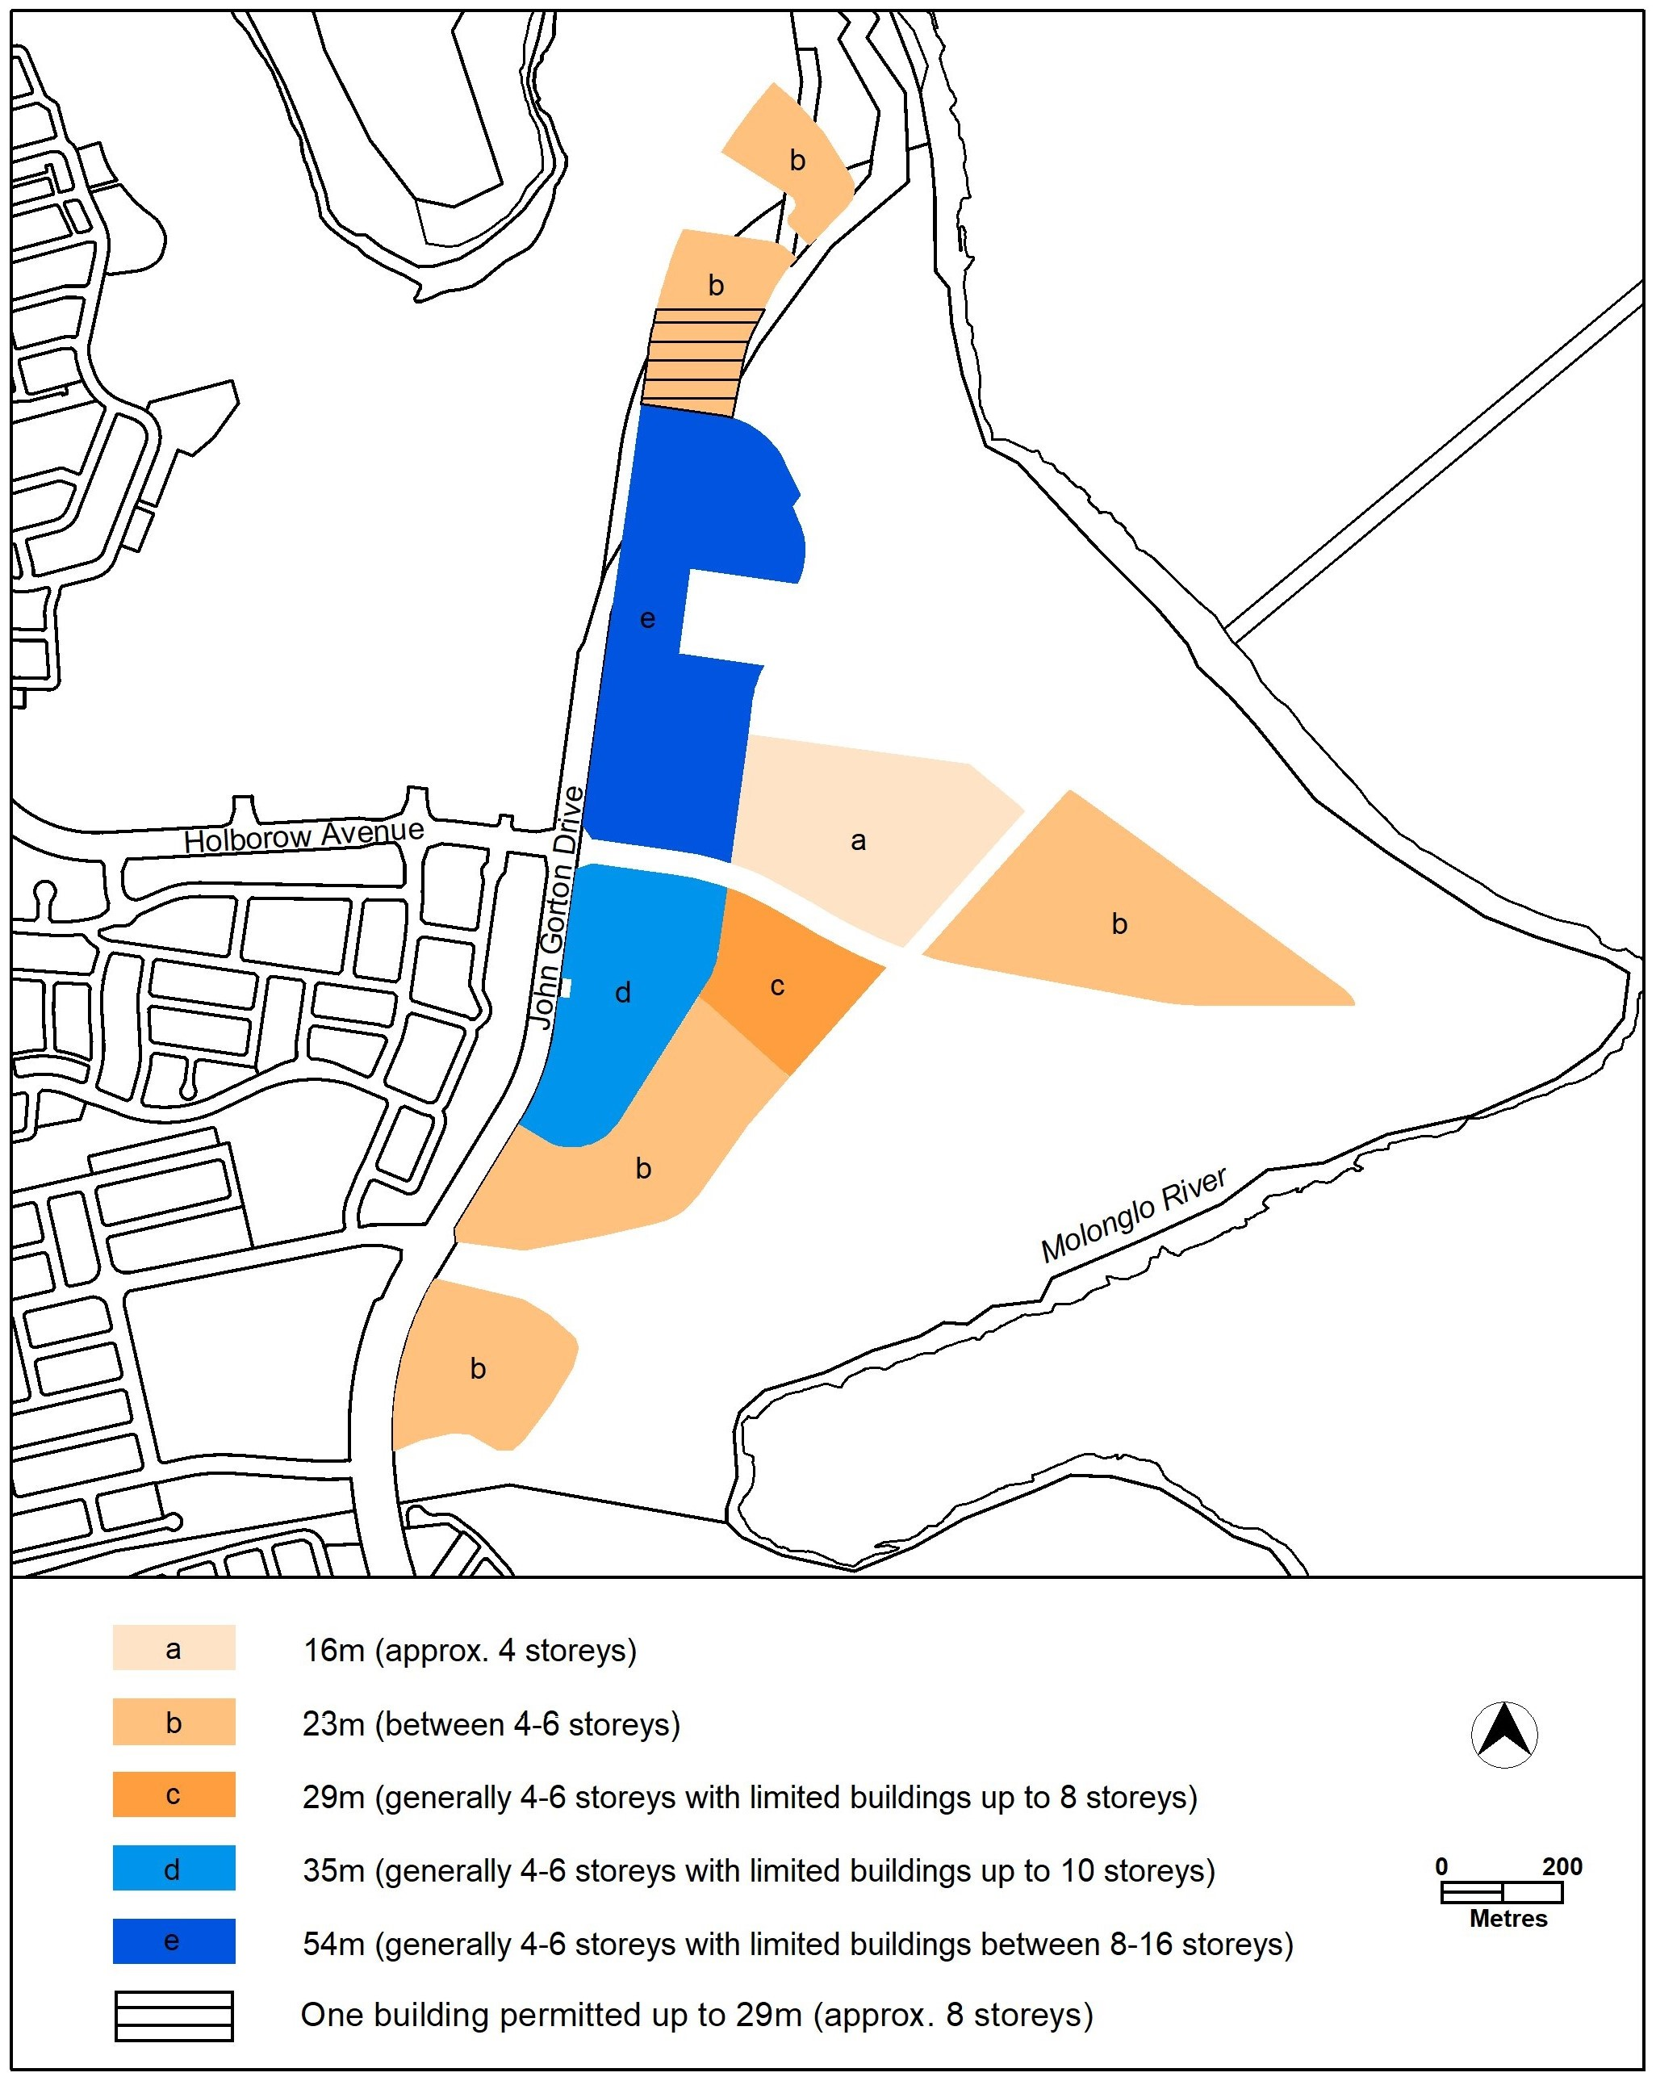

Figure 26B – Molonglo Valley – Town Centre and surrounds – Building Heights
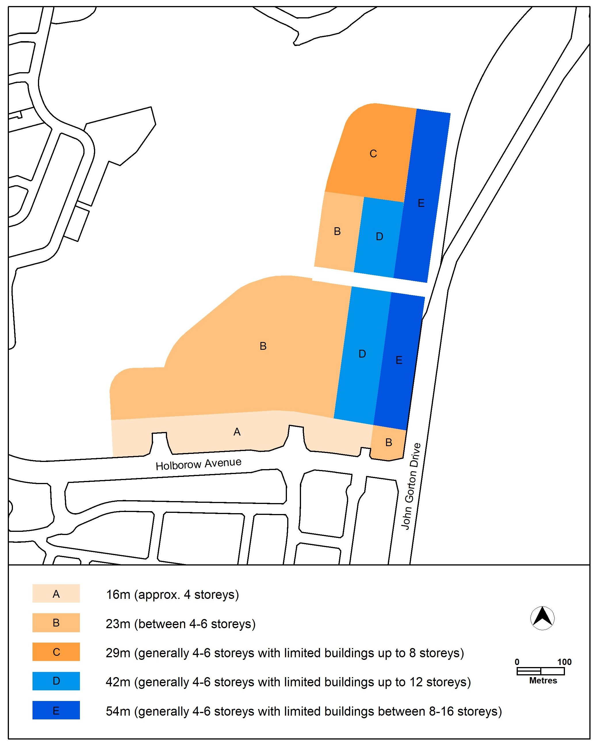

Whitlam
The following specifications provide possible solutions that should be considered in planning, placing, designing and using buildings and structures for proposed development in Whitlam:
Assessment Outcome 10 | Development is designed to minimise the noise impact from William Hovell Drive and John Gorton Drive
Specification
Noise | - For blocks identified in Figure 28, Figure 29, Figure 30, Figure 31, Figure 32 and Figure 33 with ‘acoustic protection – minimum wall height’, development is designed to minimise the noise impact from William Hovell Drive and John Gorton Drive by having dwelling walls that face these road/s being a minimum height of 6 metres above datum ground level for the length of the wall.  Note: The purpose of this specification is to provide acoustic protection measures for the estate.
  - For blocks identified in Figure 35A with ‘acoustic protection required’, façades facing William Hovell Drive require the following measures to address external road noise, including:

- Glazing: Window system meeting ≥32 dB R_{w} (≥30 dB R_{w} + C_{tr}); for example:
- ≥6.38 mm laminated glass, or
- A double-glazed system of ≥6 mm float glass | ≥12 mm air gap | ≥6 mm float glass.
- ≤6.6 m² maximum glazed façades area for each enclosed room.
- Framing system included in the R_{w} calculation.
Note: The selected window frame system and acoustic seals must not degrade the overall sound insulation performance of the window system.
- Walls: A well-mortared brick veneer or any masonry construction is acoustically suitable on the identified blocks. However, if lightweight cladding is used on the façade with direct and partial frontage to the arterial road the following typical minimum constructions would provide adequate façade sound insulation:

External wall meeting ≥51 dB R_{w} (≥42 dB R_{w}+ C_{tr}); for example:
- ≥ 9 mm compressed fibre cement board (or boards of total surface mass ≥13 kg/m2), and
- Insulated cavity:
  - ≥ 90 mm frame fully filled with fibrous acoustic insulation (≥14 kg/m³); and
- Internal cladding:
  - ≥ 2 layers of 13 mm standard core plasterboard (or other boards of surface mass ≥8.5 kg/m² each layer).

Assessment Outcome | Refer to zone assessment outcomes
Specification
Vehicle access | - For blocks identified in Figure 27, Figure 28, Figure 29, Figure 30, Figure 32, Figure 33, Figure 34, Figure 35, and Figure 35A with ‘access not permitted’, vehicular access is not permitted to or from the block from the nominated boundary.
Courtyard walls | - For blocks identified in Figure 27, Figure 28, Figure 29, Figure 30, Figure 32, Figure 33, Figure 34, Figure 35, and Figure 35A, with a ‘courtyard wall’ requirement, courtyard walls are all of the following:  - A maximum height of 1.5m  - Constructed of rendered brick, block or stonework in combination with feature panels that include openings not less than 25% of the surface area.  - Setback 600mm from the front boundary to incorporate landscaping.  - The length of the wall is to extend along the boundary and terminate 5 metres from the corner boundary adjoining a road.  Note: See Figure 36 for examples of courtyard walls.
Building heights | - For blocks identified in Figure 30 with ‘mandatory two storeys’, the mandatory number of storeys is nominated.
Setbacks | - For blocks identified in Figure 27, Figure 28, Figure 29, Figure 30, Figure 32, Figure 33, Figure 34, Figure 35, and Figure 35A, the minimum boundary setbacks to floor levels are nominated.  - For blocks identified in Figure 27, Figure 28, Figure 29, Figure 30, Figure 31, Figure 32, Figure 33, Figure 34 and Figure 35 with ‘dwelling and garage side boundary setbacks as specified’, the following lower floor level side boundary setbacks within the primary building zone and the rear zone are provided:  - Minimum of 3m from side boundary 1.  - Minimum of 1.5m from side boundary 2.  Garage setback is a minimum of 1.5m from side boundary 2.  The lower floor level minimum rear boundary setback and all upper floor level setbacks in Table 4 and Table 6 of the Single Dwelling Housing Development Code apply.  Note: The northern boundary of section 11 blocks 13 and 17 are considered side setbacks for the purposes of this rule.  - For blocks identified in Figure 35 with ‘exceptions to minimum front boundary setbacks do not apply’, the exceptions to minimum front boundary setbacks for large and midsized blocks shown in Table 3 of the Single Dwelling Housing Development Control do not apply.  - For blocks identified in Figure 35A with ‘dwelling and garage side boundary setbacks’, the following dwelling and garage setbacks apply:  - Side setbacks are a minimum of 3m.  - Garage setback is 1.5m.  - No zero side setbacks.
Habitable rooms | - Blocks identified in Figure 35A are to provide habitable rooms above the garage.
Garage doors and carports | - For blocks identified in Figure 35 with ‘maximum width of garage door and carports’, the maximum total width of garage doors and external width of carports is the lesser of:  - 6m.  - 50% of the façade of the dwelling.
Finished floor level | - For blocks identified in Figure 35 with ‘finished floor level no lower than front boundary RL’, the finished floor level of any dwelling entrance accessible from the front boundary must be no lower than the front boundary reduced level (RL) where the pathway from that entrance connects to the front boundary.
Acoustic protection | - For blocks identified in Figure 32 and Figure 33 as ‘additional noise affected blocks’, façades for single level dwellings must be between a minimum height of 3 metres and a maximum height of 4.5 metres above datum ground level. Dwellings more than a single level are not permitted. Dwellings more than a single level will require an individual acoustic assessment to be submitted.
Bushfire asset protection zone | - For blocks identified in Figure 35 in an ‘asset protection zone’, habitable structures are not permitted.
Development requirements | - Development complies with the specifications identified in Figure 37, Figure 38, Figure 39, Figure 40, Figure 41, Figure 42, Figure 43, and Figure 44.

Figure 27 Whitlam – Ongoing Provisions
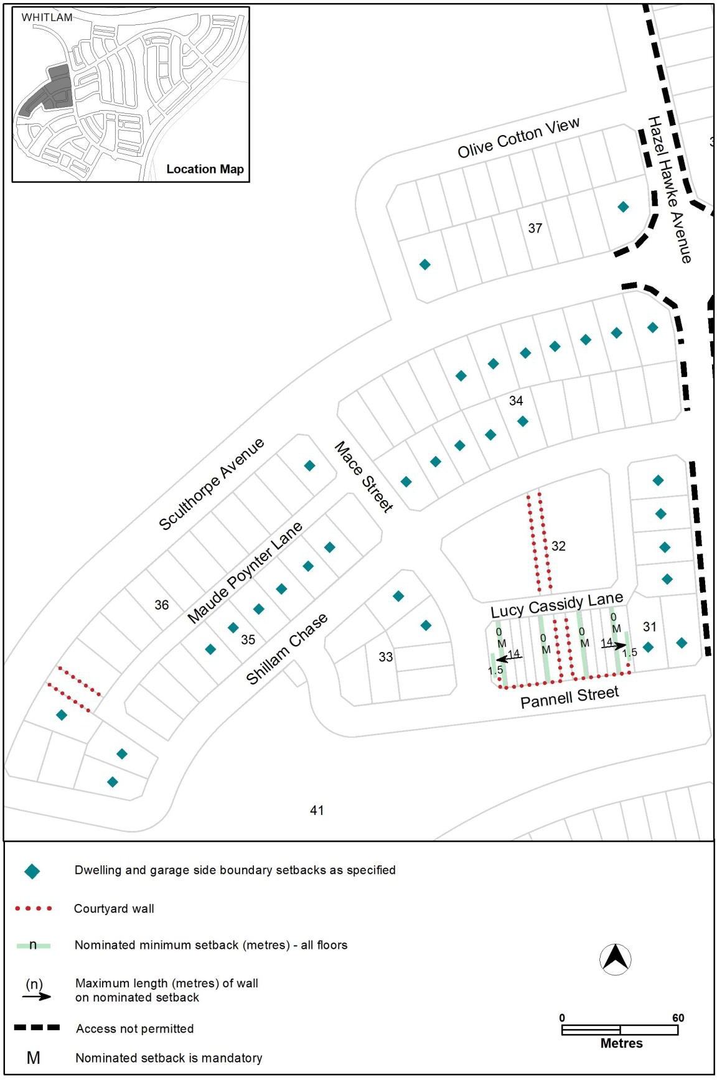

Figure 28 Whitlam – Ongoing Provisions
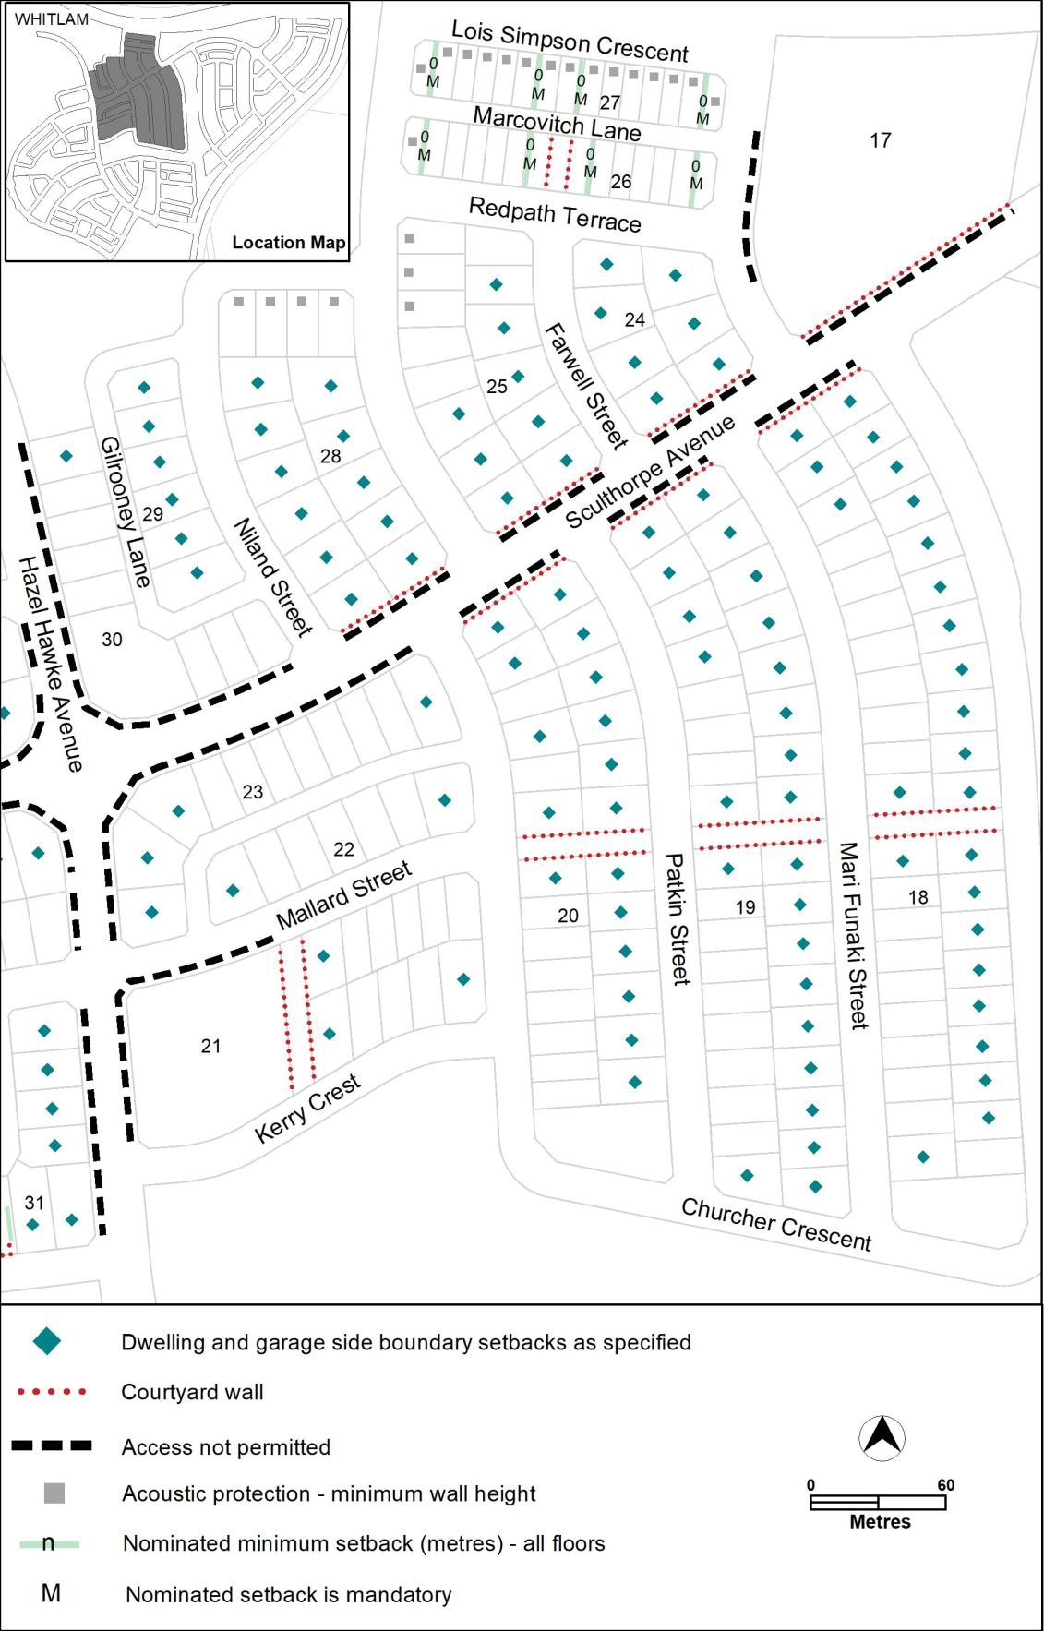

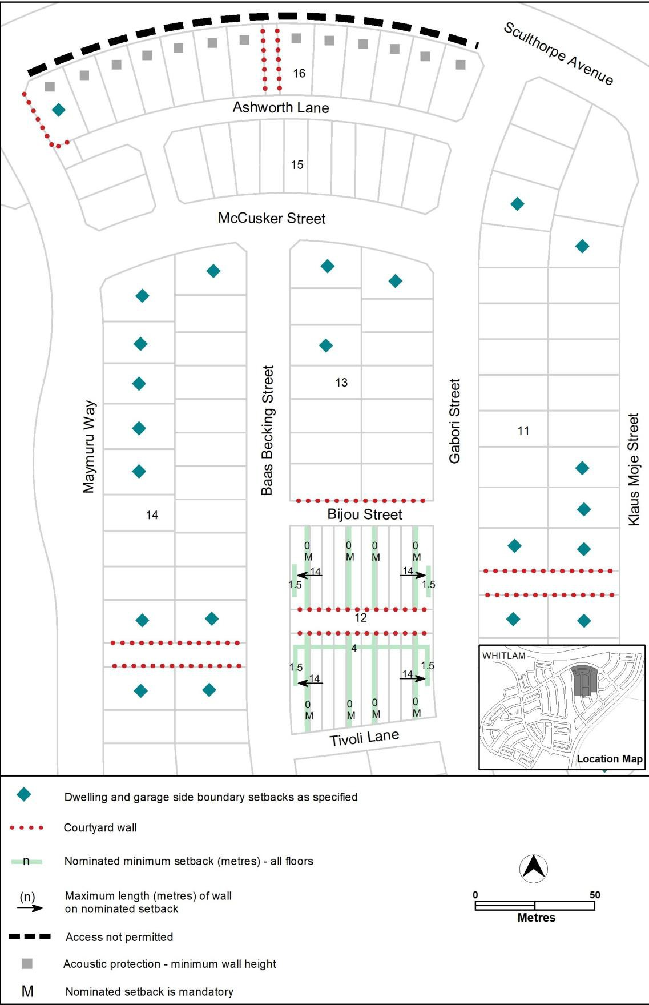
Figure 29 Whitlam – Ongoing Provisions

Figure 30 Whitlam – Ongoing Provisions
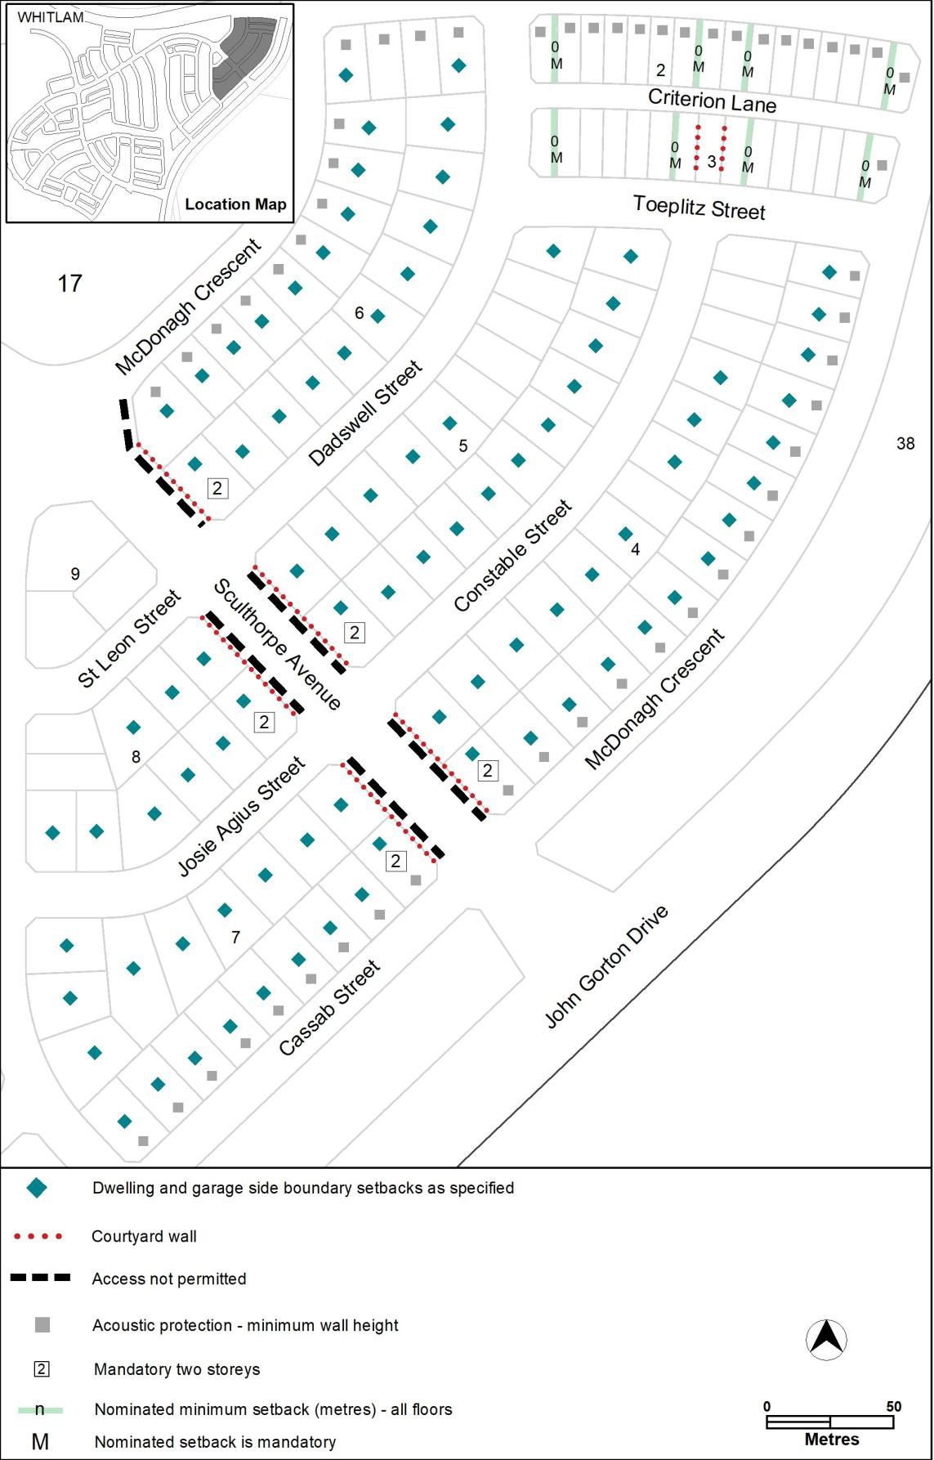

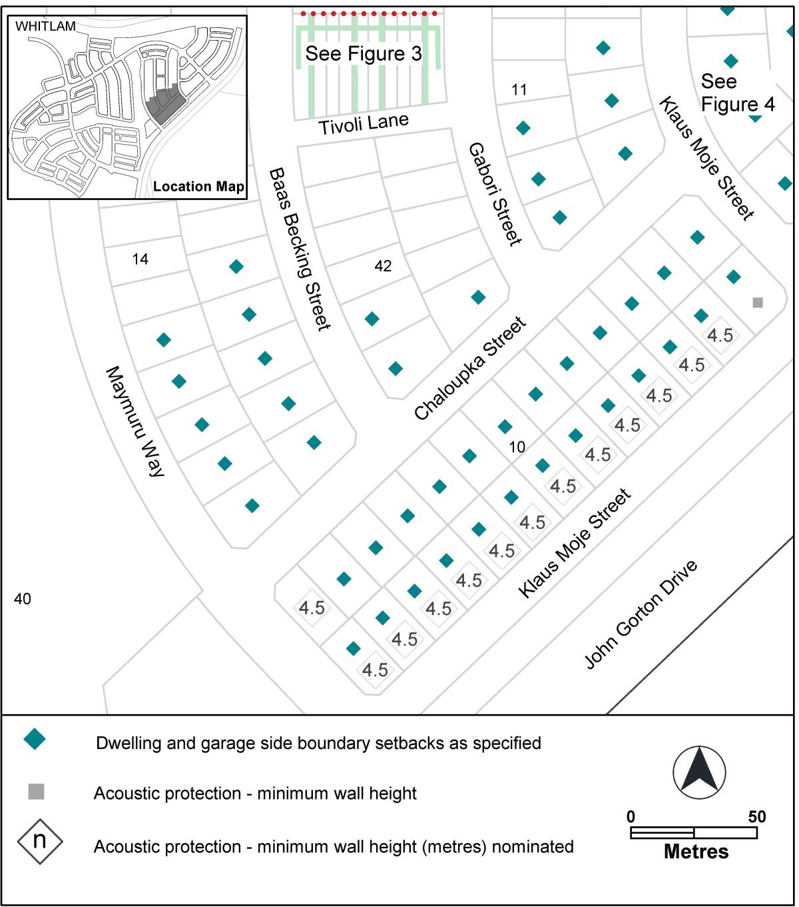
Figure 31 Whitlam – Ongoing Provisions
15
16
15

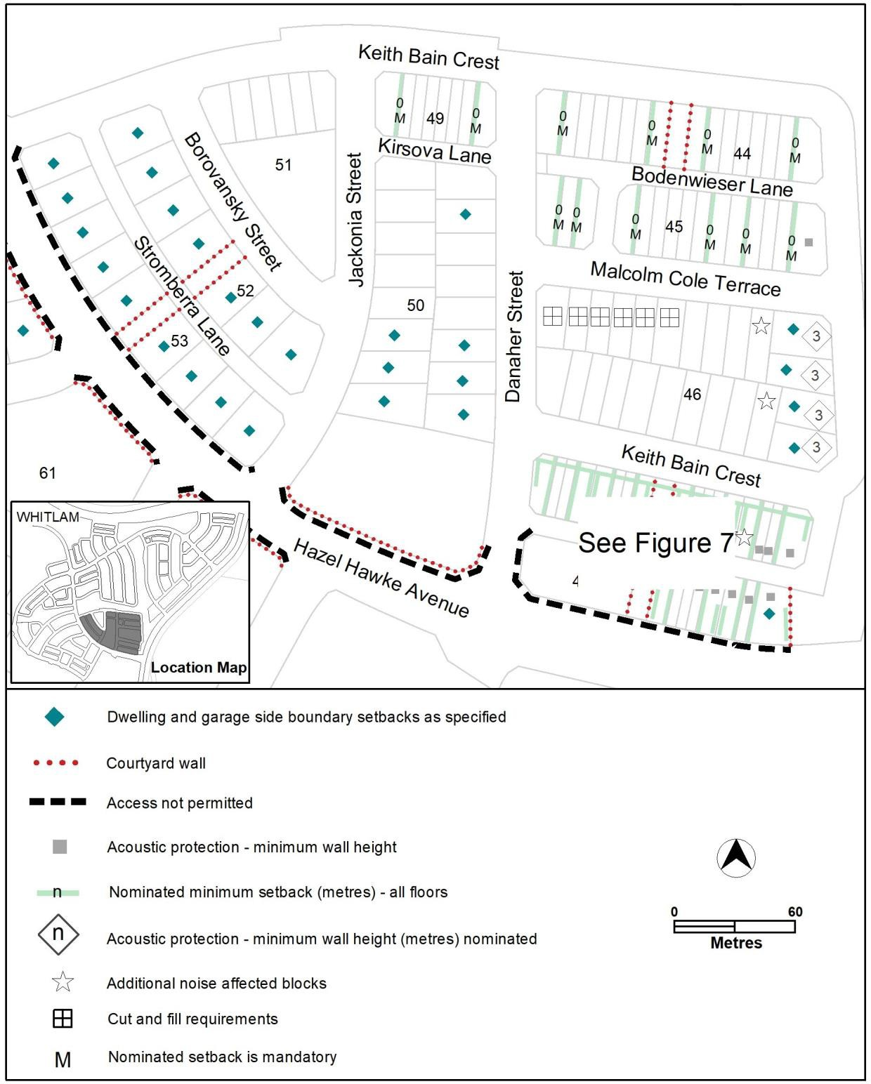
Figure 32 Whitlam – Ongoing Provisions

Figure 33 Whitlam – Ongoing Provisions
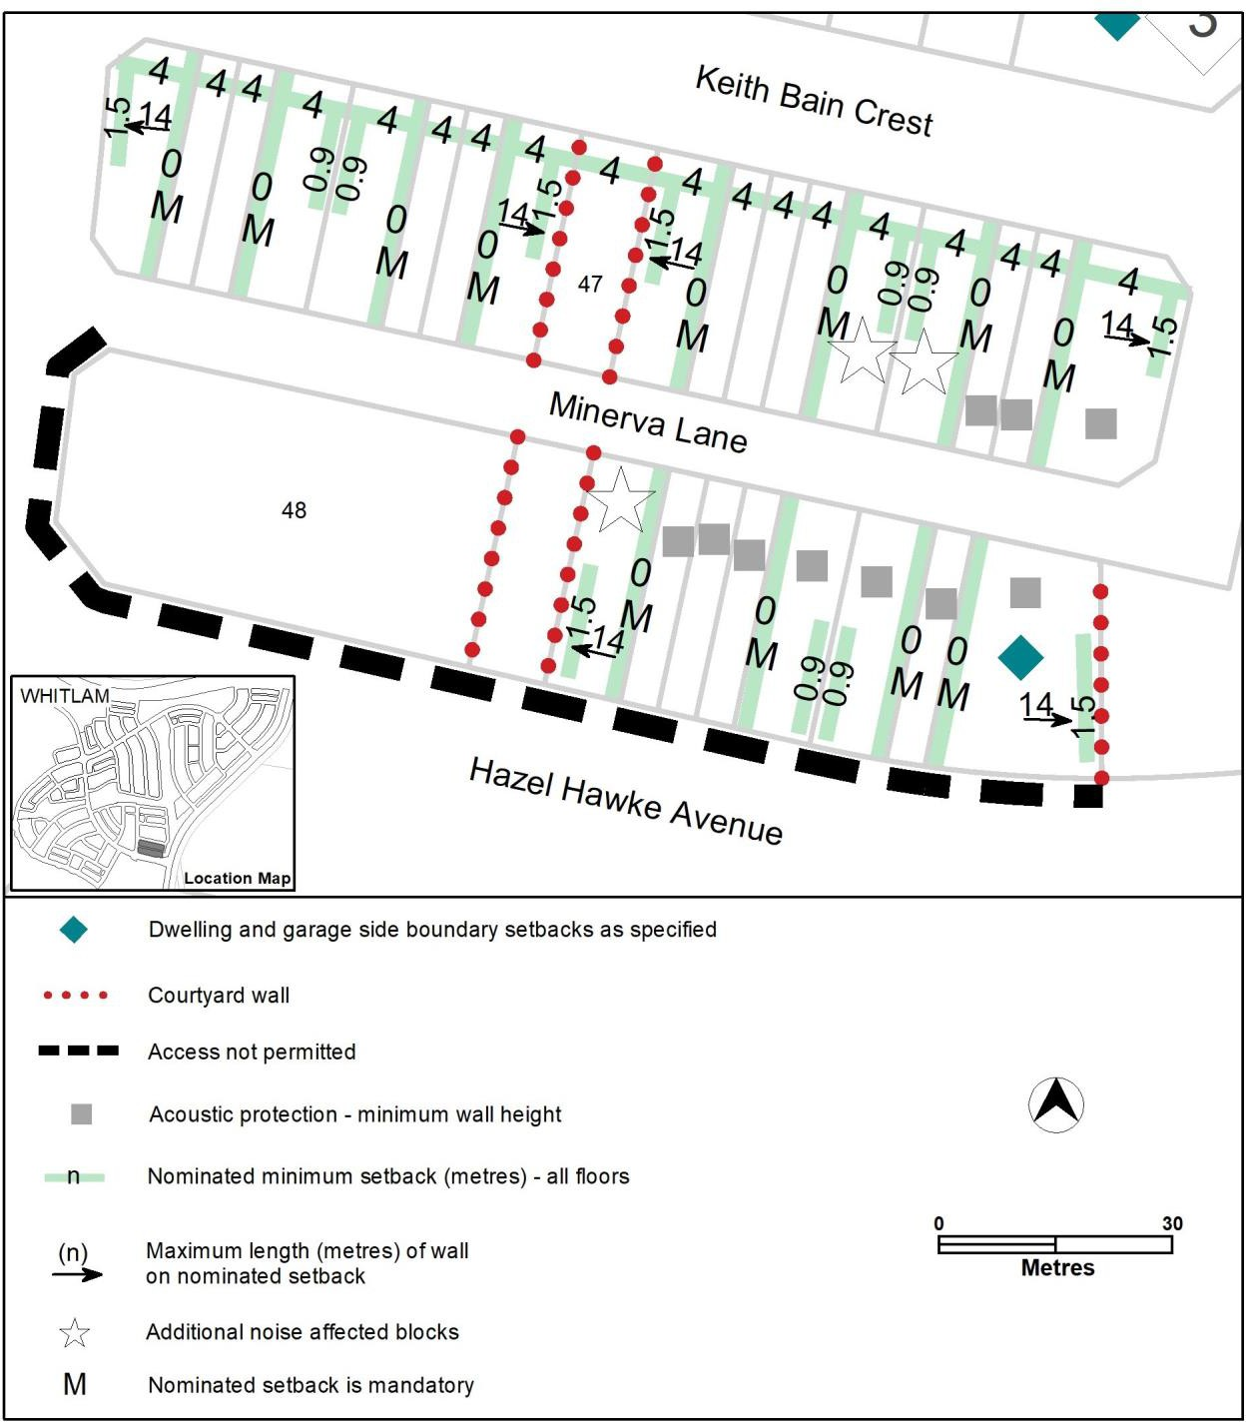

Figure 34 Whitlam – Ongoing Provisions
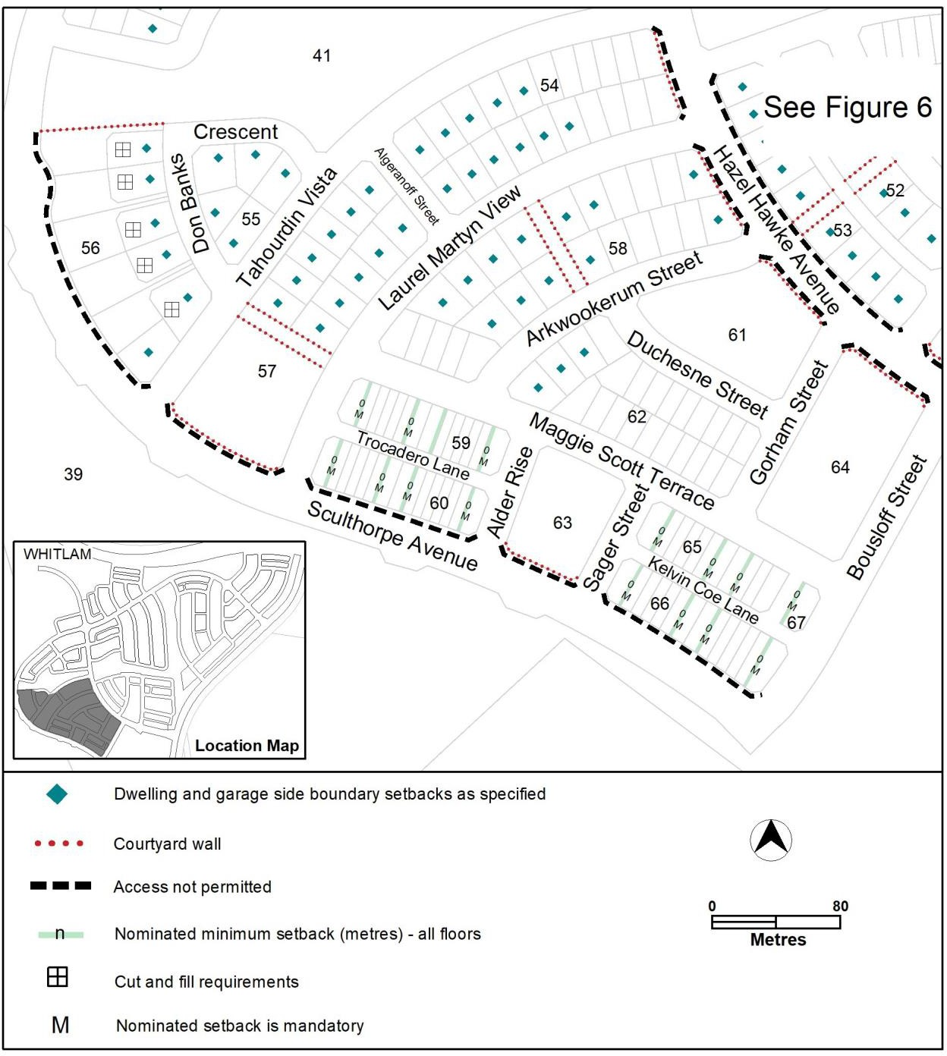

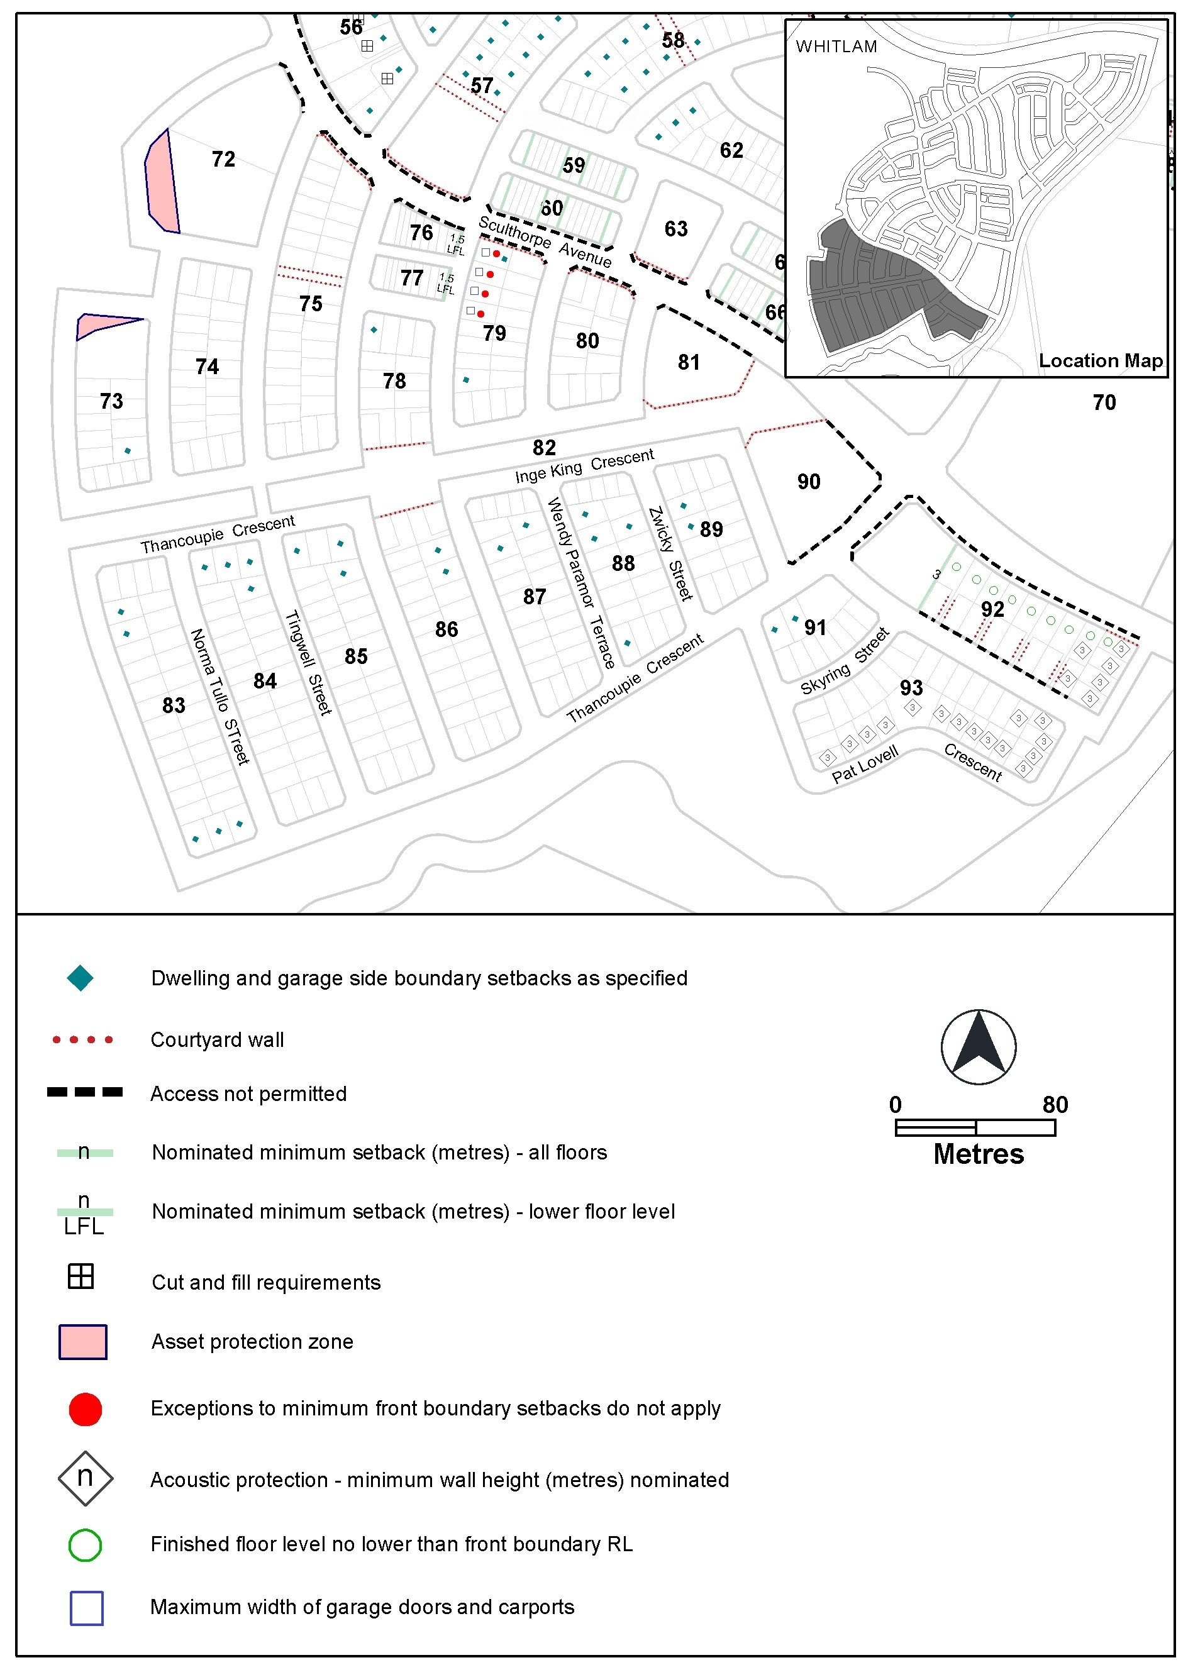
Figure 35 Whitlam – Ongoing Provisions

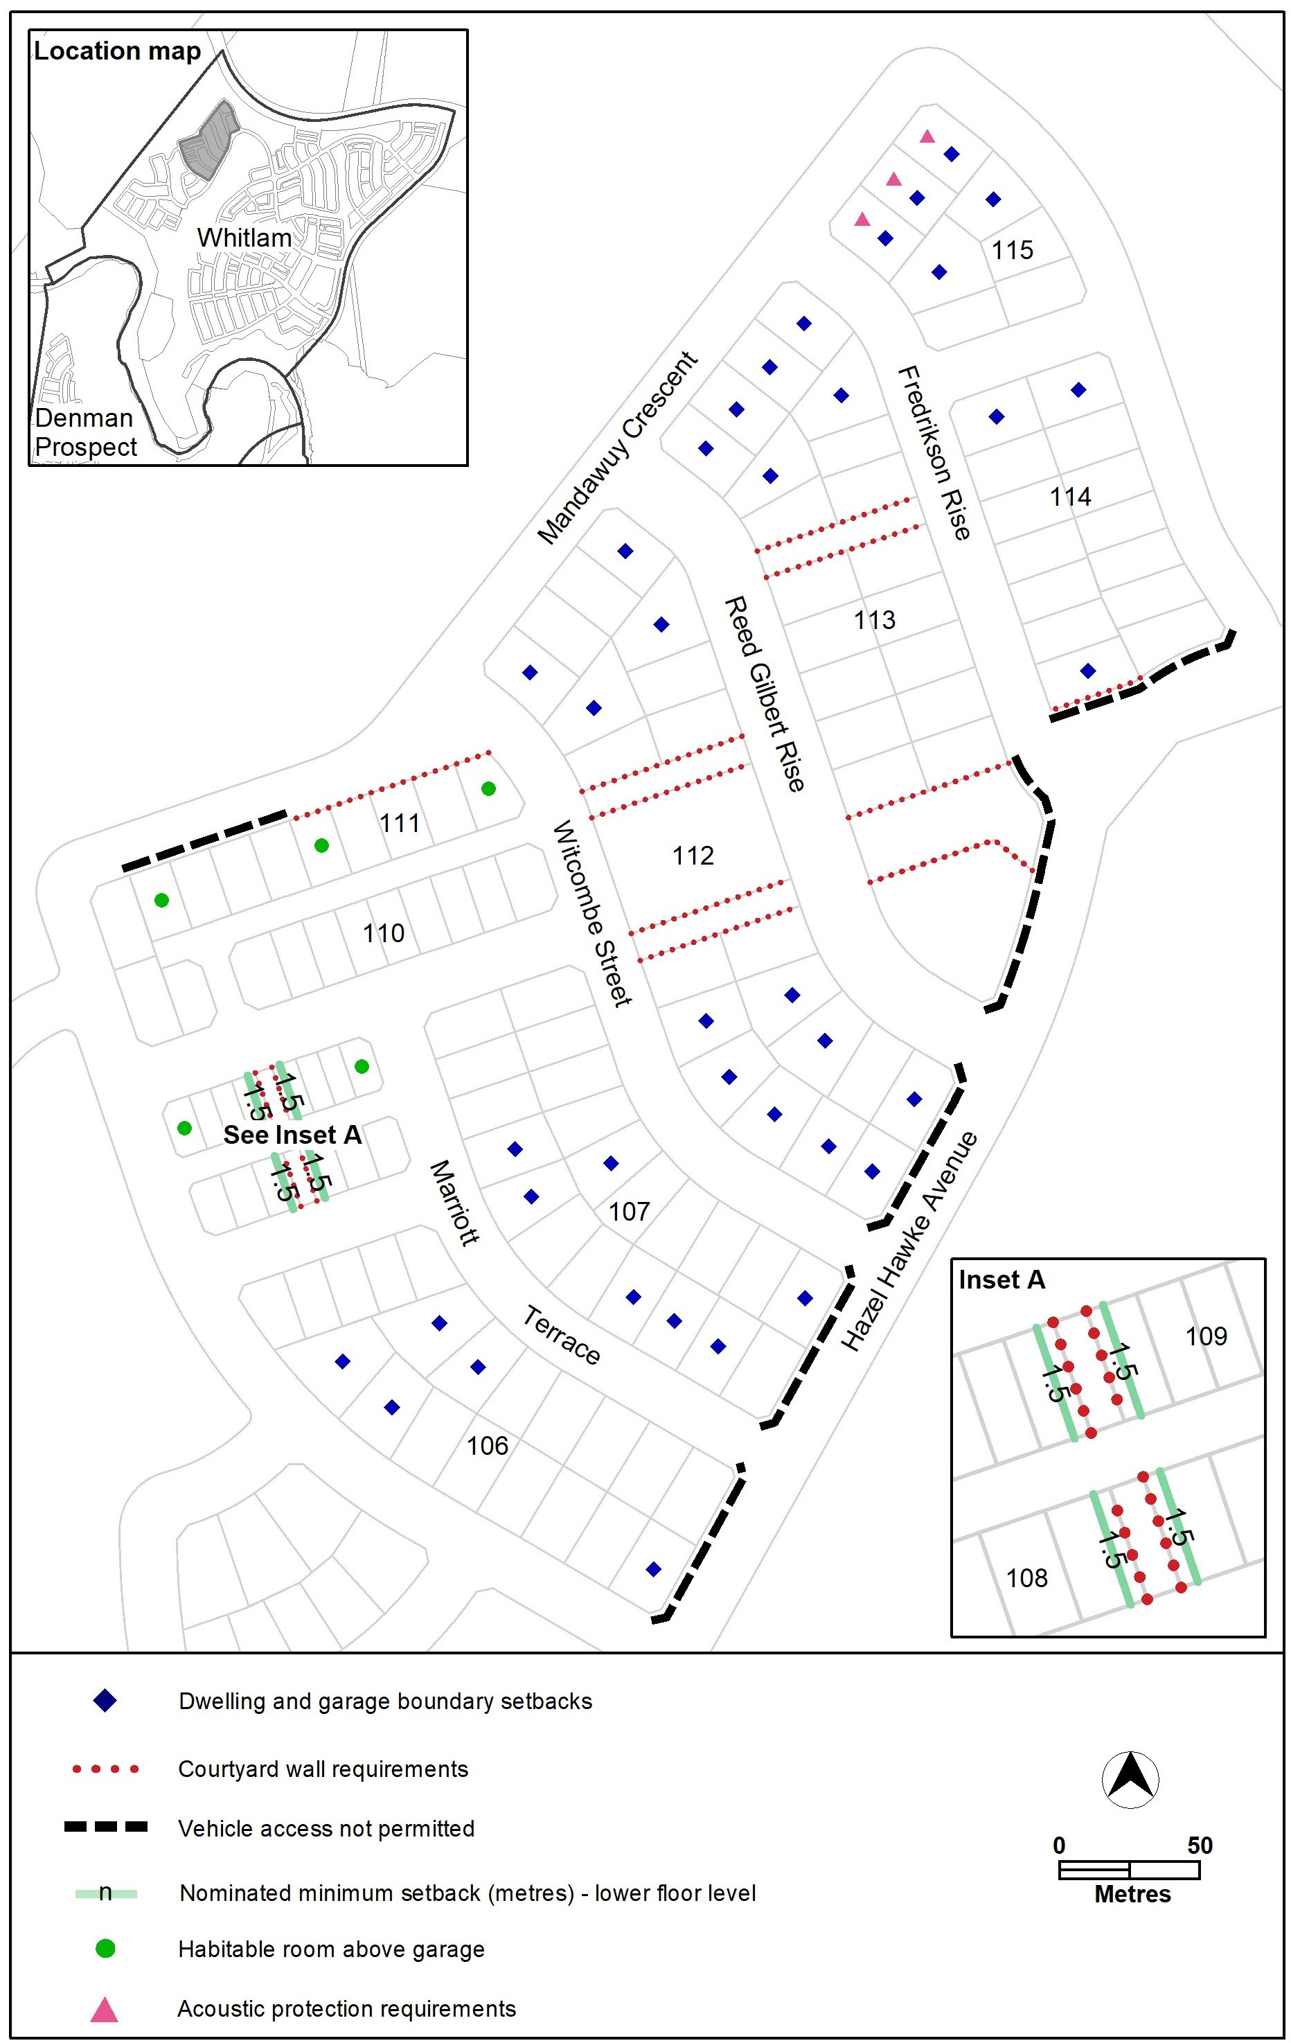
Figure 35A Whitlam – Ongoing Provisions

Figure 36 Whitlam – Ongoing Provisions (Elevation of Courtyard Wall)
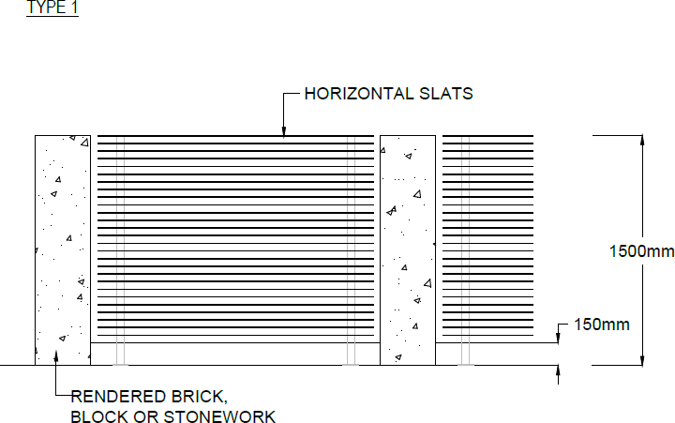
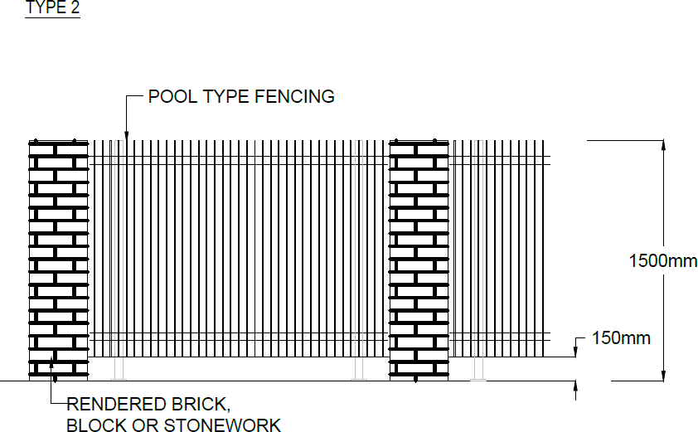

Figure 37 Whitlam – Ongoing Provisions
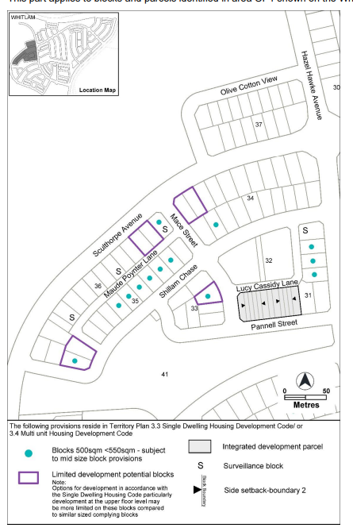
Options for development, particularly development at the upper floor level may be more limited on these blocks.

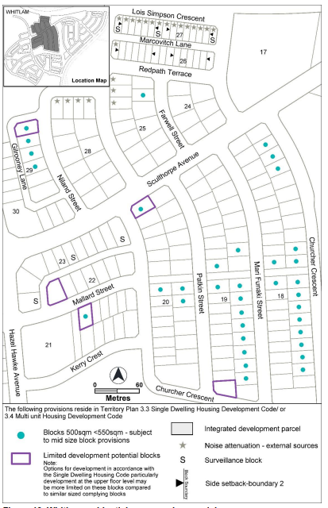
Figure 38 Whitlam – Ongoing Provisions
Options for development, particularly development at the upper floor level may be more limited on these blocks.

Figure 39 Whitlam – Ongoing Provisions
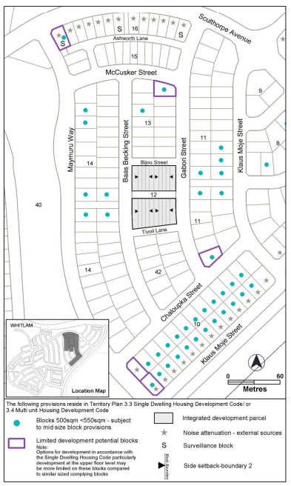
Options for development, particularly development at the upper floor level may be more limited on these blocks.

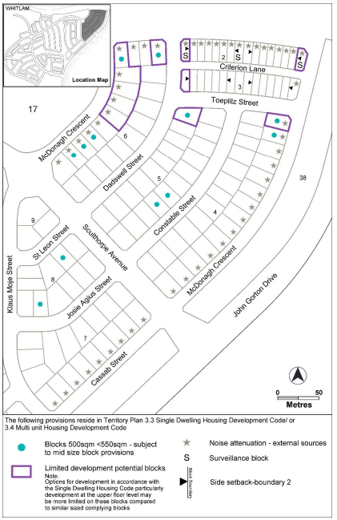
Figure 40 Whitlam – Ongoing Provisions
Options for development, particularly development at the upper floor level may be more limited on these blocks.

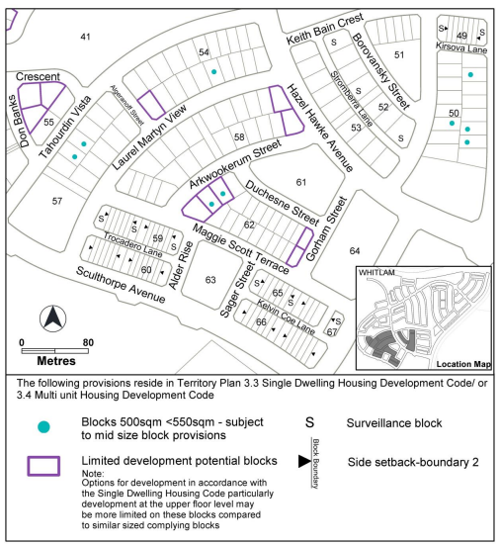
Figure 41 Whitlam – Ongoing Provisions
Options for development, particularly development at the upper floor level may be more limited on these blocks.

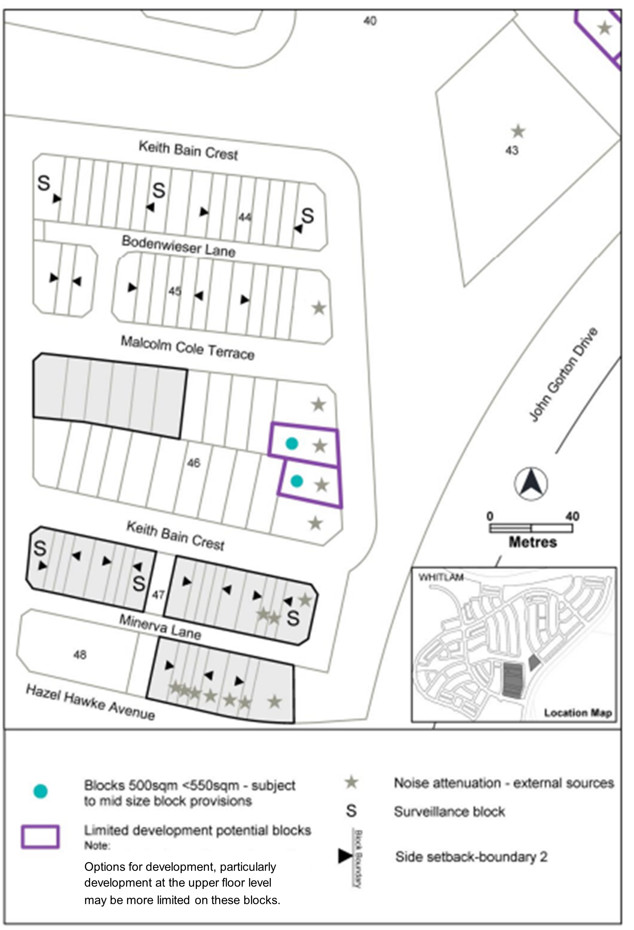
Figure 42 Whitlam – Ongoing Provisions

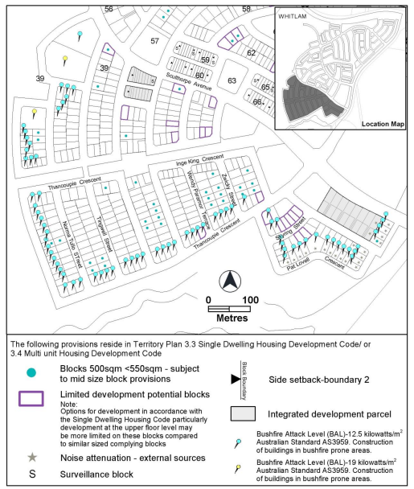
Figure 43 Whitlam – Ongoing Provisions
Options for development, particularly development at the upper floor level may be more limited on these blocks.

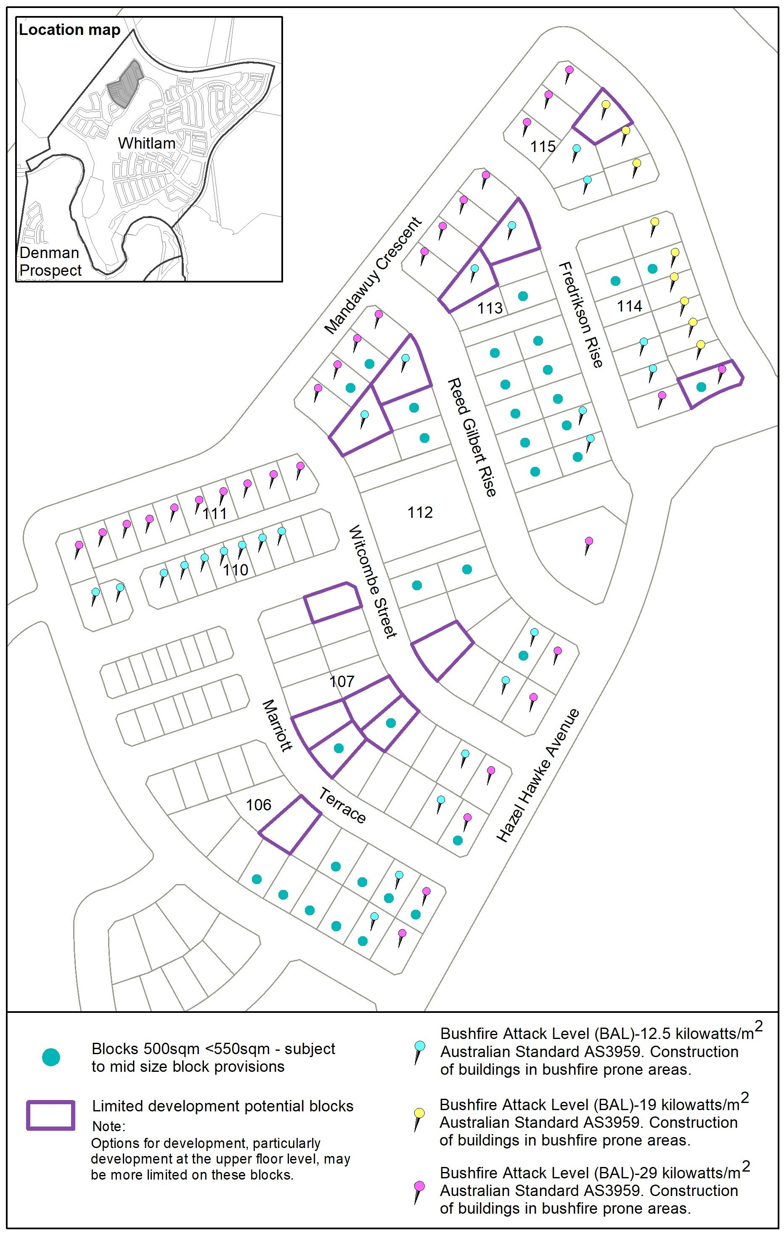
Figure 44 Whitlam – Ongoing Provisions

Wright
The following specifications provide possible solutions that should be considered in planning, placing, designing and using buildings and structures for proposed development in Wright:

No applicable specification for this suburb.

