Australian Capital Territory

Planning (Stromlo and Denman Prospect) Minor Plan Amendment 2025

**Notifiable instrument NI2025-75**

made under the

Planning Act 2023, s 85 (Making minor plan amendments)

**1 Name of instrument**

This instrument is the *Planning (Stromlo and Denman Prospect) Minor Plan Amendment 2025*.

**2 Commencement**

This instrument commences on the day after its notification day.

**3 Minor plan amendment**

I am satisfied under the *Planning Act 2023*, section 85 (1) (a) that Minor Plan Amendment 2024-m is a minor plan amendment to the Territory Plan.

**4 Dictionary**

In this instrument:

***Minor Plan Amendment 2024-m*** means the minor plan amendment in schedule 1.

Ben Green

Delegate of the territory planning authority

12 February 2025



MINOR AMENDMENT

TO THE TERRITORY PLAN

2024-m

Extending nature reserve overlay (Stromlo block 403 and Denman Prospect part block 12 section 2)

and rezoning

(Denman Prospect part block 12 section 2) under future urban area

This minor plan amendment was prepared

under part 5.3 of the *Planning Act 2023*

Contents

1.0 INTRODUCTION 1

1.1 Outline of the process 1

1.2 Summary of the amendments 2

2.0 CONSULTATION WITH THE PUBLIC 2

2.1 Consultation period 2

2.2 Comments from the public 2

2.3 Changes made after public consultation 2

3.0 TERRITORY PLAN CHANGES 3

3.1 Territory Plan Map 3

4.0 TERRITORY PLAN AMENDMENT INSTRUCTIONS 5

4.1 Territory Plan Map 5

INTERPRETATION SERVICE 6

1. INTRODUCTION
   1. Outline of the process

A minor plan amendment, or minor amendment (MA), is one way that the Territory Plan can be changed.

Section 84 of the *Planning Act 2023* (the Planning Act) outlines the different types of MAs, some of which require limited consultation to be undertaken and some of which require no consultation to be undertaken.

Under Section 85 of the Planning Act a MA can only be made where:

* any required limited consultation has taken place and the authority is satisfied that the content of the MA meets the requirements of the Act
* if the MA is not inconsistent with the planning strategy or any relevant district strategy
* any comments received during the consultation period and from the National Capital Authority have been considered.

This MA to the Territory Plan (MA2024-m) has been prepared under the following sections of the Planning Act:

* section 84 (2) (e) and section 89 (1).

This MA required limited consultation to be undertaken (section 84 (2) (e) and section 89 (1)) and was released for public consultation in accordance with the Act.

The MA is not inconsistent with the planning strategy or the Molonglo District Strategy.

The National Capital Authority received a copy of this MA.

For more information on the content of the Territory Plan and minor plan amendment processes please refer to the Environment, Planning and Sustainable Development (EPSDD) website [The Territory Plan - Environment, Planning and Sustainable Development Directorate - Planning (act.gov.au)](https://www.planning.act.gov.au/professionals/our-planning-system/the-territory-plan).

* 1. Summary of the amendments

MA2024–m amends the Territory Plan Map to:

1. add the public land overlay ‘Pc – a nature reserve’ to Stromlo rural block 403 and part of Denman Prospect section 2 block 12; and
2. rezone part of Denman Prospect section 2 block 12 from residential RZ1 suburban to non-urban NUZ3 Hills, Ridges and Buffer.
3. CONSULTATION WITH THE PUBLIC
   1. Consultation period

Under section 84 (2) (e) of the *Planning Act 2023*, the relevant part of this minor amendment was subject to limited public consultation of at least 20 working days.

Written comments were invited on MA2024-m from the public from 12 September 2024 until 11 October 2024.

* 1. Comments from the public

Twenty-seven (27) public comments were received. Sixteen (16) comments were from individuals, nine (9) comments were from community groups, one (1) comment was from a statutory body, and one (1) comment was from the development industry. The main comments and concerns raised during consultation relating to the changes proposed in the minor amendment were:

* Strong support for the proposed nature reserve.
* Block 402 should also be included in the proposed reserve.
* Existing future urban area (FUA) overlay which covers the proposed reserve, should be removed.
* Northern part of Block 403 should be included in the proposed nature reserve
* Extension of Holborow Avenue through the proposed reserve should not be permitted.
* Proposed reserve should not be created until the development of walking and fire trails have been completed.
* Concern about urban development making it difficult to protect the environmental values of the site.
  1. Changes made after public consultation

No changes were made to the minor amendment after public consultation.

1. TERRITORY PLAN CHANGES
   1. Territory Plan Map

Changes are made to the Territory Plan Map to land within the future urban area (FUA) overlay of the Molonglo Valley District by adding the public land overlay ‘Pc – a nature reserve’ to Stromlo rural block 403 and part of Denman Prospect section 2 block 12 (also known as Bluetts block). Part of Denman Prospect section 2 block 12 is rezoned from residential RZ1 suburban to non-urban NUZ3 Hills, Ridges and Buffer. These changes are being made in response to a request from the Conservator of Flora and Fauna and the changes will protect the land from development and preserve it as nature reserve.

The amendment to make changes to the nature reserve overlay and rezone under FUA is not inconsistent with the Planning Strategy or any principles and policies in the Molonglo Valley District Strategy.

Location map

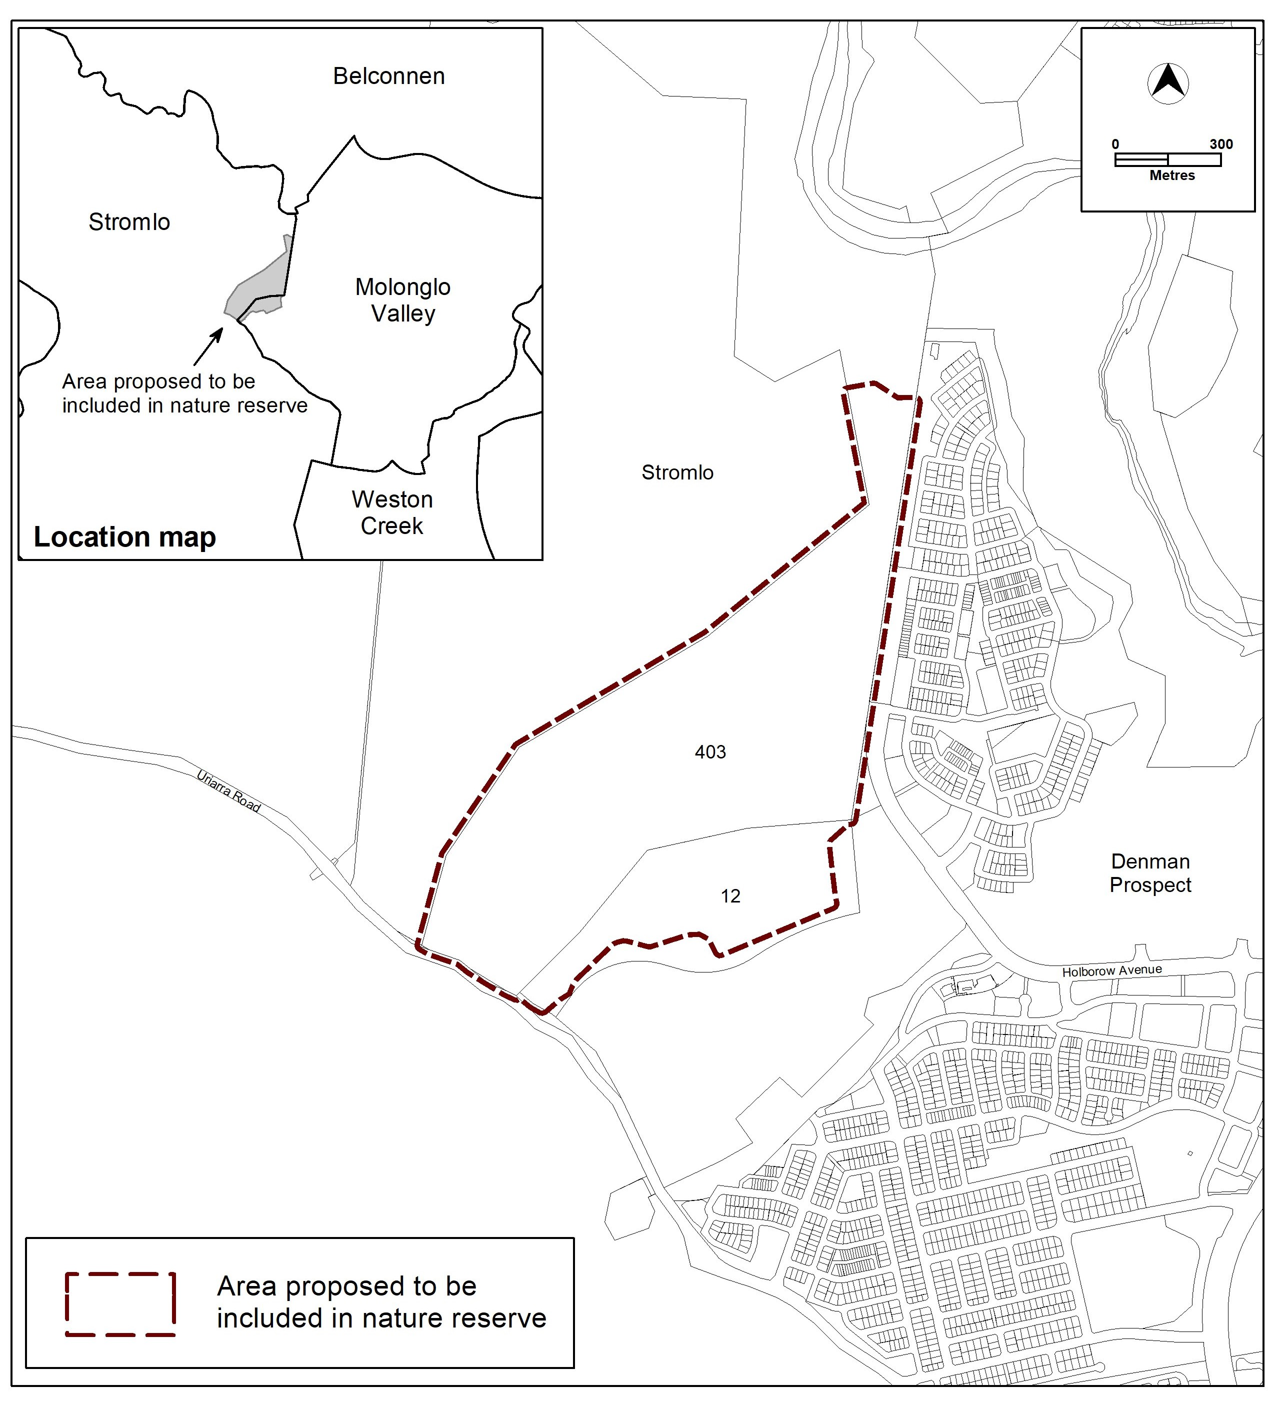

3.2 Territory Plan Map

Existing Territory Plan Map

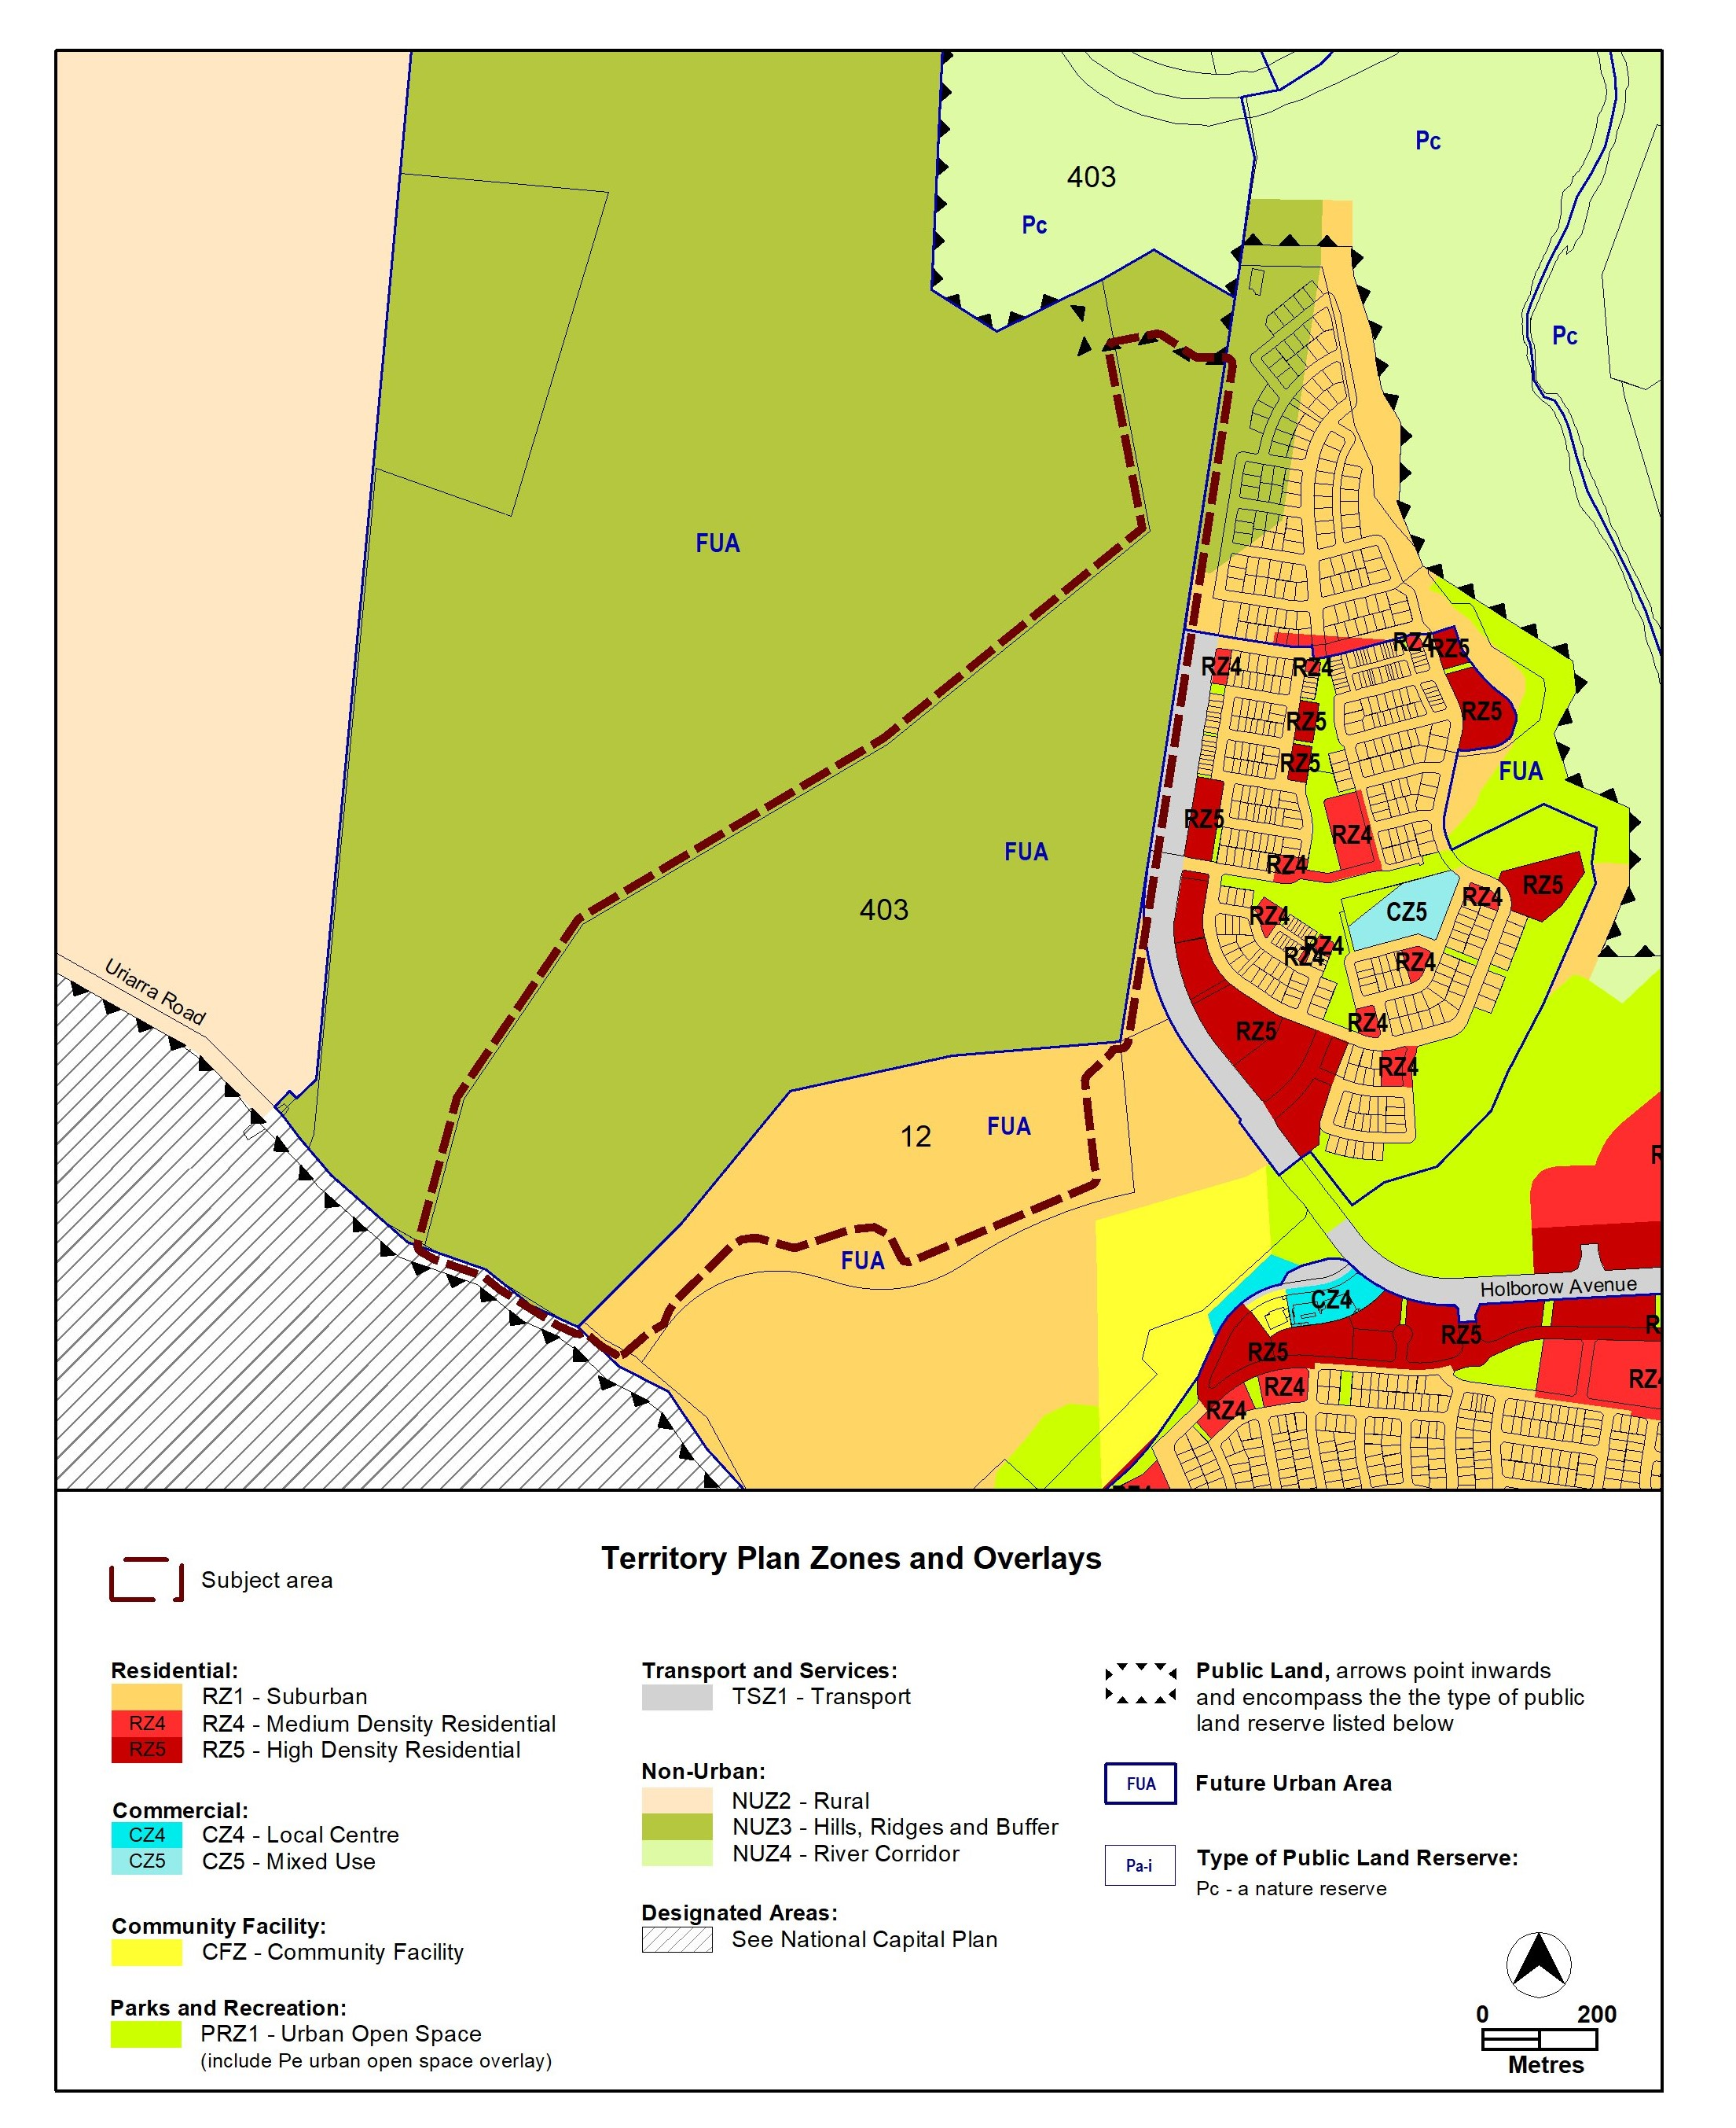

1. TERRITORY PLAN AMENDMENT INSTRUCTIONS

This section provides the instructions for how MA2024-m amends the Territory Plan.

* 1. Territory Plan Map

The relevant part of the Territory Plan map is varied as indicated below. 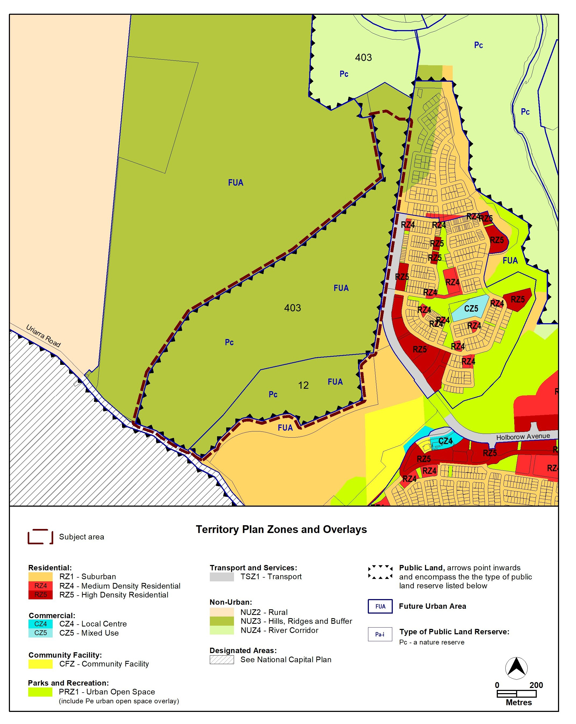

INTERPRETATION SERVICE

To speak to someone in a language other than English please telephone the Telephone Interpreter Service (TIS) **13 14 50**

| LANGUAGE | DETAILS |
| --- | --- |
| English | If you need an interpreter please call: **13 14 50** |
| Mandarin (Simplified Chinese) / 简体中文 | 如果您需要翻译，请致电：**13 14 50** |
| Arabic / العربية | إذا كنت بحاجة إلى مترجم شفهي اتصل بالرقم: **50 14 13** |
| Cantonese (Traditional Chinese) / 繁體中文 | 如果你需要傳譯員，請致電：**13 14 50** |
| Vietnamese /  Tiếng Việt | Nếu bạn cần thông dịch viên, xin gọi: **13 14 50** |
| Korean / 한국어 | 통역사가 필요할 경우 다음 번호로 전화하시기 바랍니다: **13 14 50** |
| Spanish / Español | Si necesita un intérprete, llame al **13 14 50** |
| Persian (Farsi) / فارسی | اگر به مترجم نیاز دارید، لطفاً به این شماره تلفن کنید: **50 14 13** |
| Dari / دری | اگر به یک ترجمان شفاهی نیاز دارید لطفاً به شمارۀ **131450** زنگ بزنید. |
| Punjabi / ਪੰਜਾਬੀ | ਜੇਕਰ ਤੁਹਾਨੂੰ ਕਿਸੇ ਦੁਭਾਸ਼ੀਏ ਦੀ ਲੋੜ ਹੈ ਤਾਂ ਕਿਰਪਾ ਕਰਕੇ ਫੋਨ ਕਰੋ: **13 14 50** |
| Tamil / தமிழ் | உங்களுக்கு மொழிபெயர்த்துரைப்பாளர் ஒருவர் தேவைப்பட்டால் **13 14 50** என்ற எண்ணை அழைக்கவும் |
| Greek / Ελληνικά | Αν χρειάζεστε διερμηνέα, τηλεφωνήστε: **13 14 50** |
| Italian / Italiano | Se hai bisogno di un interprete, chiama: **13 14 50** |
| Hazaragi /  هزاره گی | اگه ده ترجمان ضرورت ده رید، لطفاً ده شماره 50 14 13  تماس بگیرید. |
| Thai / ภาษาไทย | หากคุณต้องการล่าม กรุณาโทรไปที่ 13 14 50 |
| Karen / ကညီကျိၥ် | ဖဲနမ့ၢ်လိၣ်ဘၣ်ပှၤကတိၤကျိးထံတၢ်တဂၤအခါ၀ံသးစူၤကိးဘၣ်-၁၃၁ ၄၅၀ တက့ၢ်. |

**Telephone and Interpreter Service 13 14 50 - Canberra and District - 24 hours a day, seven days a week**