Australian Capital Territory
Planning (Inner North and City and Inner South District Policies) Minor Plan Amendment 2026

Notifiable instrument NI2026-205
made under the
Planning Act 2023, s 85 (Making minor plan amendments)

1 Name of instrument
This instrument is the Planning (Inner North and City and Inner South District Policies) Minor Plan Amendment 2026.
2 Commencement
This instrument commences on the day after its notification day.
3 Minor plan amendment
I am satisfied under section 85 (1) (a) of the Planning Act 2023 that Minor Plan Amendment 2026-09 is a minor plan amendment to the Territory Plan.
4 Dictionary
In this section:
Minor Plan Amendment 2026-09 to the Territory Plan means the minor plan amendment in schedule 1.

James Bennett
Delegate of the territory planning authority
29 April 2026


Schedule 1

MINOR PLAN AMENDMENT TO THE TERRITORY PLAN
2026 – 09

Inner North and City and Inner South District Policies

This minor plan amendment was prepared
under part 5.3 of the Planning Act 2023
Contents
1.0 INTRODUCTION 1
1.1 Outline of the process 1
1.2 Summary of the proposal 1
2.0 PROPOSED TERRITORY PLAN CHANGES 2
2.1 Inner North and City District Policy – Assessment Requirement 4 2
2.2 Inner North and City District Policy – Figure 9 3
2.3 Inner South District Policy – Assessment Requirements 40 and 41 4
3.0 TERRITORY PLAN AMENDMENT INSTRUCTIONS 5
3.1 Inner North and City District Policy – Assessment Requirement 4 5
3.2 Inner North and City District Policy – Figure 9 6
3.3 Inner South District Policy – Assessment Requirements 40 and 41 7
INTERPRETATION SERVICE 8

- INTRODUCTION
  - Outline of the process
Minor plan amendment 2026 -09 Inner North and City and Inner South District Policies (MA 2026-09) to the Territory Plan is minor plan amendment (MA) prepared under section 84 1) a) of the Planning Act 2023 (the Planning Act).

Section 84 of the Planning Act outlines the different types of MAs, some which require limited consultation to be undertaken and some which require no consultation to be undertaken. Section 84 1) a) is an MA that:
- would not adversely affect anyone’s rights if approved; and
- has as its only object the correction of a formal error in the plan.

Under Section 85 of the Planning Act a MA can only be made where:
- any required limited consultation has taken place and the authority is satisfied that the content of the MA meets the requirements of the Planning Act
- if the MA is not inconsistent with the planning strategy or any relevant district strategy
- any comments received during the consultation period and from the National Capital Authority have been considered.

This MA does not require limited consultation to be undertaken under the Planning Act 2023.

The MA is not inconsistent with the planning strategy or any relevant district strategy. Further details of the changes are contained in section 2 of this document.

For more information on the content of the Territory Plan and minor plan amendment processes please refer to the Territory Planning Authority’s (the Authority) website.
  - Summary of the proposal
MA 2026-09 amends the following:
- revise assessment requirement 4 of the Inner North and City District Policy (INC District Policy) for the ‘Northbourne Avenue area’ to make it consistent with the policy of the previous Territory Plan
- revise figure 9 of the INC District Policy to make it consistent with the National Capital Plan (NCP).
- revise assessment requirement 40 and 41 of the Inner South District Policy (IS District Policy) to make consistent with the policy of the previous Territory Plan.

- PROPOSED TERRITORY PLAN CHANGES
This section contains details of the proposed changes to be made to the Territory Plan.

Detailed changes made by this MA can be found in Section 3 of this document.

  - Inner North and City District Policy – Assessment Requirement 4
Assessment Requirement 4 (AR4) of the INC District Policy relates to buildings fronting Northbourne Avenue, Macarthur Avenue, Wakefield Avenue and Antill Street.

AR4 required these building to:
- incorporate uses at ground floor level that generate activity
- not to achieve residential use
- provide direct pedestrian access at street level; and avoid extensive lengths of blank walls

AR4 was derived from Rule 3(R3)/Criterion 3(C3) of the Northbourne Avenue Corridor Precinct Map and Code (NAPC), of the previous Territory Plan 2008. R3/C3 stated, among other things, that the restriction on residential use only applied to the ground floor and to certain road frontages in the ‘Dickson Node’ and ‘Macarthur Node’ as shown on Figure 9 of the INC District Policy.

Whereas the current Territory Plan erroneously prohibits residential use to all floors and to every frontage street/avenue frontage specified irrespective of whether they are within and outside of the ‘Dickson Node’ and ‘Macarthur Node’.

Therefore, this MA will revise AR4 to be consistent with the NAPC by limiting the prohibition on residential:
- to the ground floor
- to specific road frontages within the ‘Dickson Node’ and ‘Macarthur Node’ as shown in Figure 9 of INC District Policy.

The amendments made to AR4 by this MA are shown in context below with amendments in blue and removed text shown in orange.

Control |  | Assessment requirement
Land and site use | 4. In the ‘Dickson node’ and ‘Macarthur node’ accordance with shown on Figure 9, development at the ground floor level complies with all of the following:  - Building fronting Northbourne Avenue, Macarthur Avenue, Wakefield Avenue and Antill Street incorporate uses on the ground floor that generate activity in the public space, in a form that is with the needs of the area.  - On the frontage of Northbourne Avenue, Wakefield Avenue, Antill Street or Mouat Street residential use is not achieved, buildings have ground floor uses that generate activity in the public space, direct pedestrian access is provided at street level, buildings and avoid extensive lengths of blank walls.

  - Inner North and City District Policy – Figure 9
Figure 9 of the INC District Policy is relied on for a variety of controls along Northbourne Avenue. The extent of the ‘Macarthur Node’ on Figure 9 was meant to replicate Figure 151 of the NCP which includes all of block 9 section 7 Braddon.

Figure 9, shown below, omits the southern portion of block 9 section 7 Braddon which was not intended.

Therefore, this MA will revise Figure 9 to extend the ‘Macarthur Node’ to the southern portion of block 9 section 7 Braddon.

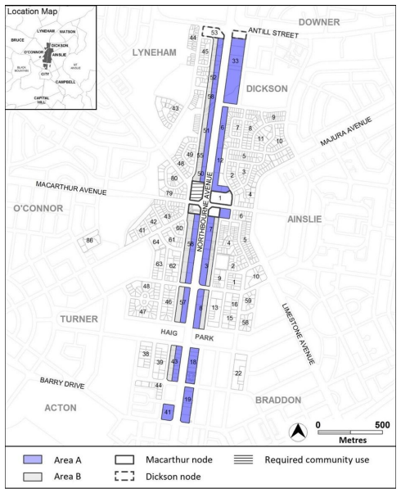
Figure 9 of the INC District Policy

  - Inner South District Policy – Assessment Requirements 40 and 41
Assessment Requirements 40 (AR40) and 41 (AR41) of the IS District Policy relate to street frontage and car parking for development in Griffith.

AR40 and AR41 were derived from Criterion 30 (C30) of the Griffith Precinct Map and Code, of the previous Territory Plan. C30 applied to block 6, section 31 Griffith only. Whereas AR40 and AR41 erroneously apply to all of Griffith.

Therefore, this MA will revise AR40 and AR41 to confirm that they apply to block 6, section 31 Griffith only, consistent with the previous Territory Plan. The amendments made to AR40 and AR41 by this MA are shown in context below with amendments in blue and removed (relocated from AR41 to AR40 b)) text shown in orange.

Control |  | Assessment requirement
Street frontage and car parking | 40. On block 6 section 31 Griffith:  - Buildings appear as though it is one large house and basement parking is not directly visible from street frontages.  - Ramp to basement car parking maintains the value of the streetscape and allows safe and efficient vehicle and pedestrian movement.  41. Ramp to basement car parking maintains the value of the streetscape and allows safe and efficient vehicle and pedestrian movement.

- TERRITORY PLAN AMENDMENT INSTRUCTIONS
This section provides the legal instructions for how MA 2026-09 proposes to amend the Territory Plan.

  - Inner North and City District Policy – Assessment Requirement 4
Substitute Assessment Requirement 4 of the Inner North and City District Policy with the following.

Control |  | Assessment requirement
Land and site use | 4. In the ‘Dickson node’ and ‘Macarthur node’ shown on Figure 9, development at the ground floor level complies with all of the following:  - Building fronting Northbourne Avenue, Macarthur Avenue, Wakefield Avenue and Antill Street incorporate uses on the ground floor that generate activity in the public space, in a form that is with the needs of the area.  - On the frontage of Northbourne Avenue, Wakefield Avenue, Antill Street or Mouat Street residential use is not achieved, buildings have ground floor uses that generate activity in the public space, direct pedestrian access is provided at street level and avoid extensive lengths of blank walls.

Insert link to from the words ‘Figure 9’ in the assessment requirement above to Figure 9 of the Inner North and District Policy.

  - Inner North and City District Policy – Figure 9
Substitute Figure 9 of the Inner North and City District Policy with the following figure.

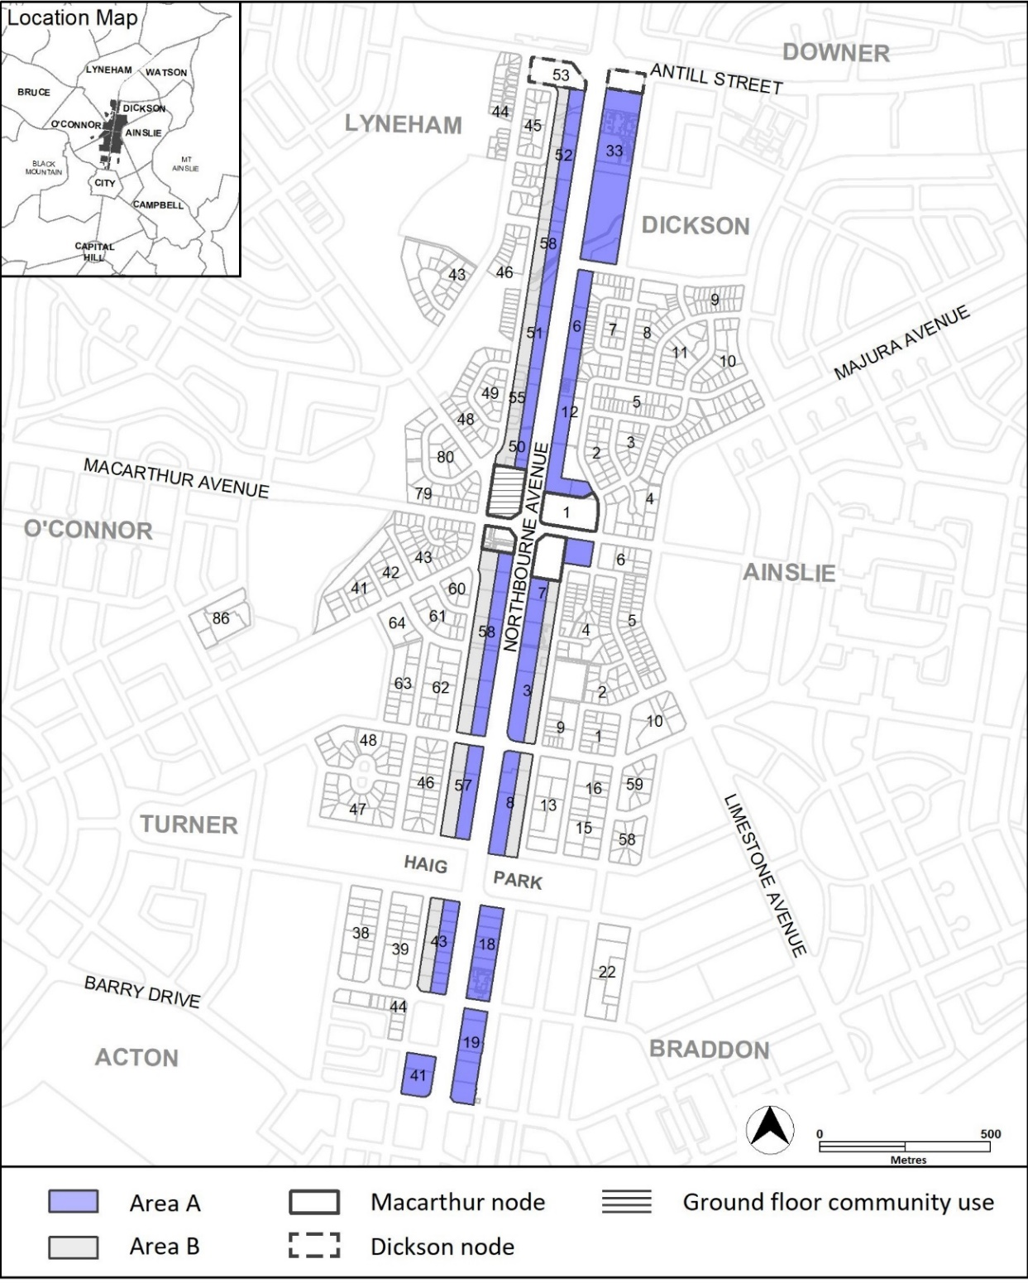

  - Inner South District Policy – Assessment Requirements 40 and 41
Substitute Assessment Requirement 40 with the following.

Control |  | Assessment requirement
Street frontage and car parking | 40. On block 6 section 31 Griffith:  - Buildings appear as though it is one large house and basement parking is not directly visible from street frontages.  - Ramp to basement car parking maintains the value of the streetscape and allows safe and efficient vehicle and pedestrian movement.

Omit Assessment Requirement 41 from the Inner South District Policy.

INTERPRETATION SERVICE
To speak to someone in a language other than English please telephone the Telephone Interpreter Service (TIS) 13 14 50
LANGUAGE | DETAILS
English | If you need an interpreter please call: 13 14 50
Mandarin (Simplified Chinese) / 简体中文 | 如果您需要翻译，请致电：13 14 50
Arabic / العربية | إذا كنت بحاجة إلى مترجم شفهي اتصل بالرقم: 50 14 13
Cantonese (Traditional Chinese) / 繁體中文 | 如果你需要傳譯員，請致電：13 14 50
Vietnamese /  Tiếng Việt | Nếu bạn cần thông dịch viên, xin gọi: 13 14 50
Korean / 한국어 | 통역사가 필요할 경우 다음 번호로 전화하시기 바랍니다: 13 14 50
Spanish / Español | Si necesita un intérprete, llame al 13 14 50
Persian (Farsi) / فارسی | اگر به مترجم نیاز دارید، لطفاً به این شماره تلفن کنید: 50 14 13
Dari / دری | اگر به یک ترجمان شفاهی نیاز دارید لطفاً به شمارۀ 131450 زنگ بزنید.
Punjabi / ਪੰਜਾਬੀ | ਜੇਕਰ ਤੁਹਾਨੂੰ ਕਿਸੇ ਦੁਭਾਸ਼ੀਏ ਦੀ ਲੋੜ ਹੈ ਤਾਂ ਕਿਰਪਾ ਕਰਕੇ ਫੋਨ ਕਰੋ: 13 14 50
Tamil / தமிழ் | உங்களுக்கு மொழிபெயர்த்துரைப்பாளர் ஒருவர் தேவைப்பட்டால் 13 14 50 என்ற எண்ணை அழைக்கவும்
Greek / Ελληνικά | Αν χρειάζεστε διερμηνέα, τηλεφωνήστε: 13 14 50
Italian / Italiano | Se hai bisogno di un interprete, chiama: 13 14 50
Hazaragi / هزاره گی | اگه ده ترجمان ضرورت ده رید، لطفاً ده شماره 50 14 13 تماس بگیرید.
Thai / ภาษาไทย | หากคุณต้องการล่าม กรุณาโทรไปที่ 13 14 50
Karen / ကညီကျိၥ် | ဖဲနမ့ၢ်လိၣ်ဘၣ်ပှၤကတိၤကျိးထံတၢ်တဂၤအခါ၀ံသးစူၤကိးဘၣ်-၁၃၁ ၄၅၀ တက့ၢ်.

Telephone and Interpreter Service 13 14 50 - Canberra and District - 24 hours a day, seven days a week

