Australian Capital Territory
Planning (Inner South Health Centre) Major Plan Amendment 2026
Notifiable instrument NI2026–208
made under the
Planning Act 2023, s 75 (Minister’s powers in relation to draft plan amendments)

1 Name of instrument
This instrument is the Planning (Inner South Health Centre) Major Plan Amendment 2026.
2 Major plan amendment
(1) I approve under section 75 (2) (a) of the Planning Act 2023 (the Act) the Major Plan Amendment 06 to the Territory Plan.
(2) In accordance with the Act, section 75 (5) (c), a major plan amendment must be presented to the Legislative Assembly and may only commence by commencement notice under section 80 (2).
3 Dictionary
In this instrument:
Major Plan Amendment 06 to the Territory Plan means the Major Plan Amendment in schedule 1.
Chris Steel MLA
Minister for Planning and Sustainable Development
30 April 2026

Schedule 1

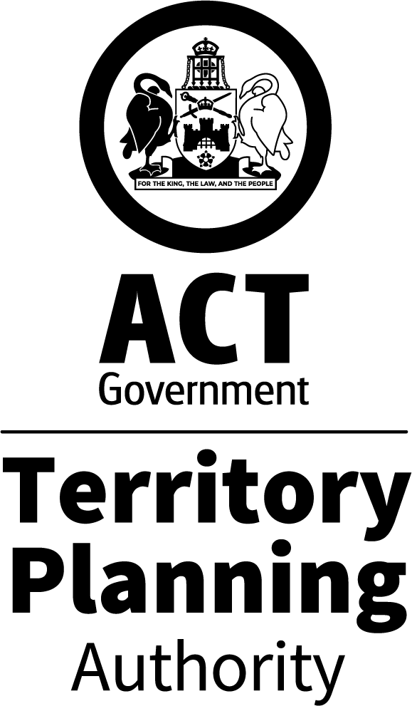

MAJOR PLAN AMENDMENT
to the
TERRITORY PLAN 06
Inner South Health Centre
Blocks 33 and 39
Section 78 Griffith

April 2026
This draft major plan amendment was prepared
under division 5.2.7 of the Planning Act 2023
Contents
1.0 INTRODUCTION 1
1.1 Purpose 1
1.2 Outline of the process 1
2.0 SUMMARY OF MAJOR PLAN AMENDMENT 06 2
2.1 Site description 2
2.2 Summary of amendments to the Territory Plan 3
2.3 Summary of consequential amendments to other documents 4
3.0 NEED FOR THE MAJOR PLAN AMENDMENT 5
4.0 CONSULTATION 6
4.1 Consultation with entities 6
4.2 Consultation with the public 6
5.0 MAJOR PLAN AMENDMENT 06 7
5.1 Amendments to the Territory Plan Map 7
5.2 Amendment to the Inner South District Policy 8
INTERPRETATION SERVICE 9

- INTRODUCTION
  - Purpose

This document is major plan amendment 06 (MPA-06) to the Territory Plan.

Key parts of this document are:
- section 2 – summarises the MPA, including amendments to the Territory Plan
- section 3 – why this MPA was undertaken
- section 5 – detailed amendment instructions to the Territory plan made by this MPA

  - Outline of the process
A major plan amendment (MPA) is a statutory process under the Planning Act 2023 (Planning Act) that enables the Territory Plan to be amended. The three types of MPAs are:
- Proponent-initiated
- Authority-initiated
- Minister-initiated

MPA-06 is an Authority-initiated MPA.

Under section 63 of the Planning Act, the Authority made draft major plan amendment 06 (DPA-06) available for public comment from 7 October 2025 to 19 November 2025 with late comments accepted until 10 December 2025. Following consultation, the Authority considered whether to revise or withdraw the DPA.

After consultation concluded, the Authority considered the comments and gave DPA-06 to the Minister for referral to the relevant Legislative Assembly Standing committee (the Standing Committee). The Standing Committee did not prepare a report in relation to DPA-06.

With the above complete, and in considering the background papers, the ACT Planning Strategy 2018 and relevant District Policies, the Minister for Planning and Sustainable Development approved MPA-06.

The Minister must now present MPA-06 to the Legislative Assembly which may reject it completely or partly. If passed by the Legislative Assembly, the MPA may commence and become part of the Territory Plan.

A commencement notice or rejection notice will be published on the major plan amendment webpage.

For more information about the content of the Territory Plan and the major plan amendment processes please refer to the City and Environment Directorate’s Planning website.

- SUMMARY OF MAJOR PLAN AMENDMENT 06
This section summarises:
- the amendments MPA-06 made to the Territory Plan and supporting documents
- outlines the relevant subject area

Amendments to the Territory Plan by this MPA are summarised in section 2.2 and shown in detail at section 5 of this document.

  - Site description
The site for the health centre is located adjacent to the Griffith local centre, on the corner of Throsby Crescent and Throsby Lane on Blocks 33, 34 and 39 Section 78 Griffith.
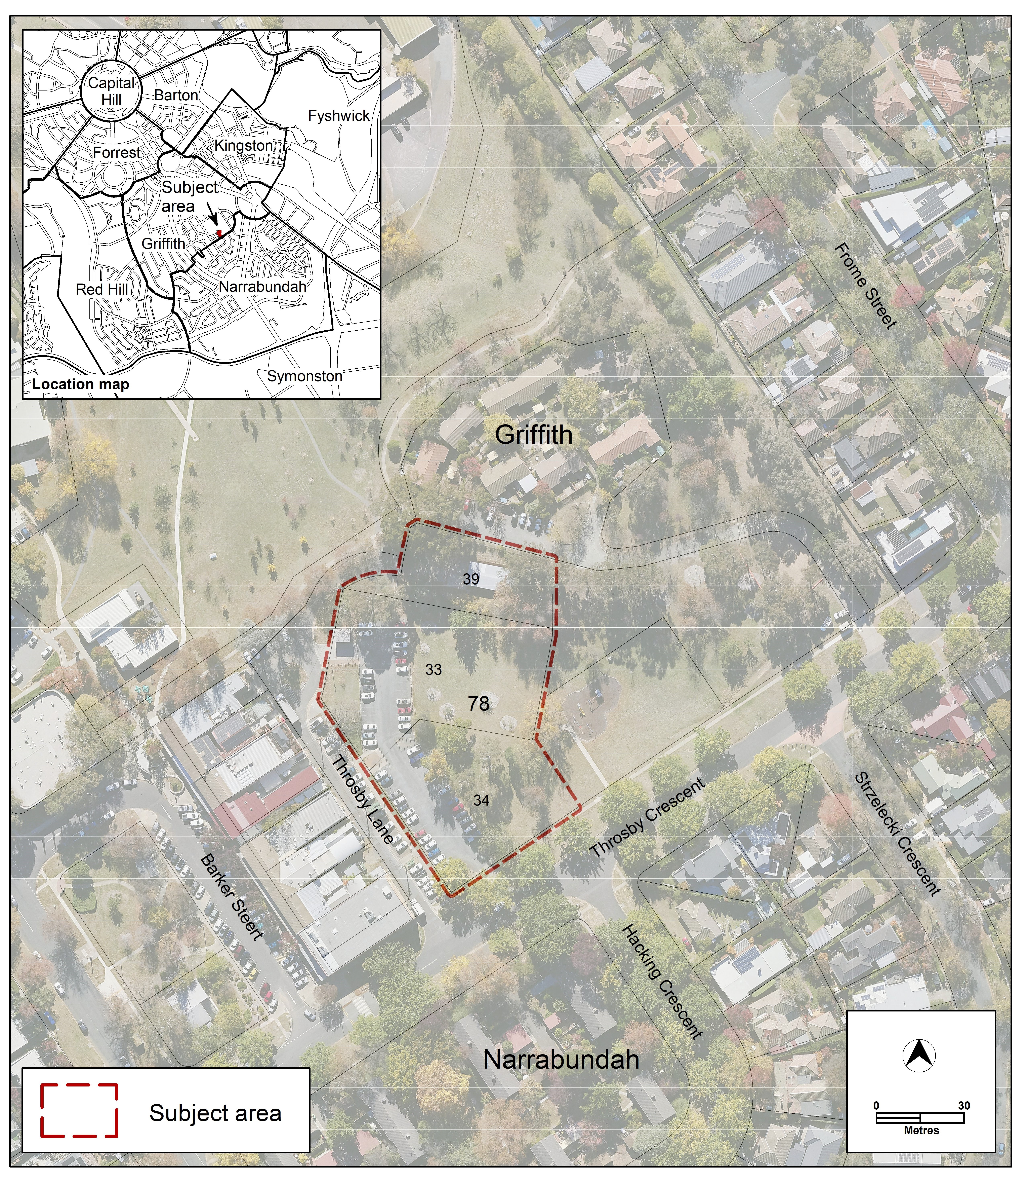
Figure 1 – Location Map

The health centre will be located on a parcel of land that includes a portion of a local park known as Throsby Park (which contains the Griffith Shops Playground that is proposed to be relocated as part of a separate development application to accommodate the proposed health facility) and part of the shops’ overflow car parking area. The Griffith Shops is located west of the site, with residential properties located north, east, and south of the site.

  - Summary of amendments to the Territory Plan
MPA-06 amends the Territory Plan by rezoning Blocks 33 and 39 Section 78 Griffith from PRZ1 Urban Open Space and PRZ2 Restricted Access Recreation zones to CFZ Community Facility Zone to permit the proposed health facility on the site.

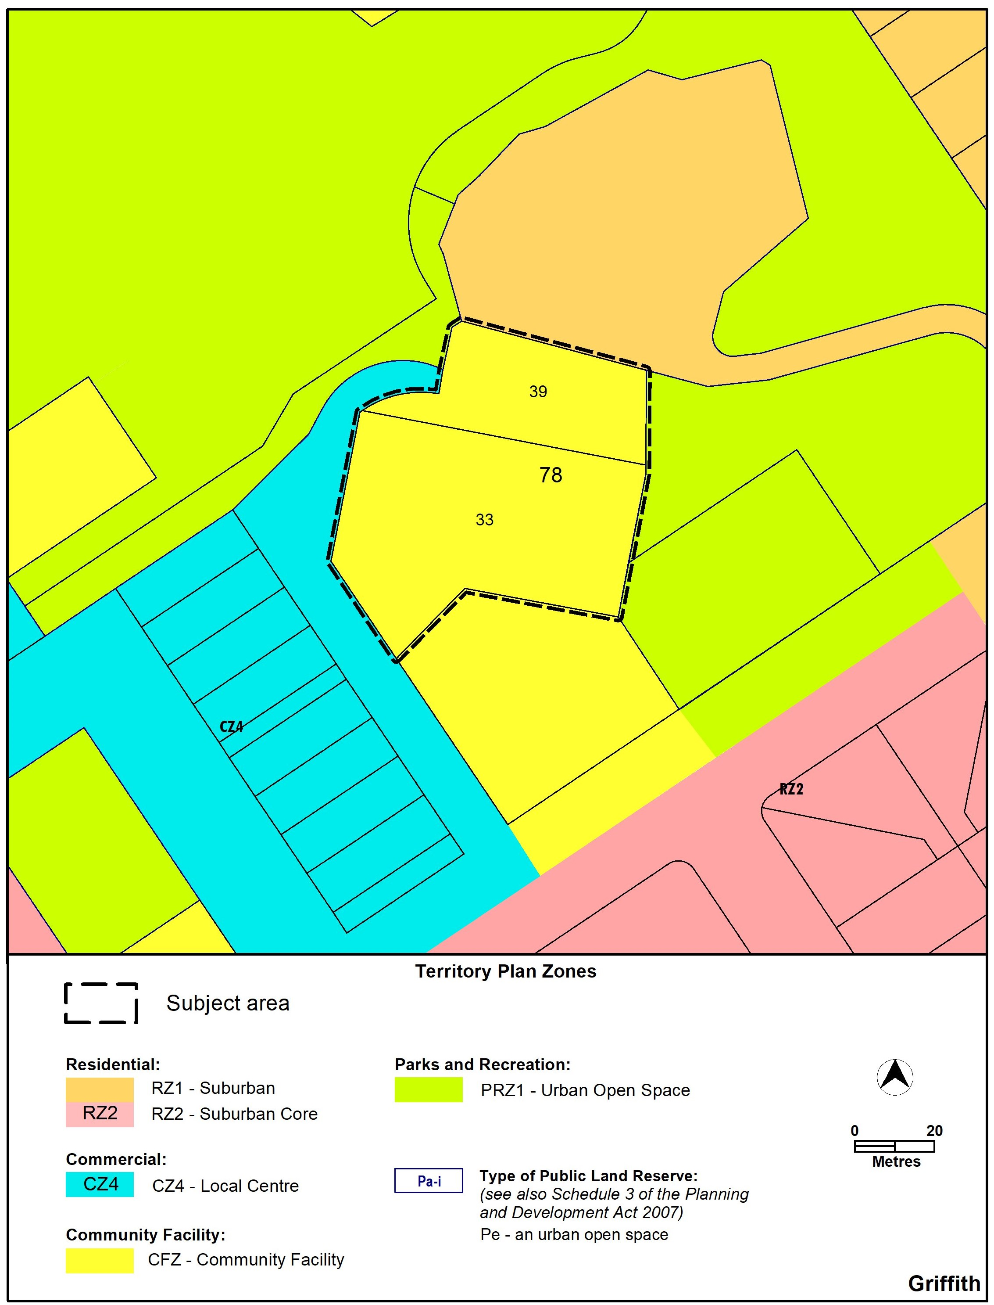
Figure 2 –Territory Plan zoning as amended by MPA-06

Further detail of the amendments being made to the Territory Plan by this MPA
can be found in section 5 of this document.

  - Summary of consequential amendments to other documents
Documents, such as the technical specifications and development controls are not part of the Territory Plan. Therefore, they cannot be amended as part of an MPA and must be amended separately when/if the MPA commences.

MPA-06 does not propose to consequentially amend any other documents.

- NEED FOR THE MAJOR PLAN AMENDMENT
The ACT Government is committed to delivering new health centres in the community to provide more affordable, accessible health care to Canberrans closer to home. The Inner South Health Centre (Griffith) is one of four new health centres the ACT Government has committed to building across the Territory.

The Inner South Health Centre project will offer a greater variety of community-based health services for people in the Inner South district. Services will include oral health services, post-acute care management, rapid access clinics and chronic disease management services.

More details about the health centre are contained in the supporting report.

In order to deliver the Inner South Health Centre on the subject site, a rezoning was required for Blocks 33 and 39 Section 78 Griffith through the preparation of a major amendment to the Territory Plan. The rezoning will enable the development of the Inner South Health Centre on the subject site within the Community Facility Zone.

- CONSULTATION
  - Consultation with entities
In accordance with section 62 of the Planning Act the Authority consulted with the following in relation to this MPA:
- the National Capital Authority
- the Conservator of Flora and Fauna
- the Environment Protection Authority
- the Heritage Council
- each referral entity
- if unleased or leased public land, each custodian of the land likely to be affected.

Comments received from these and other entities were considered in the preparation of and by the Minister in approving this MPA.

  - Consultation with the public
Written comments were invited from the public on the DPA from 7 October 2025 to 19 November 2025, with late comments being accepted until 10 December 2025.

Fifty-seven (57) comments were received during the public consultation period.

Several comments indicated support for the proposal. The main concerns raised were:
- traffic and parking
- loss of green space, mature trees, parkland and the playground
- lack of adequate community consultation
- lack of adequate public transport
- other locations in the Inner South more suitable for a health centre
- not a walk-in centre as originally proposed / no GP facilities

Changes were made to DPA-06 following public consultation. A site-specific assessment outcome was added to the Inner South District Policy requiring a green open space corridor to be provided on Block 39 to maintain blue-green network open space connectivity between Throsby Park and Blaxland Park.

Most of the matters raised have either been addressed or are more appropriately dealt with at the detailed design stage as part of a future development application for the site.

- MAJOR PLAN AMENDMENT 06
  - Amendments to the Territory Plan Map
The relevant part of the Territory Plan map is varied in accordance with Figure 3:

Figure 3 –Territory Plan Map as amended by MPA-06

  - Amendment to the Inner South District Policy

Under ‘Area specific assessment outcomes’, insert the following under Assessment Outcome 4 for Griffith:

Locality | Assessment outcome
Griffith | 4A. A green open space corridor is retained on Block 39 Section 78 Griffith to provide active travel and blue-green network connection between Throsby Park and Blaxland Park.

INTERPRETATION SERVICE
To speak to someone in a language other than English please telephone the Telephone Interpreter Service (TIS) 13 14 50
LANGUAGE | DETAILS
English | If you need an interpreter please call: 13 14 50
Mandarin (Simplified Chinese) / 简体中文 | 如果您需要翻译，请致电：13 14 50
Arabic / العربية | إذا كنت بحاجة إلى مترجم شفهي اتصل بالرقم: 50 14 13
Cantonese (Traditional Chinese) / 繁體中文 | 如果你需要傳譯員，請致電：13 14 50
Vietnamese /  Tiếng Việt | Nếu bạn cần thông dịch viên, xin gọi: 13 14 50
Korean / 한국어 | 통역사가 필요할 경우 다음 번호로 전화하시기 바랍니다: 13 14 50
Spanish / Español | Si necesita un intérprete, llame al 13 14 50
Persian (Farsi) / فارسی | اگر به مترجم نیاز دارید، لطفاً به این شماره تلفن کنید: 50 14 13
Dari / دری | اگر به یک ترجمان شفاهی نیاز دارید لطفاً به شمارۀ 131450 زنگ بزنید.
Punjabi / ਪੰਜਾਬੀ | ਜੇਕਰ ਤੁਹਾਨੂੰ ਕਿਸੇ ਦੁਭਾਸ਼ੀਏ ਦੀ ਲੋੜ ਹੈ ਤਾਂ ਕਿਰਪਾ ਕਰਕੇ ਫੋਨ ਕਰੋ: 13 14 50
Tamil / தமிழ் | உங்களுக்கு மொழிபெயர்த்துரைப்பாளர் ஒருவர் தேவைப்பட்டால் 13 14 50 என்ற எண்ணை அழைக்கவும்
Greek / Ελληνικά | Αν χρειάζεστε διερμηνέα, τηλεφωνήστε: 13 14 50
Italian / Italiano | Se hai bisogno di un interprete, chiama: 13 14 50
Hazaragi / هزاره گی | اگه ده ترجمان ضرورت ده رید، لطفاً ده شماره 50 14 13 تماس بگیرید.
Thai / ภาษาไทย | หากคุณต้องการล่าม กรุณาโทรไปที่ 13 14 50
Karen / ကညီကျိၥ် | ဖဲနမ့ၢ်လိၣ်ဘၣ်ပှၤကတိၤကျိးထံတၢ်တဂၤအခါ၀ံသးစူၤကိးဘၣ်-၁၃၁ ၄၅၀ တက့ၢ်.

Telephone and Interpreter Service 13 14 50 - Canberra and District - 24 hours a day, seven days a week

