Australian Capital Territory
Planning (Forrest) Major Plan Amendment 2026
Notifiable instrument NI2026–216
made under the
Planning Act 2023, s 75 (Minister’s powers in relation to draft plan amendments)

1 Name of instrument
This instrument is the Planning (Forrest) Major Plan Amendment 2026.
2 Major plan amendment
(1) I approve under section 75 (2) (a) of the Planning Act 2023 (the Act) the Major Plan Amendment B to the Territory Plan.
(2) In accordance with the Act, section 75 (5) (c), a major plan amendment must be presented to the Legislative Assembly and may only commence by commencement notice under section 80 (2).
3 Dictionary
In this instrument:
Major Plan Amendment B to the Territory Plan means the Major Plan Amendment in schedule 1.
Chris Steel MLA
Minister for Planning and Sustainable Development
1 May 2026

Schedule 1
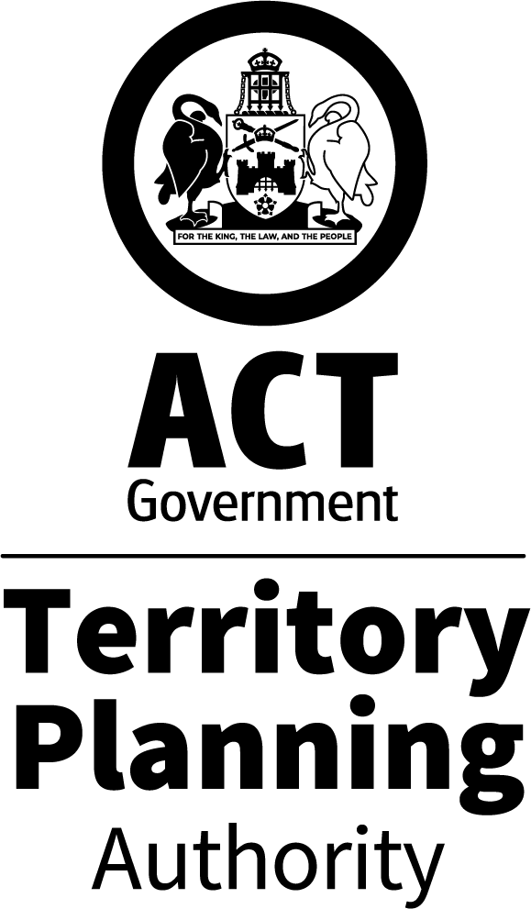

MAJOR PLAN AMENDMENT
to the
TERRITORY PLAN B
Forrest Section 19 Blocks 5, 6, 9, 11 and 12
Rezoning from Commercial CZ6 and Residential RZ1 to Commercial CZ5 Mixed Use

April 2026
This major plan amendment was prepared
under division 5.2.7 of the Planning Act 2023
Contents
1.0 INTRODUCTION 4
1.1 Purpose 4
1.2 Outline of the process 4
2.0 SUMMARY OF MAJOR PLAN AMENDMENT B 5
2.1 Site description 5
2.2 Summary of amendments to the Territory Plan 8
3.0 NEED FOR THE MAJOR PLAN AMENDMENT 9
4.0 CONSULTATION 10
4.1 Consultation with entities 10
4.2 Consultation with the public 10
5.0 MAJOR PLAN AMENDMENT B 11
5.1 Amendments to the Territory Plan Map 11
5.2 Amendments to D04 Inner South District Policy – Assessment Outcomes 12
5.3 Amendments to D04 Inner South District Policy – Assessment Requirements 12
5.4 Amendments to E02 Commercial Zones Policy – Land use table 13
INTERPRETATION SERVICE 14

- INTRODUCTION
  - Purpose
This document is major plan amendment B – Forrest Section 19 Blocks 5, 6, 9, 11 and 12 (DPA-B) to the Territory Plan.

Key parts of this document are:
- section 2 – summarises the MPA, including amendments to the Territory Plan
- section 3 – why this MPA was undertaken
- section 5 – detailed amendment instructions to the Territory Plan made by this MPA

  - Outline of the process
A major plan amendment (MPA) is a statutory process under the Planning Act 2023 (Planning Act) that enables the Territory Plan to be amended. The three types of MPAs are:
- Proponent-initiated
- Authority-initiated
- Minister-initiated

MPA-B incorporates two proponent-initiated major plan amendments (Block 9 Section 19 Forrest and Blocks 5, 6 and 11 Section 19 Forrest) and an Authority-initiated major plan amendment (Block 12 Section 19 Forrest) to the Territory Plan.

Under section 63 of the Planning Act, the Authority made draft major plan amendment B (DPA-B) available for public comment from 7 March 2025 to 22 April 2025. Late comments were accepted until 6 May 2025. Following consultation, the Authority considered whether to revise or withdraw the DPA.

After consultation concluded, the Authority considered the comments and gave DPA-B to the Minister for referral to the relevant Legislative Assembly Standing committee (the Standing Committee). The Standing Committee prepared a report in relation to DPA-B. The report was released on 19 January 2026 with one recommendation. The report was tabled in the Legislative Assembly on 3 February 2026. The Government prepared a response to the recommendation in the report.

With the above complete, and in considering the background papers, the ACT Planning Strategy 2018 and relevant District Policies, the Minister for Planning and Sustainable Development approved MPA-B.

The Minister must now present MPA-B to the Legislative Assembly which may reject it completely or partly. If passed by the Legislative Assembly, the MPA may commence and become part of the Territory Plan.

A commencement notice or rejection notice will be published on the major plan amendment webpage.
For more information about the content of the Territory Plan and the major plan amendment processes please refer to the City and Environment Directorate’s Planning website.

- SUMMARY OF MAJOR PLAN AMENDMENT B
This section summarises the amendments MPA-B made to the Territory Plan and outlines the relevant subject area.

Amendments to the Territory Plan made by this MPA are summarised in section 2.2 and shown in detail at section 5 of this document.

  - Site description
Broadly, Section 19, and the directly adjoining Section 12 Forrest to the west are located in Canberra’s Inner South District and contains a variety of land uses and zones. The zones are PRZ2 Restricted Access Recreation, Residential RZ1 Suburban, RZ2 Suburban Core, CFZ Community Facility and Commercial CZ6 Leisure and Accommodation (see Figure 2).

Section 19 and Section 12 have a diverse range of uses including the Canberra Bowling Club, Forrest Tennis Club, Free Serbian Orthodox Church, Forrest Hotel, town houses, apartments, and the Italian Cultural Centre.

The area of Section 19 subject to this major plan amendment is shown in Figure 1 and consists of Blocks 5, 6, 9, 11 and 12.

Blocks 2 and 4 Section 12 (Residential RZ2 Suburban Core Zone), Block 3 Section 12 (bowling club - PRZ2 Restricted Access Recreation Zone), Block 8 Section 19 (tennis club - PRZ2 Restricted Access Recreation Zone) and Block 2 Section 19 (church – CFZ Community Facility Zone) were not included in the change area in the Inner South District Strategy, and have therefore been excluded from MPA-B. Adjoining the bowling club directly to the north and south is a residential townhouse development on land that the bowling club sold in the 1990s in order to secure revenue to rebuild the clubhouse and greens. The tennis club site has a public land ‘Pi’ Sport and recreation reserve overlay, and the church site is listed as a heritage place on the ACT Heritage Register.

South of the subject site is an area generally characterised by low density residential dwellings and is zoned RZ2. The Forrest Primary School is located to the north of Section 19 and the planning controls for this area are contained in the National Capital Plan administered by the National Capital Authority. Commercial office buildings are located to the east facing Canberra Avenue. To the west adjoining the subject blocks is the tennis club, the bowls club, and the church. Further to the west is predominantly single dwellings on large residential blocks in the RZ1 Suburban Zone.

All of the blocks in Section 19 are well connected to main arterial roads (either Canberra Avenue to the east or Hobart Avenue to the west). The site is well connected to public transport with a bus stop located on National Circuit, adjacent the tennis courts. A Light Rail stop is anticipated to be located approximately 500m from the site. The Manuka shopping centre, Telopea Park School and Forrest Primary School are also all located within walking distance of the site. The nearby Barton office precinct also offers a range of recreational amenities.

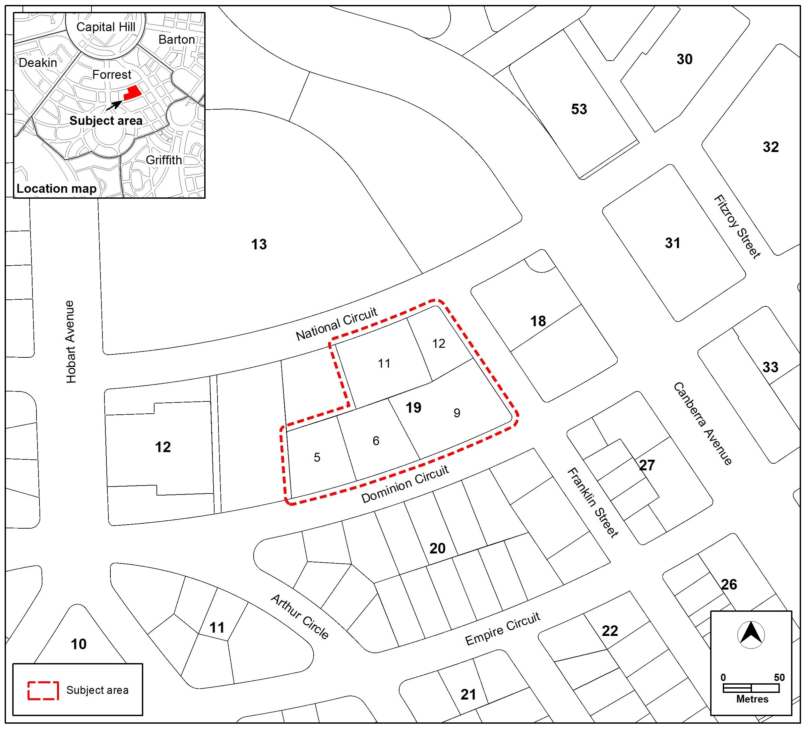
Figure 1 – Location Map

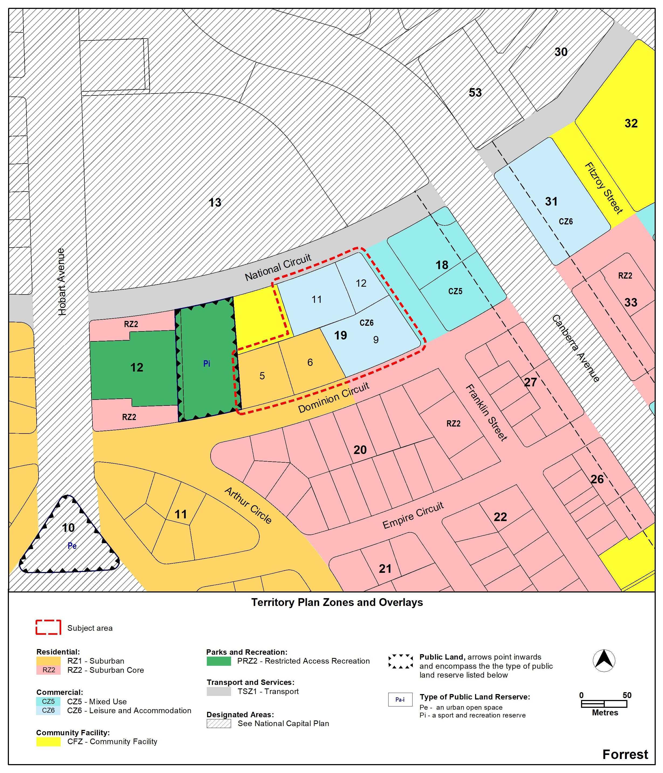
Figure 2 Current Territory Plan Map

The site subject to MPA-B contains the following blocks and uses:
  - Block 5 – occupied by low-rise multi unit residential buildings and motel
  - Block 6 – contains a hotel and serviced apartments
  - Block 9 – is used as a carpark (previously occupied by the Italo-
Australian Club)
  - Block 11 – contains a 2-storey hotel/apartments
  - Block 12 – occupied by the Italian Cultural Centre (community activity centre)

  - Summary of amendments to the Territory Plan

Amendments to the Territory Plan map

MPA-B rezones Blocks 5, 6, 9, 11 and 12 in Section 19 Forrest from Commercial CZ6 Leisure and Accommodation zone and Residential RZ1 Suburban zone to Commercial CZ5 Mixed Use zone.

Amendments to the Inner South District Policy

MPA-B introduces new provisions in the Inner South District Policy that includes:

Site specific assessment outcomes to:
- limit vehicular access from Block 9 to Dominion Circuit to provide safe and efficient traffic movement, pedestrian movement and active travel
- protect residential amenity by considering how commercial uses and taller buildings are appropriately setback from Dominion Circuit (new following consultation – see section 4.3)
- Mitigate impacts of noise and overlooking from new buildings to the surrounding community and recreation uses (new following consultation – see section 4.3)

Assessment requirements to:
- prescribe a maximum height of building (revised following consultation – see section 4.3)
- require landscaping to the Dominion Circuit frontage
- limit gross floor area for shop selling food to 250m²

Amendments to the Commercial Zones Policy

MPA-B adds commercial accommodation use to the land use table as a permissible use in the CZ5 zone.

The amendments are shown in detail at section 5 of this document.

- NEED FOR THE MAJOR PLAN AMENDMENT
Canberra’s population is growing quickly, and the ACT has a limited amount of available land for new suburbs. To manage future growth in a sustainable way, the majority of new housing is required to be provided within existing suburbs, through urban infill and increased density. This provides the opportunity for current and future residents to live in walkable suburbs close to public transport, and high-quality services, including employment, health and education facilities and open spaces.

The MPA is consistent with the Inner South District Strategy. The Inner South District Strategy identifies Blocks 5, 6, 9, 11 and 12 Section 19 as a key site and category 2 change area where detailed planning can proceed, consultation needs to occur, and change could happen within 0–10 years. The supporting reports for the DPA provide details of the further planning work.

Section 19 is surrounded by a mix of low and medium density residential development, the Forrest Primary School, and mid-rise office uses. DPA-B aims to transform this key site, in line with the recommendations of the Inner South District Strategy, into a mixed-use development precinct supporting a mix of commercial and residential uses and delivering critical housing supply to Canberra’s well located Inner South district.

Consistent with the Planning Strategy 2018 and Inner South District Strategy, the change of zoning will provide opportunities to contribute to a sustainable and compact city. The changes will provide mixed use development opportunities that will accommodate the growing residential population in Forrest, a suburb that is well connected to workplaces, retail and community facilities and in proximity to public transport and the future light rail corridor.

The Italian Cultural Centre on Block 12, who has not expressed a desire to redevelop the site at this time, are able to continue to operate as a community activity centre under the proposed CZ5 zoning. This zoning change implements the aims of the District Strategy and would enable future redevelopment opportunities, if sought. Changes to the Crown Lease may also be required for future development.

MPA-B aims to conserve the existing qualities of the suburb of Forrest and respect the neighbourhood character surrounding Section 19, particularly by preserving green spaces, trees, and streetscapes which can also be enhanced with careful consideration of the interface with the surrounding land uses.

The supporting reports contain more detail about the need for the MPA.

- CONSULTATION
  - Consultation with entities
In accordance with section 62 of the Planning Act the Authority must consult with each of the following in relation to this MPA:
- the National Capital Authority
- the Conservator of Flora and Fauna
- the Environment Protection Authority
- the Heritage Council
- each referral entity
- if unleased or leased public land, each custodian of the land likely to be affected.

Comments received from these and other entities were considered in the preparation of and by the Minister in approving this MPA.

  - Consultation with the public
Written comments were invited from the public from 7 March 2025 to 22 April 2025. Late comments were accepted until 6 May 2025.

Five public comments were received during the public consultation period and eleven late public comments were accepted until 6 May 2025. One confidential comment was also received.

Some comments expressed support for the amendment. The main concerns related to inappropriate increase in density, bulk and scale, excessive building heights, increased parking pressure and traffic along Dominion Circuit, noise and overlooking of existing residences, and heritage impacts.

Changes were made to DPA-B following consultation to the Inner South District Policy:
- Maximum height in storeys was changed to height of building in metres (26 metres).
- A new site-specific assessment outcome was added to protect the residential amenity of properties to the south of Dominion Circuit by considering adequate setbacks to new tall building elements and/or to ground floor commercial uses.
- A new site-specific assessment outcome was added to limit noise and overlooking impacts of community and recreation uses surrounding the site.

Most of the matters raised have either been addressed or are more appropriately dealt with at the detailed design stage as part of future development applications for the subject site.

- MAJOR PLAN AMENDMENT B
  - Amendments to the Territory Plan Map
The relevant part of the Territory Plan map is varied in accordance with Figure 3.

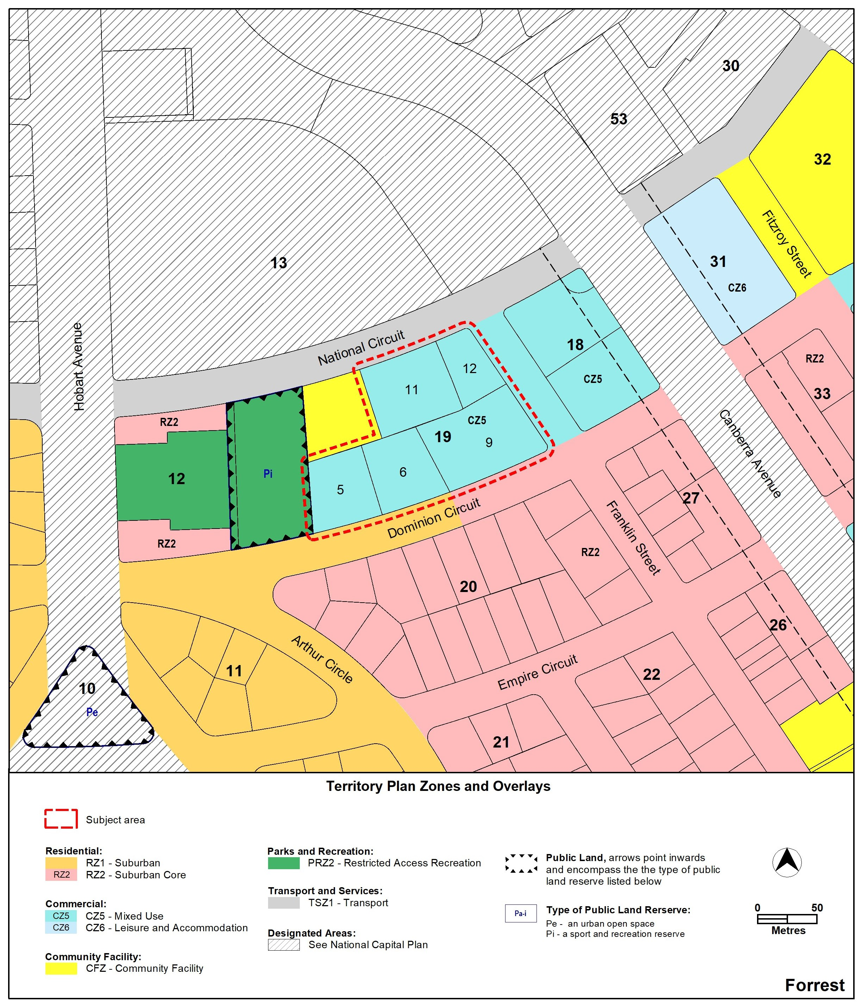
Figure 3 – Territory Plan Map amended by MPA-B
  - Amendments to D04 Inner South District Policy – Assessment Outcomes

Insert new area specific assessment outcomes under Locality - Forrest

Locality | Assessment outcome
Forrest | 2A. Vehicular access from Block 9 Section 19 to Dominion Circuit is limited to provide safe and efficient traffic movement, pedestrian movement and active travel.
2B. Tall building elements and/or where ground floor commercial uses are adequately setback from Dominion Circuit to protect the residential amenity of located opposite Blocks 5, 6 and 9 Section 19.
2C. Noise and overlooking impacts are mitigated to adjoining community and recreational uses to the west, north and north-east of Blocks 5, 6, 9, 11 and 12 Section 19.

  - Amendments to D04 Inner South District Policy – Assessment Requirements

Insert new assessment requirements, under Locality - Forrest.

Locality | Assessment requirement
Forrest
Building heights | - On Blocks 5, 6, 9, 11 and 12 Section 19, the maximum height of building is 26 metres.
Setbacks – Rooftop elements | - On Blocks 5, 6, 9, 11 and 12 Section 19, the following are setback a minimum distance of 3m from the façade of the floor immediately below:  - roof top plant and plant screening, lift overruns, antennas, photovoltaic panels, air conditioning units, non gross floor area architectural features, chimneys, flues and vents
Gross floor area | - On Blocks 5, 6, 9, 11 and 12 Section 19, the maximum gross floor area for a shop or supermarket selling food is 250m².
Access driveways | - On Blocks 5 and 6 Section 19, no new access driveways onto Dominion Circuit are permitted.
Site suitability | - For Blocks 5, 6, 9, 11 and 12 Section 19, an intrusive detailed site investigation, in accordance with the Environment Protection Authority endorsed guidelines, must be undertaken:  - by a suitably qualified environmental consultant to determine whether past activities have impacted the site from a contamination perspective and;  - to determine whether the site is suitable for the proposed uses, prior the approval of a development application.
Landscaping | - For Blocks 5, 6, and 9 Section 19, landscaping to the Dominion Circuit frontage is provided to reflect the residential character opposite.
  - Amendments to E02 Commercial Zones Policy – Land use table

Under Land Use / Development Type for ‘Commercial accommodation use’

Add ‘Y’ to CZ5

INTERPRETATION SERVICE
To speak to someone in a language other than English please telephone the Telephone Interpreter Service (TIS) 13 14 50
LANGUAGE | DETAILS
English | If you need an interpreter please call: 13 14 50
Mandarin (Simplified Chinese) / 简体中文 | 如果您需要翻译，请致电：13 14 50
Arabic / العربية | إذا كنت بحاجة إلى مترجم شفهي اتصل بالرقم: 50 14 13
Cantonese (Traditional Chinese) / 繁體中文 | 如果你需要傳譯員，請致電：13 14 50
Vietnamese /  Tiếng Việt | Nếu bạn cần thông dịch viên, xin gọi: 13 14 50
Korean / 한국어 | 통역사가 필요할 경우 다음 번호로 전화하시기 바랍니다: 13 14 50
Spanish / Español | Si necesita un intérprete, llame al 13 14 50
Persian (Farsi) / فارسی | اگر به مترجم نیاز دارید، لطفاً به این شماره تلفن کنید: 50 14 13
Dari / دری | اگر به یک ترجمان شفاهی نیاز دارید لطفاً به شمارۀ 131450 زنگ بزنید.
Punjabi / ਪੰਜਾਬੀ | ਜੇਕਰ ਤੁਹਾਨੂੰ ਕਿਸੇ ਦੁਭਾਸ਼ੀਏ ਦੀ ਲੋੜ ਹੈ ਤਾਂ ਕਿਰਪਾ ਕਰਕੇ ਫੋਨ ਕਰੋ: 13 14 50
Tamil / தமிழ் | உங்களுக்கு மொழிபெயர்த்துரைப்பாளர் ஒருவர் தேவைப்பட்டால் 13 14 50 என்ற எண்ணை அழைக்கவும்
Greek / Ελληνικά | Αν χρειάζεστε διερμηνέα, τηλεφωνήστε: 13 14 50
Italian / Italiano | Se hai bisogno di un interprete, chiama: 13 14 50
Hazaragi / هزاره گی | اگه ده ترجمان ضرورت ده رید، لطفاً ده شماره 50 14 13 تماس بگیرید.
Thai / ภาษาไทย | หากคุณต้องการล่าม กรุณาโทรไปที่ 13 14 50
Karen / ကညီကျိၥ် | ဖဲနမ့ၢ်လိၣ်ဘၣ်ပှၤကတိၤကျိးထံတၢ်တဂၤအခါ၀ံသးစူၤကိးဘၣ်-၁၃၁ ၄၅၀ တက့ၢ်.

Telephone and Interpreter Service 13 14 50 - Canberra and District - 24 hours a day, seven days a week.

