Australian Capital Territory
Planning (Various) Minor Plan Amendment 2026 (No 2)*
Notifiable instrument NI2026–258
made under the
Planning Act 2023, s 85 (Making minor plan amendments)

1 Name of instrument
This instrument is the Planning (Various) Minor Plan Amendment 2026 (No 2).
2 Commencement
This instrument commences on the day after its notification day.
3 Minor plan amendment
I am satisfied under the Planning Act 2023, section 85 (1) that Minor Plan Amendment 2026-01 is a minor plan amendment to the territory plan.
4 Dictionary
In this instrument:
Minor Plan Amendment 2026-01 means the minor plan amendment to the territory plan in schedule 1.

James Bennett
Delegate of the Territory Planning Authority
28 May 2026

Schedule 1

MINOR AMENDMENT
TO THE TERRITORY PLAN
2026-01

Amendments to various district policies and rezoning under future urban area in the division of Watson

This minor plan amendment was prepared
under part 5.3 of the Planning Act 2023
Contents
1.0 INTRODUCTION 1
1.1 Outline of the process 1
1.2 Summary of the minor amendment 2
2.0 CONSULTATION WITH THE PUBLIC 3
2.1 Consultation period 3
2.2 Comments from the public 3
2.3 Changes made following consultation 3
3.0 TERRITORY PLAN CHANGES 4
3.1 Inner North and City District Policy 4
3.2 Inner South District Policy 4
3.3 Tuggeranong District Policy 6
3.4 Territory Plan Map 7
4.0 TERRITORY PLAN AMENDMENT INSTRUCTIONS 11
4.1 Part D: D03 – Inner North and City District Policy 11
4.2 Part D: D04 – Inner South District Policy 11
4.3 Part D: D08 – Tuggeranong District Policy 12
4.4 Part B – Territory Plan Maps 13
INTERPRETATION SERVICE 14

- INTRODUCTION
  - Outline of the process
Minor plan amendment 2026-01 (MA2026-01) to the Territory Plan is a minor plan amendment (MA) prepared under section 84 (2) (d) and (e) and section 89 (1) of the Planning Act 2023 (the Act).

Section 84 of the Act outlines the different types of MAs, some which require limited consultation to be undertaken and some which require no consultation to be undertaken.

Under section 85 of the Act a MA can only be made where:
- any required limited consultation has taken place and the authority is satisfied that the content of the MA meets the requirements of the Act
- if the MA is not inconsistent with the planning strategy or any relevant district strategy
- any comments received during the consultation period and from the National Capital Authority have been considered.

This MA required limited consultation to be undertaken and was released for public consultation in accordance with the Act.

The MA is not inconsistent with the planning strategy, the Inner North and City District Strategy, the Inner South District Strategy and the Tuggeranong District Strategy.

The National Capital Authority has received a copy of this MA.

For more information on the content of the Territory Plan and minor plan amendment processes please refer to the Planning website: The Territory Plan - City and Environment Directorate - Planning

  - Summary of the minor amendment

MA2026–01 makes the following changes:

Inner North and City District Policy

- Introduce a new assessment requirement to limit the gross floor area for specific uses to 500m²

Inner South District Policy

- Revise Figure 7 by excluding part block 7 section 21 Kingston from the hatched area which allows up to 4 storey development and excluding part block 11 section 21 Kingston from Area ‘A’ which allows up to 6 storey development.

Tuggeranong District Policy

- Clarify Assessment Requirement 46 a) pertaining to roof pitch for buildings in Tharwa.

Territory Plan Map

- Rezone blocks 10, 11 and 12 section 74 Watson, under future urban area (FUA) overlay, from Commercial CZ6 – Leisure and Accommodation Zone to Residential RZ5 – High Density Residential Zone and Commercial CZ5 – Mixed Use Zone.

- CONSULTATION WITH THE PUBLIC
  - Consultation period
Under section 84 (2) of the Planning Act 2023, this minor amendment was subject to limited public consultation of at least 20 working days. Written comments on MA2026-01 were invited from the public from 10 April 2026 and closed on 11 May 2026.
  - Comments from the public
One public comment was received during the consultation period.

The submitter requested adding a further clarification to the changes to the Inner South District Policy for Kingston Section 21 to limit building within 3m from the Block 12 boundary on Block 10 and 11 adjoining to the south and west.

The Territory Planning Authority (the Authority) notes the comment. The Authority considers that there is no need to mandate setbacks on blocks 10 and 11 via an additional provision in the Inner South District Policy. This would effectively minimise the developable area on blocks 10 and 11 in favour of development of block 12. Further, it is considered that setbacks are already appropriately captured through existing provisions contained in the Commercial Zones Policy, the relevant design guides and relevant DA considerations in the Planning Act 2023.
  - Changes made following consultation
No changes were made following consultation on MA2026-01.

- TERRITORY PLAN CHANGES
  - Inner North and City District Policy
A component of this minor amendment is to rezone land under FUA for Blocks 10, 11 and 12 Section 74 in Watson from Commercial CZ6 – Leisure and Accommodation Zone to Residential RZ5 - High Density Residential Zone and a small area of Commercial CZ5 – Mixed Use Zone (see further details in section 3.4 below).

The small parcel of CZ5 land is included to provide convenient access to commercial and retail uses for the local community without significantly impacting on the viability of established uses within existing commercial centres in the Inner North district. To safeguard the surrounding commercial centres hierarchy, whilst still encouraging a range of commercial and retail uses to service the growing Watson residential population, a gross floor area limit of 500m² for specific uses has been introduced as a mandatory assessment requirement in the Inner North and City District Policy. These specific uses are: ‘café’, ‘club’, ‘drink establishment’, ‘restaurant’, ‘shop’, ‘supermarket’ and ‘take-away food shop’.
  - Inner South District Policy
Figure 7 Kingston – Group Centre – building height

This clarification enables the additional heights within Assessment Requirement 49 of the Inner South District Policy relating to Sections 20, 21 and 22 in the Kingston - Group Centre to align with existing lease boundaries. The provision had allowed a narrow, unusable area of two blocks to be theoretically constructed for increased height. This MA corrects the anomaly.

Inner South District Policy - Assessment Requirement 49 states:

“For development on Sections 20 and 21, and blocks in Section 22 addressing Jardine Street, the height of buildings is the lesser of 9m above datum ground level or 2 storeys, except for the following areas shown in Figure 7:
- Hatched area—the lesser of 15m above datum ground level or 4 storeys
- Area ‘A’—the lesser of 21m above datum ground level or 6 storeys.”

A blanket 20m dimension measured from the boundary of Kennedy Street was used to allow up to 2 storeys or 9m in height, with taller 4 storeys or 15m permitted in the hatched area behind (as shown in Figure 7). Similarly, the additional height allowance within Area ‘A’ of 6 storeys or 21m follows the 20m dimension line.

While this dimension wholly contains Blocks 8, 9 and 10, it does not align with the block boundaries of Blocks 6 and 12 due to the different block orientation. The original intent was that the height provisions would apply to these blocks (and a portion of Blocks 8, 9, and 10). The current drafting of this provision unintentionally allows a narrow, unusable sliver of adjoining Blocks 7 and 11 to also be constructed to the taller height. This is now being clarified through this minor amendment.

The lease boundaries between Blocks 6 and 7 and Blocks 11 and 12 on the corner blocks are proposed to be used to regularise the additional height allowances, rather than the 20m dimension line, which will still apply to Blocks 8, 9, and 10. This aligns with the original policy intent and will allow more logical development opportunities, should these blocks be redeveloped.
Figure 7 Kingston – Group Centre – building height – extract to show the blocks subject to this amendment and the proposed changes
Excerpt from Figure 7 – existing | Excerpt from Figure 7 – proposed
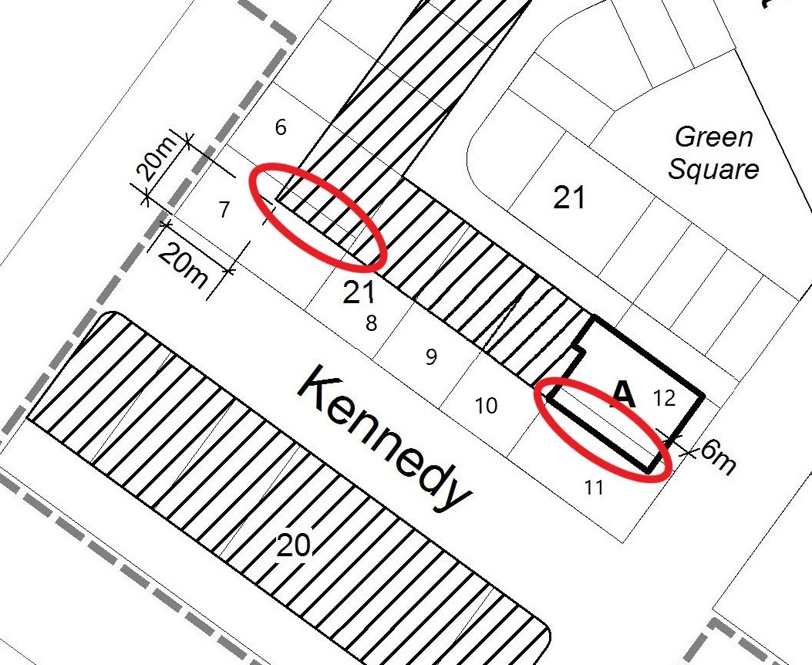 | 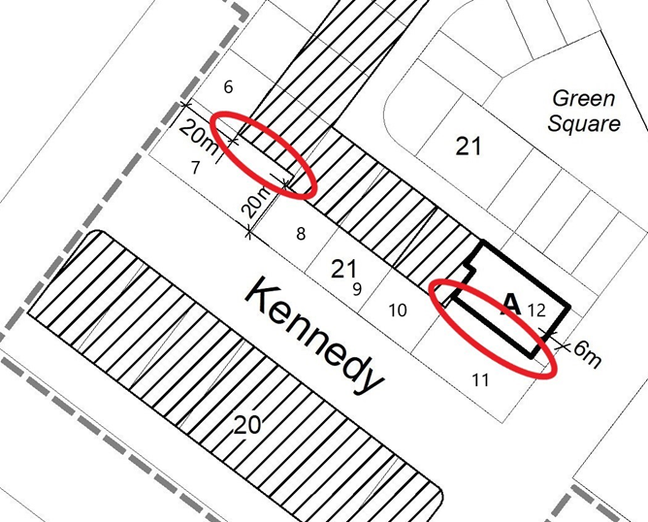

Figure 7 of the Inner South District Policy is proposed to be amended as follows:

Existing Figure – Figure 7 Kingston – Group Centre – building height
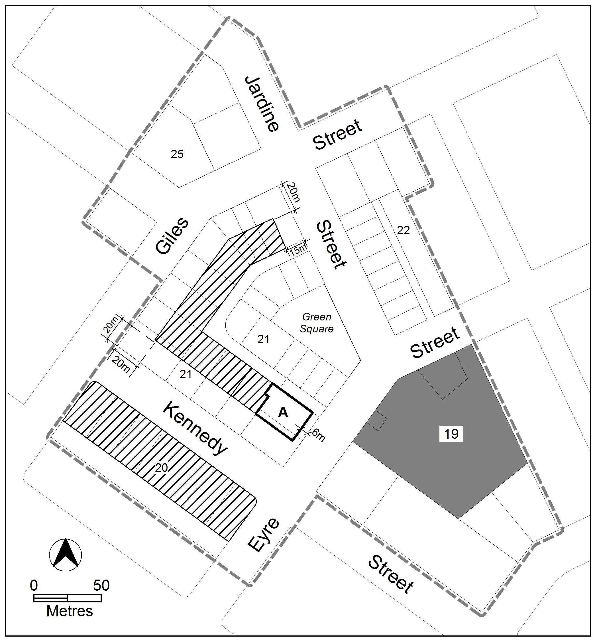
Proposed Figure – Figure 7 Kingston – Group Centre – building height
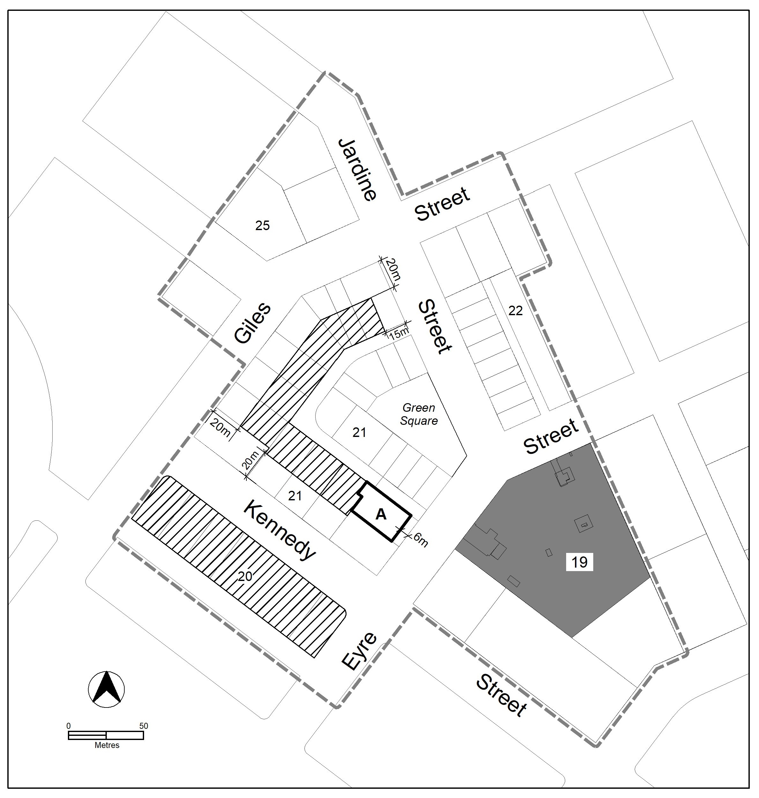

  - Tuggeranong District Policy
The Tharwa Village Plan that was endorsed in September 2018 provided recommendations on planning principles and design guidance for future development in the village. A variation to the Territory Plan (Variation 359 that commenced in 2019) incorporated some of the planning policy recommendations contained within the village plan. Design guidelines for future buildings were subsequently imposed into the previous Tharwa Precinct Map and Code and now the Tuggeranong District Policy.

The current drafting of these provisions, as mandatory requirements, does not meet the original intent of the Tharwa Village Plan where these controls were proposed as planning and design guidance to encourage and maintain the rural character of the area. These were not envisaged to be immutable and inflexible mandatory provisions.

Slight adjustments have been made to Assessment Requirement 46 a) to provide flexibility to the roof pitch. Previously roof pitches had to be between 30º and 45º. The change allows for a greater range in roof pitch while maintaining a preference for steep pitches. The amendments also note that this requirement may not apply where inconsistent with relevant heritage or conservation provisions.

The purpose is to clarify the rationale for the provisions and provide the necessary flexibility that was envisaged when the Tharwa Village Plan was prepared.
  - Territory Plan Map
The Territory Plan map is amended by rezoning Blocks 10, 11 and 12, Section 74 Watson from Commercial CZ6 – Leisure and Accommodation Zone to a combination of Residential RZ5 - High Density Residential Zone and Commercial CZ5 – Mixed Use Zone. This amendment brings the indicative zoning under future urban area (FUA) into line with the future development intentions of these blocks. The rezoning indicates that the blocks will predominantly be zoned RZ5 and that there will be a smaller amount of CZ5 located on the site.

The intent of the rezoning is to highlight the future development intention of primarily residential housing with a smaller amount of commercial use to avoid disruption to the established commercial centre hierarchy.

While this rezoning under FUA changes the indicative zoning only, the new indicative zoning will enable future additional high-density housing in an area close to public open spaces, nature reserves, and existing commercial and community facilities.

The rezoning under FUA is not inconsistent with the Inner North and City District Strategy where the site is identified as a Category 1 change area (where change could happen within 0-5 years). The amendment will support the supply of additional well-located dwellings. The site is well positioned near key employment and education hubs, with direct access to the R9 rapid bus route and active-travel infrastructure, facilitating sustainable travel. Its location provides strong connections to nearby nature reserves and broad rezoning will allow future development to adequately consider and design to protect significant registered trees on site.

Proximity to existing community facilities and the Watson Local Centre, combined with the flexibility of CZ5 zoning, allows for a range of community, commercial and residential uses that enhance local liveability. As a Category 1 change area, the amendment directly contributes to meeting the district’s housing supply and affordability objectives.

The RZ5 and CZ5 zoning directly supports the District Strategy’s vision for a compact, transit-oriented Inner North and City district. RZ5 facilitates higher-density residential development in locations with strong transport access, increasing housing supply and enabling diverse housing types, including affordable and social housing, supporting walkable neighbourhoods and reducing reliance on private vehicles.

Location Map – Watson section 74
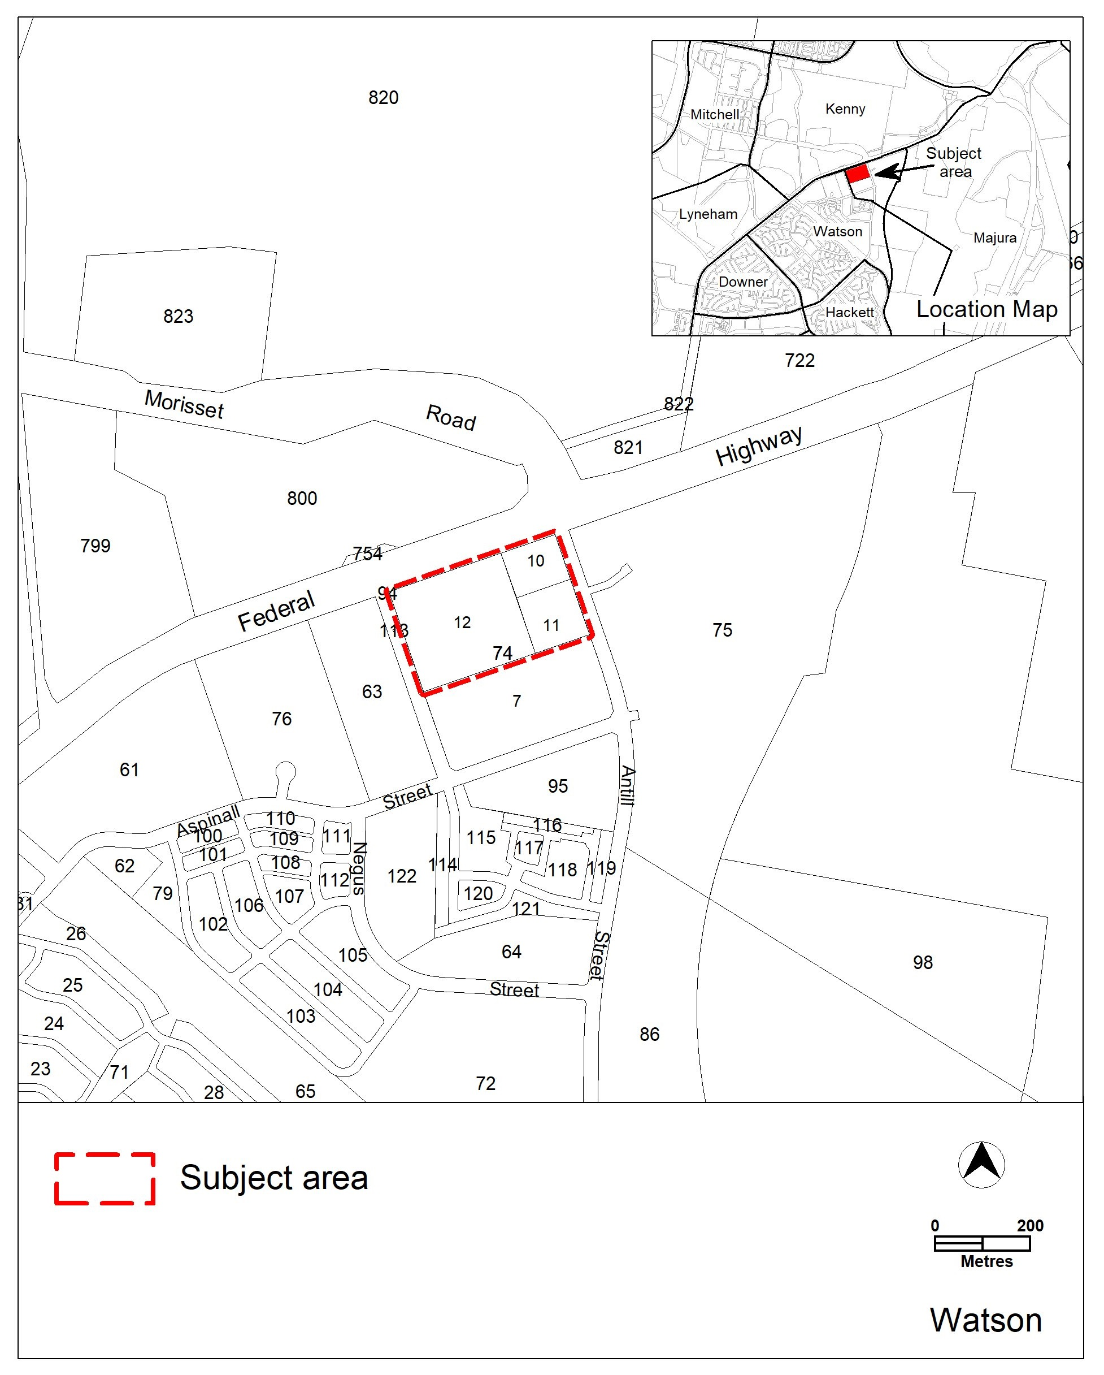

Existing Territory Plan Map – Watson section 74
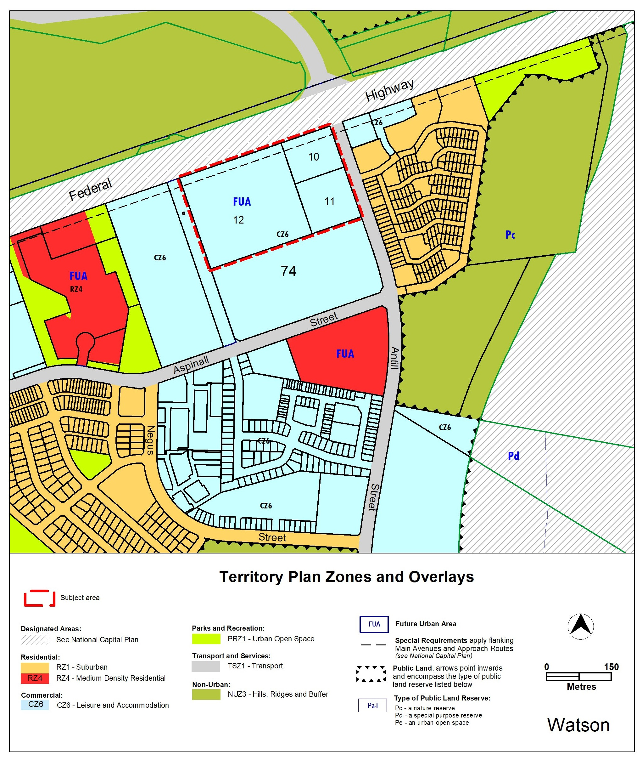

The Territory Plan Map is amended as follows:

Territory Plan Map – section 74 Watson
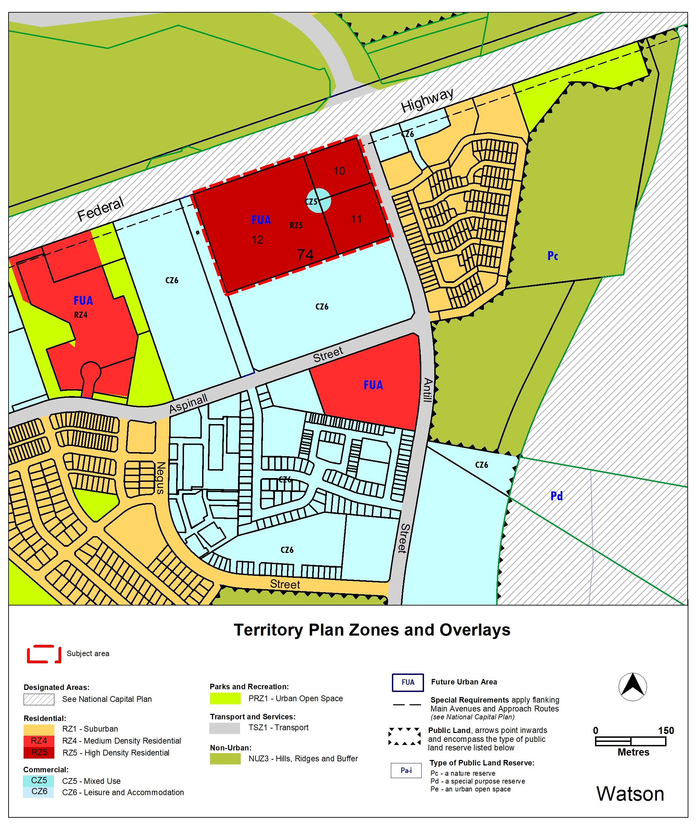
- TERRITORY PLAN AMENDMENT INSTRUCTIONS
This section provides the legal instructions for how MA2026-01 amends the Territory Plan.
  - Part D: D03 – Inner North and City District Policy
Add a new Control and Assessment requirement 133
Control | Assessment requirement
Gross floor area | - For the CZ5 area in Watson Section 74 the maximum gross floor area for café, club, drink establishment, restaurant, shop, supermarket and take-away food shop is 500m²

  - Part D: D04 – Inner South District Policy
Figure 7 Kingston – Group Centre – building height

Substitute:

  - Part D: D08 – Tuggeranong District Policy
Assessment Requirement 46:

Substitute

Roofs are:
- Steep pitched gable and/or hip roof design*.
- A prominent feature of dwellings and recognisable as a separate element to the verandahs.
- Constructed using corrugated metal, or similar, in a neutral and non-reflective colour or traditional galvanised finish.

* Note: Roofs should generally be between 30º and 45º. This requirement does not apply for a registered heritage place, where heritage conservation provisions and/or heritage advice takes precedence.

  - Part B – Territory Plan Maps
The relevant part of the Territory Plan map is varied as indicated below.

Section 74 Watson

INTERPRETATION SERVICE
To speak to someone in a language other than English please telephone the Telephone Interpreter Service (TIS) 13 14 50
LANGUAGE | DETAILS
English | If you need an interpreter please call: 13 14 50
Mandarin (Simplified Chinese) / 简体中文 | 如果您需要翻译，请致电：13 14 50
Arabic / العربية | إذا كنت بحاجة إلى مترجم شفهي اتصل بالرقم: 50 14 13
Cantonese (Traditional Chinese) / 繁體中文 | 如果你需要傳譯員，請致電：13 14 50
Vietnamese /  Tiếng Việt | Nếu bạn cần thông dịch viên, xin gọi: 13 14 50
Korean / 한국어 | 통역사가 필요할 경우 다음 번호로 전화하시기 바랍니다: 13 14 50
Spanish / Español | Si necesita un intérprete, llame al 13 14 50
Persian (Farsi) / فارسی | اگر به مترجم نیاز دارید، لطفاً به این شماره تلفن کنید: 50 14 13
Dari / دری | اگر به یک ترجمان شفاهی نیاز دارید لطفاً به شمارۀ 131450 زنگ بزنید.
Punjabi / ਪੰਜਾਬੀ | ਜੇਕਰ ਤੁਹਾਨੂੰ ਕਿਸੇ ਦੁਭਾਸ਼ੀਏ ਦੀ ਲੋੜ ਹੈ ਤਾਂ ਕਿਰਪਾ ਕਰਕੇ ਫੋਨ ਕਰੋ: 13 14 50
Tamil / தமிழ் | உங்களுக்கு மொழிபெயர்த்துரைப்பாளர் ஒருவர் தேவைப்பட்டால் 13 14 50 என்ற எண்ணை அழைக்கவும்
Greek / Ελληνικά | Αν χρειάζεστε διερμηνέα, τηλεφωνήστε: 13 14 50
Italian / Italiano | Se hai bisogno di un interprete, chiama: 13 14 50
Hazaragi / هزاره گی | اگه ده ترجمان ضرورت ده رید، لطفاً ده شماره 50 14 13 تماس بگیرید.
Thai / ภาษาไทย | หากคุณต้องการล่าม กรุณาโทรไปที่ 13 14 50
Karen / ကညီကျိၥ် | ဖဲနမ့ၢ်လိၣ်ဘၣ်ပှၤကတိၤကျိးထံတၢ်တဂၤအခါ၀ံသးစူၤကိးဘၣ်-၁၃၁ ၄၅၀ တက့ၢ်.

Telephone and Interpreter Service 13 14 50 - Canberra and District - 24 hours a day, seven days a week

