Australian Capital Territory
Planning (Macnamara rezone under FUA) Minor Plan Amendment 2026 (No 1)
Notifiable instrument NI2026–366
made under the
Planning Act 2023, s 85 (Making minor plan amendments)

1 Name of instrument
This instrument is the Planning (Macnamara rezone under FUA) Minor Plan Amendment 2026 (No 1).
2 Commencement
This instrument commences on the day after its notification day.
3 Minor plan amendment
I make Minor Plan Amendment 2026-07 as contained in schedule 1.

James Bennett
Delegate of the territory planning authority
29 July 2026

Schedule 1
(see s 3)


MINOR PLAN AMENDMENT
TO THE TERRITORY PLAN
2026-07

Rezoning under future urban area in the division of Macnamara

This minor plan amendment was prepared
under part 5.3 of the Planning Act 2023
Contents
1.0 INTRODUCTION 1
1.1 Outline of the process 1
1.2 Summary of the minor amendment 1
2.0 CONSULTATION WITH THE PUBLIC 2
2.1 Consultation period 2
2.2 Comments from the public 2
3.0 TERRITORY PLAN CHANGES 3
3.1 Part B – Territory Plan Map 3
4.0 TERRITORY PLAN AMENDMENT 8
4.1 Amendment to the Territory Plan Maps (Part B) 8
INTERPRETATION SERVICE 9

- INTRODUCTION
  - Outline of the process
Minor plan amendment 2026-07 (MA2026-07) to the Territory Plan is a minor plan amendment (MA) prepared under section 84 (2)(e) and section 89(1) of the Planning Act 2023 (the Act).

Section 84 of the Act outlines the different types of MAs, some which require limited consultation to be undertaken and some which require no consultation to be undertaken.

Under Section 85 of the Act a MA can only be made where:
- any required limited consultation has taken place and the authority is satisfied that the content of the MA meets the requirements of the Act
- if the MA is not inconsistent with the planning strategy or any relevant district strategy
- any comments received during the consultation period and from the National Capital Authority have been considered.

This MA required limited consultation to be undertaken and was released for public consultation in accordance with the Act.

This MA is not inconsistent with the planning strategy or the Belconnen District Strategy.

The National Capital Authority has received a copy of this MA.

For more information on the content of the Territory Plan and minor plan amendment processes please refer to the Planning website: The Territory Plan - City and Environment Directorate - Planning

  - Summary of the minor amendment
MA2026–07 makes the following changes to the Territory Plan Map:

Rezones Block 1 Section 2 and part Block 9 Section 3 Macnamara, under a future urban area (FUA) overlay from the current zonings (Figure 2) to the amended zonings (Figure 3).

- CONSULTATION WITH THE PUBLIC
  - Consultation period
Under section 84 (2) of the Planning Act 2023, this minor amendment was subject to limited public consultation of at least 20 working days. Written comments on MA2026-07 were invited from the public from 22 May 2026 and closed on 30 June 2026.
  - Comments from the public
No public comments were received during the consultation period.

- TERRITORY PLAN CHANGES
MA2026-07 makes changes to parts of the following Territory Plan:
- Part B – Territory Plan Map

  - Part B – Territory Plan Map
This MA rezones Block 1 Section 2 and part Block 9 Section 3 Macnamara, under a future urban area (FUA) overlay in the following ways:

Current zoning
Residential RZ1 – Suburban
Residential RZ3 – Urban Residential
CFZ - Community Facility
PRZ1 - Urban Open Space

Amended zoning
Residential RZ1 – Suburban
Residential RZ3 – Urban Residential
Residential RZ4 – Medium Density Residential
Residential RZ5 – High Density Residential
Commercial CZ5 – Mixed Use
Commercial CZ6 – Leisure and Accommodation
CFZ – Community Facility
PRZ1 - Urban Open Space
TSZ1 – Transport
NUZ3 – Hills Ridges and Buffer

The rezoning under FUA is not inconsistent with the Belconnen District Strategy where the site is identified as Key Site 8 and a Category 1 change area (where change could happen within 0-5 years). The rezoning will support the supply of additional well-located dwellings and supports the District Strategy’s vision for the Ginninderry community. The vision states: ‘the Ginninderry community, ultimately home to around 30,000 residents, will be renowned as a model of sustainable development, where planning and designing with Country is the hallmark. Ginninderry will sit harmoniously in the landscape and provide a mix of housing types, from separate houses to compact attached dwellings and low-rise apartments, the latter focussed in and around the thriving new group centre. Social and affordable housing and community facilities will be integrated throughout, ensuring the community is socially diverse and inclusive’.

The intent of the rezoning is to establish the future development intention for Macnamara North to enable compact, efficient, and sustainable urban development on identified greenfield land. Concentrating residential density along Pro Hart Avenue and around the neighbourhood centre represents an efficient use of land and infrastructure, supports public transport viability, and reduces reliance on private vehicles, consistent with sustainable urban growth objectives.

While this is a rezoning under FUA and changes the indicative zoning only, the revised zoning will enable a range of diverse housing types improving housing choice, affordability and demographic diversity. It will allow for future housing, public open spaces and networks and commercial and community facilities. The significant area of CFZ: Community Facility zone will be retained and an area of CZ6: Leisure and Accommodation zoned land which will be co-located with the Community Facility zoned land.

Varied residential zoning enables a diverse housing types, including missing-middle housing, at densities appropriate to proximity to services, public transport, and open space. Increased densities are focused along Pro Hart Avenue and within the surrounding area, supporting sustainable movement patterns and aligning with established development outcomes in Macnamara South and Strathnairn. The future street and movement framework will prioritise walking, cycling, and public transport, ensuring legibility, equitable access, and sustainable travel choices.

The rezoning will assist in delivering an integrated, environmentally responsive, and well-connected urban structure that supports sustainable growth, housing diversity, employment opportunity, and long-term place-making outcomes for Macnamara North.

Figure 1 Location Map – Macnamara North
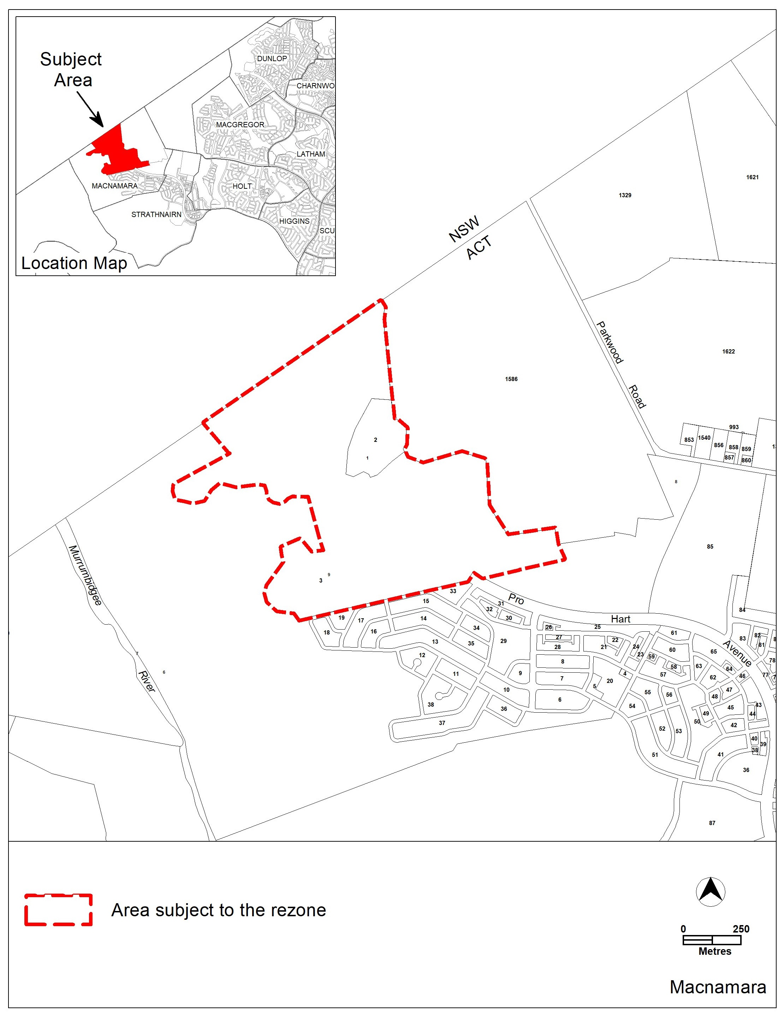

Figure 2 Existing Territory Plan Map – Macnamara North
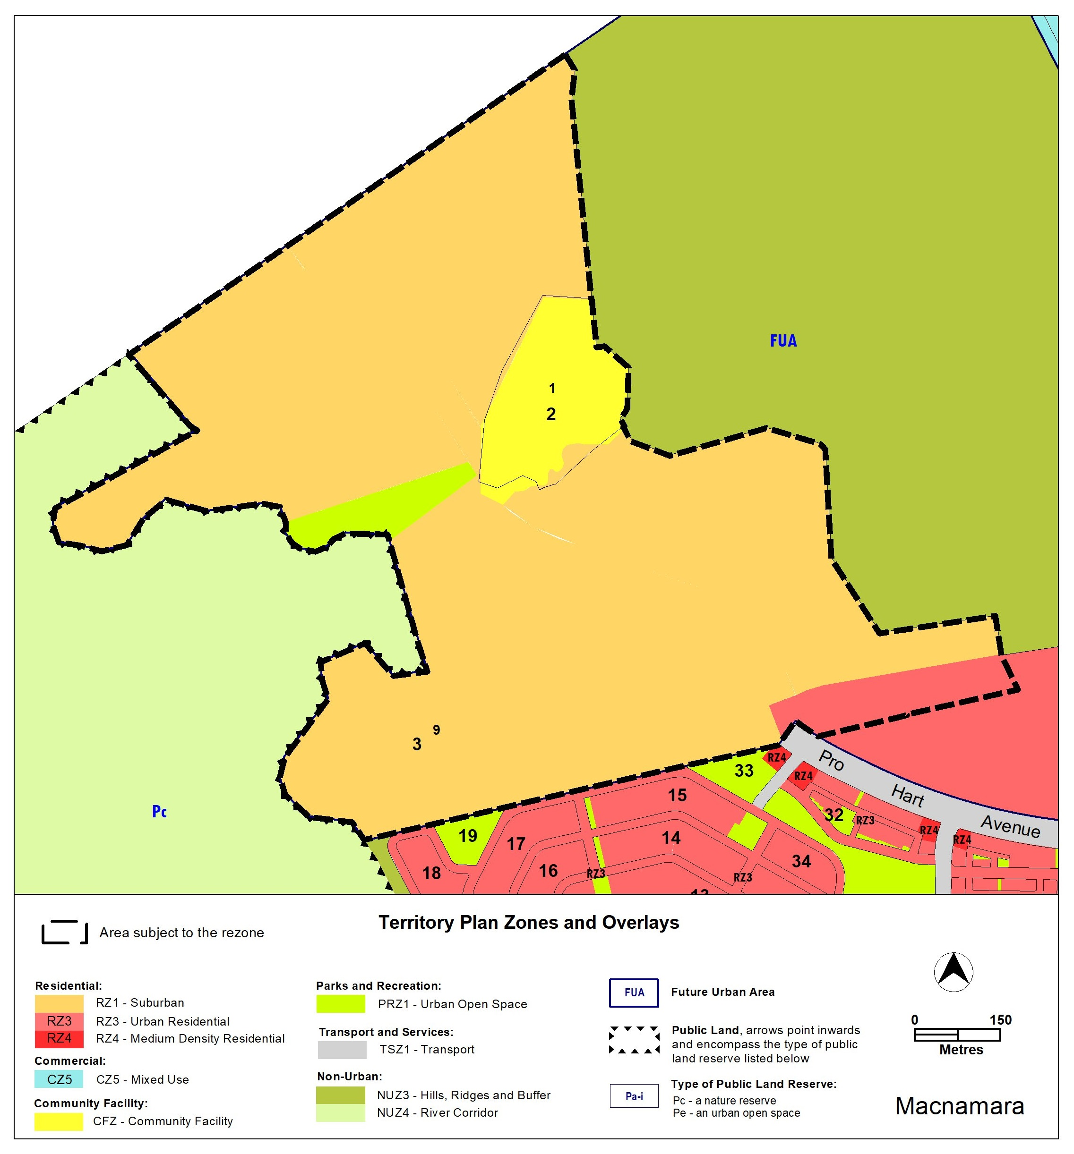

The Territory Plan Map is to be amended as follows:

Figure 3 Territory Plan Map – Macnamara North
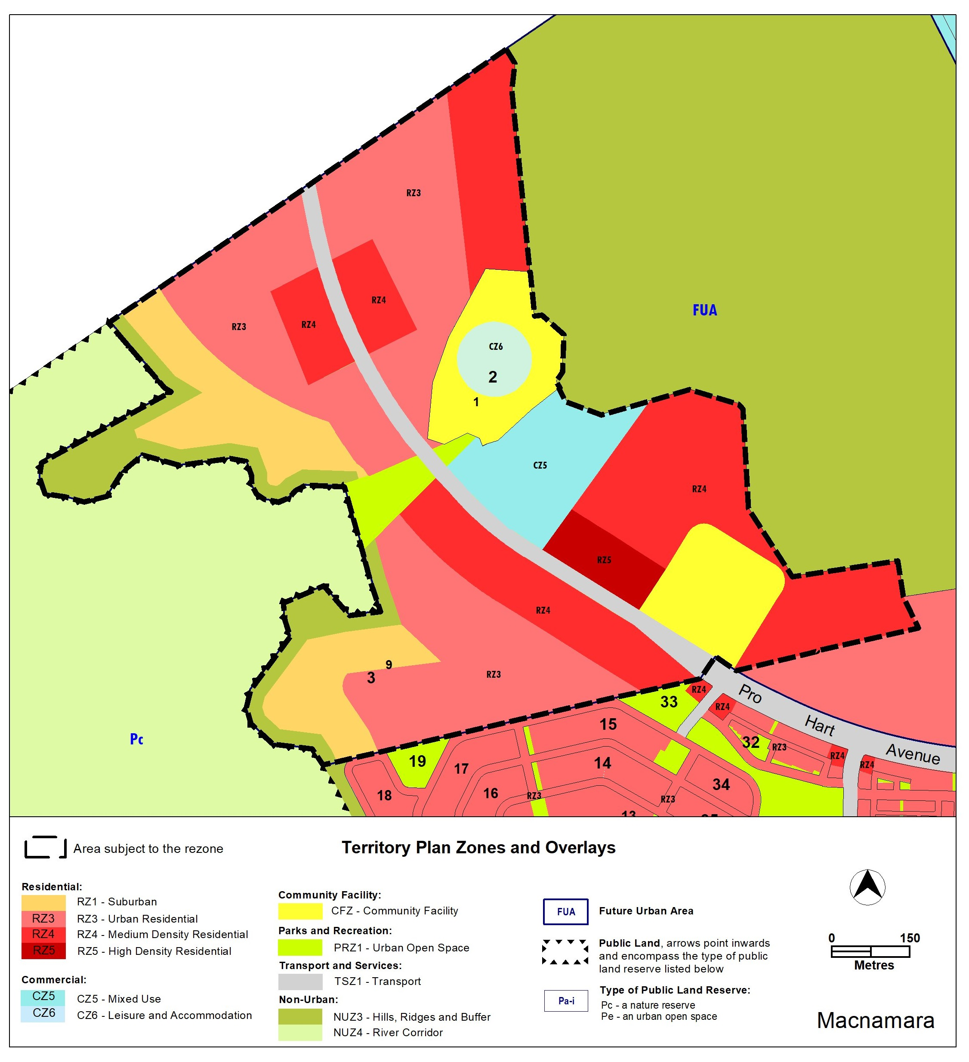

- TERRITORY PLAN AMENDMENT
  - Amendment to the Territory Plan Maps (Part B)
1. Territory Plan map

The relevant part of the Territory Plan map is varied as indicated below.

INTERPRETATION SERVICE
To speak to someone in a language other than English please telephone the Telephone Interpreter Service (TIS) 13 14 50
LANGUAGE | DETAILS
English | If you need an interpreter please call: 13 14 50
Mandarin (Simplified Chinese) / 简体中文 | 如果您需要翻译，请致电：13 14 50
Arabic / العربية | إذا كنت بحاجة إلى مترجم شفهي اتصل بالرقم: 50 14 13
Cantonese (Traditional Chinese) / 繁體中文 | 如果你需要傳譯員，請致電：13 14 50
Vietnamese /  Tiếng Việt | Nếu bạn cần thông dịch viên, xin gọi: 13 14 50
Korean / 한국어 | 통역사가 필요할 경우 다음 번호로 전화하시기 바랍니다: 13 14 50
Spanish / Español | Si necesita un intérprete, llame al 13 14 50
Persian (Farsi) / فارسی | اگر به مترجم نیاز دارید، لطفاً به این شماره تلفن کنید: 50 14 13
Dari / دری | اگر به یک ترجمان شفاهی نیاز دارید لطفاً به شمارۀ 131450 زنگ بزنید.
Punjabi / ਪੰਜਾਬੀ | ਜੇਕਰ ਤੁਹਾਨੂੰ ਕਿਸੇ ਦੁਭਾਸ਼ੀਏ ਦੀ ਲੋੜ ਹੈ ਤਾਂ ਕਿਰਪਾ ਕਰਕੇ ਫੋਨ ਕਰੋ: 13 14 50
Tamil / தமிழ் | உங்களுக்கு மொழிபெயர்த்துரைப்பாளர் ஒருவர் தேவைப்பட்டால் 13 14 50 என்ற எண்ணை அழைக்கவும்
Greek / Ελληνικά | Αν χρειάζεστε διερμηνέα, τηλεφωνήστε: 13 14 50
Italian / Italiano | Se hai bisogno di un interprete, chiama: 13 14 50
Hazaragi / هزاره گی | اگه ده ترجمان ضرورت ده رید، لطفاً ده شماره 50 14 13 تماس بگیرید.
Thai / ภาษาไทย | หากคุณต้องการล่าม กรุณาโทรไปที่ 13 14 50
Karen / ကညီကျိၥ် | ဖဲနမ့ၢ်လိၣ်ဘၣ်ပှၤကတိၤကျိးထံတၢ်တဂၤအခါ၀ံသးစူၤကိးဘၣ်-၁၃၁ ၄၅၀ တက့ၢ်.

Telephone and Interpreter Service 13 14 50 - Canberra and District - 24 hours a day, seven days a week

