Australian Capital Territory
Planning (Gungahlin District) Technical Specifications 2026 (No 1)
Notifiable instrument NI2026-375
made under the
Planning Act 2023, s 51 (Technical specifications)

1 Name of instrument
This instrument is the Planning (Gungahlin District) Technical Specifications 2026 (No 1).
2 Commencement
This instrument commences on the day after its notification day.
3 Technical specifications
I make the technical specifications at schedule 1.
4 Revocation
This instrument revokes the Planning (Gungahlin District) Technical Specifications 2024 (No 4) (NI2024-624).

George Cilliers
Chief Planner
3 August 2026

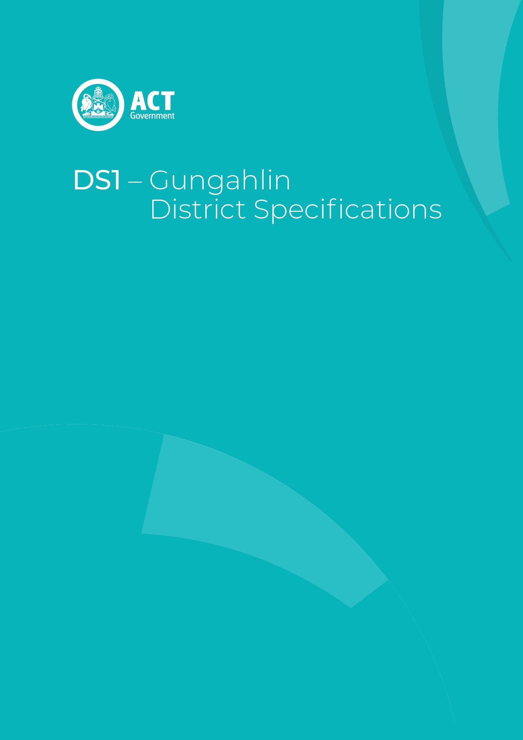
Schedule 1 (see s 3)

Table of Contents
Table of Contents 3
Gungahlin District planning technical specifications 5
1. Amaroo 6
Development provisions 6
Figure 1 Amaroo – Ongoing Provisions 6
2. Bonner 7
3. Casey 7
4. Crace 7
5. Forde 7
6. Franklin 7
7. Gungahlin (suburb/town centre) 8
Land use 8
Entertainment precinct 8
Active frontages 8
Figure 2 Gungahlin - Land available for Community Facility CFZ zone 9
Figure 3 Gungahlin 10
Figure 4 Gungahlin – Entertainment Precinct 11
8. Hall 12
9. Harrison 12
10. Jacka 12
Principal Private Open Space (PPOS) 12
Building height 12
Setbacks 12
Build depth 12
Habitable room 12
Fencing 12
Walls 13
Visual corridor 13
Garages/Carports 13
Parking 13
Site Coverage 13
Development provisions 13
Table 1 Jacka – Fencing controls 13
Diagram 1 Jacka – Corner block fencing 14
Diagram 2 Jacka – Typical fencing treatment 15
Figure 5 Jacka – Ongoing Provisions 16
Figure 6 Jacka – Ongoing Provisions 17
Figure 7 Jacka – Ongoing Provisions 18
Figure 8 Jacka – Ongoing Provisions 19
Figure 9 Jacka – Ongoing Provisions 20
Figure 10 Jacka – Ongoing Provisions 21
Figure 11 Jacka – Ongoing Provisions 22
Figure 12 Jacka – Ongoing Provisions 23
Figure 13 Jacka – Ongoing Provisions 24
11. Kenny 25
12. Mitchell 25
13. Moncrieff 25
14. Nicholls 25
15. Ngunnawal 25
16. Palmerston 26
17. Taylor 26
Gross floor area 26
Vehicle access 26
Building height 26
Awning 26
Waste 26
Consolidation 26
Principal private open space 27
Development provisions 27
Figure 14 Taylor – Ongoing Provisions 28
Figure 15 Taylor – Ongoing Provisions 29
Figure 16 Taylor – Ongoing Provisions 30
Figure 17 Taylor – Ongoing Provisions 31
Figure 18 Taylor – Ongoing Provisions 32
Figure 19 Taylor – Ongoing Provisions 33
Figure 20 Taylor – Ongoing Provisions 34
Figure 21 Taylor – Ongoing Provisions 35
Figure 22 Taylor – Ongoing Provisions 36
Figure 23 Taylor – Ongoing Provisions 37
Figure 24 Taylor – Ongoing Provisions 38
Figure 25 Taylor – Ongoing Provisions 39
Figure 26 Taylor – Ongoing Provisions 40
Figure 27 Taylor – Ongoing Provisions 41
Figure 28 Taylor – Ongoing Provisions 42
Figure 29 Taylor – Ongoing Provisions 43
Figure 30 Taylor – Ongoing Provisions 44
Figure 31 Taylor – Ongoing Provisions 45
18. Throsby 46
Figure 32 Throsby – Ongoing Provisions 46

Gungahlin District planning technical specifications
The primary assessment consideration for a development application is the assessment outcomes in the Territory Plan. In demonstrating compliance with the assessment outcomes, consideration may be given to the relevant planning technical specifications which may serve as a benchmark. While all assessment outcomes are to be met, not all outcomes are covered by a specification.

Planning technical specifications are used as a possible solution or to provide guidance for identified aspects of a development proposal. The specifications may also be used as a reference or benchmark in the preparation and assessment of development proposals to demonstrate compliance with the assessment outcomes, and the Territory Plan.
Where a proposed development complies with a relevant provision in the planning technical specifications and the development comprehensively addresses the assessment outcome, further assessment regarding those specific provisions will not be required.
The specifications in the Gungahlin District Specifications can be used to demonstrate compliance with the assessment outcomes in the Gungahlin District Policy or the relevant zone policy. Where there is a specific assessment outcome in the Gungahlin District Policy, this takes precedence over the equivalent outcome in the zone policy. Where there is no specific assessment outcome in the Gungahlin District Policy, the specification can be used to demonstrate compliance with the assessment outcomes in the zone policy.
The Territory Planning Authority may consider advice or written support from a referral entity to demonstrate compliance with a relevant assessment outcome. Where endorsement from an entity is noted as a planning specification, entity referral may be required.
Consistent with the Gungahlin District Policy, this Gungahlin District Specifications comprises specifications for specific localities, structured according to the localities.
These specifications will only apply to the specific sites or locations they refer to and should be used in conjunction with the relevant district policy, i.e., Part D1: Gungahlin District Policy.

Amaroo
The following specifications provide possible solutions that should be considered in planning, placing, designing and using buildings and structures for proposed development in Amaroo:
Assessment Outcome: | Refer to zone assessment outcome
Specification
Development provisions | - Development complies with the specifications identified in Figure 1.

Figure 1 Amaroo – Ongoing Provisions
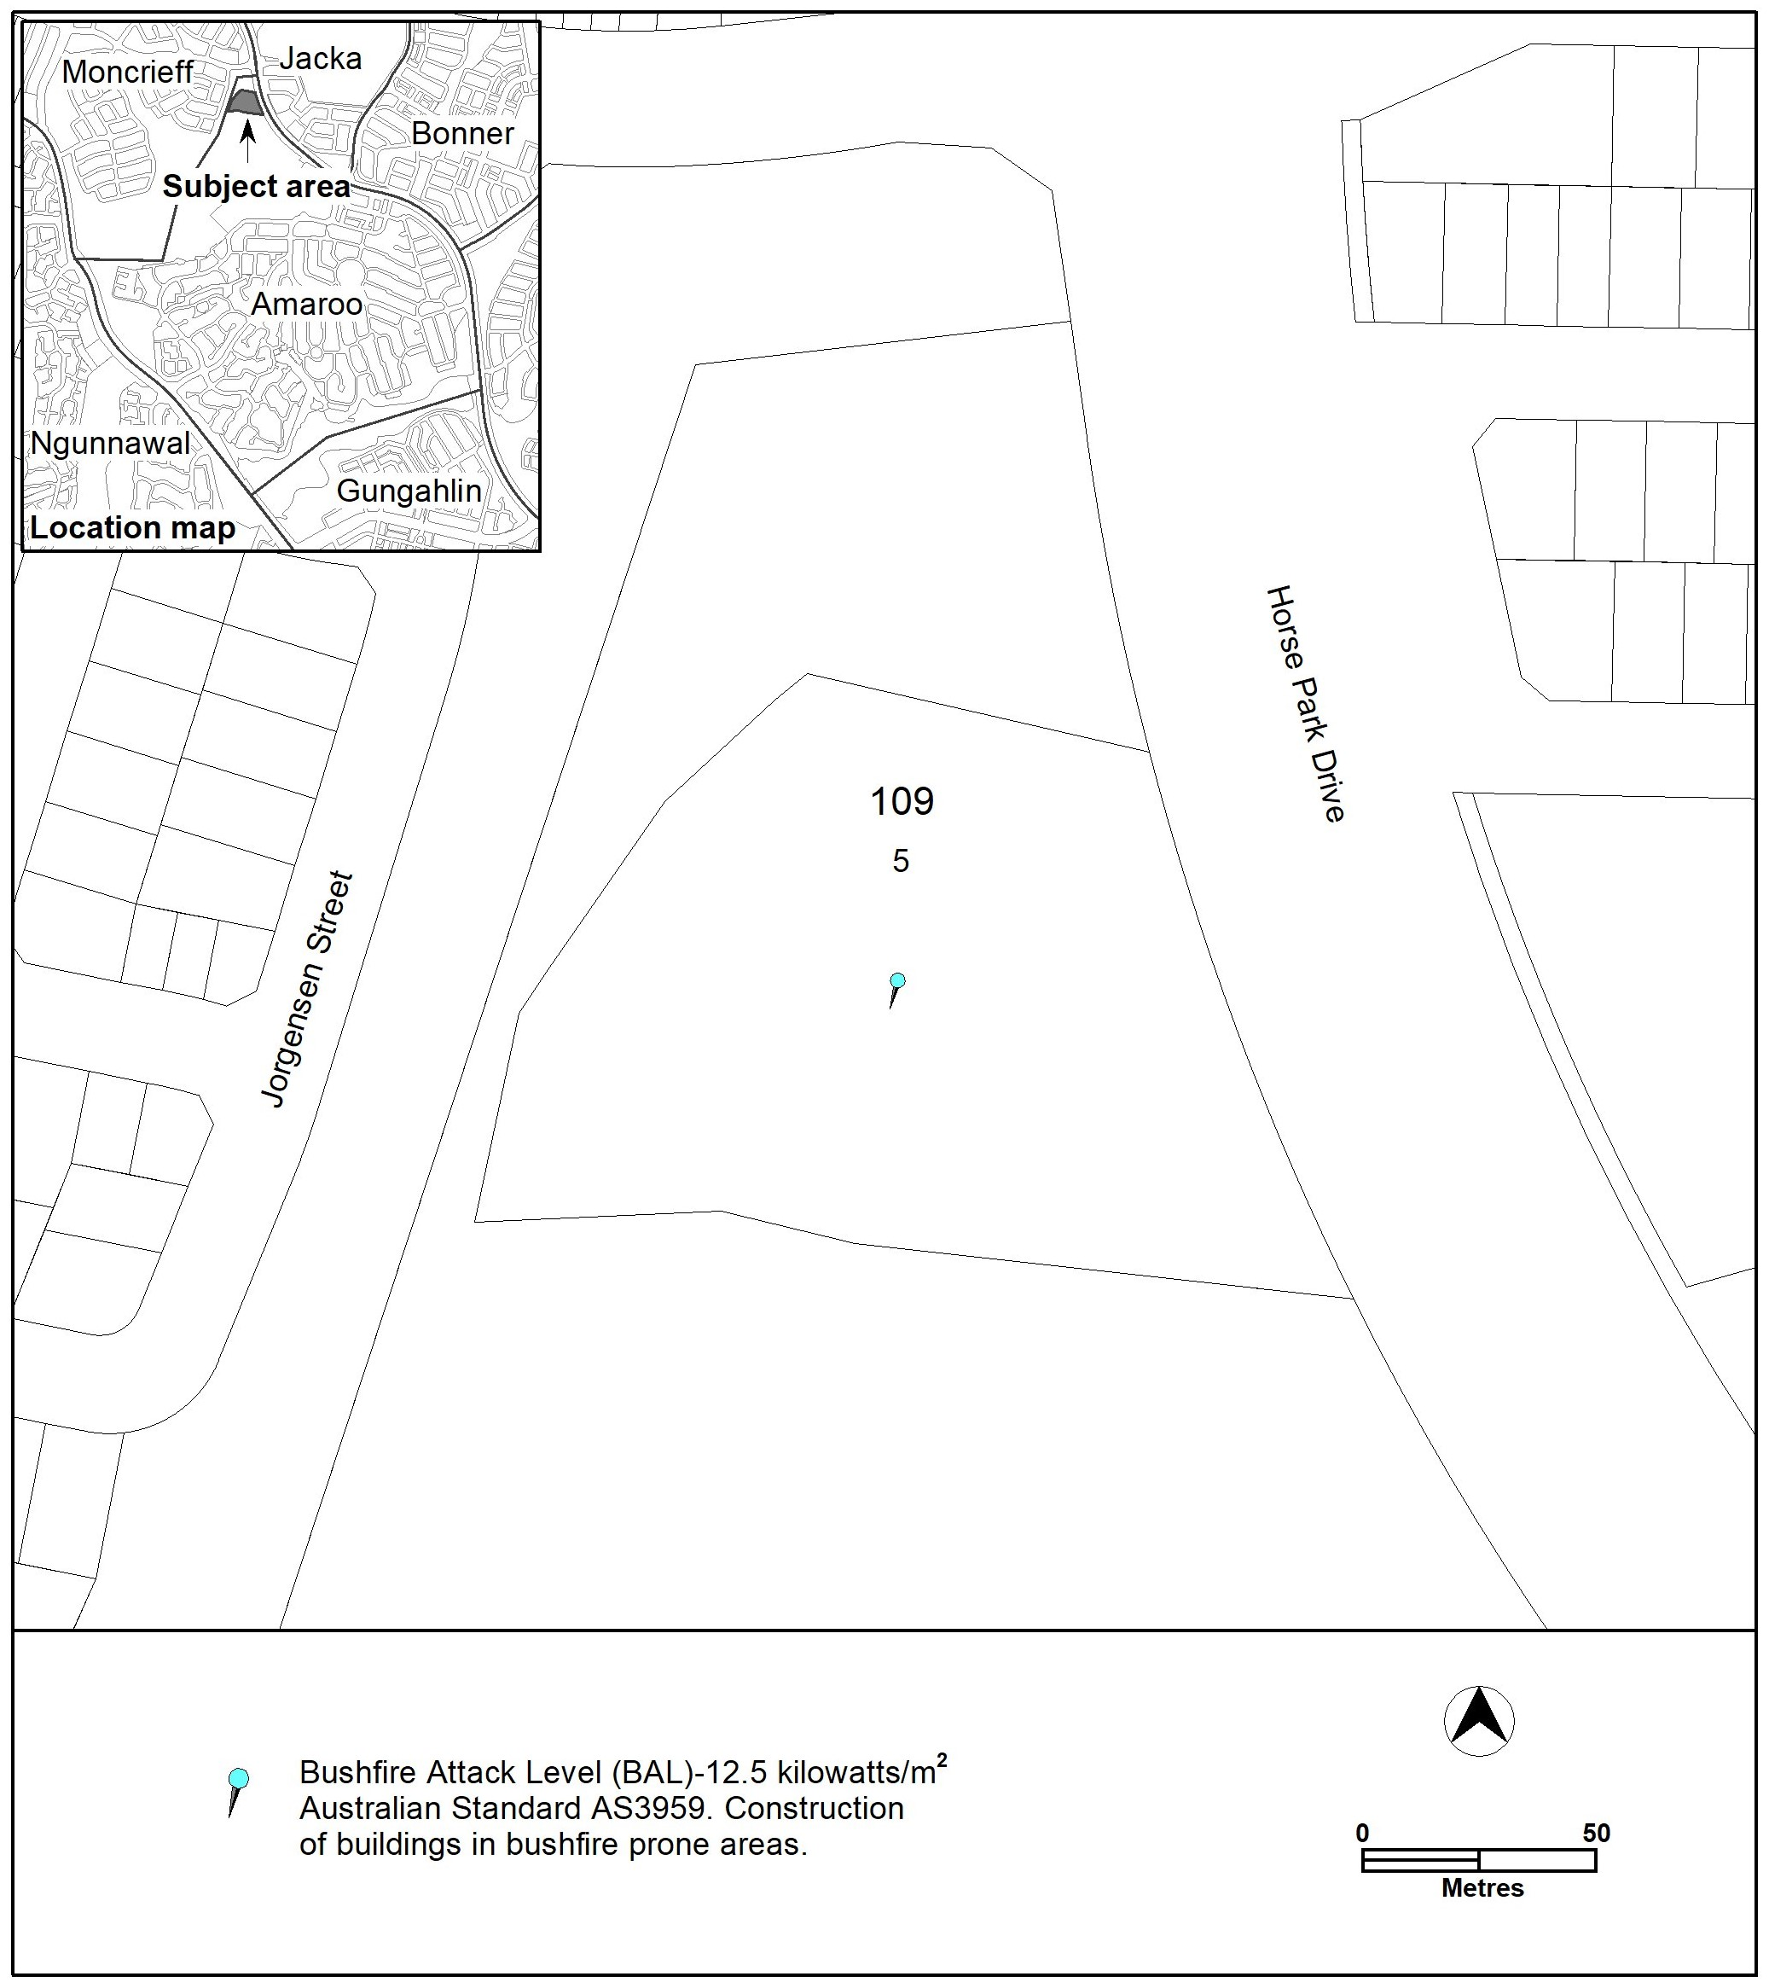

Bonner
The following specifications provide possible solutions that should be considered in planning, placing, designing and using buildings and structures for proposed development in Bonner:

No applicable specification for this suburb.

Casey
The following specifications provide possible solutions that should be considered in planning, placing, designing and using buildings and structures for proposed development in Casey:

No applicable specification for this suburb.

Crace
The following specifications provide possible solutions that should be considered in planning, placing, designing and using buildings and structures for proposed development in Crace:

No applicable specification for this suburb.

Forde
The following specifications provide possible solutions that should be considered in planning, placing, designing and using buildings and structures for proposed development in Forde:

No applicable specification for this suburb.

Franklin
The following specifications provide possible solutions that should be considered in planning, placing, designing and using buildings and structures for proposed development in Franklin:

No applicable specification for this suburb.

Gungahlin (suburb/town centre)
The following specifications provide possible solutions that should be considered in planning, placing, designing and using buildings and structures for proposed development in Gungahlin:

Assessment Outcome | Refer to zone assessment outcome
Specification
Land use | - A minimum of 3.8 hectares of land is provided with a community facility zone within the grey area shown in Figure 2.
Entertainment precinct | - In accordance with Figure 4 within the Gungahlin Entertainment Precinct all noise emitting development must achieve outdoor noise levels compliant with the Noise Zone Standard.
Active frontages | - In accordance with Figure 3, building frontages shown as:  - ‘Active Frontage – Adaptable Built Form’ ground floor frontage requires buildings to incorporate clear display windows or shop fronts and provide pedestrian access and egress for persons with disabilities.  - ‘Active Frontage – Partial’, ground floor frontages and building designs: incorporate clear display windows and shop frontages at ground level; blank walls without windows are a maximum of 50% of the building frontage and is articulated or designed to make a positive contribution to the streetscape; and incorporates pedestrian access for access and egress for persons with disabilities at the main and secondary entrances.

Figure 2 Gungahlin - Land available for Community Facility CFZ zone
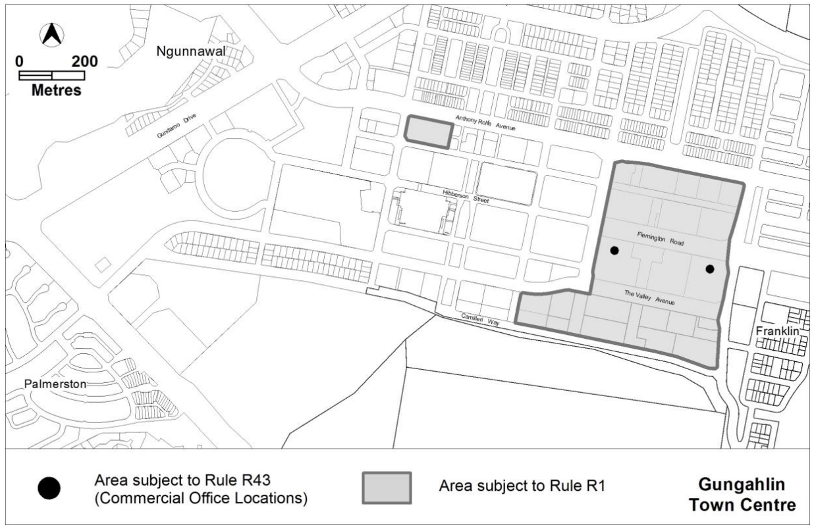
Community needs assessment

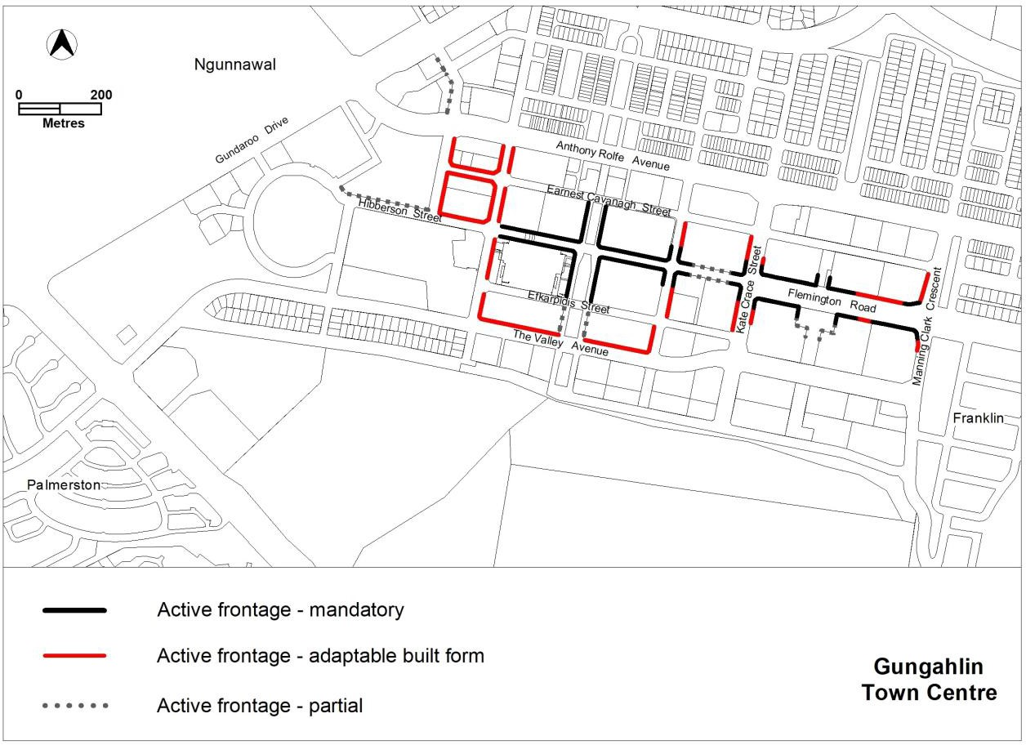
Figure 3 Gungahlin

Figure 4 Gungahlin – Entertainment Precinct
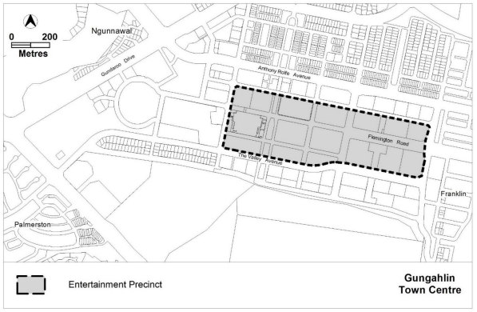

Hall
The following specifications provide possible solutions that should be considered in planning, placing, designing and using buildings and structures for proposed development in Hall:

No applicable specification for this suburb.

Harrison
The following specifications provide possible solutions that should be considered in planning, placing, designing and using buildings and structures for proposed development in Harrison:

No applicable specification for this suburb.

Jacka
The following specifications provide possible solutions that should be considered in planning, placing, designing and using buildings and structures for proposed development in Jacka:
Assessment Outcome: | Refer to zone assessment outcome
Specification
Principal Private Open Space (PPOS) | - Upper level PPOS permitted on nominated blocks in Figure 9 and Figure 10.  - For nominated blocks in Figure 9 with ‘PPOS A’ principal private open space provided at the upper floor level must comply with the following:  - Is not less than 12m² with a minimum dimension of 3m.
Building height | - The mandatory number of storeys is nominated in Figure 8, Figure 9 and Figure 10.
Setbacks | - Minimum boundary setbacks to floor levels are identified in Figure 9 and Figure 10.  - Buildings on blocks identified in Figure 9 and Figure 10 must be constructed to nominated boundaries.  Note: These provisions do not apply to setbacks for garages and/or carports.
Build depth | - Maximum building depth is 16m from front street boundary for nominated blocks in Figure 9 and Figure 10.
Habitable room | - Nominated blocks in Figure 8 must have a habitable room other than a bedroom fronting open space.
Fencing | - This provision applies to nominated boundaries in Figure 5, Figure 6, and Figure 7. Fences are to be constructed in accordance with Table 1.  The following applies to all fences:  - Provide both solid and semi-transparent elements within fencing/courtyard designs.  - Private open space cannot be lower than 1m below the front boundary level for a depth of 3m from the front boundary to the open space.  - Maximum fence/wall height is the cumulative height of retaining wall and fence (see Diagram 2).  - Refer to planning controls for nomination of gate, street address and letterbox to identified blocks.  The following applies to fencing on corner blocks:  - No fencing permitted within 6m of the corner (refer to Diagram 1).  - Fencing forward of the block line.  - 6m setback to alignment intersection.  - 50% @ 0m setback (total length).  - 50% @ 0.6m setback (total length).  - No maximum fencing length.
Walls | - Maximum length of wall at nominated setback cannot exceed nominated length in Figure 10.
Visual corridor | - Buildings must be setback to achieve a 12m wide visual corridor through nominated blocks as shown in Figure 9 and Figure 10.
Garages/Carports | - Minimum setback to garage/carport is nominated in Figure 9 and Figure 10.  - Garage/carport locations are specified in Figure 9 and Figure 10.
Parking | - For blocks nominated in Figure 9 with ‘Parking Requirements’, only one onsite parking space is required.
Site Coverage | - For blocks nominated in Figure 9 site coverage area calculations for each block must include the area of the block plus one-eighth of the Community Title open space area. Final site coverage calculations must meet the minimum requirements for compact blocks in the Residential Zones Policy.
Development provisions | - Development complies with the specifications identified in Figure 11, Figure 12, and Figure 13.

Table 1 Jacka – Fencing controls
 |  |  |  | Minimum setback |  | Maximum height
Location (refer to Figures) |  | Fencing | Provide Access Gate |  | For screening plants |  | Where located adjacent to the dwellings PPOS
 | Fence to pedestrian link | Yes | Yes | 100% at 0m |  | 1.5m | 1.5m
 | Fence to Boundary A | Yes | No | 100% at 0m |  | 1.5 | 1.5m
 | Fence to Boundary B | Yes | Yes |  | 100% at 0.6m | 1.5m | 1.5m
 | Fence to Section B | Yes | Yes |  | 100% at 0m | 1.8m | 1.8m

Diagram 1 Jacka – Corner block fencing
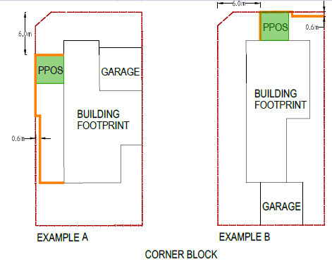
6.0m
0.6m
6.0m
0.6m

Diagram 2 Jacka – Typical fencing treatment

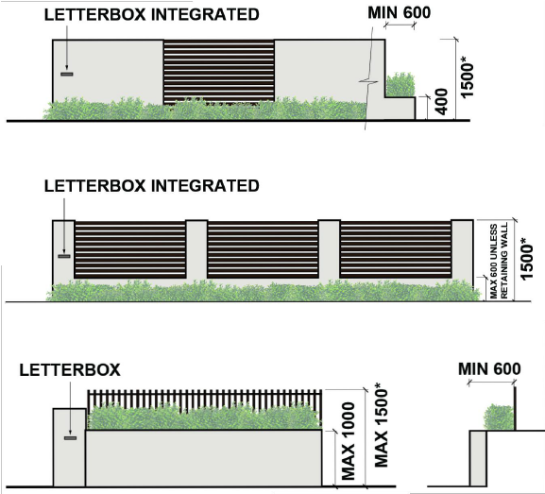

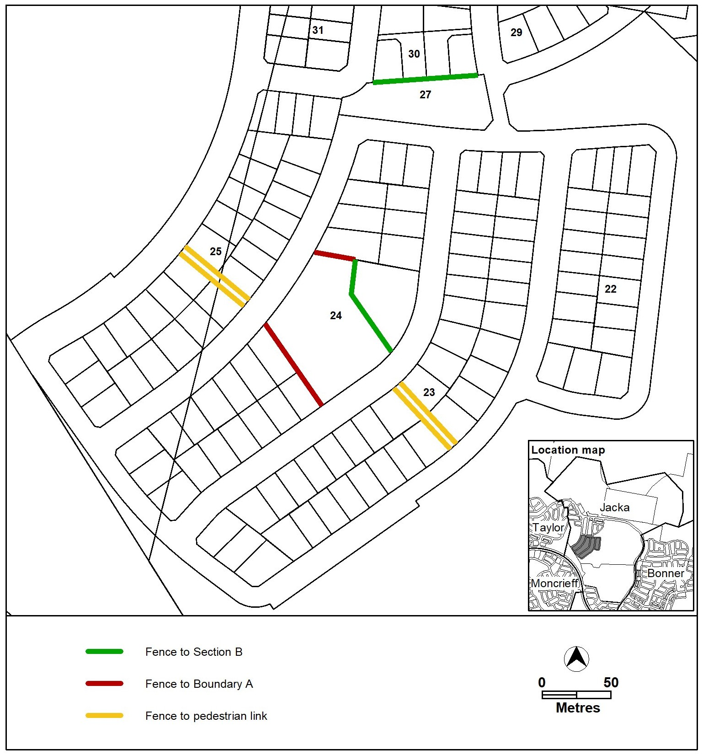
Figure 5 Jacka – Ongoing Provisions

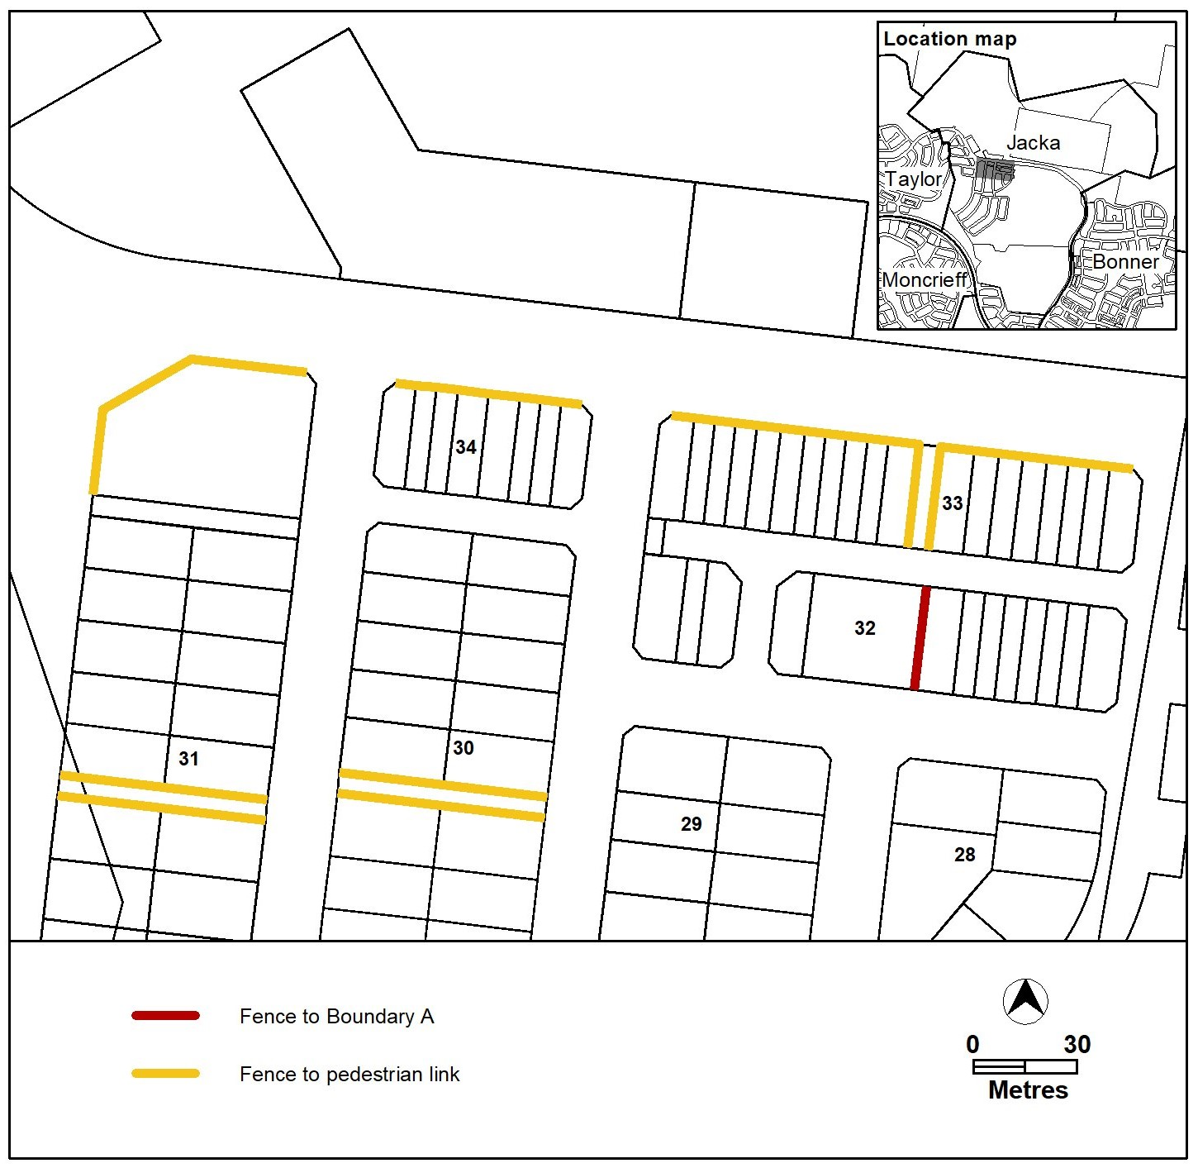
Figure 6 Jacka – Ongoing Provisions

Figure 7 Jacka – Ongoing Provisions
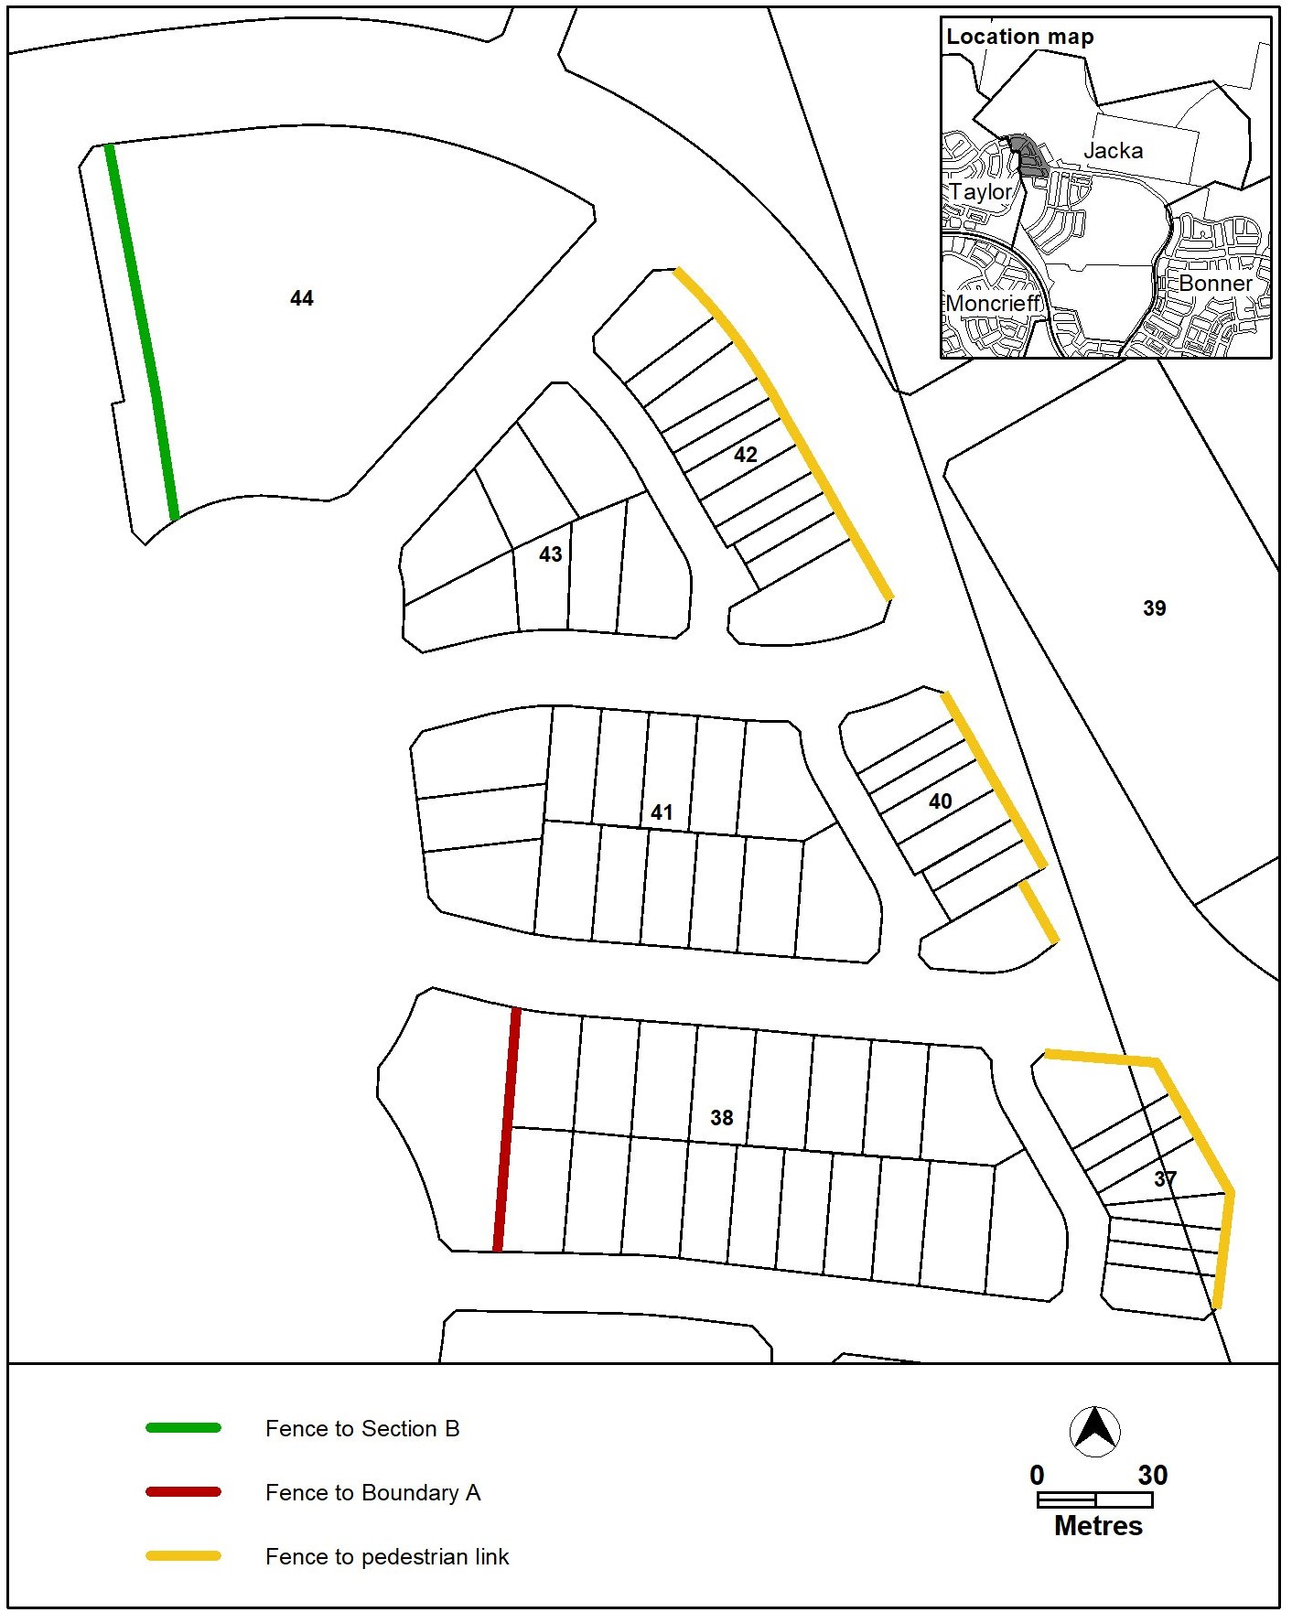

Figure 8 Jacka – Ongoing Provisions
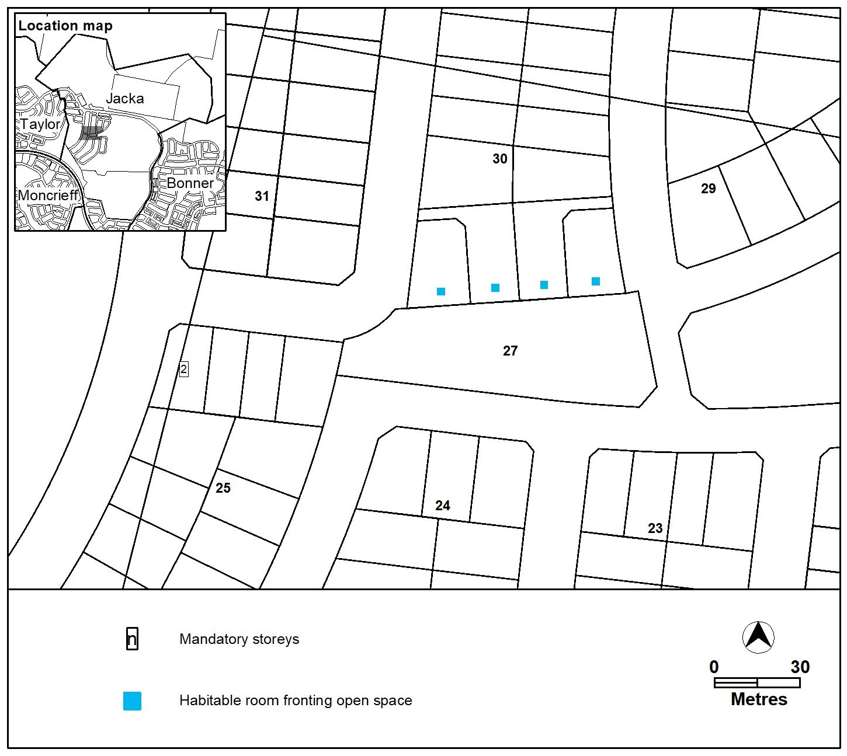

Figure 9 Jacka – Ongoing Provisions

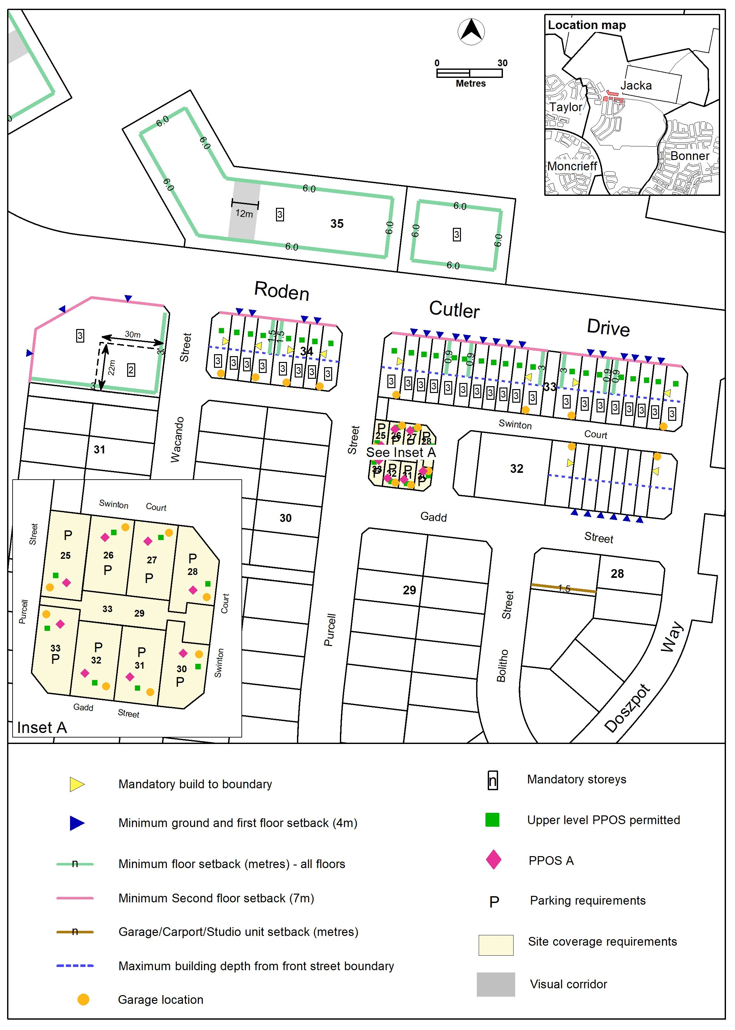

Figure 10 Jacka – Ongoing Provisions

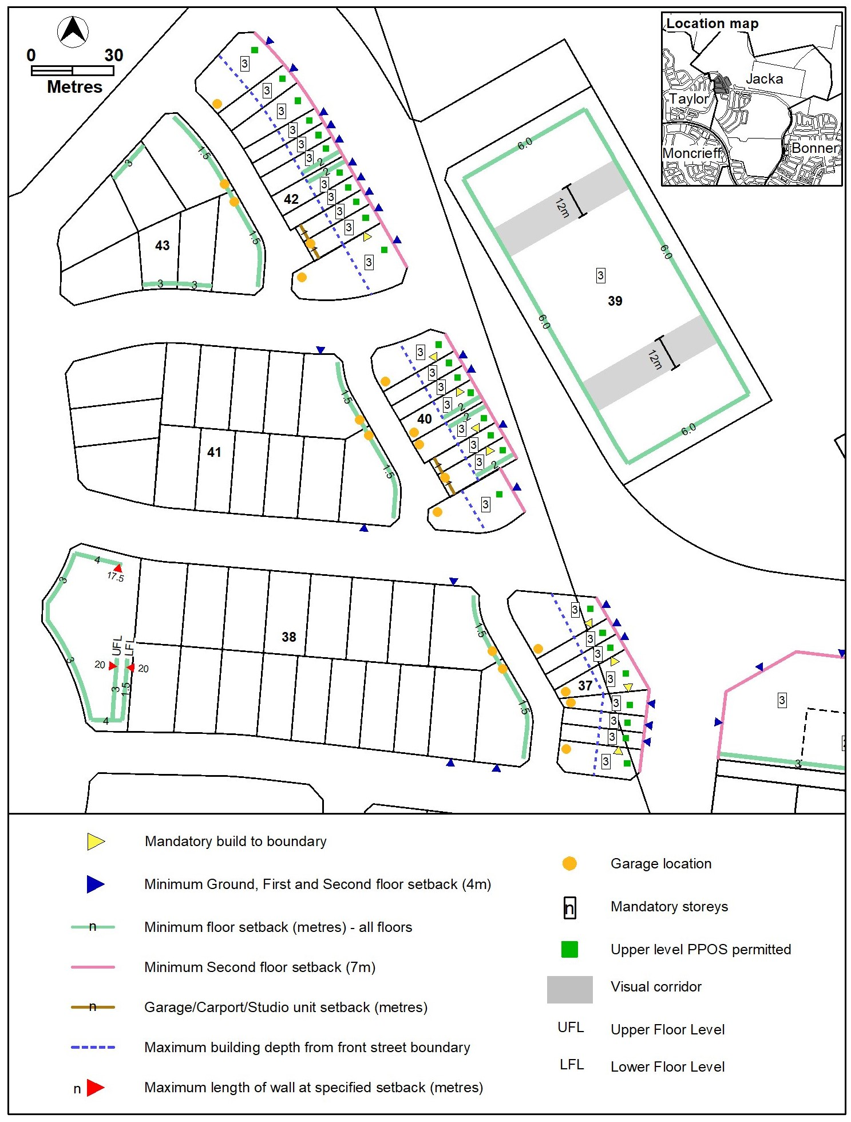
Minimum ground and first floor setback (4m)
Build to boundary

Figure 11 Jacka – Ongoing Provisions

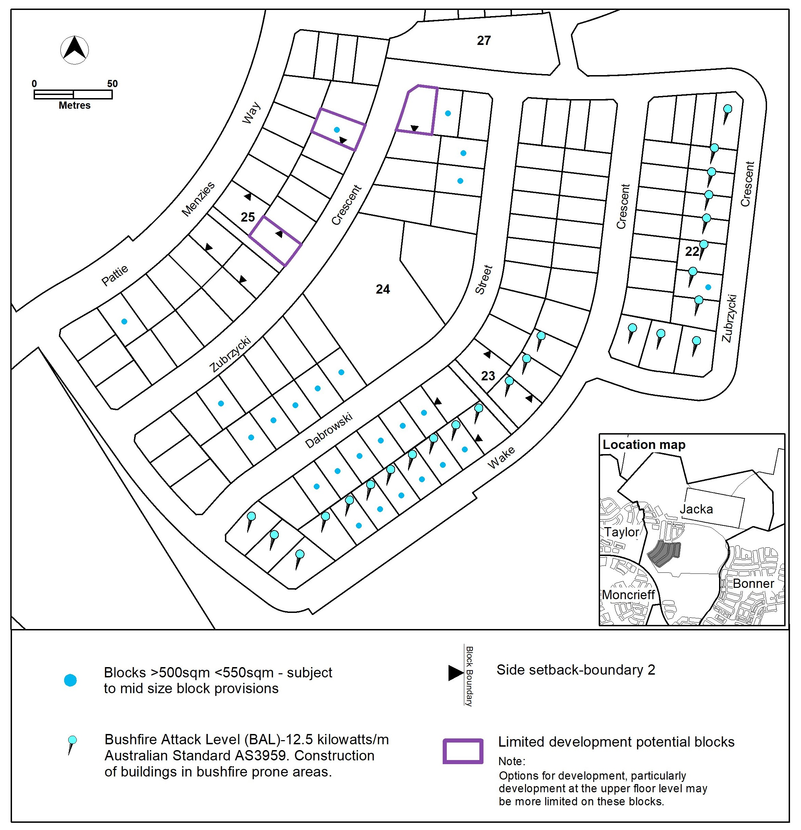

Figure 12 Jacka – Ongoing Provisions

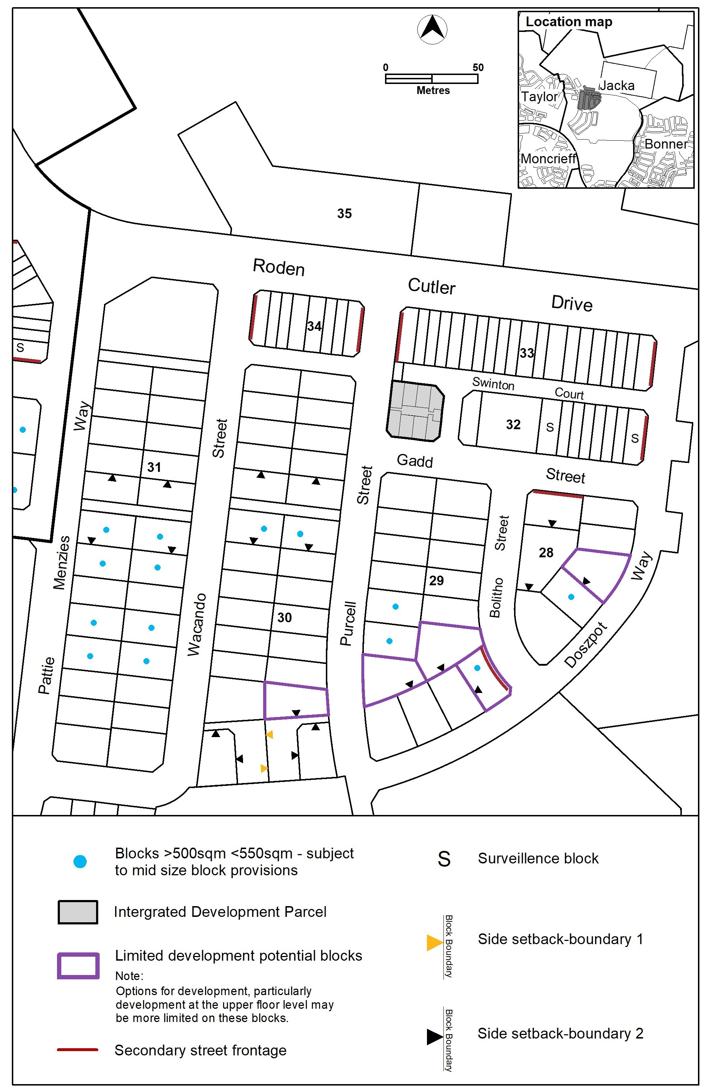

Figure 13 Jacka – Ongoing Provisions

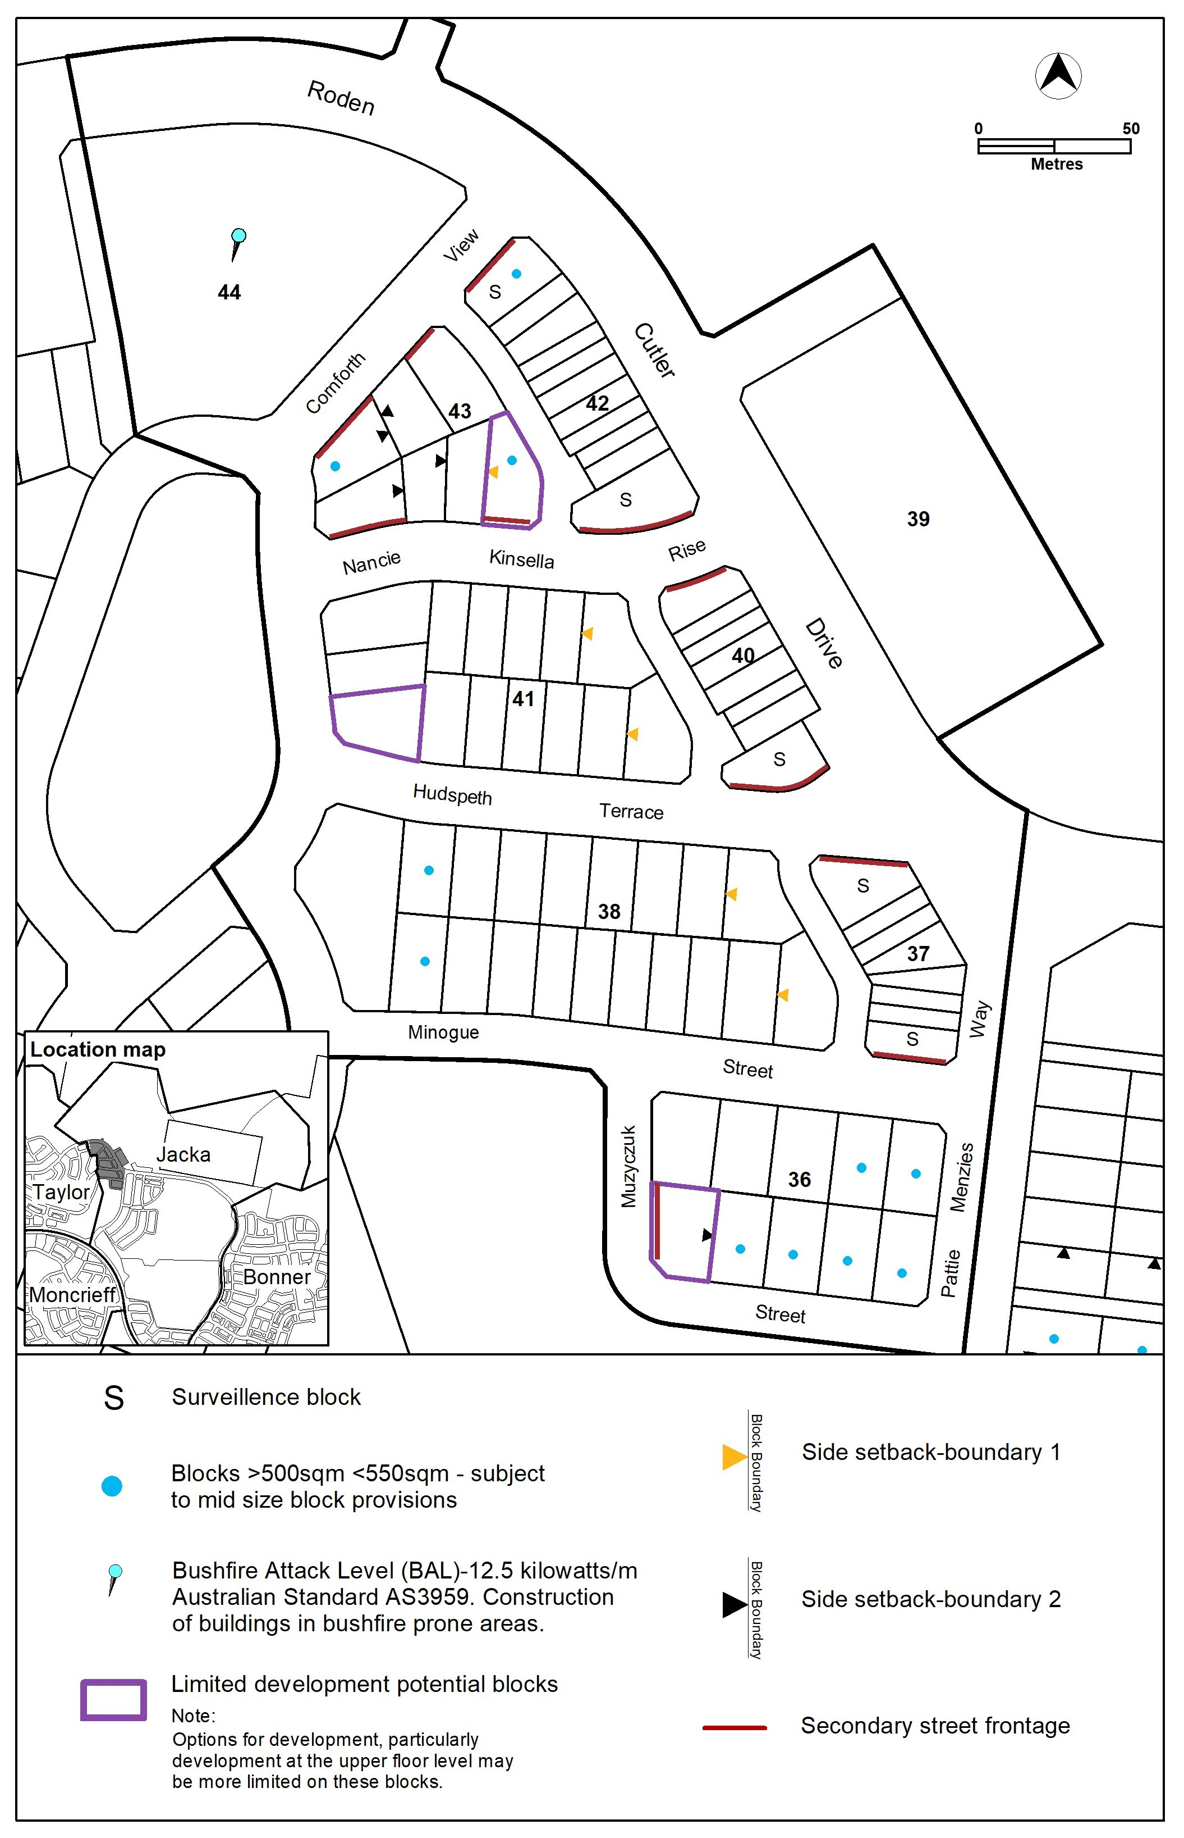

Kenny
The following specifications provide possible solutions that should be considered in planning, placing, designing and using buildings and structures for proposed development in Kenny:

No applicable specification for this suburb.

Mitchell
The following specifications provide possible solutions that should be considered in planning, placing, designing and using buildings and structures for proposed development in Mitchell:

No applicable specification for this suburb.

Moncrieff
The following specifications provide possible solutions that should be considered in planning, placing, designing and using buildings and structures for proposed development in Moncrieff:

No applicable specification for this suburb.

Nicholls
The following specifications provide possible solutions that should be considered in planning, placing, designing and using buildings and structures for proposed development in Nicholls:

No applicable specification for this suburb.

Ngunnawal
The following specifications provide possible solutions that should be considered in planning, placing, designing and using buildings and structures for proposed development in Ngunnawal:
No applicable specification for this suburb.

Palmerston
The following specifications provide possible solutions that should be considered in planning, placing, designing and using buildings and structures for proposed development in Palmerston:

No applicable specification for this suburb.

Taylor
The following specifications provide possible solutions that should be considered in planning, placing, designing and using buildings and structures for proposed development in Taylor:

Assessment Outcome: | Refer to zone assessment outcome
Specification
Gross floor area | - In accordance with Figure 22, the following gross floor area limits apply to section 51:  - Shop, excluding supermarket – 500m².  - Supermarket -200m².
Vehicle access | - No vehicle access is permitted to or from blocks as indicated in Figure 22.
Building height | - The maximum number of storeys is nominated in Figure 22.
Awning | - A 3m awning is required along active frontages as nominated in Figure 22.
Waste | - On blocks identified in Figure 15, waste will be collected within the property boundary.
Consolidation | - For blocks identified in Figure 16, Figure 17, Figure 18, Figure 19, Figure 20, and Figure 21, consolidation complies with all of the following:  - The consolidated block is to be used only for the purpose of supportive housing.  - Not more than 2 blocks are consolidated.  - All blocks proposed to be consolidated have adjoining street frontages.  - None of the blocks proposed to be consolidated has been previously  consolidated.  Note: This provision applies to consolidation of blocks in RZ1, one or more of which is a standard block, but does not apply to the consolidation of standard block with unleased territory land.
Principal private open space | - For blocks identified in Figure 16, Figure 17, Figure 18, Figure 19, Figure 20, and Figure 21, at least one area of principal private open space on the block complies with all of the following:  - Minimum area and dimensions specified in the table below.  - At ground level.  - Directly accessible from, and adjacent to, a habitable room other than a bedroom.  - Screened from adjoining public streets and public open space.  - Located behind the building line, except where enclosed by a courtyard wall.  - Is not located to the south, south-east or south-west of the dwelling, unless it achieves not less than 3 hours of direct sunlight onto 50% of the minimum principal private open space area between the hours of 9am and 3pm on the winter solstice (21 June).  Note: Overshadowing from vegetation is not considered when assessing solar access.  * For the purpose of this table, dwelling size is defined as the sum of all floor area measured to the outside face of externals walls including internal walls between the living areas and garage (but excluding the garage).
  Block type | Dwelling Size* | Minimum Area | Minimum Dimension
  Mid sized  Large | up to 105m² | 28m² | 4m
  Mid sized  Large | 105m² or greater | 36m² | 6m
Development provisions | - Development complies with the specifications identified in Figure 14 to Figure 31.

Figure 14 Taylor – Ongoing Provisions

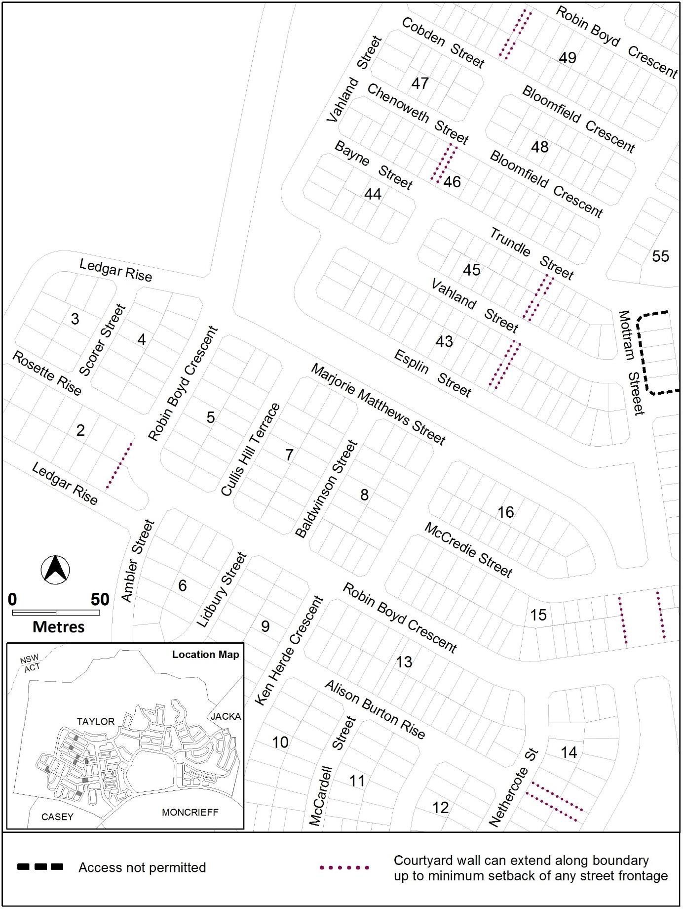

Figure 15 Taylor – Ongoing Provisions
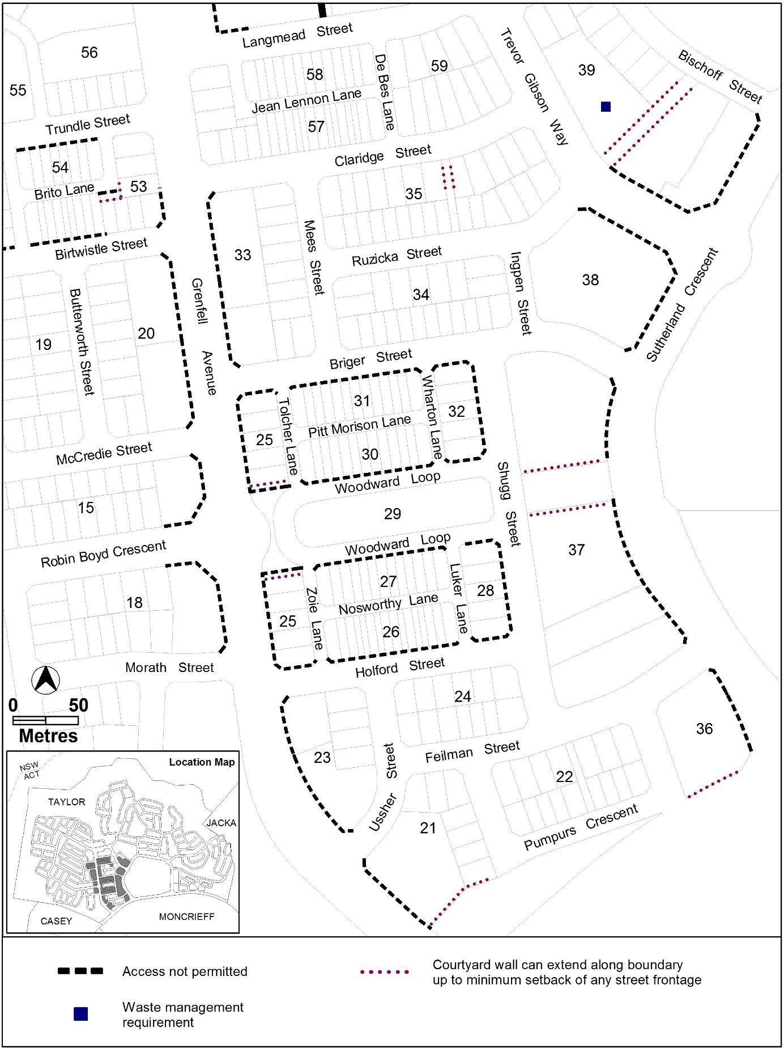

Figure 16 Taylor – Ongoing Provisions

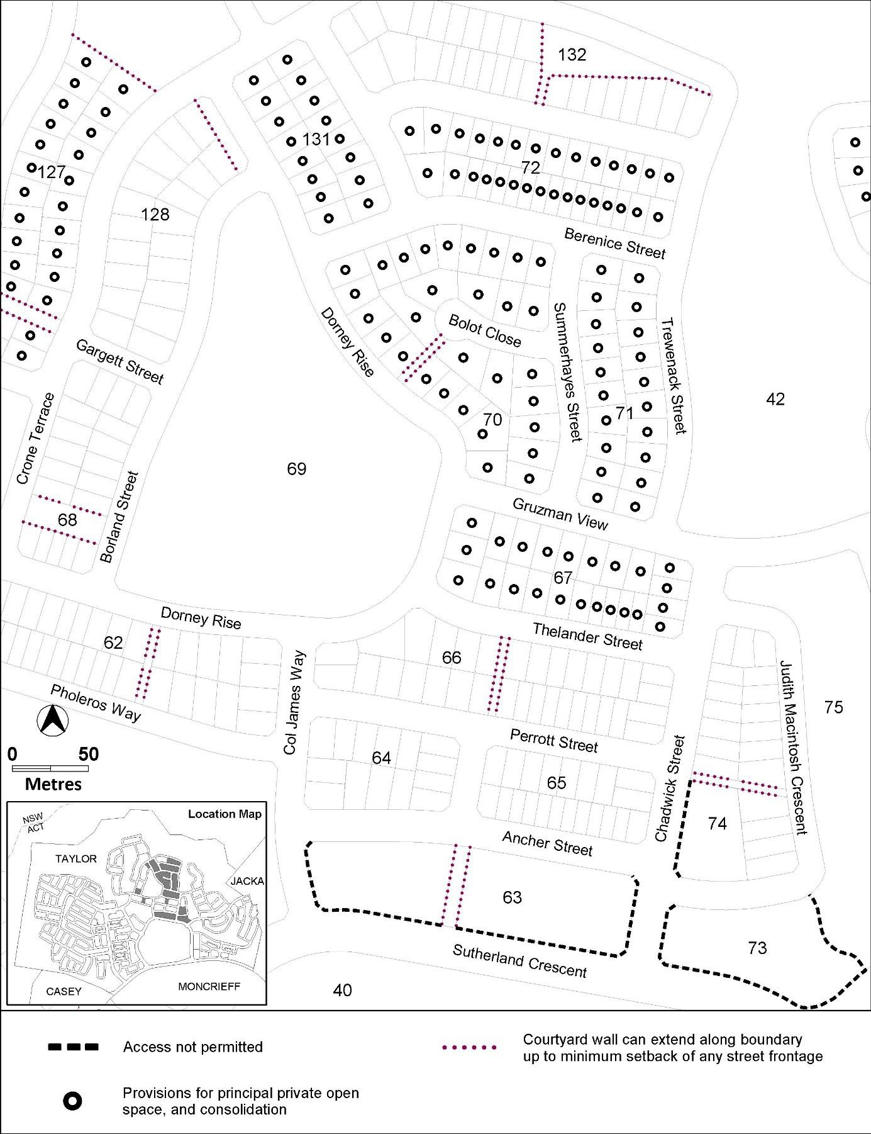

Figure 17 Taylor – Ongoing Provisions
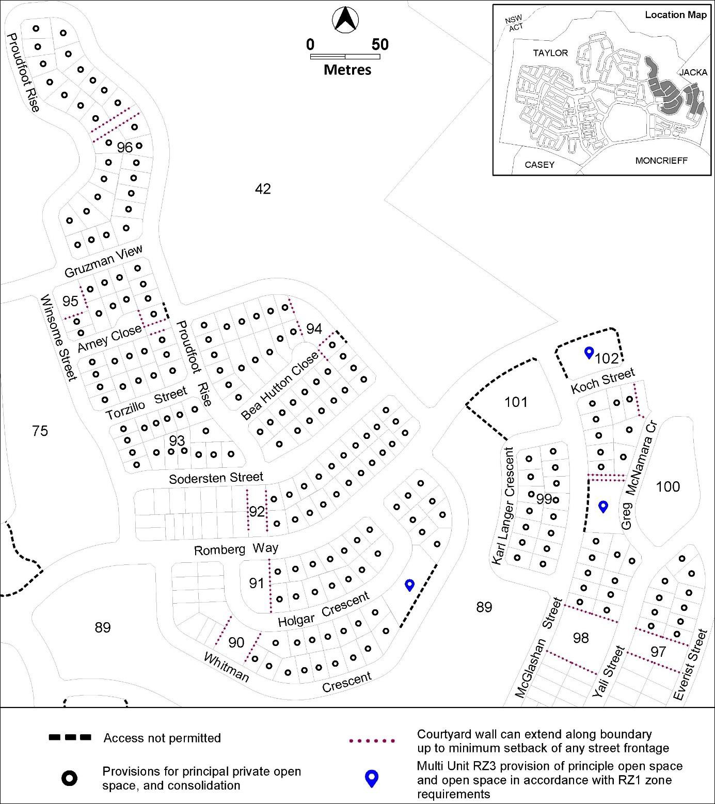

Figure 18 Taylor – Ongoing Provisions
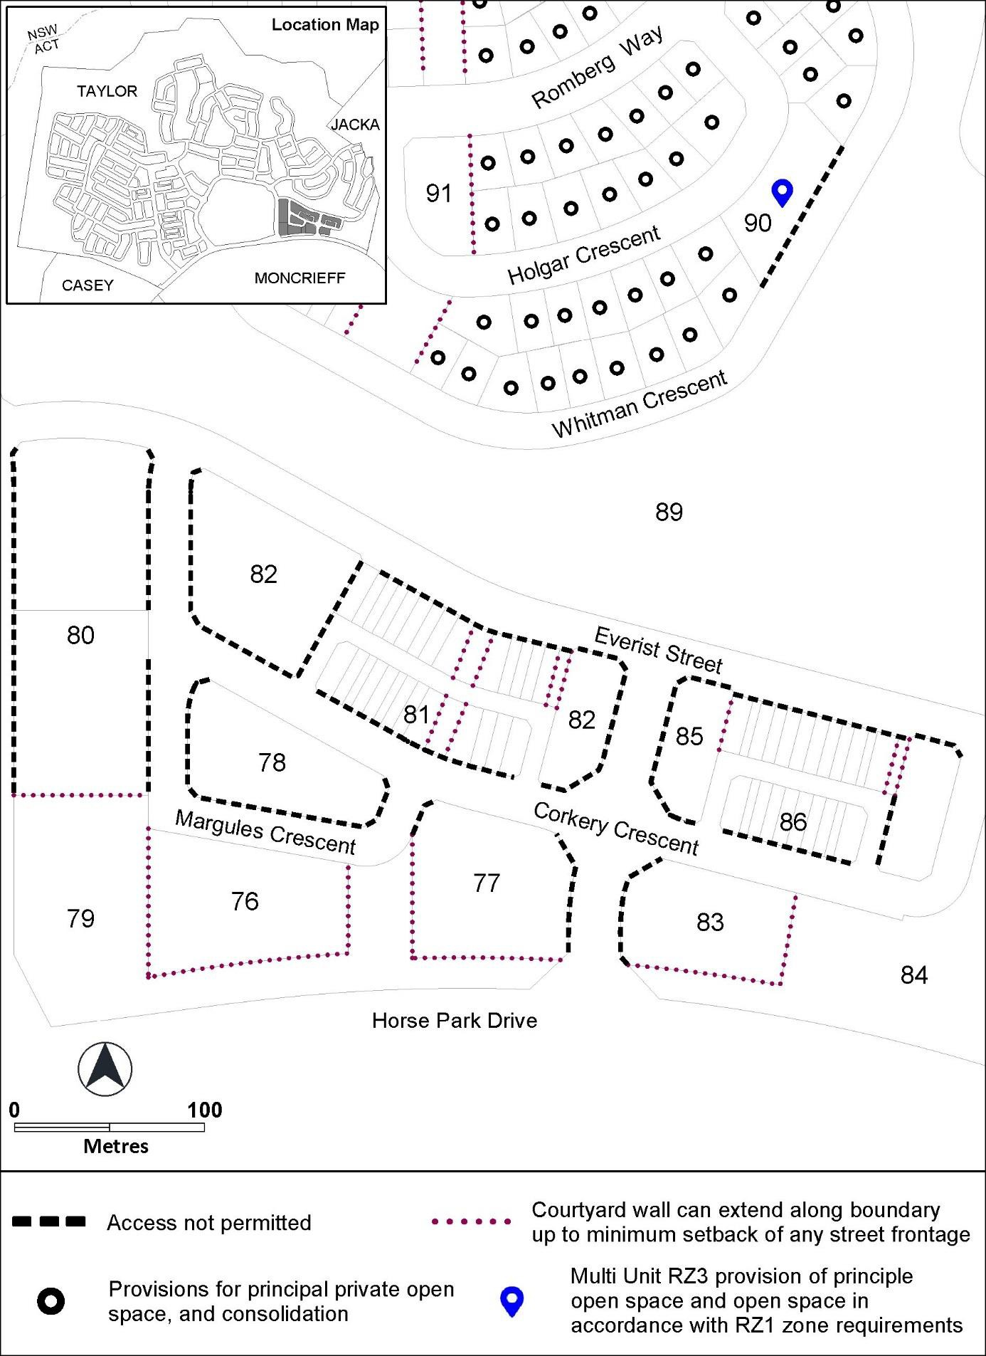

Figure 19 Taylor – Ongoing Provisions
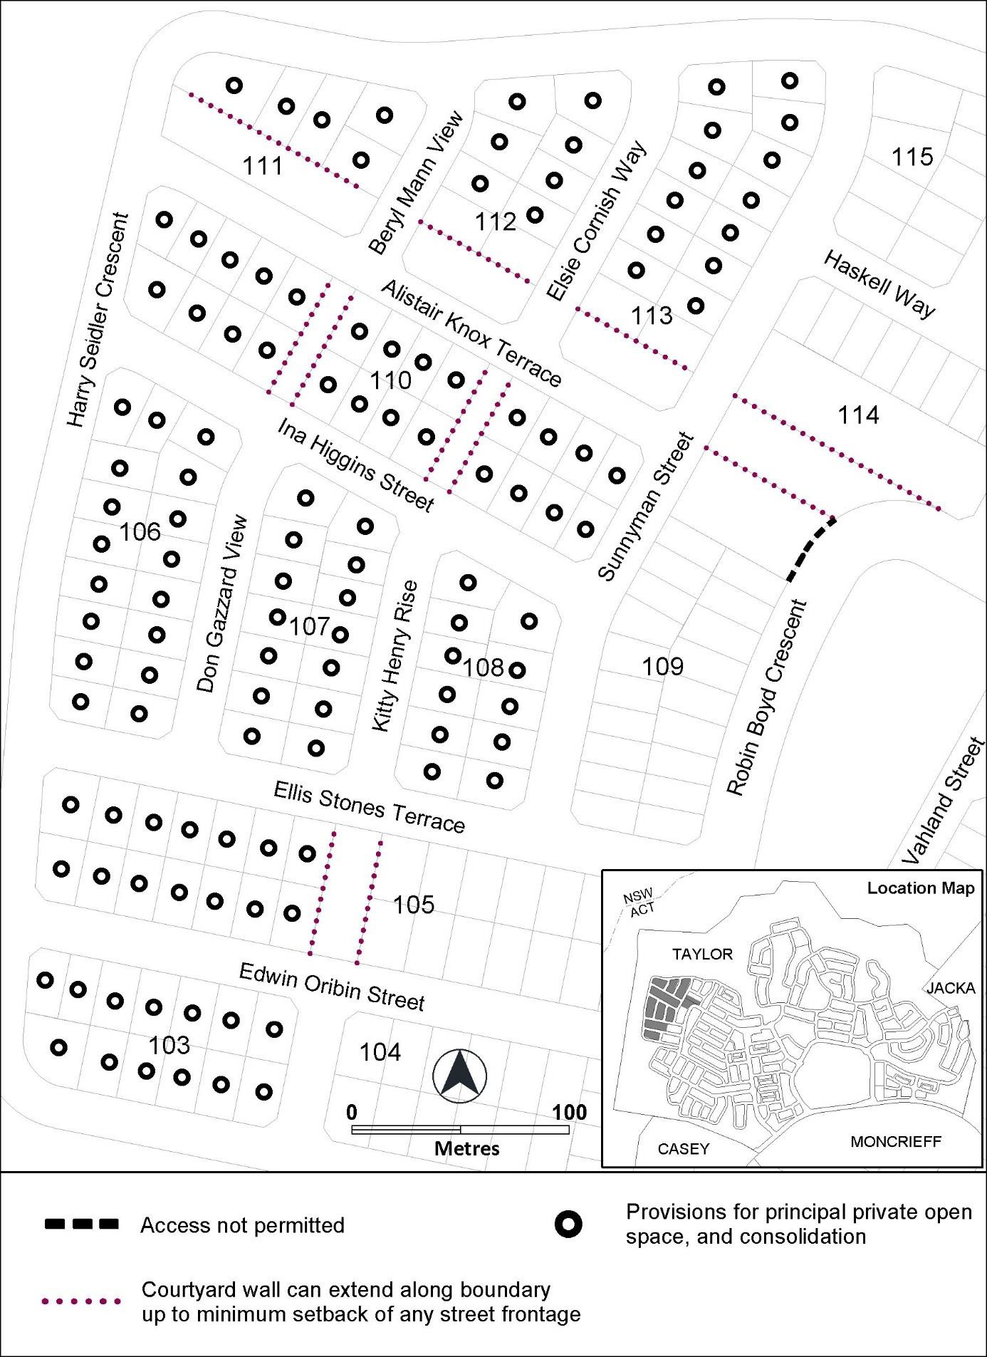

Figure 20 Taylor – Ongoing Provisions

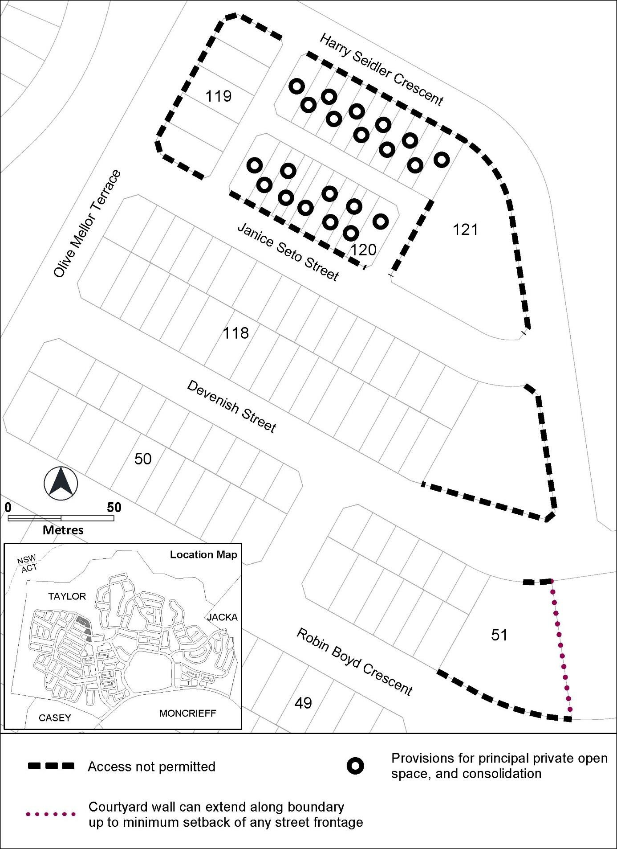

Figure 21 Taylor – Ongoing Provisions
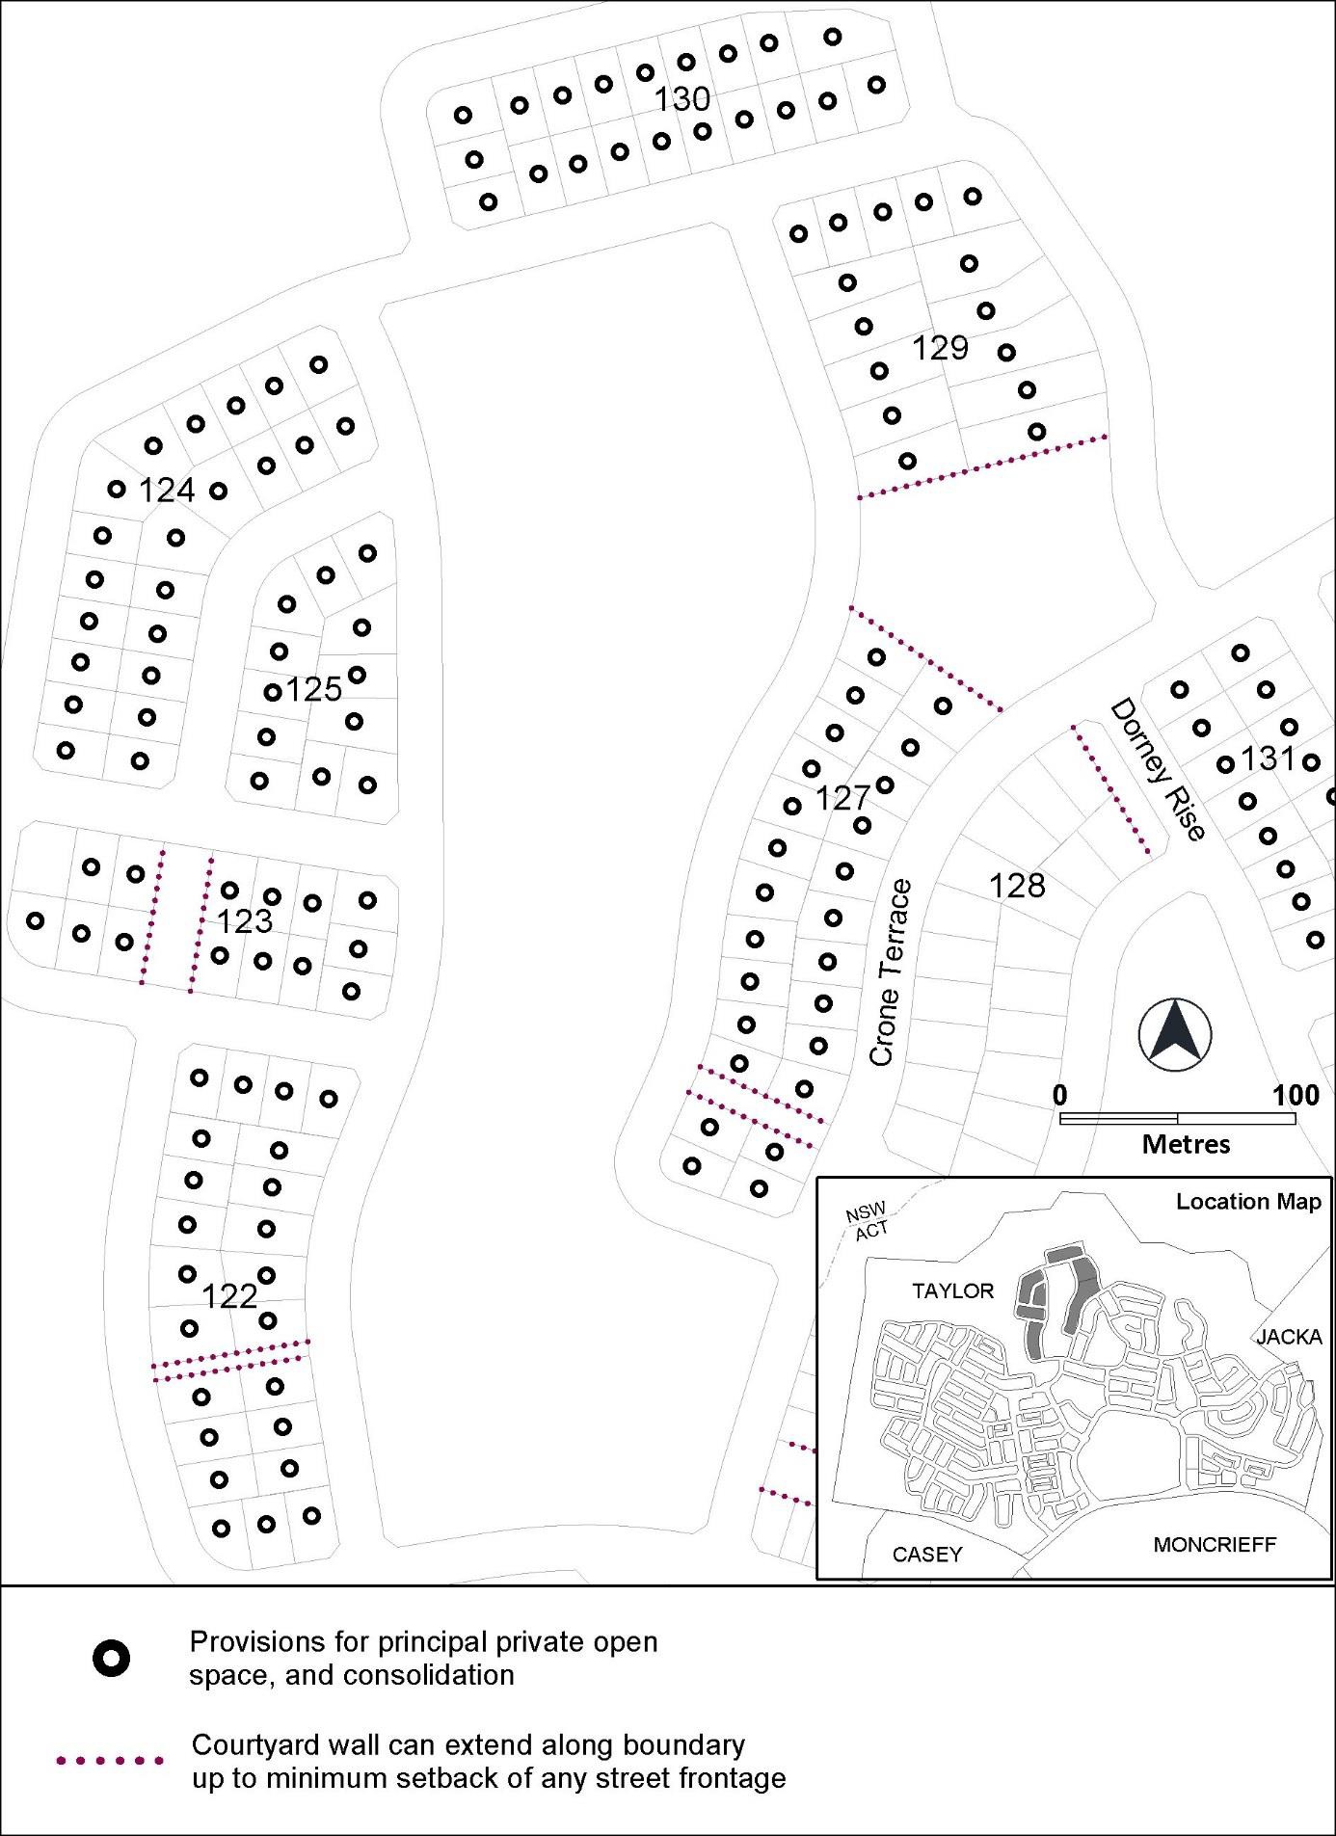

Figure 22 Taylor – Ongoing Provisions
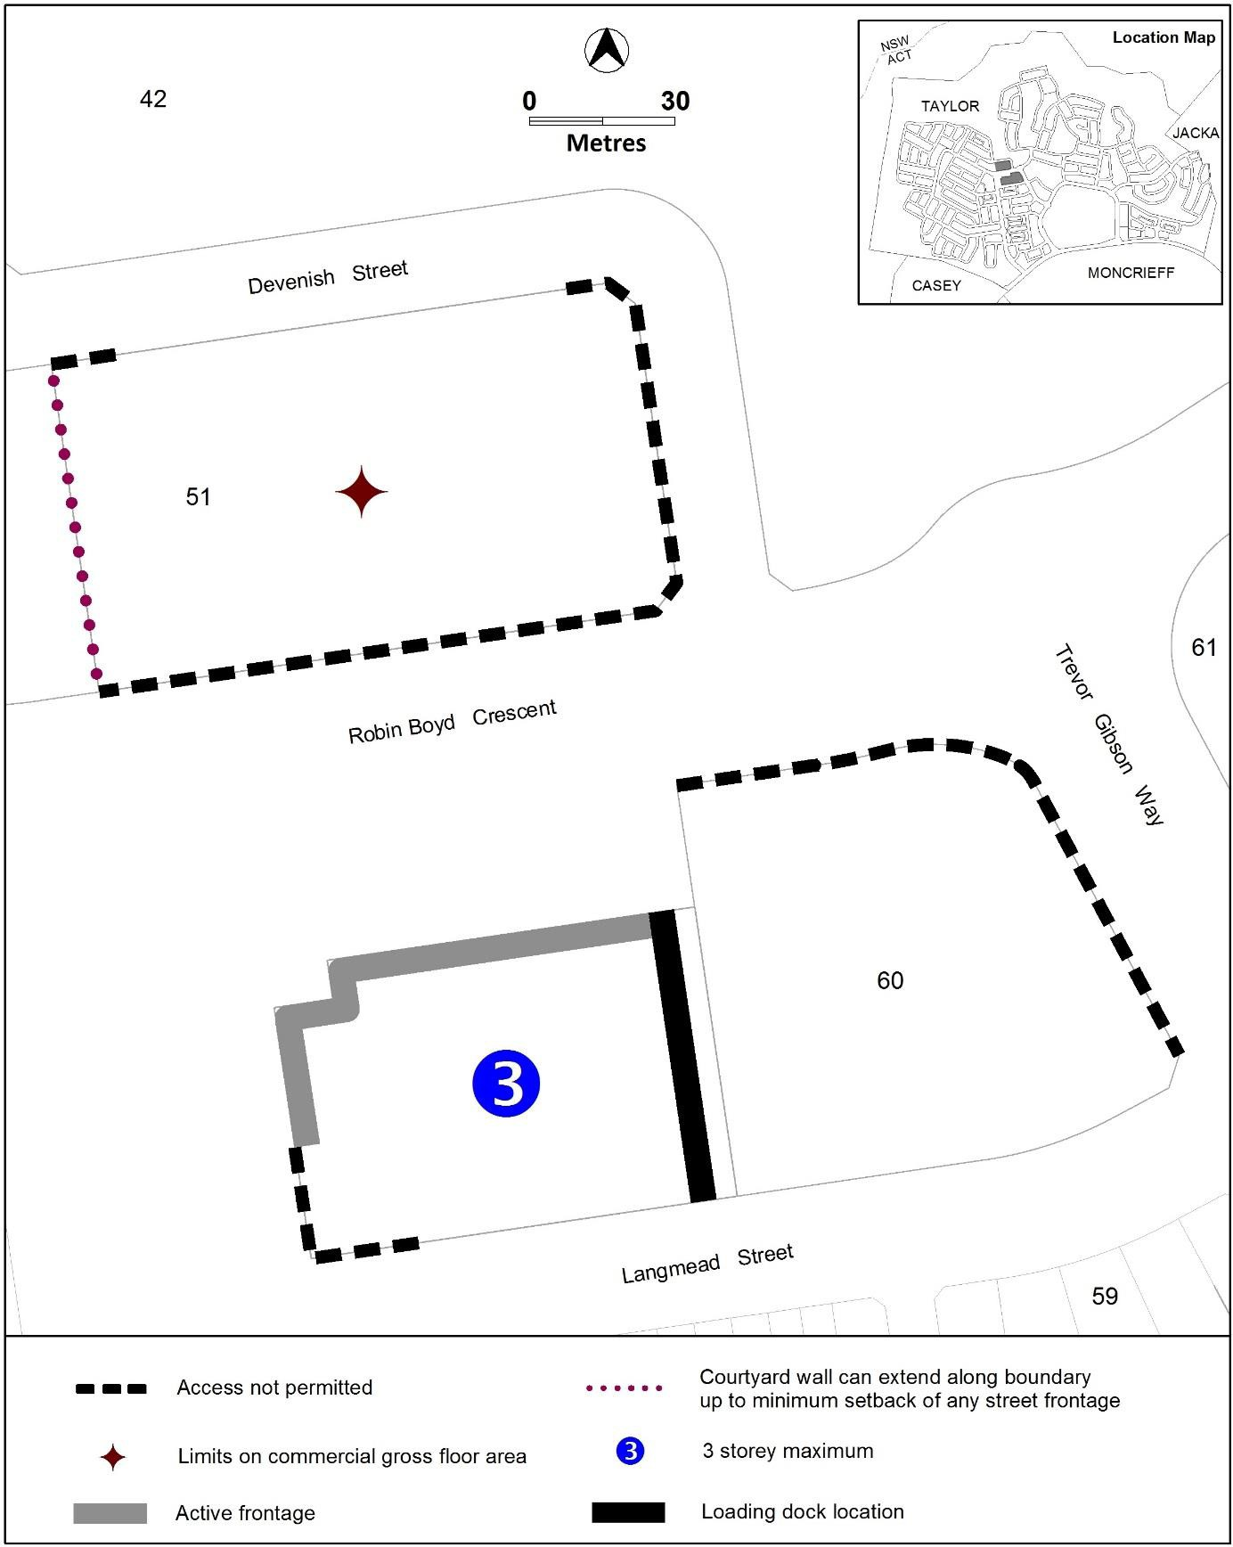

Figure 23 Taylor – Ongoing Provisions
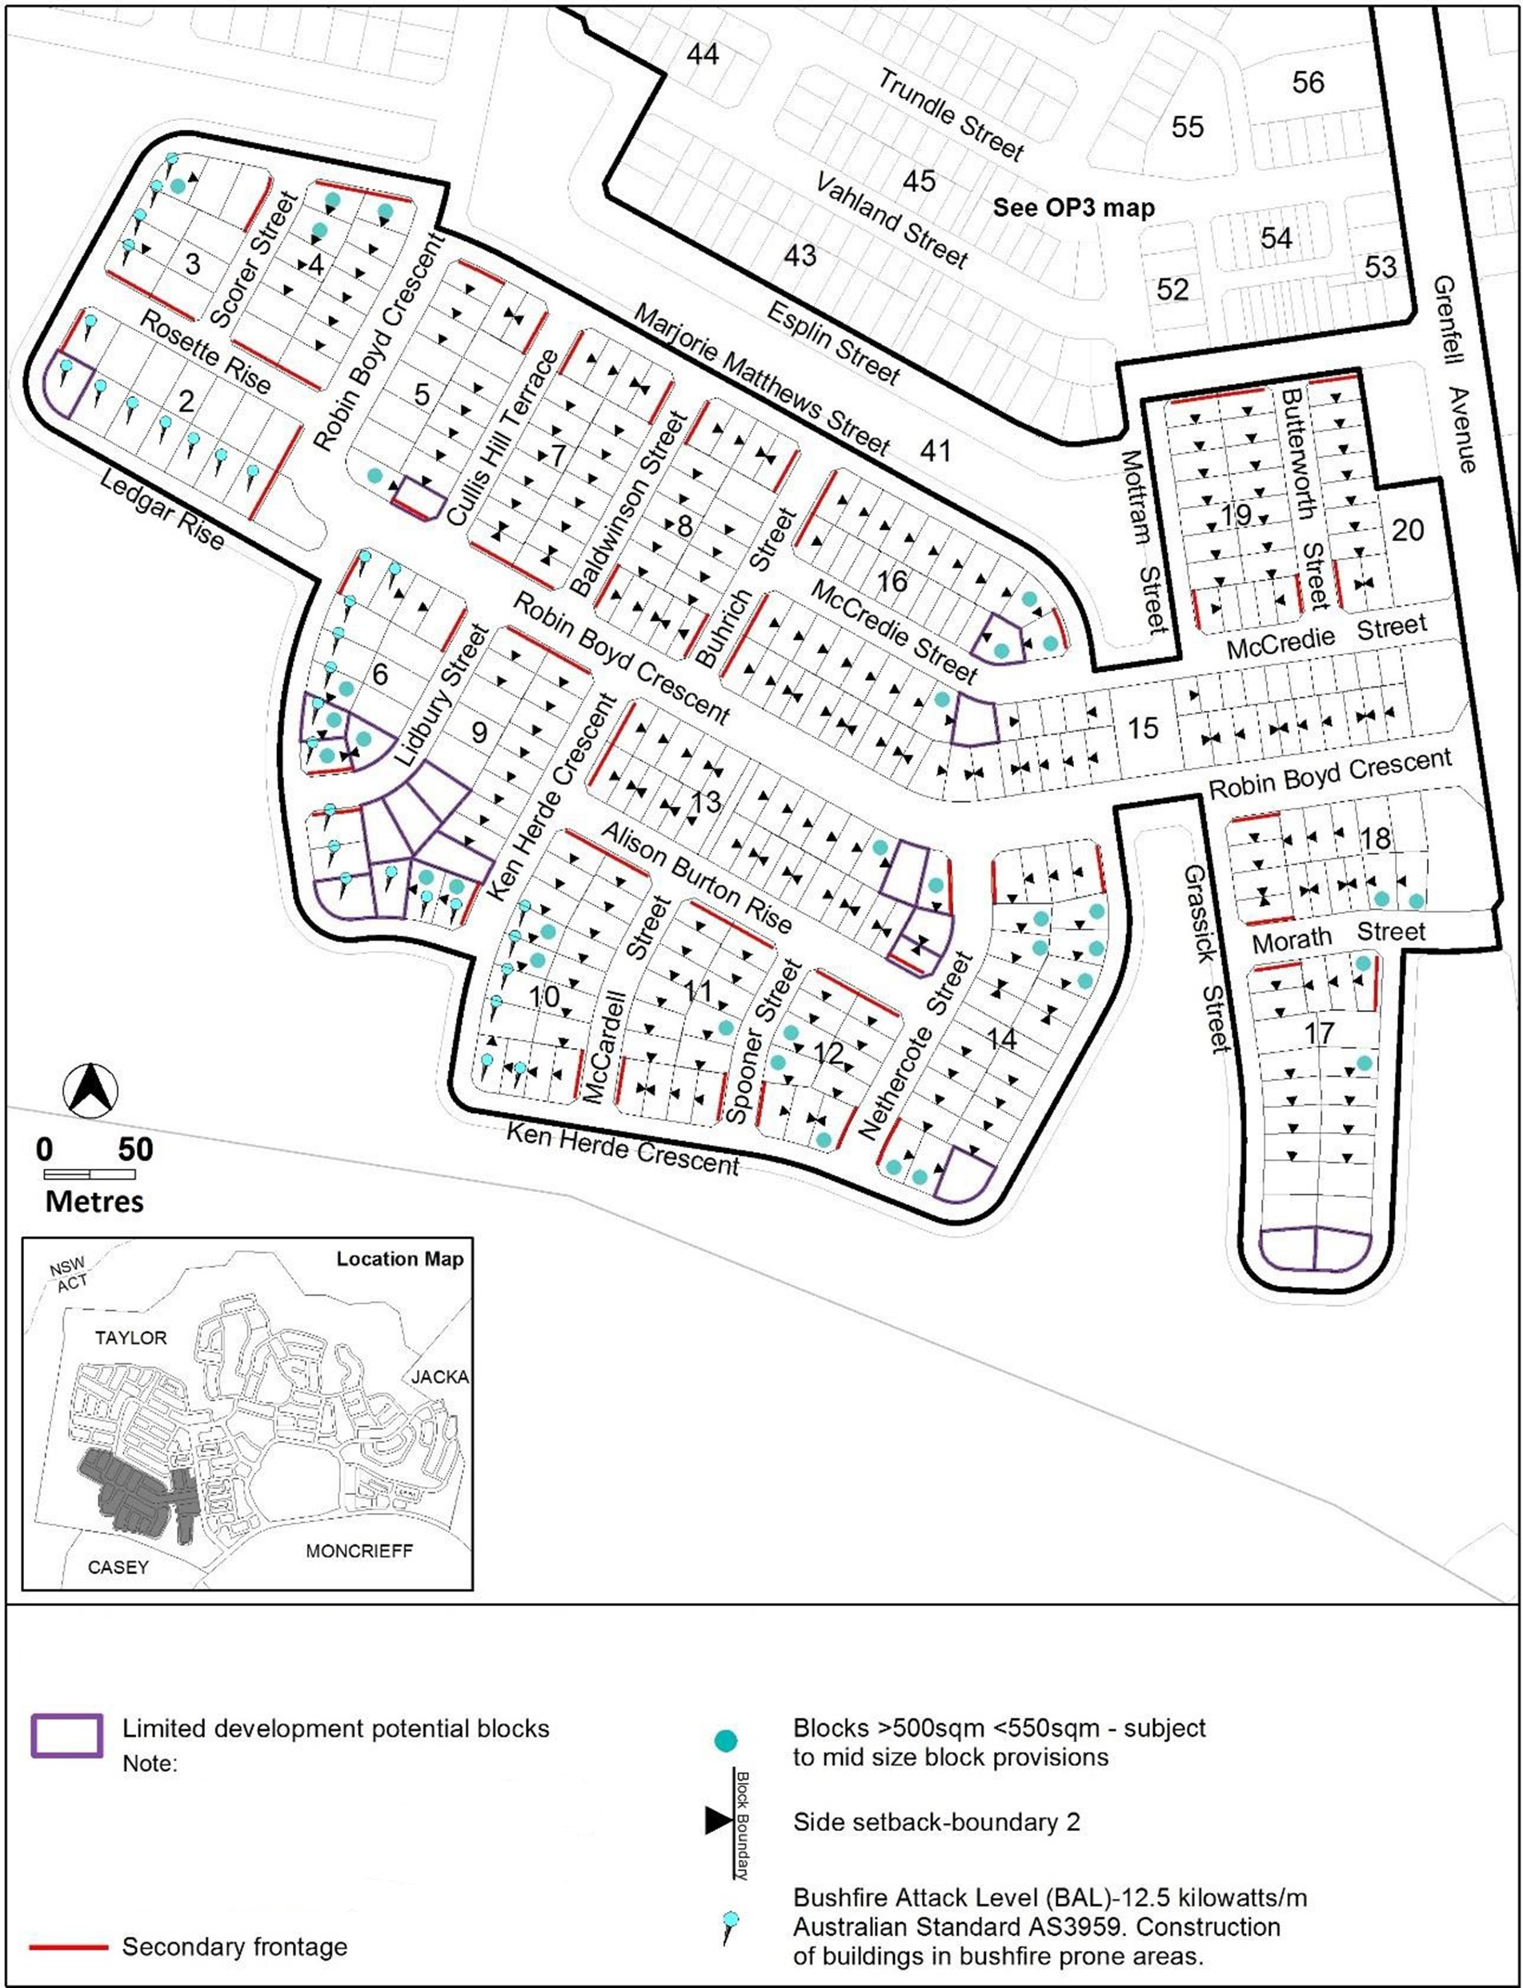
Options for development particularly development at the upper floor level may be more limited on these blocks.

Figure 24 Taylor – Ongoing Provisions
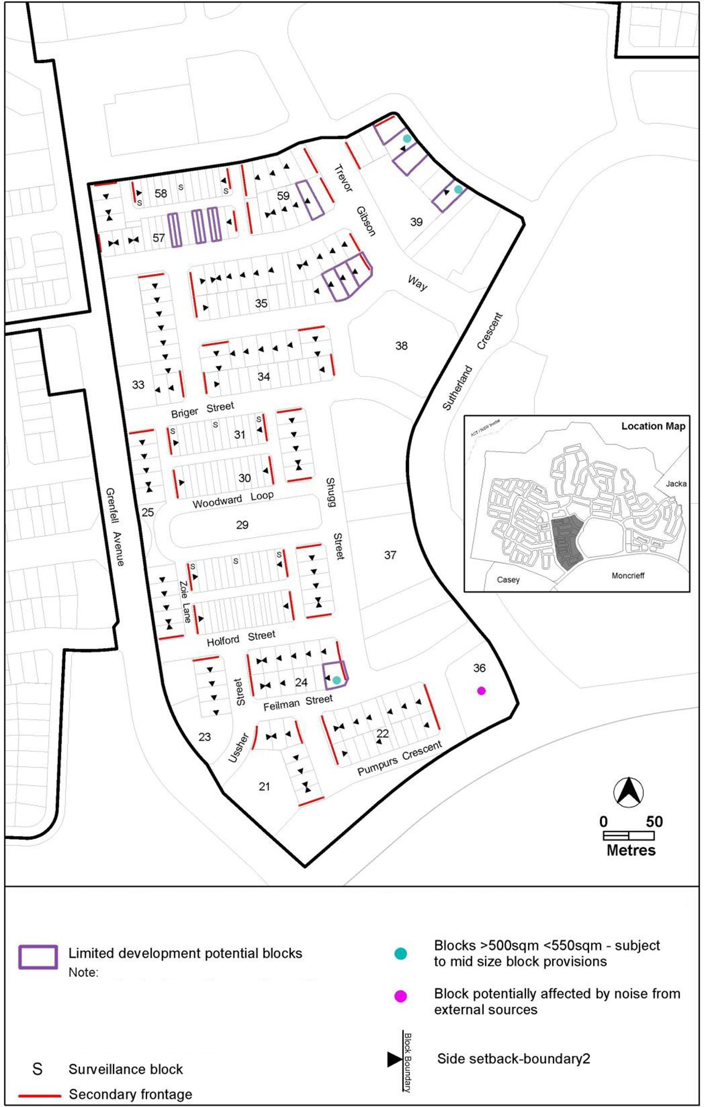
Options for development particularly development at the upper floor level may be more limited on these blocks.

Figure 25 Taylor – Ongoing Provisions
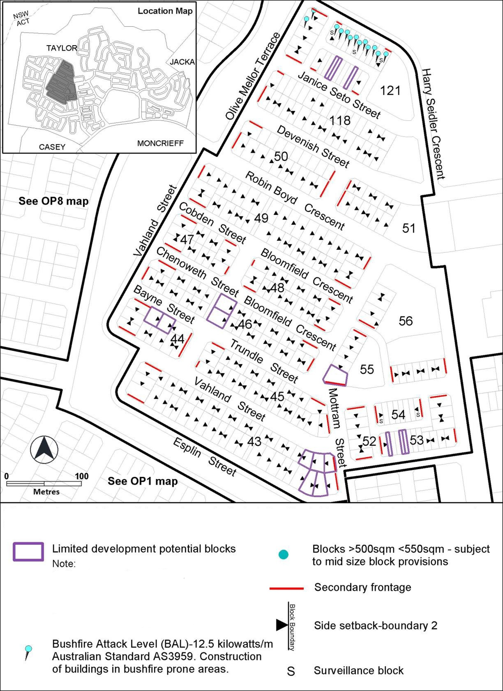
Options for development particularly development at the upper floor level may be more limited on these blocks.

Figure 26 Taylor – Ongoing Provisions
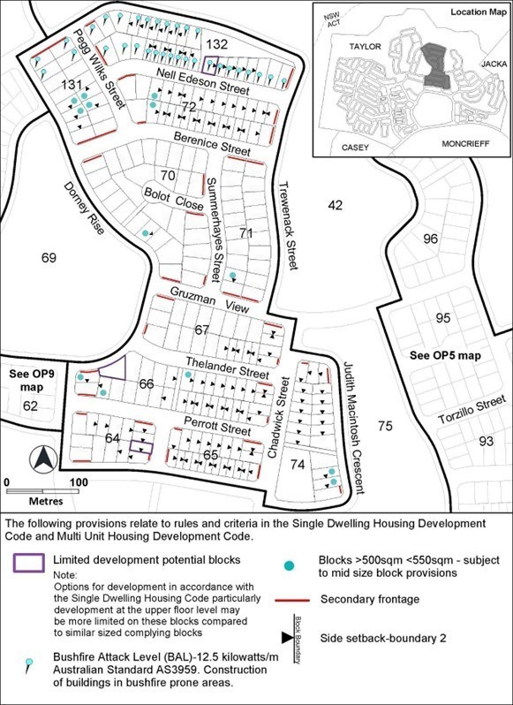

Options for development particularly development at the upper floor level may be more limited on these blocks.

Figure 27 Taylor – Ongoing Provisions
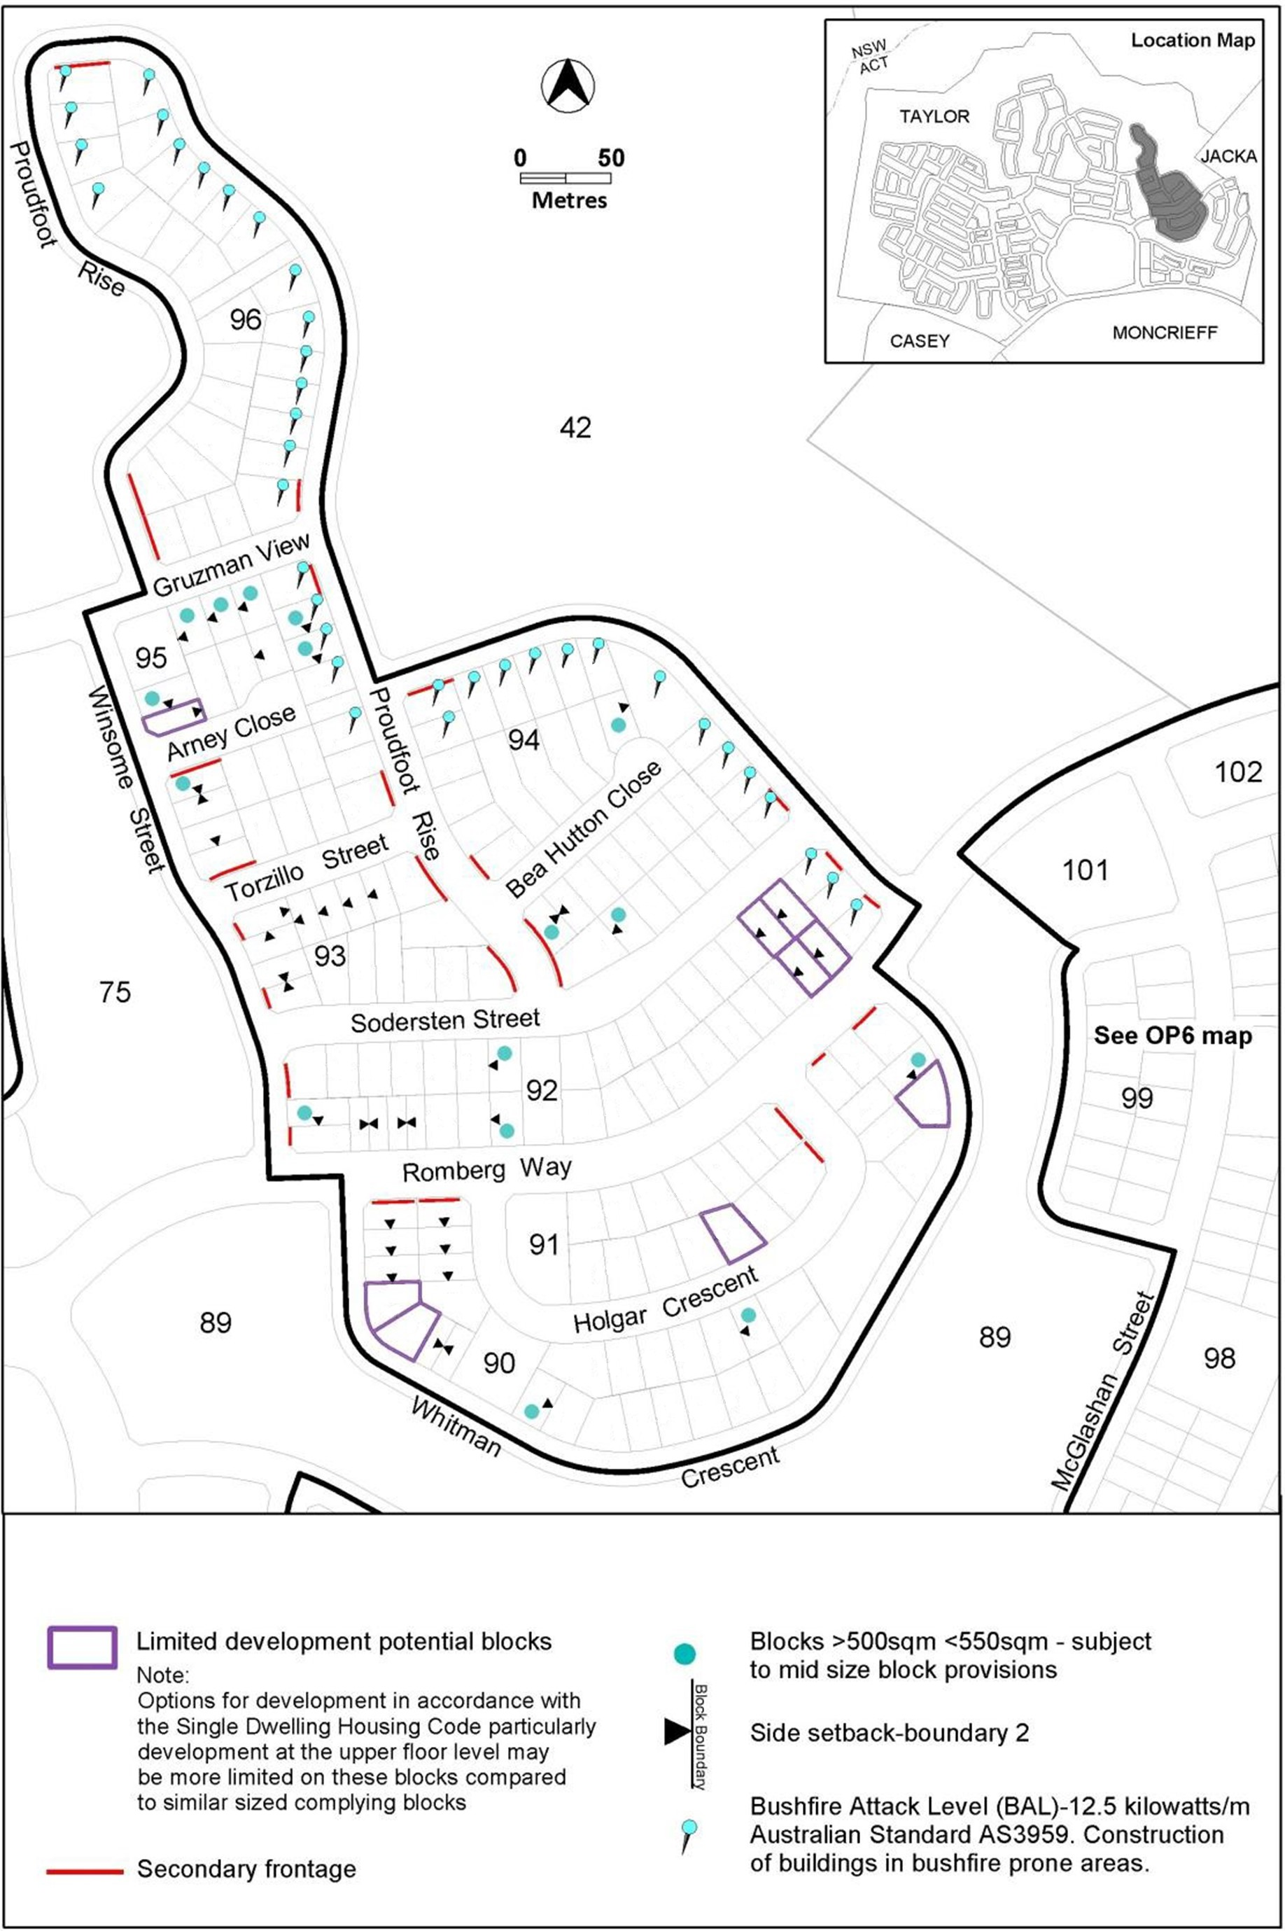

Figure 28 Taylor – Ongoing Provisions
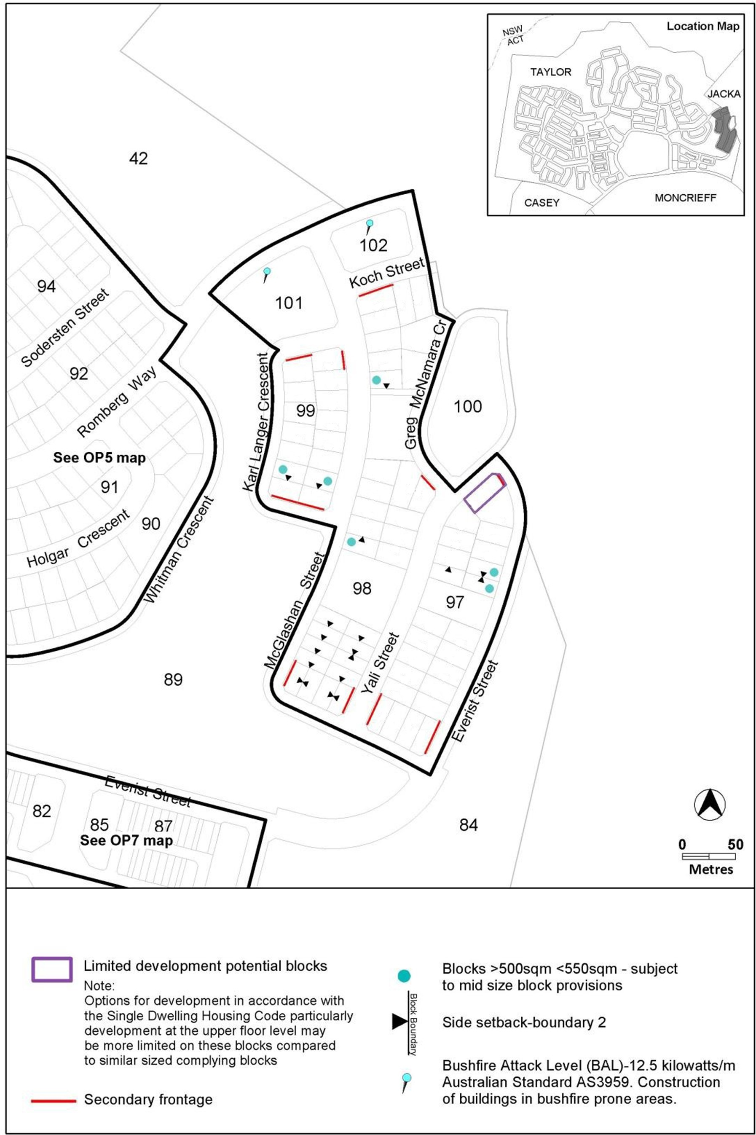
Options for development particularly development at the upper floor level may be more limited on these blocks.

Figure 29 Taylor – Ongoing Provisions
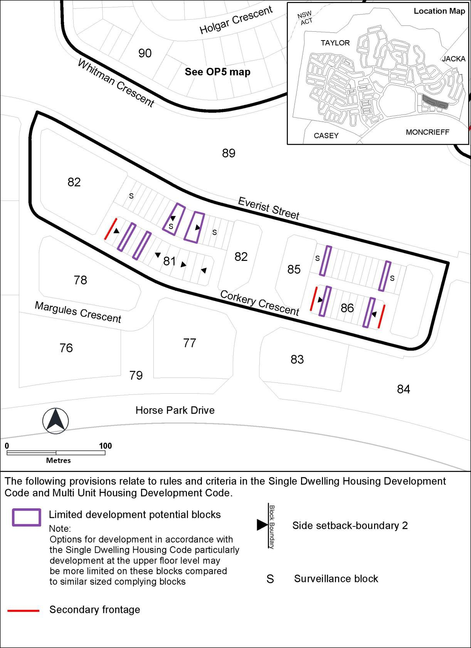
Options for development particularly development at the upper floor level may be more limited on these blocks.
[Grab your reader’s attention with a great quote from the document or use this space to emphasize a key point. To place this text box anywhere on the page, just drag it.]

Figure 30 Taylor – Ongoing Provisions
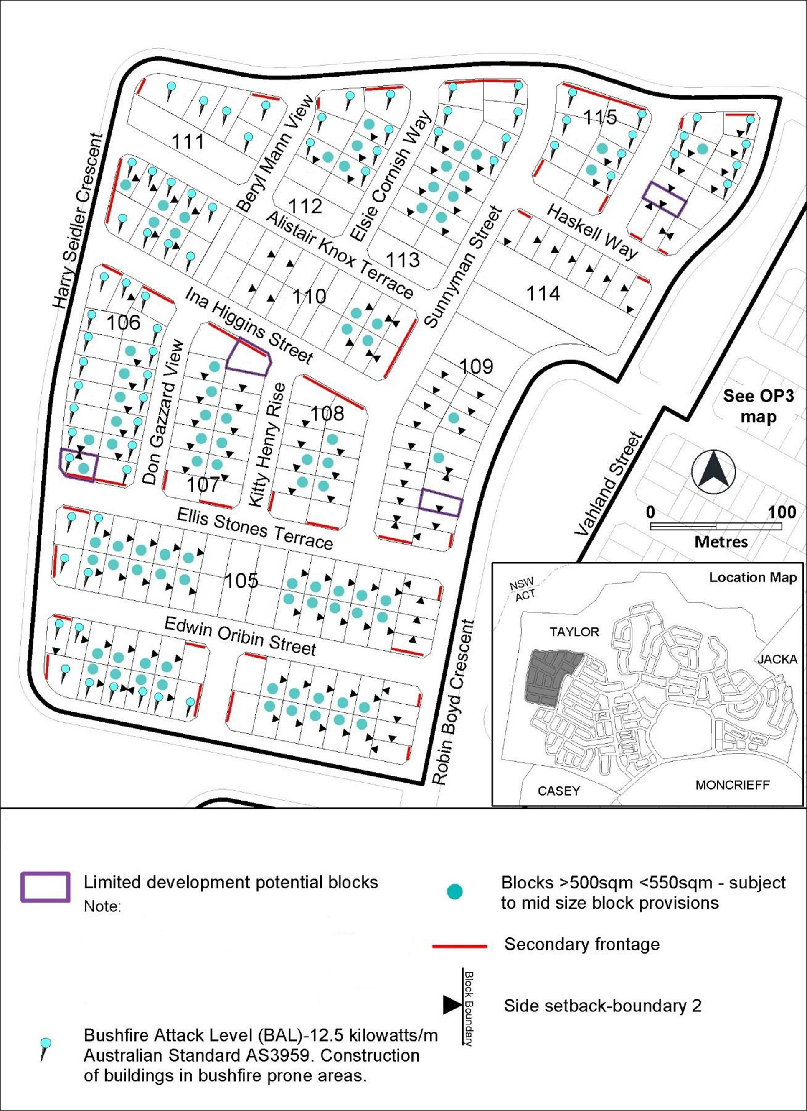
Options for development particularly development at the upper floor level may be more limited on these blocks.

Figure 31 Taylor – Ongoing Provisions
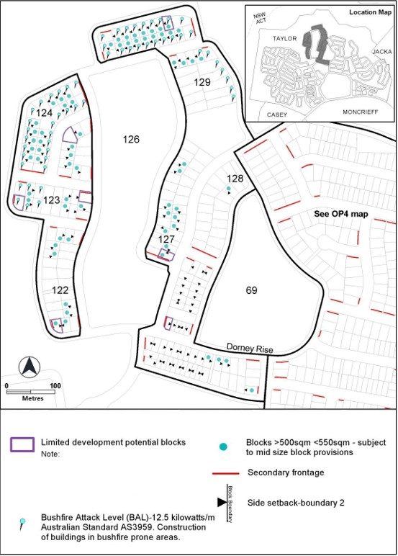
Options for development particularly development at the upper floor level may be more limited on these blocks.

Throsby
The following specifications provide possible solutions that should be considered in planning, placing, designing and using buildings and structures for proposed development in Throsby:

Figure 32 Throsby – Ongoing Provisions

