Australian Capital Territory
Heritage (Decision about Provisional Registration of Gungahlin Homestead, Crace) Notice 2026
Notifiable instrument NI2026-438
made under the
Heritage Act 2004, s 34 (Notice of decision about provisional registration)

1 Name of instrument
This instrument is the Heritage (Decision about Provisional Registration of Gungahlin Homestead, Crace) Notice 2026.
2 Commencement
This instrument commences on the day after its notification day.
3 Decision about provisional registration
On 23 September 2026, the ACT Heritage Council (the council) decided to provisionally register Gungahlin Homestead, Block 348, Section 0, Crace (the place).
4 Description of the place
The provisional registration details of the place are in schedule 1.
5 Reasons for the decision
The council decided to provisionally register the place as it is satisfied on reasonable grounds that the place is likely to have heritage significance as defined by section 10 of the Heritage Act 2004 (the Act). A detailed statement of reasons, including an assessment against the heritage significance criteria, is provided in schedule 1.
6 Date provisional registration takes effect
The provisional registration of the place takes effect on the day the council enters into the register the details of the place, and an indication that the registration is provisional.
7 Indication of the council’s intention
The council intends to decide whether to register the place under the Act, division 6.2 during the period of provisional registration.
8 Invitation to make written comments during public consultation period
(1) The council invites written comments about the registration of the place. Any written comments must be made within 4 weeks after the day this notice is notified.
(2) Written comments can be provided to the council by the following methods:
(a) mail to
The Secretary
ACT Heritage Council
480 Northbourne Avenue
DICKSON ACT 2602
(b) email to heritage.registrations@act.gov.au
Dr Mary Clare Swete Kelly
Secretary (as delegate for)
ACT Heritage Council
24 September 2026

Schedule 1

(See sections 4 and 5)


AUSTRALIAN CAPITAL TERRITORY
HERITAGE REGISTER
Provisional registration
For the purposes of s 33 of the Heritage Act 2004, a provisional entry to the heritage register has been prepared by the ACT Heritage Council for the following place:

GUNGAHLIN HOMESTEAD
BLOCK 348 AND SECTION 0, CRACE
DATE OF DECISION
23 September 2026
DATE OF PROVISIONAL REGISTRATION
The day after the notice is notified on the Legislation Register.
PERIOD OF EFFECT OF PROVISIONAL REGISTRATION
5 months commencing on the day after the notice is notified.
Extended Period (if applicable) Start Date ________ End Date ________
Copies of the Register Entry are available for inspection at ACT Heritage. For further information please contact:
The Secretary
ACT Heritage Council
GPO Box 158
CANBERRA ACT 2601
Telephone 13 22 81

Preamble
Gungahlin Homestead is located on lands that the Ngunnawal and other First Nations peoples have had connections to for many thousands of years. The name ‘Gungahlin’ is derived from the Ngunnawal language and is understood to mean ‘white man's house,’ describing the European homestead constructed at the site in the 19th century.
Following the transformation of the landscape into a rural pastoral property, the connections of Ngunnawal and other First Nations peoples to this place continued throughout the site's history. One notable example is the contribution of local Aboriginal men Bobby Deumonga, Johnny Taylor and Jimmy Taylor to the success of the Ginninderra Cricket Team between 1850-1870, which was based at the homestead.
Ngunnawal and other First Nations people continue to care for Country and maintain cultural connections throughout the ACT today, including to the lands on which Gungahlin Homestead is located.
Gungahlin Homestead was listed on the Commonwealth Heritage List in 2004 for its connection to the CSIRO, which occupied the site from 1953 to 2015 as a research centre, carrying out pioneering environmental and ecological research at the site for over 70 years.
In December 2025, its National Land status was revoked, and it was removed from the Commonwealth Heritage List. Under the terms of the National Land revocation, the property was nominated to the ACT Heritage Register.
The site is now privately owned and managed.

Statement of heritage significance
This statement refers to the heritage significance of the place as required by s 12(d) of the Heritage Act 2004 (the Heritage Act).
The Gungahlin Homestead complex is a distinctive example of a mid-late 19th century grazier’s residence on a former rural property. It is significant to the ACT for its associations with 19th century pastoralism and with Federation, providing insights into pastoral life on the Limestone Plains prior to the establishment of Canberra. It is a now-rare example of 19th century country estates of the pre-Canberra rural district and exemplifies key Georgian and Victorian architectural styles applied to rural living. Potential archaeological resources associated with the homestead complex may provide further physical evidence of its development and occupation, and a tangible connection to this chapter of its history.
Gungahlin Homestead is also significant for its connection to the Davis and Crace families, notable contributors to life on the Limestone Plains prior to the establishment of the Australian Capital Territory.
The homestead consists of a residence built in 2 main stages situated on the highest point of a terraced landscape, as well as an historic dam, servants’ quarters, coach house, laundry, and remnants of a carriageway and arrival loop, and areas of archaeological potential associated with the historical occupation and operation of the homestead complex. The terraces have been altered and no longer contain the original gardens, however they remain clearly visible indicating the historic morphology of the homestead complex. The paddocks surrounding the homestead are associated with the earlier home farm. The tree-lined driveway, once impressive and reflecting the prosperity of the rural period, added a sense of arrival along the driveway with the homestead prominently visible.
The first stage of the homestead was completed in 1865. The main house is a 2-storey late Georgian style rendered masonry residence. The surviving outbuildings, including a laundry, coach house, servants’ quarters and cellar, also date to the 1860s. A large Victorian addition in rough-faced sandstone was completed in 1883 by noted architect John Gregory and Crace, and transformed the homestead complex into a rural mansion with a carriageway and arrival loop. A dam and pond with a windmill pump and gear to supply the house with water was also added as part of this extension.

Location of the place
This statement refers to the name and location of the place as required by ss 12 (a) and (b) of the Heritage Act.
Gungahlin Homestead, Block 348, Section 0, 80 Bellenden Street, Crace.

Description of the place
This statement refers to the description of the place as required by s 12(c) of the Heritage Act. The attributes described in this section form part of the heritage significance of the place. For the purposes of s 12(c) of the Heritage Act, the provisional registration boundary of the place is at Figure 1.
Gungahlin Homestead, also previously known as ‘Goongarline’ or ‘Gungarline’, is a grazier’s residence on a formal rural property located 10 kilometres north of the Canberra city centre. It is set back from the Barton Highway and occupies the highest point of a 35.6-hectare site.
The homestead is an exceptional example of a mid-late 19th century grazier’s residence and was built in 2 stages. The first stage, completed in 1865, is a 2-storey rendered masonry main residence that was commissioned by William Davis Junior. The surviving outbuildings, laundry, coach house, servants’ quarters, and cellar, also date to the 1860s. A large addition in rough-faced sandstone was completed in 1883 for Edward Crace. These stages show different approaches of rural living; the Davis Family were overseers, whilst the Crace family were landed gentry.
The oldest section of the house is the northern section, with its 2-storey rendered masonry exterior. The front door is located off the verandah to the west. Upon entering, the cedar stairs to the first floor are to the right and the dining room ahead. East of the dining room is a school room, then the kitchen. These rooms formed the nucleus of the plan which was later extended.
The most prominent component of the exterior is the 1883 addition to the south of the house, which dominates the original wing in scale and mass. This section of the house also features a dramatic pair of bay windows on the southern facade. With the new addition in place, the formal entry was moved to a lobby on the addition's far western side. A paned window is centred over the arched, double leaf front door. From the lobby, access to the house is through a long hall running eastward, featuring an ornamental wooden staircase. South of this hallway is a drawing room and a dining room. Further to the east is a back hall, pantry, storage and toilet.
Access to the property is from the east via a picturesque tree-lined driveway, edged in local stone, ending in a turning circle, both of which are extant. The original carriage loop, still discernible through tree plantings and stone edging, was compromised when a new building was cut into the southern side several decades ago. The line of the loop is still visible. The loss of some of the older trees has created a more open character than the original, which contained an intimate setting.
The homestead sits on the highest point of a terraced landscape which is typical of a homestead complex of the period. These ascending terraces would have historically housed the gardens and the lesser outbuildings. Currently these stepped terraces are where the later CSIRO buildings have been sited with minor modifications. However, this historical manipulation of sloping land is still evident in the topography surrounding the main homestead.
The homestead also features a dam which is over 100 years old, located approximately 150 metres west of the residence.
During the period of CSIRO tenure from 1953 onwards, a number of administrative and research buildings were constructed on the site, primarily clustered around the homestead to the north, east, and south. As a result, the historic homestead is partially enclosed by later development, contributing to an institutional character that contrasts with its former rural setting.
During the CSIRO tenure Gungahlin Homestead had no masterplan, as such the site demonstrates activities, features and characteristics considered typical of institutional research and development facilities of the second half of the 20th century.
Within the context of the pre-Australian Capital Territory landscape, Gungahlin Homestead is one of several large country mansions constructed in the region during the 19th century which retains integrity of fabric and architectural character.
The Gungahlin Homestead complex is important in demonstrating the principal characteristics of a 19th century grazier’s residence and has the following attributes of significance:
- the siting of the homestead on a natural rise, occupying a prominent position emphasised by an ascending terraced landscape
- 2 distinct stages of construction, the 1860s Georgian style original buildings and later 1880s Victorian style addition, reflecting the evolving needs of the occupants and cycles of rural prosperity
- the presence of historic outbuildings of modest character and scale to the rear of the homestead including laundry, coach house, servants’ quarters, smoking room, and cellar
- the evidence of terraces intentionally created in the topography surrounding the main residence which would have historically contained gardens and outbuildings
- extant pan tiles in the servants’ quarters and laundry
- Picturesque tree-lined driveway and carriage loop, extending from the south-west of the site to the homestead to provide a formal arrival sequence
- the remains of the original dam, established more than 100 years ago approximately 150 metres west of the homestead, built to provide a reliable source of freshwater in the isolated setting
- Mature tree scape developed over time including significant specimen trees
The 1860s building:
- 2-storey masonry core of the 1860s wing, including the roof profile and chimneys (excluding the single-storey extensions to the west, north and east)
- cedar internal staircase
The 1880s building:
- 2-storey sandstone wing including roof areas, chimneys, and verandah
- decorative wooden internal staircase
- large bay windows to the south
All other structures on the site relate to the successful adaptive reuse and occupation of the site by the CSIRO and were erected post-1953.
The remnant open grassy woodland south and west of the homestead, provide a reference to the pastoral history of the site and was used by the CSIRO for research. While these aspects connect to the history of the site, they are not identified as significant features. for the purpose of heritage registration.
Additionally, currently available archaeological reports, records and information identify multiple areas of medium and high archaeological potential across the Gungahlin Homestead precinct. The extent and distribution of these areas suggest that the place may be understood as an archaeological landscape illustrating its development and occupation throughout the nineteenth and early twentieth centuries. The 1994 archaeological assessment of the site identified 22 features warranting conservation or archaeological management across the homestead complex and broader precinct, some associated with extant buildings and others with former structures, features and activities (Heffernan and Klaver 1994). Sites included the homestead and courtyard, former outbuildings and service structures, earth closets, yards and fences, agricultural features, occupation sites, artefact scatters and refuse deposits, as well as elements of the historic water-management system, including tanks, wells, a dam and race. Potential archaeological remains that could be uncovered at such sites include subsurface structural evidence, postholes, pits, earlier floor and yard surfaces, landscape elements, occupation and refuse deposits. While the extent of and condition of potential remains is not currently known, if substantial and intact archaeological resources exist, they have the potential to provide important evidence of the development of Gungahlin and the lives and experiences of its residents and workers.

Conservation objective
The guiding conservation objective is that Gungahlin Homestead shall be conserved and appropriately managed in a manner respecting its heritage significance.
The ACT Heritage Council may make heritage guidelines applicable to the place under s 25 of the Heritage Act.
For further information on managing the place, or for advice on proposed works or development, please contact ACT Heritage via email at heritage@act.gov.au or via 13 22 81.

Reason for provisional registration
This statement refers to the heritage significance of the place as required in s 12(d) of the Heritage Act.
The Council has assessed the Gungahlin Homestead against the heritage significance criteria and is reasonably satisfied that the place is likely to have heritage significance when assessed against criteria (a), (b), (d), and (h) under s 10 of the Heritage Act. A place is considered to have heritage significance if it meets one or more of the criteria.
Table 1 Criteria that the Council consider have been met.
Criterion | (a) | (b) | (c) | (d) | (e) | (f) | (g) | (h)
Met | Yes | Yes | No | Yes | No | No | No | Yes

Assessment against the heritage significance criteria
This statement refers to the heritage significance of the place as required by s 12(d) of the Heritage Act.
In assessing the heritage significance of Gungahlin Homestead, the Council considered:
- the original nomination and documentary evidence supplied by the nominator, including a commissioned heritage report by Lovell Chen (2025)
- the Council’s Heritage Assessment Policy (March 2018)
- the report by ACT Heritage titled, Background Information Gungahlin Homestead, containing photographs and information on history, description, condition and integrity
- a site visit by representatives of the ACT Heritage Council and ACT Heritage on 5 August 2026.
According to s 10 of the Heritage Act, a place or object has heritage significance if it meets one or more of the following criteria. Future research may alter the findings of this assessment.

(a) importance to the course or pattern of the ACT’s cultural or natural history
MEETS CRITERION.
The Council is satisfied on reasonable grounds that the place is likely to meet this criterion.
The Gungahlin Homestead complex, including the surviving 19th century outbuildings (laundry, coach house, servants’ quarters and cellar), driveway, carriage loop, dam, and potential associated archaeological deposits is of historical significance to the ACT for its associations with 19th century pastoralism and Federation.
The property was granted to John Palmer in the late-1820s, in recognition of his services to the Colony of New South Wales as Assistant Commissary General. Subsequent owners included the Davis and Crace families, notable contributors to life on the Limestone Plains prior to the establishment of the Federal Capital Territory.
Gungahlin Homestead is one of a few remaining 19th century country estates of the pre-Canberra rural district. It is important for its ability to convey a history of rural property living, encompassing major changes of homestead architecture resulting from economic booms. Potential archaeological resources, if intact and substantial, may provide further physical evidence of this history and the development and occupation of the homestead and its cultural landscape.
The 1862-65 rendered brick Georgian style northern section of the homestead, along with remaining historic outbuildings and the historic dam, portray the first major phase of rural property development under William Davis Junior.
The grand sandstone Victorian style addition of 1883 that transformed the homestead complex into a rural mansion, a carriage way and loop, demonstrate a period of economic rural prosperity during the ownership of Edward Crace.
Gungahlin Homestead is important for its association with Federation, being one of 3 imposing rural mansions estates (along with Duntroon and Yarralumla) acquired by the Federal Government following the establishment of the FCT to provide for national institutions during a period when the Federal government had limited funding for development.
Gungahlin Homestead meets the threshold criteria of representativeness, extensiveness, integrity, and rarity for this criterion.

(b) has uncommon, rare or endangered aspects of the ACT’s cultural or natural history
MEETS CRITERION.
The Council is satisfied on reasonable grounds that the place is likely to meet this criterion.
The Gungahlin Homestead provides uncommon insights into life on the Limestone Plains prior to the establishment of Canberra (1820s to 1910s).
Within the context of the pre-Canberra rural landscape, Gungahlin Homestead is one of a few extant, large 19th century country estates. Gungahlin Homestead is of notable integrity, preserving the broader homestead complex such as historic outbuildings, driveway, carriage loop, and dam.
Many of Gungahlin’s 19th century ‘grand estate’ equivalents in terms of scale and sophistication have been subject to a greater level of physical change associated with their adaptation. This is the case for Duntroon and Yarralumla, 2 comparable pastoral estates which have been transformed for military and government purposes respectively. Others, like Cuppacumbalong and Tuggeranong, were primarily pastoral properties rather than landscaped estates, with Woden Homestead still functioning as such.
Gungahlin Homestead meets the threshold criteria of rarity, integrity, and extensiveness in this regard.
The following comparative list of extant 19th century homesteads illustrates this:
Place name | Heritage status | Key distinguishing features
Gungahlin Homestead | Nominated to the ACT Heritage Register, formerly on the Commonwealth Heritage List from 2004 to 2025 | Large estate with extant outbuildings, driveway, carriage loop and dam, sophisticated architecture, landscaped estate, and modified internals.
Duntroon House | Included on the Commonwealth Heritage List | Major pastoral estate, extensively modified and adapted for military use, outbuildings demolished, sympathetic annex built in 1996.
Yarralumla Homestead | Part is listed on the ACT Heritage Register and part is listed on the Commonwealth Heritage List | Major pastoral estate, now Government House (Commonwealth Heritage List), significantly modified and expanded in 20th century for government use, woolshed & outbuildings extant (ACT Heritage Register).
Lanyon Homestead | ACT Heritage Register | Major pastoral estate, significant 20th century extension, extensive complex of extant outbuildings, major restoration works undertaken.
Cuppacumbalong Homestead | ACT Heritage Register | Major pastoral property, pastoral rather than landscaped estate, third homestead on the site built in 1923.
Woden Homestead | ACT Heritage Register | Large pastoral property, pastoral rather than landscaped estate, many historic outbuildings, well preserved.
Tuggeranong Homestead | ACT Heritage Register | Large pastoral property, pastoral rather than landscaped estate, largely federation style rebuild, significant alterations.
Lambrigg Homestead | ACT Heritage Register | Medium scale, modest building.
Mugga-Mugga | ACT Heritage Register | Small, simple stone cottage, modified.
Horse Park Homestead | ACT Heritage Register | Small.
Gold Creek Homestead | Rejected for inclusion on the ACT Heritage Register | Small, significantly modified, heritage values lost.
Westermans Homestead | ACT Heritage Register | Very small, basic farmhouse, largely unchanged.
Orroral Valley Homestead | ACT Heritage Register | Very small, shelter, largely unchanged.

(c) potential to yield important information that will contribute to an understanding of the ACT’s cultural or natural history
Does not meet criterion.
The Council is not satisfied on reasonable grounds that the place is likely to meet this criterion.
Previous reporting and investigations indicate that archaeological deposits and structures associated with the operation and occupation of Gungahlin Homestead in the 19th and early 20th centuries are likely to survive within the precinct. These resources may provide information about the development and operation of the property and the lives of those who lived and worked at the homestead. However, the information currently available provides insufficient evidence on the nature, extent and integrity of the archaeological resource to establish whether it has the potential to make a substantial contribution to understanding the ACT’s cultural history at a Territory level.
No Aboriginal cultural heritage places, or areas with high potential for Aboriginal cultural heritage to be present, have been identified at the homestead.

(d) importance in demonstrating the principal characteristics of a class of cultural or natural places or objects
MEETS CRITERION.
The Council is satisfied on reasonable grounds that the place is likely to meet this criterion.
Gungahlin Homestead is a rare example of a place that demonstrates the principal architectural characteristics of Georgian style and Victorian style architecture in one site.
The 2-storey rendered masonry Georgian style northern section of the homestead (along with the remaining historic outbuildings) was built in the 1860s. It reflects colonial Georgian architecture in Australia, that is typical of pre-Federation prosperous rural homesteads in New South Wales.
Georgian style architecture is expressed through the homestead’s symmetry, balanced rectangular form, ordered floorplan, and emphasis on horizontal lines, rather than ornamentation. Its rendered brick with minimal surface decoration, simple gabled roof, evenly spaced shuttered windows, and enclosed verandas all symbolise Georgian style order, restraint, and symmetry.
The grand sandstone Victorian style addition of 1883 transformed the homestead complex into a rural mansion. Victorian style architecture is expressed through an emphasis on status, grander scale and larger, more complex massing. Grandeur is expressed through its sandstone exterior, a decorative staircase, and large bay windows. It is also expressed in its twin-gabled composition, stronger vertical emphasis, and a move away from strict symmetry. The carriage way and loop are also exemplary of Victorian-era estate planning.
Gungahlin Homestead meets the threshold indicators of representativeness, distinctiveness, rarity, and integrity for this criterion.

(e) importance in exhibiting particular aesthetic characteristics valued by the ACT community or a cultural group in the ACT
Does not meet criterion.
The Council is not satisfied on reasonable grounds that the place is likely to meet this criterion.
While Gungahlin Homestead exhibits aesthetic characteristics that are clearly identifiable and rare, they are not demonstrably valued by the wider ACT community or a cultural group.
Gungahlin Homestead does not meet the threshold indicator of ‘valued by the ACT community or a cultural group in the ACT’, as this has not been objectively tested and/or clearly demonstrated.

(f) importance in demonstrating a high degree of creative or technical achievement for a particular period
Does not meet criterion.
The Council is not satisfied on reasonable grounds that the place is likely to meet this criterion.
While the Gungahlin Homestead is a particularly well preserved and uncommon example of a mid-late 19th century grazier’s residence, its construction was not out of the ordinary for the time. Available evidence indicates that the creative or technical achievements of the place are unlikely to be beyond the ordinary. Today’s appreciation for the place lies primarily in its historic character.
Gungahlin Homestead does not meet the threshold indicator or exceptionality for this criterion.

(g) has a strong or special association with the ACT community, or a cultural group in the ACT for social, cultural or spiritual reasons
Does not meet criterion.
The Council is not satisfied on reasonable grounds that the place is likely to meet this criterion.
There is no demonstrable and documented evidence that the place has a special association with a recognisable community or cultural group. The place does not meet the threshold requiring demonstrable, enduring and widely recognised social value.

(h) has a special association with the life or work of a person, or people, important to the history of the ACT
MEETS CRITERION.
The Council is satisfied on reasonable grounds that the place is likely to meet this criterion.
Gungahlin Homestead is significant for its close association with the lives of William Davis Junior and Edward Crace, two notable contributors to life on the Limestone Plains prior to the establishment of the Federal Capital Territory.
After the 1861 Land Act, William Davis selected the Gungahlin portion of the estate and built the Georgian style home there in 1862 as a country residence. As a dominant landholder and prominent local figure, William Davis became known as ‘the squire of Ginninderra’. He named the house ‘Goongarline’ (or ‘Gungarline’) and the locality has borne this name or similar names since, with the area ultimately becoming Gungahlin.
Edward Crace, in turn, moved into Davis' homestead with his family and bought out Davis’ interest by 1880. A successful pastoralist, Crace also bought the neighbouring Charnwood station, bringing his total holding to 8,150 acres, and making him one of the largest landholders of the area. He ultimately became known as ‘the new squire of Ginninderra’ due to his wealth and local prominence. In 1883 Crace added the large, 2-storey Victorian extension to the Homestead and, later, a pond with a windmill pump and gear to supply the house with water, as well as the carriageway and loop.
Under Crace’s ownership, the first private telephone in the district was installed at the homestead after Edward agreed to pay the cost of extending the line from the Ginninderra Post Office to the house.
By 1891 Australia entered a financial crisis and it was only because of the close ties of the Crace family with Mort and Co., one of Australia’s most important wool-broking and pastoral finance firms, that the homestead was saved from being sold. The family continued to live there until 1915, when the property was resumed by the Commonwealth following the establishment of the Federal Capital.
Gungahlin Homestead’s special and important connection to William Davis and Edward Crace meets the threshold indicators of influence and degree of association.

Provisional registration boundary
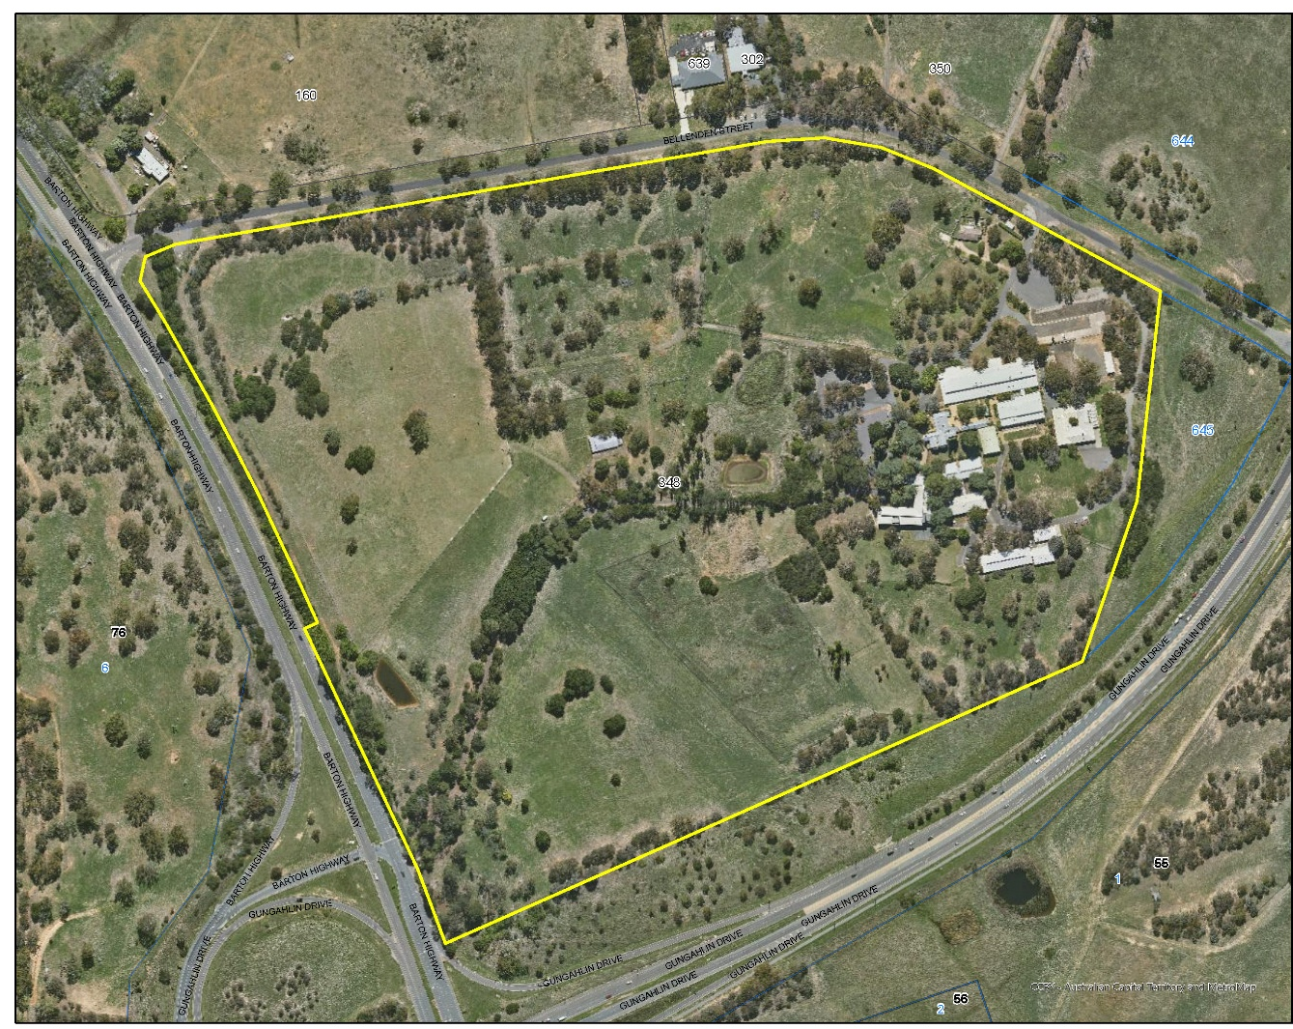
Figure Provisional registration boundary.

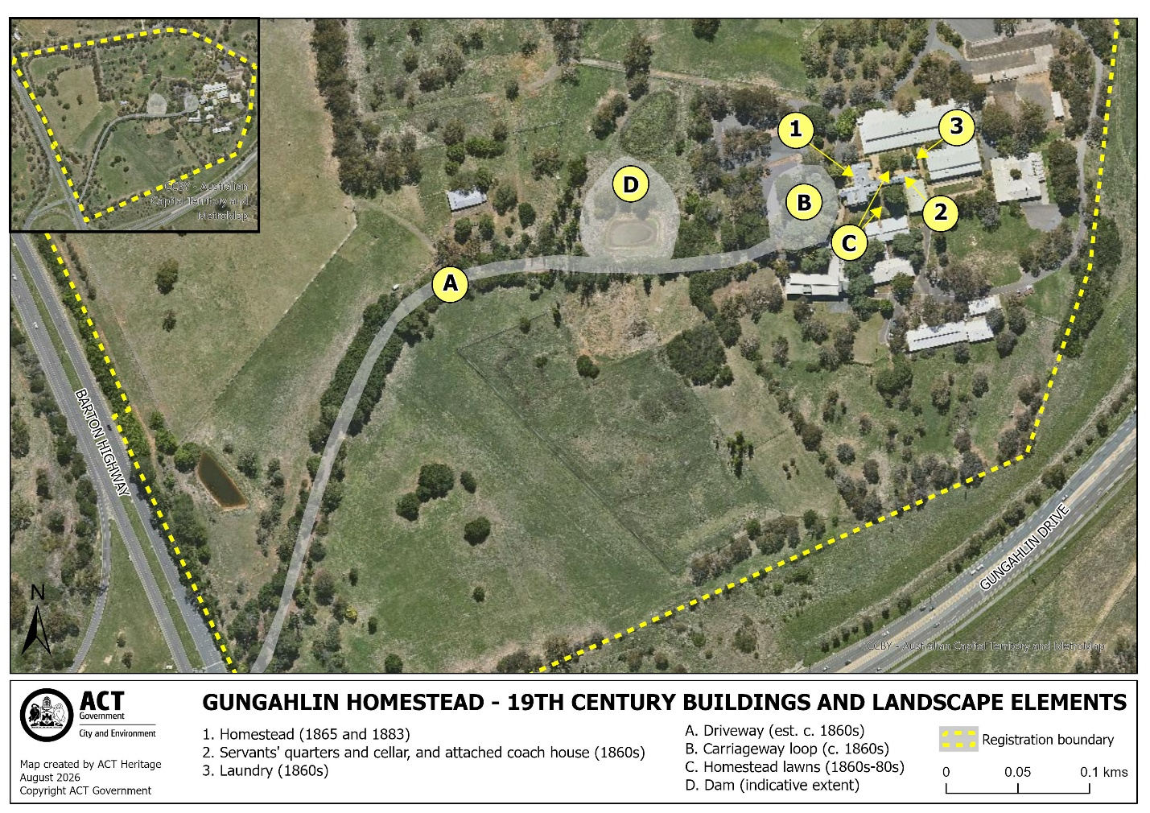
Figure 2: Gungahlin Homestead 19th century buildings and landscape elements.

