Australian Capital Territory

Nature Conservation (Murray Crayfish) Conservation Advice 2026

Notifiable instrument NI2026–456
made under the
Nature Conservation Act 2014, s 90C (Conservation advice)

1 Name of instrument
This instrument is the Nature Conservation (Murray Crayfish) Conservation Advice 2026.

2 Commencement
This instrument commences on the day after its notification day.

3 Conservation advice for Murray Crayfish
Schedule 1 sets out the conservation advice for the Murray Crayfish (Euastacus armatus).

4 Revocation
This instrument revokes the Nature Conservation (Murray River Crayfish) Conservation Advice 2020 (NI2020-352).

Simon Clulow
Chair, Scientific Committee
7 October 2026
Schedule 1
(see s 3)

Conservation Advice
Murray Crayfish – Euastacus armatus

Conservation Status
The Murray Crayfish Euastacus armatus (von Martens, 1866), is recognised as threatened in the following jurisdictions:
International Data Deficient, International Union for Conservation of Nature (IUCN) Redlist
National Vulnerable, Environment Protection and Biodiversity Conservation Act 1999
ACT Vulnerable, Nature Conservation Act 2014
NSW Vulnerable, Fisheries Management Act 1994
Victoria Threatened, Flora and Fauna Guarantee Act 1988
SA Protected, Fisheries Management Act 2007

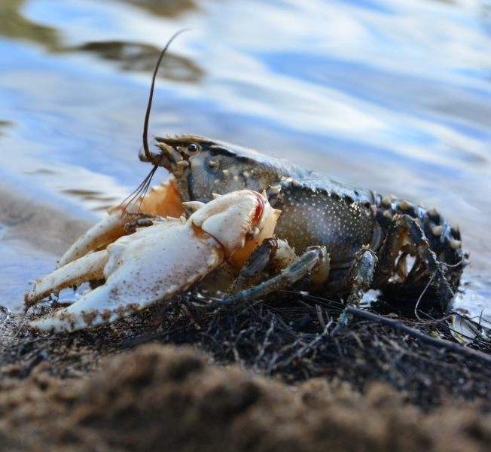
ELIGIBILITY
The Murray Crayfish is eligible to be included in the Vulnerable Category of the ACT Threatened Native Species List under the Nature Conservation Act 2014 (NC Act) under the IUCN Criterion A – A2bcde+A3bcde+A4bcde. The factors that make the Murray Crayfish eligible for listing as Vulnerable nationally include a reduction of over 30% in national numbers over three generations (1984–2022 = 39 years) and the reduction has not ceased, the cause has not ceased and is not fully known in some reaches but is likely due to different reasons in various reaches. Specifically, the reduction in the availability of preferred habitat (boulder and overhanging vegetation cover), adverse water quality events, particularly post bushfire sediment inputs in upland reaches and blackwater disturbances in core lowland habitats (TSSC 2025) have contributed to the recent reduction in numbers. The frequency and magnitude of these blackwater events is increasing, exacerbated by declining catchment yield and river flow, reductions in floodplain inundation and driven by accelerating anthropogenic climate change (Balcombe et al. 2011; Steffen et al. 2018; Chiew et al. 2022; Fowler et al. 2022; Zheng et al. 2024). Also, recreational harvest (and illegal poaching) (A2d) and introduced species (A2e) impact across the range of the species and are suspected to be contributing to population size reduction (TSSC 2025).
  - Murray Crayfish (Mark Jekabsons – ACT Government)

DESCRIPTION AND ECOLOGY

The Murray Crayfish – Murunung (Winanggaay Ngunnawal Language Aboriginal Corporation) is the second largest freshwater crayfish in the world, averaging 200 mm in length, but reportedly growing up to 500 mm (170 mm Occipital Carapace Length (OCL)) and 2.7 kg (Geddes 1990). It has large white claws, the body is generally dark green, brown or black with white spikes on the cephalon, thorax and abdomen.

Murray Crayfish are long-lived and may live for 30 to 50 years. Females mature at five to nine years of age (60 and 95 mm OCL) and males from four years of age. Mating occurs in May and females carry eggs under their tail from late autumn, releasing juveniles in late spring to early summer. In the ACT, egg carrying (berried) females are typically larger than 75 mm OCL (average 92 mm) (ACT Government unpublished data), though smaller berried females have been collected in sections of the upper Murrumbidgee River Catchment (Starrs et al. 2015). Fecundity appears to be correlated with female size with between 150 and 1500 eggs per female (McCormack 2012).

Distribution and Habitat

The Murray Crayfish is found in a wide variety of permanent rivers and large streams in the southern Murray–Darling Basin (MDB – Map 1) to approximately 700 metres above sea level (Gilligan et al 2007). In the local region it is known from the Murrumbidgee River, lower Cotter River below the Cotter Dam, Tumut River, Goobragandra River and the lower Goodradigbee River (Lintermans 2002; ACT Government 2018b).

Map 1 Modelled Distribution of the Murray Crayfish (TSSC 2025)

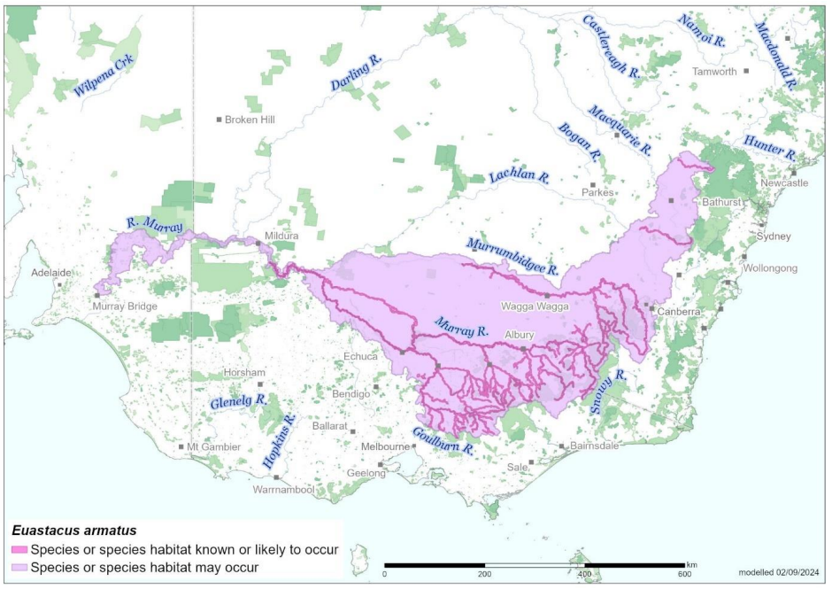

Source: Base map Geoscience Australia; species distribution data Species of National Environmental Significance database

Abundance is known to decline with altitude (Raadik et al. 2001) and the ACT is at the edge of the upper altitudinal range and currently has a low abundance of the species (Ryan 2005; Gilligan et al. 2007; NSW Fisheries Scientific Committee 2013). In the ACT, region boulder/cobble substrate along with other structure such as snags may provide important cover (Fulton et al. 2010). The species prefers intermediate flow velocities, deeper pools and glides with overhanging vegetation for shading (Noble and Fulton 2016).

Threats
The major threats to the species are hypoxic blackwater events (related to infrequent floodplain inundation) in more lowland habitats (Todd et al. 2018; Whiterod et al. 2018). The main identified threats to the Murray Crayfish in the ACT Action Plan (ACT Government 2018b) include:
- Overfishing (historical and illegal)
- riparian vegetation removal
- sedimentation
- residential development
- river regulation
- reduction in water quality
- fire
- invasive species and disease (Aphanomyces astaci (crayfish plague))
- changing climate.

Major Conservation Objective
The overall objective of the action plan (ACT Government 2018b) is to maintain in the long term, viable, wild populations of Murray Crayfish as a component of the indigenous aquatic biological resources of the ACT and as a contribution to regional and national conservation of the species. This includes the need to maintain natural evolutionary processes and resilience.

Conservation PRIORITIES
The 2018 Action Plan for Murray River Crayfish (ACT Government 2018b) identifies actions and the following main priorities to:
- protect the species from harvest
- protect sites in the ACT where the species occurs
- manage habitat to conserve populations
- enhance the long-term viability of populations
- improve understanding of the species’ ecology, habitat and threats
- maintain vigilance in illegal wildlife/aquarium trade
- improve community awareness and support for the species and freshwater fish conservation.
Further actions in the ACT should include to actively seek opportunities to involve members of local indigenous communities in on ground conservation activities for this species.

Conservation Issues
It is recommended that quantitative targets and resourcing requirements are clearly identified in any Action Plan or other related projects/programs relevant to this species. Broader conservation issues need to be considered in developing and implementing actions arising from this advice and the species listing assessment (DCCEEW 2024).

Critical Habitat
Critical habitat is not established in the Commonwealth Conservation Advice as it appears that the species is tolerant of a variety of in-stream habitat conditions across its altitudinal range but at a microhabitat scale, the species prefers cool, flowing-water habitats (lotic) proximal to clay banks for burrowing, and wood or rock cover is characteristic of occupied areas (Gilligan et al. 2007).
No Critical Habitat as defined under section 207A of the EPBC Act has been identified or included in the Register of Critical Habitat.

Climate Change
Climate change impacts are inevitable and will affect the persistence of many species within the ACT. Climate change, especially through increased temperatures and severe weather impacts, including hypoxic blackwater, low flow periods, and fire impacts are considered the greatest climate related issues for the Murray Crayfish. There is a need to investigate the potential influence of climate change on the long-term survival prospects of the species, due to altered temperatures, rainfall patterns/moisture availability, bushfires, environmental stressors and diseases, including to: assess the thermal tolerance of Murray Crayfish in more detail to ascertain its physiological limits, sensitivity and vulnerability; and to investigate the impacts of climate change on the species’ habitat (vegetation assemblages, water availability, water and air temperatures).

Disease Risk
The potential catastrophic impacts of the crayfish plague (Panteleit et al. 2017) entering Australia on the population viability of freshwater crayfish will require rapid management responses (DAWE 2019) to prevent extinction and a reassessment of priorities if biosecurity barriers are breached. The aquarium trade is a major pathway of carrier species of crayfish plague and illegal wildlife/aquarium trade the greatest risk of entry to Australia.

Jurisdictional Collaboration
As a species formerly distributed across the southern Murray–Darling Basin, including the Murrumbidgee River upstream and downstream of the ACT, the development of any policies, plans or strategies for the Murray Crayfish will need discussion and collaboration between relevant jurisdictional entities.

Ngunnawal Community Engagement
The ACT Government should actively facilitate, the inclusion of the Ngunnawal people in the conservation of this species and its habitat as part of Ngunnawal Country. For example, the Ginninderry Conservation Trust and Ginninderry Caring for Country indigenous rangers working together to undertake local surveys for the species. Reference to the draft Cultural Resource Management Plan (ACT Government in prep.) would be useful to inform culturally appropriate resource management including of native species that aligns with achieving conservation outcomes for the species.

Other Relevant Advice, plans or Prescriptions
- Commonwealth Conservation Advice – Murray Crayfish (TSSC 2025)
- ACT Aquatic and Riparian Conservation Strategy (ACT Government 2018a)
- ACT Action Plan – Murray River Crayfish (ACT Government 2018b)

Listing Background
The Murray Crayfish was initially listed as the Murray River Crayfish in the ACT as an Endangered species on 6 January 1997 in accordance with section 21 of the Nature Conservation Act 1980. At that time, the Flora and Fauna Committee (now the Scientific Committee) concluded that the assessment satisfied the following criteria:
2.2 species is observed, estimated, inferred or suspected to be at risk of premature extinction in the ACT region in the medium-term future as demonstrated by:
2.2.1 current serious decline in population or distribution from evidence based on:
2.2.1.1 direct observation, including comparison of historical and current records
2.2.1.3 a serious decline in quality and quantity of habitat
2.2.1.4 high actual or potential levels of exploitation or persecution.
The Murray Crayfish is listed as a Vulnerable species under the Environment Protection and Biodiversity Conservation Act 1999 (EPBC Act), effective 5 March 2025. It is assessed as Vulnerable under Criterion 1 (A2bcde+A3bcde+A4bcde) of the EPBC Act.

Action Plan Decision
The Murray Crayfish currently has an Action Plan in the ACT under the Nature Conservation Act 2014. The ACT Scientific Committee recommends to the Minister for the Environment that the ACT continue having an action plan for the Murray Crayfish under the ACT Aquatic and Riparian Conservation Strategy.
In the Commonwealth Conservation Advice for the Murray Crayfish the TSSC recommends that a National Recovery Plan is required, as there are multiple ongoing and interacting threats that need a coordinated strategic approach to management across multiple jurisdictions (TSSC 2025).

References
ACT Government 2018a. ACT Aquatic and Riparian Conservation Strategy and Action Plans. Environment, Planning and Sustainable Development Directorate, Canberra. Available from: https://www.legislation.act.gov.au/di/2018-240/
ACT Government 2018b. Murray River Crayfish (Euastacus armatus) Action Plan. Environment, Planning and Sustainable Development Directorate, Canberra. Available from: https://www.legislation.act.gov.au/View/di/2018-240/current/PDF/2018-240.PDF
Alves N, Coughran J, Furse J and Lawler S 2010. Euastacus armatus. The IUCN Red List of Threatened Species. Accessed 20 December 2019 from: http://dx.doi.org/10.2305/IUCN.UK.2010-3.RLTS.T8136A12889370.en
Balcombe SR, Sheldon F, Capon SJ, Bond NR, Hadwen WL, Marsh N and Bernays SJ 2011. Climatechange threats to native fish in degraded rivers and floodplains of the Murray–Darling Basin, Australia. Marine and Freshwater Research 62: 1099–1114.
Chiew F H, Zheng H, Potter NJ, Charles SP, Thatcher M, Ji F, Syktus J, Robertson DE, and Post DA 2022. Different hydroclimate modelling approaches can lead to a large range of streamflow projections under climate change: implications for water resources management. Water 14: 2730
DAWE 2019. Australian aquatic veterinary emergency plan (AQUAVETPLAN) for crayfish plague (version 2.0). Department of Agriculture Water and the Environment, Commonwealth of Australia. Canberra.
https://www.agriculture.gov.au/sites/default/files/documents/aquavetplan-crayfish-plague.pdf
Fowler K, Peel M, Saft M, Peterson TJ, Western A, Band L, Petheram C, Dharmadi S, Tan KS and Zhang L 2022. Explaining changes in rainfall–runoff relationships during and after Australia's Millennium Drought: a community perspective. Hydrology and Earth System Sciences 26: 6073–6120.
Fulton C, Starrs D and Ruibal M 2010. Distribution, abundance and habitat-use of upland river populations of Murray River Crayfish (Euastacus armartus). Final Report to the ActewAGL Future Water Planning Group, Canberra.
Geddes MC 1990. The Murray. Murray–Darling Basin Commission, Canberra.
Gilligan D, Rolls R, Merrick J, Lintermans M, Duncan P and Kohen J 2007. Scoping the knowledge requirements for Murray Crayfish (Euastacus armartus). Fisheries Final Report Series. Narrandera Fisheries Centre, Narrandera.
Lintermans M 2002. Fish in the Upper Murrumbidgee Catchment: A Review of Current Knowledge. Environment ACT, Canberra.
McCormack RB 2012. A Guide to Australia's Spiny Freshwater Crayfish. CSIRO Publishing, Melbourne.
Noble M and Fulton C 2016. Habitat specialization and sensitivity to change in a threatened crayfish occupying upland streams. Aquatic Conservation: Marine and Freshwater Ecosystems 27(1): 90–102.
NSW Fisheries Scientific Committee 2013. The Murray crayfish – Euastacus armatus as a vulnerable species. Final determination. Ref No. FD53. NSW Department of Primary Industries, Crows Nest.
Panteleit J, Keller N, Kokko H, Jussila J, Makkonen J, Theissinger K and Schrimpf A 2017. Investigation of ornamental crayfish reveals new carrier species of the crayfish plague pathogen (Aphanomyces astaci). Aquatic Invasions 12(1): 77–83.
http://www.aquaticinvasions.net/2017/AI_2017_Panteleit_etal.pdf
Raadik T, O'Connor P and Mahoney JC 2001. Fish and Decopod Crustacean Survey, Regional Forest Agreement Process, Victoria 1997–1999. Summary Report. Department of Natural Resources and Environment, Victoria.
Ryan K 2005. The home range behaviour of the Murray River Crayfish Euastacus armartus (Decapoda: Parastacidae) in the Murrumbidgee River. Australian Capital Territory. Honours thesis. (University of Canberra, Canberra.
Starrs D, Ebner B and Fulton C 2015. Ceasefire: Minimal aggression among Murray River crayfish feeding upon patches of allochthonous material. Australian Journal of Zoology 63: 115–121.
Steffen W, Vertessy R, Dean A, Hughes L, Bambrick H, Gergis J and Rice M 2018. Deluge and Drought: Australia’s Water Security in a Changing Climate. Climate Council of Australia, Ltd. https://www.climatecouncil.org.au/wp-content/uploads/2018/11/Climate-Council-Water-Security-Report.pdf
Threatened Species Scientific Committee (TSSC) 2025. Conservation Advice Euastacus armatus Murray Crayfish. Department of Climate Change, Energy, the Environment and Water (Commonwealth), Canberra. http://www.environment.gov.au/biodiversity/threatened/species/pubs/81537-conservation-advice-05032025.pdf
Todd CR, Whiterod N, Raymond SM, Zukowski S, Asmus M, and Todd MJ 2018. Integrating fishing and conservation in a risk framework: A stochastic population model to guide the proactive management of a threatened freshwater crayfish. Aquatic Conservation: Marine and Freshwater Ecosystems 28(4): 954–968.
Whiterod NS, Zukowski S, Asmus M, Todd CR and Gwinn DC 2018. Take the long way home: Minimal recovery in a K-selected freshwater crayfish impacted by significant population loss. Ecological indicators 89: 622–630.
Zheng H, Chiew FH, Post DA, Robertson DE, Charles SP, Grose MR and Potter NJ 2024. Projections of future streamflow for Australia informed by CMIP6 and previous generations of global climate models. Journal of Hydrology 636: 131286.

Further Information
Further information on the related Action Plan or other threatened species and ecological communities can be obtained from: Environment, Planning and Sustainable Development Directorate (EPSDD).
Phone: (02) 132281, EPSDD Website: https://www.act.gov.au/environment

Attachment A: Listing Assessment (TSSC 2025)
