Australian Capital Territory

Nature Conservation (Swampland Cool Skink) Conservation Advice 2026

Notifiable instrument NI2026–459
made under the
Nature Conservation Act 2014, s 90C (Conservation advice)

1 Name of instrument
This instrument is the Nature Conservation (Swampland Cool Skink) Conservation Advice 2026.

2 Commencement
This instrument commences on the day after its notification day.

3 Conservation advice for Swampland Cool Skink
Schedule 1 sets out the conservation advice for Swampland Cool Skink (Pseudemoia rawlinsoni).

Simon Clulow
Chair, Scientific Committee
7 October 2026
Schedule 1
(see s 3)

Conservation Advice
Swampland Cool Skink – Pseudemoia rawlinsoni

Conservation Status
The Swampland Cool Skink – Pseudemoia rawlinsoni Hutchinson & Donnellan (1988) – is recognised as threatened in the following jurisdictions:
National Vulnerable, Environment Protection and Biodiversity Conservation Act 1999
ACT Vulnerable, Nature Conservation Act 2014
NSW Not Listed, Biodiversity Conservation Act 2016
VIC Endangered, Flora and Fauna Guarantee Act 1988
SA Vulnerable, National Parks and Wildlife Act 1972
TAS Rare, Threatened Species Protection Act 1995

ELIGIBILITY
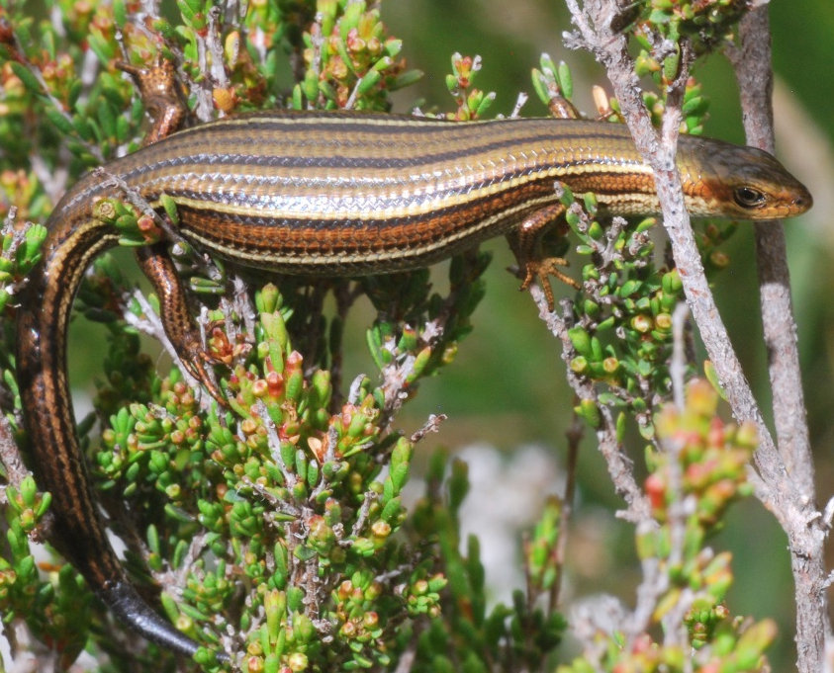
The Swampland Cool Skink is listed as Vulnerable in the ACT Threatened Native Species List under IUCN Criterion A – A2bc, A3c, A4c and Criterion B – B2ab(ii,iii,iv). The main factors that make the species eligible for listing in the Vulnerable category are an estimated national population decline of >30% over the past 3 generations (and projected to continue over the next 3 generations), its limited area of occupancy (AOO), severe fragmentation of small, relatively isolated subpopulations, decline in the area of occupancy, decline in the area and quality of habitat, and decline in the number of subpopulations nationally (DCCEEW 2026; Attachment A).

DESCRIPTION AND ECOLOGY
The Swampland Cool Skink (also known as the Glossy Grass Skink at lower elevations) is a small skink, up to 65 mm snout-vent length (SVL). Overall colouration is light olive-brown to rich reddish-brown with distinct and continuous stripes of black and pale cream. Females having longer bodies and greater tail widths, and males have larger heads and longer legs (Wotherspoon et al. 2024).
Swampland Cool Skink (Stuart Harris – NatureMapr)
Mating occurs in late summer and autumn, with females then storing sperm over winter for fertilisation in spring and giving birth to 1–9 live young (mean 4.65) in mid–late summer (Hutchinson and Donnellan 1988; Robertson and Coventry 2019; Wotherspoon et al. 2024). Female body size is positively correlated with litter size in the glossy grass skink (Wotherspoon et al. 2024). The species reaches sexual maturity at 3 years of age, at a body size of ~40 mm SVL (Wotherspoon et al. 2024). Given the estimated lifespan of the species around 7 years, the generation length of the glossy grass skink has been estimated to be 5 years (Wotherspoon et al. 2024).
Swampland Cool Skinks are active during the day and bask in the sun on low vegetation, logs and rocks, preferring undisturbed weather and site conditions (DCCEEW 2026). It is quite secretive in behaviour. Its diet has not been reported but is likely to include small arthropods (W. Osborne pers comm).

Distribution and Habitat
The Swampland Cool Skink occurs in temperate regions of southeastern Australia (Hutchinson and Donnellan 1988; Farquhar et al. 2024a) including northern Tasmania (DPIPWE 2021), south-eastern South Australia, southern and eastern Victoria, south-eastern NSW and the high country in the ACT (Map 1). The species is patchily distributed across its range, being largely restricted to coastal or near-coastal areas, except for disjunct populations in the Australian Alps (Hutchinson and Donnellan 1988; Farquhar et al. 2024a).
Figure 1: Modeled distribution of the Swampland Cool Skink (Source DCCEEW 2026)
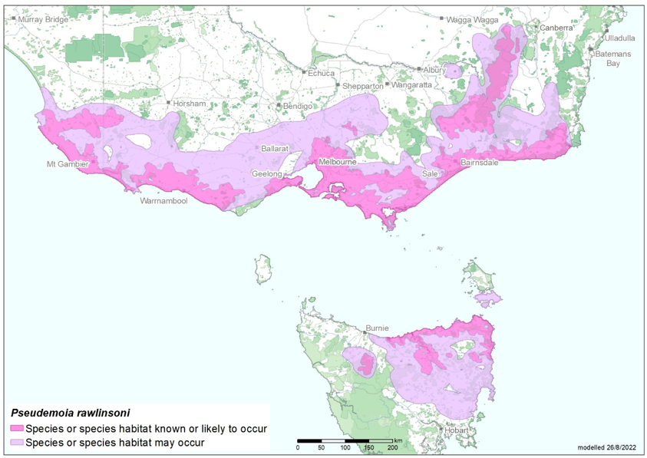
Source: Base map Geoscience Australia; species distribution data Species of National Environmental Significance database.
Caveat: The information presented in this map has been provided by a range of groups and agencies. While every effort has been made to ensure accuracy and completeness, no guarantee is given, nor responsibility taken by the Commonwealth for errors or omissions, and the Commonwealth does not accept responsibility in respect of any information or advice given in relation to, or as a consequence of, anything containing herein.
Species distribution mapping: The species distribution mapping categories are indicative only and aim to capture (a) the habitat or geographic feature that represents to recent observed locations of the species (known to occur) or habitat occurring in close proximity to these locations (likely to occur); and (b) the broad environmental envelope or geographic region that encompasses all areas that could provide habitat for the species (may occur). These presence categories are created using an extensive database of species observations records, national and regional-scale environmental data, environmental modelling techniques and documented scientific research.
The Swampland Cool Skink is a habitat specialist and occurs in densely vegetated and moist microhabitats, typically those found at the margins of creeks, swamps, lakes or otherwise boggy areas (Hutchinson and Donnellan 1988; Cogger 2014; Wilson and Swan 2021; Farquhar et al. 2024a, b).
While there are very few documented records of the species in the ACT, it has been recorded in swampy upland (subalpine and high montane) habitats above about 1200 m elevation. Specific habitats include bog, wet heath (Baeckea-Epacris spp.), fen and wet sod-tussock grassland (Gilmour et al. 1987; Helman et al. 1988; Green and Osborne 2012; W. Osborne pers. obs.).
In the ACT, the species has been recorded in Namadgi National Park, including east of Smokers Flat (Gilmour et al. 1987; at Piccadilly Circus, Mount Ginini and Ginini Flats (Hutchinson and Donnellan 1988); in the upper Cotter Catchment (Helman et al. 1988); and at Ginini Flats in 1988 and 1992, and Eighty Acres in 1989 (ACT Wildlife Atlas 2025). At Mount Ginini, during the 2018 Bush Blitz a record was made (Bush Blitz 2020) and specimen collected for the Australian National Wildlife Collection. While surveying for the Alpine She-oak Skink (Cyclodomorphus praealtus) in 2024, no sightings of the Swampland Cool Skink were made but a few sightings were made of other species in the Pseudemoia genus including for the Southern Grass Skink (P. entrecasteauxii) and Spencer’s Skink (P. spenceri) (Atkins and Pulsford 2024).

Threats
Details and the extent to which each threat is operating on the Swampland Cool Skink are outlined in the Commonwealth Conservation Advice (DCCEEW 2026). The Swampland Cool Skink is primarily threatened in the ACT by:
- habitat loss and changes caused by higher temperatures and impacts from increasingly frequent and more severe fires, both due to climate change, and feral hard-hooved animal impacts on the species habitat (including feral pig and deer damage, Gillespie (2018))
- compounding impacts including elevated predation levels after fire, especially by feral Cats (Felis catus) and European Red Foxes (Vulpes vulpes) (Stobo-Wilson et al. 2021), and habitat degradation by weeds.

Major Conservation Objective
The priority management objective should be to maintain in the long term, viable, wild populations of the species as a component of the indigenous biological resources of the ACT and as a contribution to regional and national conservation of the species. This includes the need to maintain natural evolutionary processes.

Conservation Priorities
Conservation actions are detailed in the Commonwealth Conservation Advice (DCCEEW 2025). Conservation and management priorities for the Swampland Cool Skink in the ACT should be to:
- ensure core habitat and projected core habitat under climate change are protected from disturbance (including trails or park infrastructure), planned burns and fragmentation
- undertake climate modelling to predict future distribution of the species within the ACT under a range of climate change scenarios
- in collaboration with other stakeholders and jurisdictions, conduct targeted surveys to improve understanding of the species occurrence and habitat requirements in the ACT with specific attention to this species in other relevant surveys including work in the bogs and fens, e.g. alongside the ACT Bog Program (Atkins and Pulsford 2024)
- work with other jurisdictions and stakeholders to support the research priorities for the species where practical, including studies of population genetic structure and diversity, possible thermal sex reversal, microhabitat requirements, minimum tolerable fire intervals and potential to create safe havens from predators and herbivores
- determine and incorporate the ecological needs of the Swampland Cool Skink into relevant ecological guidelines (e.g., ACT Government 2019)
- undertake targeted control of invasive predators and weeds within the habitat around skink colonies, particularly post fire if feasible, to manage impacts on populations with predator control undertaken so as not to adversely impact on other native species
- ensure active surveillance programs are in place to detect the presence of feral horses, deer and invasive predators (including pigs) around known colonies of Swampland Cool Skink, and undertake control as needed
- address knowledge gaps for this species to establish climate change ready management actions that may include opportunities for university and interjurisdictional research collaborations.
- actively seek opportunities to involve members of the local Ngunnawal community, and other Indigenous people with connection to the relevant land, in on ground conservation activities for this species
- engage with other jurisdictions to support regional and national recovery of the species.

Conservation Issues
It is recommended that quantitative targets and resourcing requirements are clearly identified in any Action Plan or other related projects/programs relevant to this species. Broader conservation issues need to be considered in developing and implementing actions arising from this advice.

Critical Habitat
The Commonwealth Conservation Advice (DCCEEW 2026) identifies ‘habitat critical to the survival’ of the species refers to areas that are necessary:
- for foraging, breeding and dispersal activities
- for the long-term maintenance of the species
- to maintain genetic diversity and long-term evolutionary development
- for the reintroduction of subpopulations or recovery of the species.
All typical habitat (such as that described above) across the species’ distribution is likely to be critical to the survival of the species. Habitat which does not fit such a description (i.e. disturbed and/or exotic habitats), but is adjacent to suitable habitat, may become suitable for the species if the vegetation is left to regenerate and become sufficiently complex in structure (Farquhar et al. 2024b). In addition, habitat which does not fit such a description now, but a) may fit the description in the future, or b) could potentially be restored to support a population of the species, with the aim of improving connectivity between subpopulations and/or increasing the area of occupancy, is also considered critical to the species’ survival.
No Critical Habitat as defined under section 207A of the EPBC Act has been identified or included in the Register of Critical Habitat under the EPBC Act.

Climate Change
Climate change impacts are inevitable and will affect the likelihood of persistence, within the ACT, of many species. Most vulnerable in this regard are those species that occupy highly fragmented habitat with highly restricted distributions, such as this species. Capacity must be developed to model the impact on this species and its habitat under likely climate change scenarios if we are to anticipate and manage the impacts of climate change. This will require a combination of research and the development of in-house capacity for the collection of relevant data and its application in climate change modelling. For species whose physiological limits are known, biophysical models can provide a predictive understanding of the habitats required for persistence in the face of climate change through an integration of data on climate and other environmental variables with measures of morphology, behaviour, physiology and life history of the species.
How to respond to climate change is challenging if we are not to simply monitor resultant declines. Options for on-ground action to assist species such as the Swampland Cool Skink to accommodate climate warming (such as assisted dispersal between isolates subject to local extinction) need to be explicitly explored.

Population Viability
With highly fragmented and declining species, such as this species, it is important to ensure actions maintain connectivity and genetic diversity to prevent functional extinction. This occurs when populations decline in abundance and become fragmented to such an extent and that the genetic diversity of the species is reduced, leading to genetic problems (e.g., inbreeding depression) and the species no longer has the capacity to rebound should conditions improve or to respond to management intervention. Systematic monitoring and collection of population data, including reproduction and survival data when available, should be used to assess population viability and species distribution. An assessment of genetic variation and inbreeding risk should be made in the case of this species, particularly for small and isolated populations to inform risks. If genetic problems exist more intensive options for bringing the species to a position where it has the potential to recover may need to be explored, such as genetic rescue.

Jurisdictional Collaboration
The location of the species habitat in the ACT high country along the NSW border requires the development of any policies and action/recovery plans to be discussed between relevant jurisdictional entities.

Ngunnawal Community Engagement
The ACT Government should actively facilitate the inclusion of the Ngunnawal people in the conservation of this species and its habitat as part of Ngunnawal Country. Referring to the draft Cultural Resource Management Plan (ACT Government in prep.) would be useful to inform culturally appropriate resource management including of native species that aligns with achieving conservation outcomes for the species.

Other Relevant Advice, plans or Prescriptions
- Commonwealth Conservation Advice – Glossy Grass Skink (DCCEEW 2026)
- Namadgi National Park Plan of Management (ACT Government 2010)
- ACT High Country Bogs and Fens Action Plan (ACT Government 2024)

Listing Background
The Swampland Cool Skink is listed as a Vulnerable species under the Environment Protection and Biodiversity Conservation Act 1999 (EPBC Act), effective 6 February 2026. It is assessed as Vulnerable under Criterion 1 (A2bc+A3c+A4c) and Criterion 2 (B2ab(ii,iii,iv)) of the EPBC Act. In 2026, under the Nature Conservation Act 2014, the ACT Scientific Committee recommended the Swampland Cool Skink be listed in the Vulnerable category in the ACT Threatened Native Species List to align with the EPBC Act listing.

Action Plan Decision
The ACT Scientific Committee does not recommend that the Minister for the Environment should make the decision to have an action plan for the species in the ACT under the Nature Conservation Act 2014 at this time. The species has only been recorded in the ACT once since the early 1990s, along the ACT/NSW border in Namadgi National Park. The key habitat areas of the species are in the ACT High Country Bogs and Fens Endangered Ecological Community along the ACT/NSW border in Namadgi National Park (above 1200 m above sea level) and its habitat is protected there. Actions in the High Country Bogs and Fens Action Plan will monitor and manage the habitat of this species. Targeted skink surveys can be conducted alongside the ACT Bog Program (Atkins and Pulsford 2024).
A National Recovery Plan is not required as an approved Commonwealth conservation advice was deemed as an effective, efficient and responsive document to guide the implementation of priority management actions, mitigate key threats and support the recovery for this species (28/01/2026). (DCCEEW 2026).

References
ACT Government 2010. Namadgi National Park Plan of Management 2010. Land Management and Planning Division, Department of Territory and Municipal Services, Canberra. https://www.legislation.act.gov.au/di/2010-192/
ACT Government 2019. Ecological Guidelines for Fire, Fuel and Access Management Operations. Environment Planning and Sustainable Development Directorate, ACT Government, Canberra. https://www.environment.act.gov.au/__data/assets/pdf_file/0009/1483830/Ecological-Guidelines-2019-ver-1.3.pdf
ACT Government 2024. ACT High Country Bogs and Fens Ecological Community Action Plan. Environment, Planning and Sustainable Development Directorate. ACT Government, Canberra.
ACT Government in prep. Draft Cultural Resource Management Plan. Environment, Planning and Sustainable Development Directorate, ACT Government, Canberra.
Atkins Z and Pulsford S 2024. Assessing two Endangered alpine reptiles: Mountain Skink & Alpine She-oak Skink – Namadgi National Park, ACT. Snowline Ecology and the Office for Nature Conservation, Environment, Planning and Sustainable Development Directorate, ACT Government, Canberra.
Bush Blitz 2020. Protected areas of the Australian Capital Territory 2018: Bush Blitz expedition report, Department of Agriculture, Water and the Environment (Commonwealth), Canberra. https://bushblitz.org.au/wp-content/uploads/2021/09/Bush-Blitz-report-Protected-Areas-of-the-ACT.pdf
Cogger HG 2014. Reptiles and Amphibians of Australia. Seventh Edition. Collingwood, Victoria, Australia, CSIRO Publishing.
Department of Climate Change, Energy, the Environment and Water (DCCEEW) 2026. Conservation Advice for Glossy Grass Skink (Pseudemoia rawlinsoni). Department of Climate Change, Energy, the Environment and Water (Commonwealth), Canberra. http://www.environment.gov.au/biodiversity/threatened/species/pubs/59160-conservation-advice-06022026.pdf
Department of Primary Industries, Parks, Water and Environment (DPIPWE) 2021. Listing Statement for Pseudemoia rawlinsoni (glossy grass skink). Threatened Species Section Department of Primary Industries, Parks, Water and Environment, Tasmanian Government, Hobart.
https://nre.tas.gov.au/Documents/Pseudemoia%20rawlinsoni%20listing%20statement.pdf
Farquhar JE, Carlesso A, Pili A, Gale N and Chapple DG 2024a. Capturing uncatalogued distribution records to improve conservation assessments of data‐deficient species: a case study using the glossy grass skink. Animal Conservation 27: 124-137.
https://zslpublications.onlinelibrary.wiley.com/doi/10.1111/acv.12892
Farquhar JE, Wotherspoon L, Porter H, Chapple DG 2024b. Habitat loss and degradation reduce the abundance of the glossy grass skink, Pseudemoia rawlinsoni. Wildlife Research 51: WR23102.
Gillespie G, Clemann N, Robertson P, Melville J, Michael D, Hutchinson M and Chapple DG 2018. Lissolepis coventryi. The IUCN Red List of Threatened Species 2018: e.T109480101A109480110. https://dx.doi.org/10.2305/IUCN.UK.2018-1.RLTS.T109480101A109480110.en. Accessed on 15 April 2024.
Gilmour, PM, Helman CE, and Osborne, WS 1987. An ecological study of the Mount Tennent Blue Gum Creek area, ACT. Conservation Council of the Southeast Region and Canberra.
Green K and Osborne W 2012. Field Guide to Wildlife of the Australian Snow Country. Reed New Holland, Sydney.
Helman CE, Gilmour PM, Osborne WS and Green K 1988. An ecological survey of the Upper Cotter Catchment wilderness area, Namadgi National Park, ACT. Conservation Council of the Southeast Region and Canberra. Funded by a National Estate Grant.
Hutchinson, MN and SC Donnellan 1988. A new species of scincid lizard related to Leiolopisma entrecasteauxii, from southeastern Australia. Transactions of the Royal Society of South Australia 112, 143–151.
Robertson P and Coventry AJ 2019. Reptiles of Victoria: A Guide to Identification and Ecology. CSIRO Publishing, Clayton South.
Stobo-Wilson AM, Murphy BP, Legge SM, Chapple DG, Crawford HM, Dawson SJ, Dickman CR, Doherty, TS, Fleming PA, Gentle M, Newsome TM, Palmer R, Rees MW, Ritchie EG, Speed J, Stuart JM, Thompson E, Turpin J and Woinarski JC 2021. Reptiles as food: predation of Australian reptiles by introduced red foxes compounds and complements predation by cats. Wildlife Research 48(5): 470–480.
Wilson S and Swan G 2021. A Complete Guide to Reptiles of Australia. Sixth Edition. Reed New Holland, Chatswood.
Wotherspoon L, Haines ML, Farquhar JE, Chapple DG 2024. Determining the generation length and level of morphological and genetic differentiation in the Data Deficient glossy grass skink (Pseudemoia rawlinsoni). Pacific Conservation Biology 30: PC23037.

Further Information
Further information on the related ecological community Action Plan or other threatened species and ecological communities can be obtained from: Environment, Planning and Sustainable Development Directorate (EPSDD).
Phone: (02) 132281, EPSDD–Environment website: https://www.act.gov.au/environment

Attachment A: Listing Assessment (DCCEEW 2026)

