Australian Capital Territory
Planning (Belconnen) Minor Plan Amendment 2026 (No 1)
Notifiable instrument NI2026–482
made under the
Planning Act 2023, s 85 (Making minor plan amendments)

1 Name of instrument
This instrument is the Planning (Belconnen) Minor Plan Amendment 2026 (No 1).
2 Commencement
This instrument commences on the day after its notification day.
3 Minor plan amendment
I make Minor Plan Amendment 2026-13 as contained in schedule 1.

James Bennett
Delegate of the territory planning authority
22 October 2026

Schedule 1
(see s3)


MINOR AMENDMENT
TO THE TERRITORY PLAN
2026-13

Amendments to the Belconnen District Policy and future urban area uplift in the division of Lawson

This minor plan amendment was prepared
under part 5.3 of the Planning Act 2023
Contents
1.0 INTRODUCTION 1
1.1 Outline of the process 1
1.2 Summary of the amendments 2
2.0 TERRITORY PLAN CHANGES 3
2.1 Part B – Territory Plan Map 3
2.2 Part D – District Policies 6
3.0 TERRITORY PLAN AMENDMENT INSTRUCTIONS 9
3.1 Part B – Territory Plan Map 9
3.2 Part D: D02 – Belconnen District Policy 10
INTERPRETATION SERVICE 12

- INTRODUCTION
  - Outline of the process
Minor plan amendment 2026-13 (MA2026-13) to the Territory Plan is a minor plan amendment (MA) prepared under section 84 (1) (c) of the Planning Act 2023 (the Act).

Section 84 of the Act outlines the different types of MAs, some which require limited consultation to be undertaken and some which require no consultation to be undertaken.

This MA is consistent with the provisions under section 84 (1) (c) of the Act and therefore no consultation is needed.

The MA is not inconsistent with the planning strategy and the Belconnen District Strategy.

The National Capital Authority will be advised of this MA.

For more information on the content of the Territory Plan and minor plan amendment processes please refer to the Planning website: The Territory Plan - City and Environment Directorate - Planning

  - Summary of the amendments
MA2026–13 proposes to:

- remove part of the future urban area overlay from land in the division of Lawson and insert Assessment Requirements consistent with the approved subdivision design application (related to DA201834093).

- TERRITORY PLAN CHANGES
MA2026-13 makes changes to parts of the following Territory Plan documents:
- Part B – Territory Plan Map
- Part D – District Policies
  - D02 Belconnen District Policy

  - Part B – Territory Plan Map
The Territory Plan map is varied to identify the zones and overlays that apply to land ceasing to be in a future urban area.

Lawson - Location map

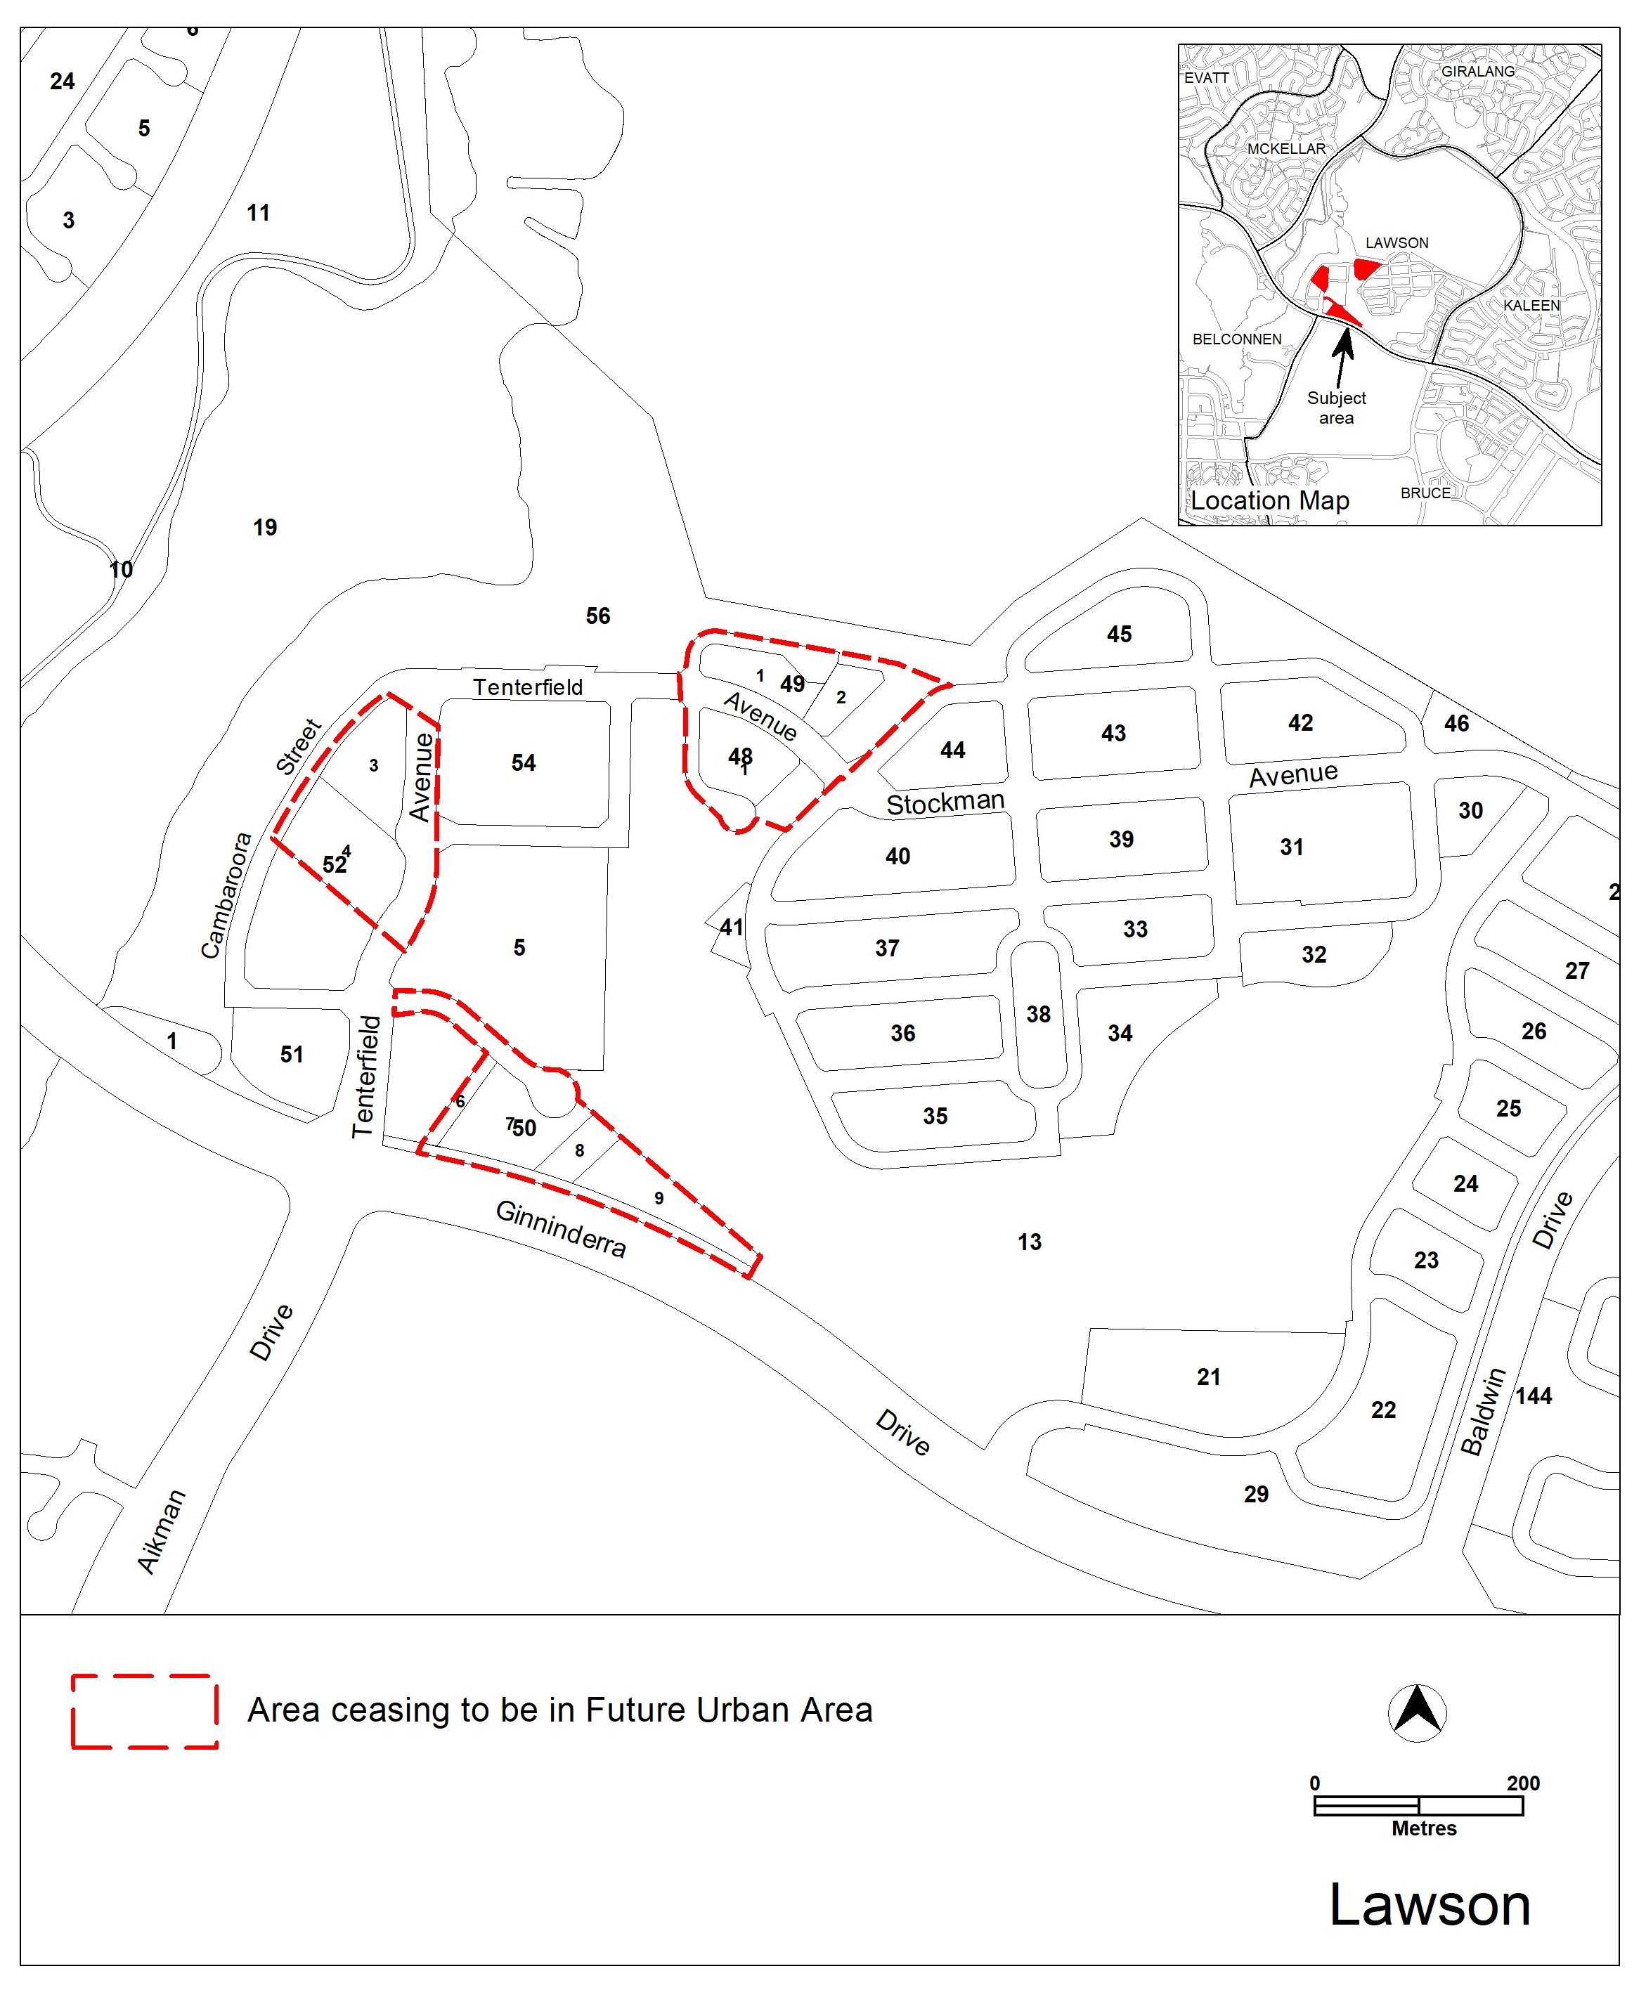
Lawson – Existing Territory Plan map

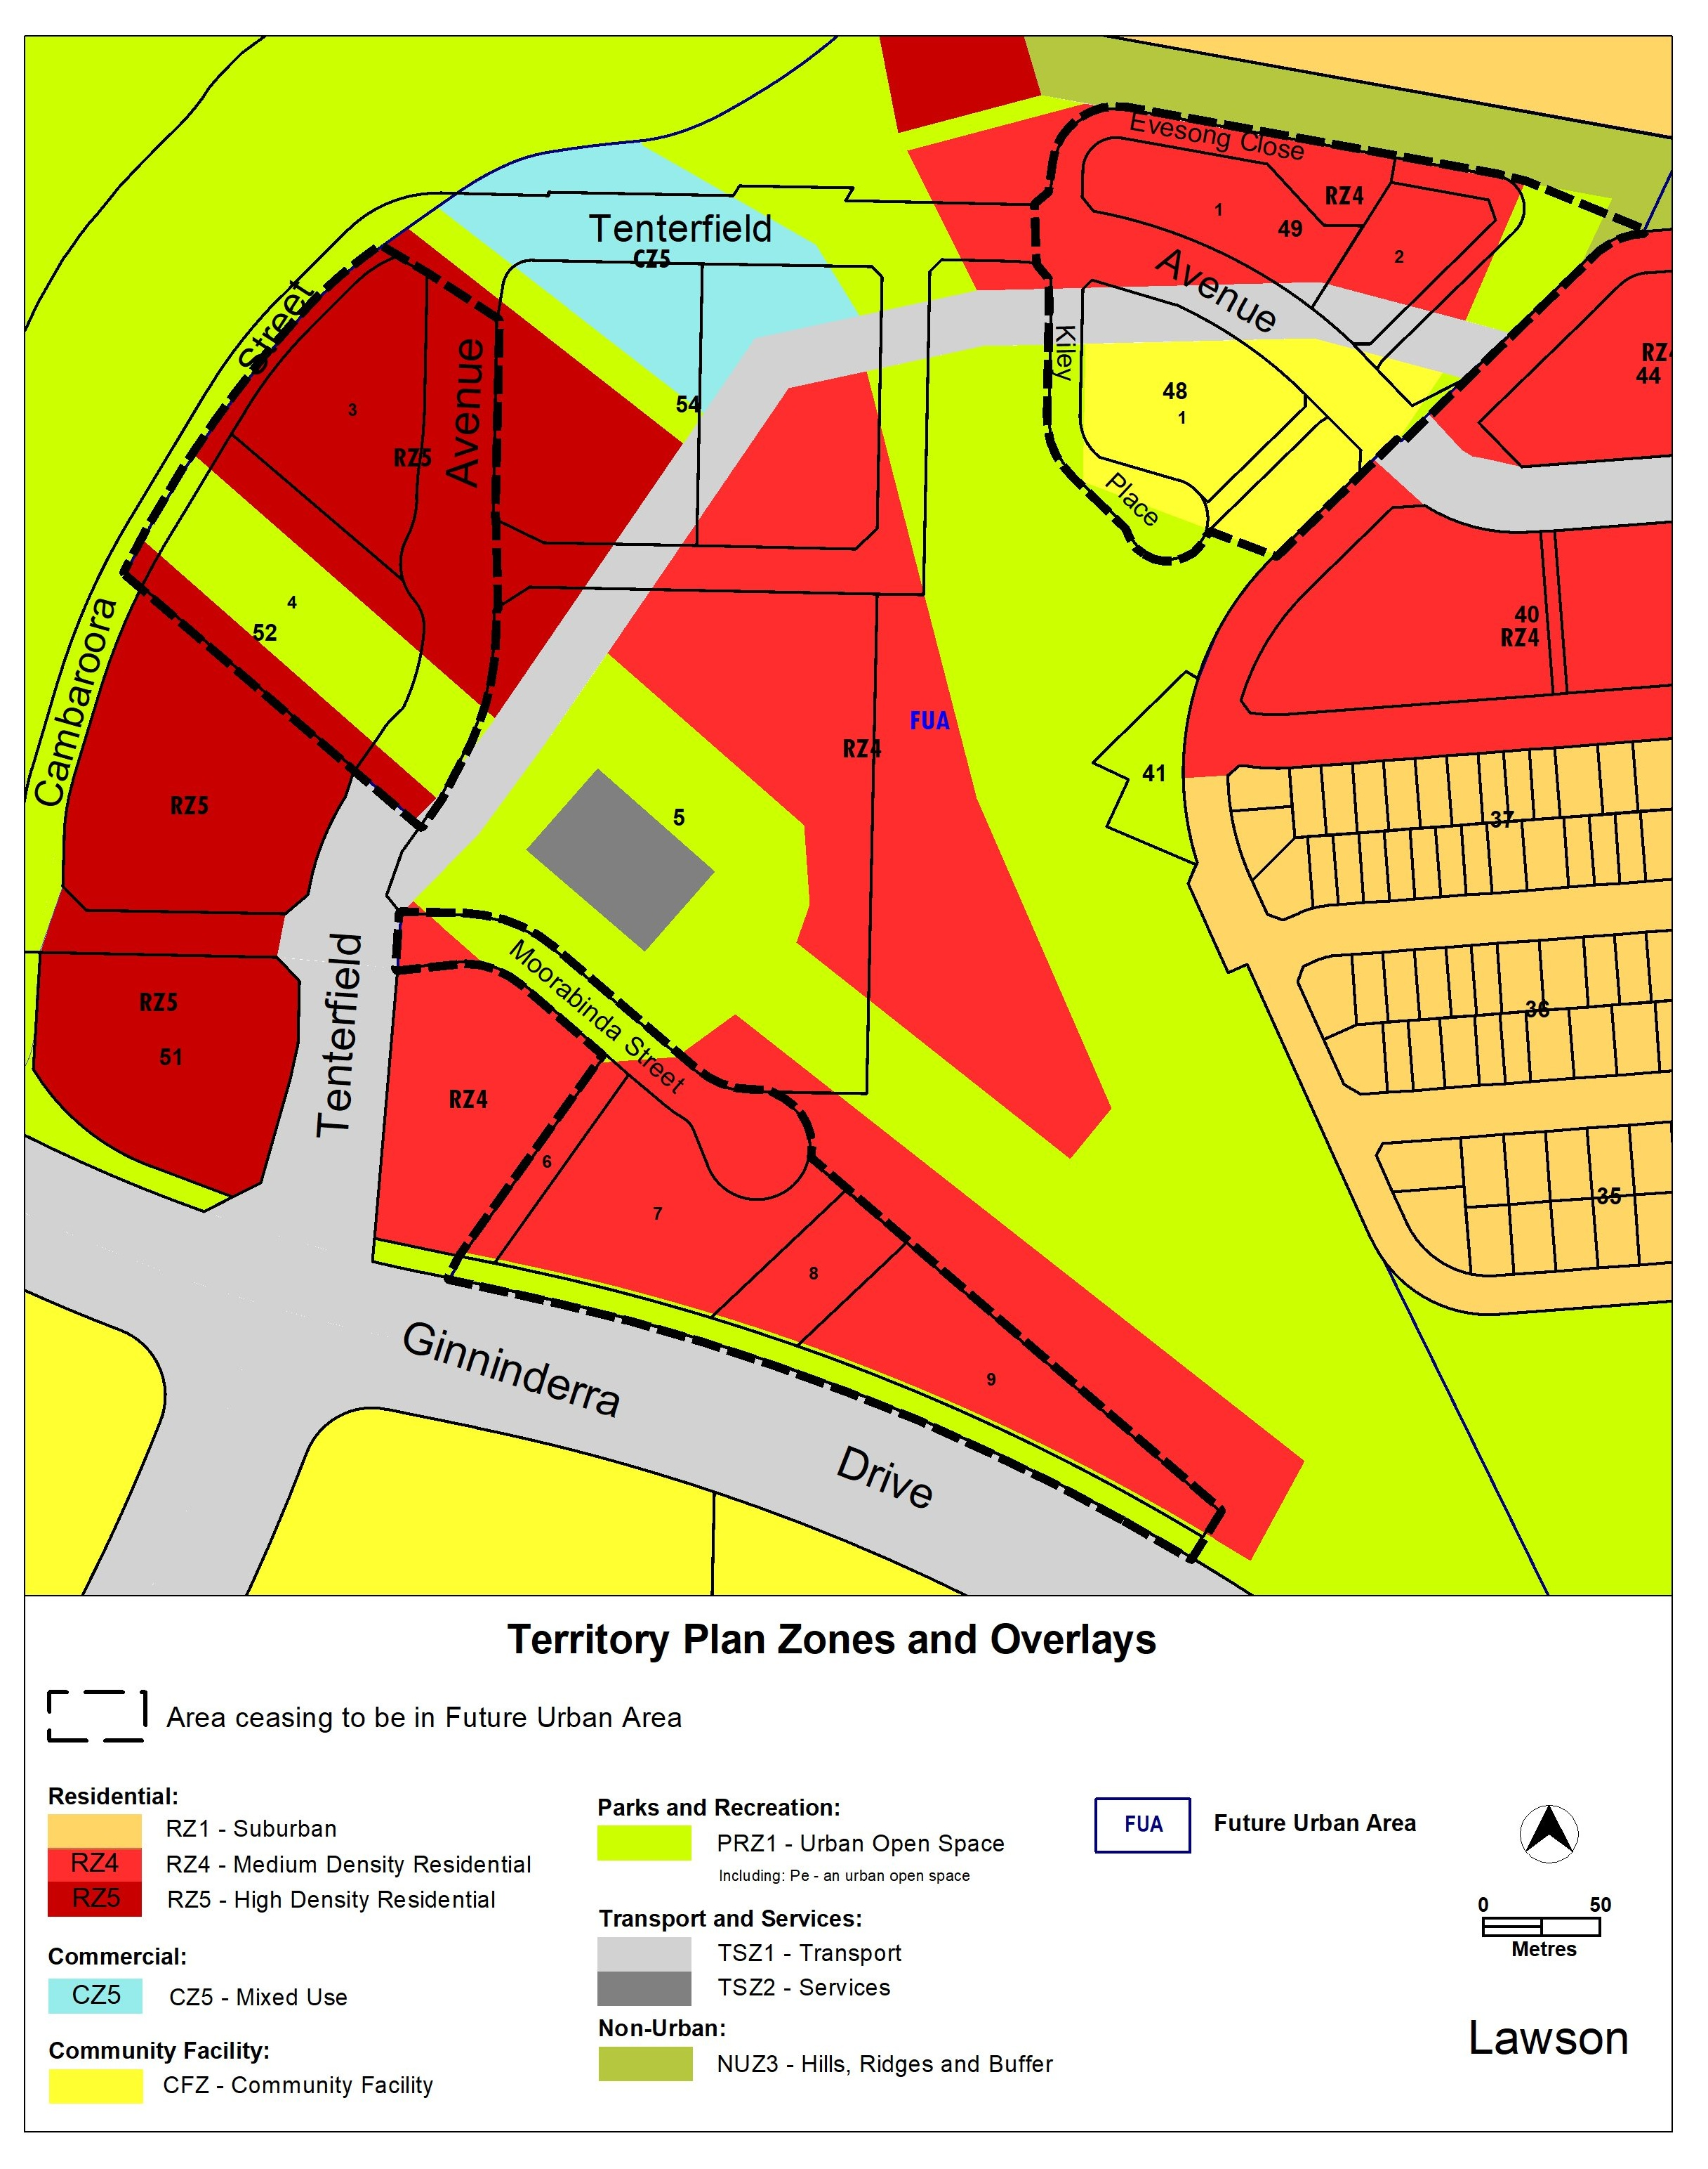

Lawson – updated Territory Plan map
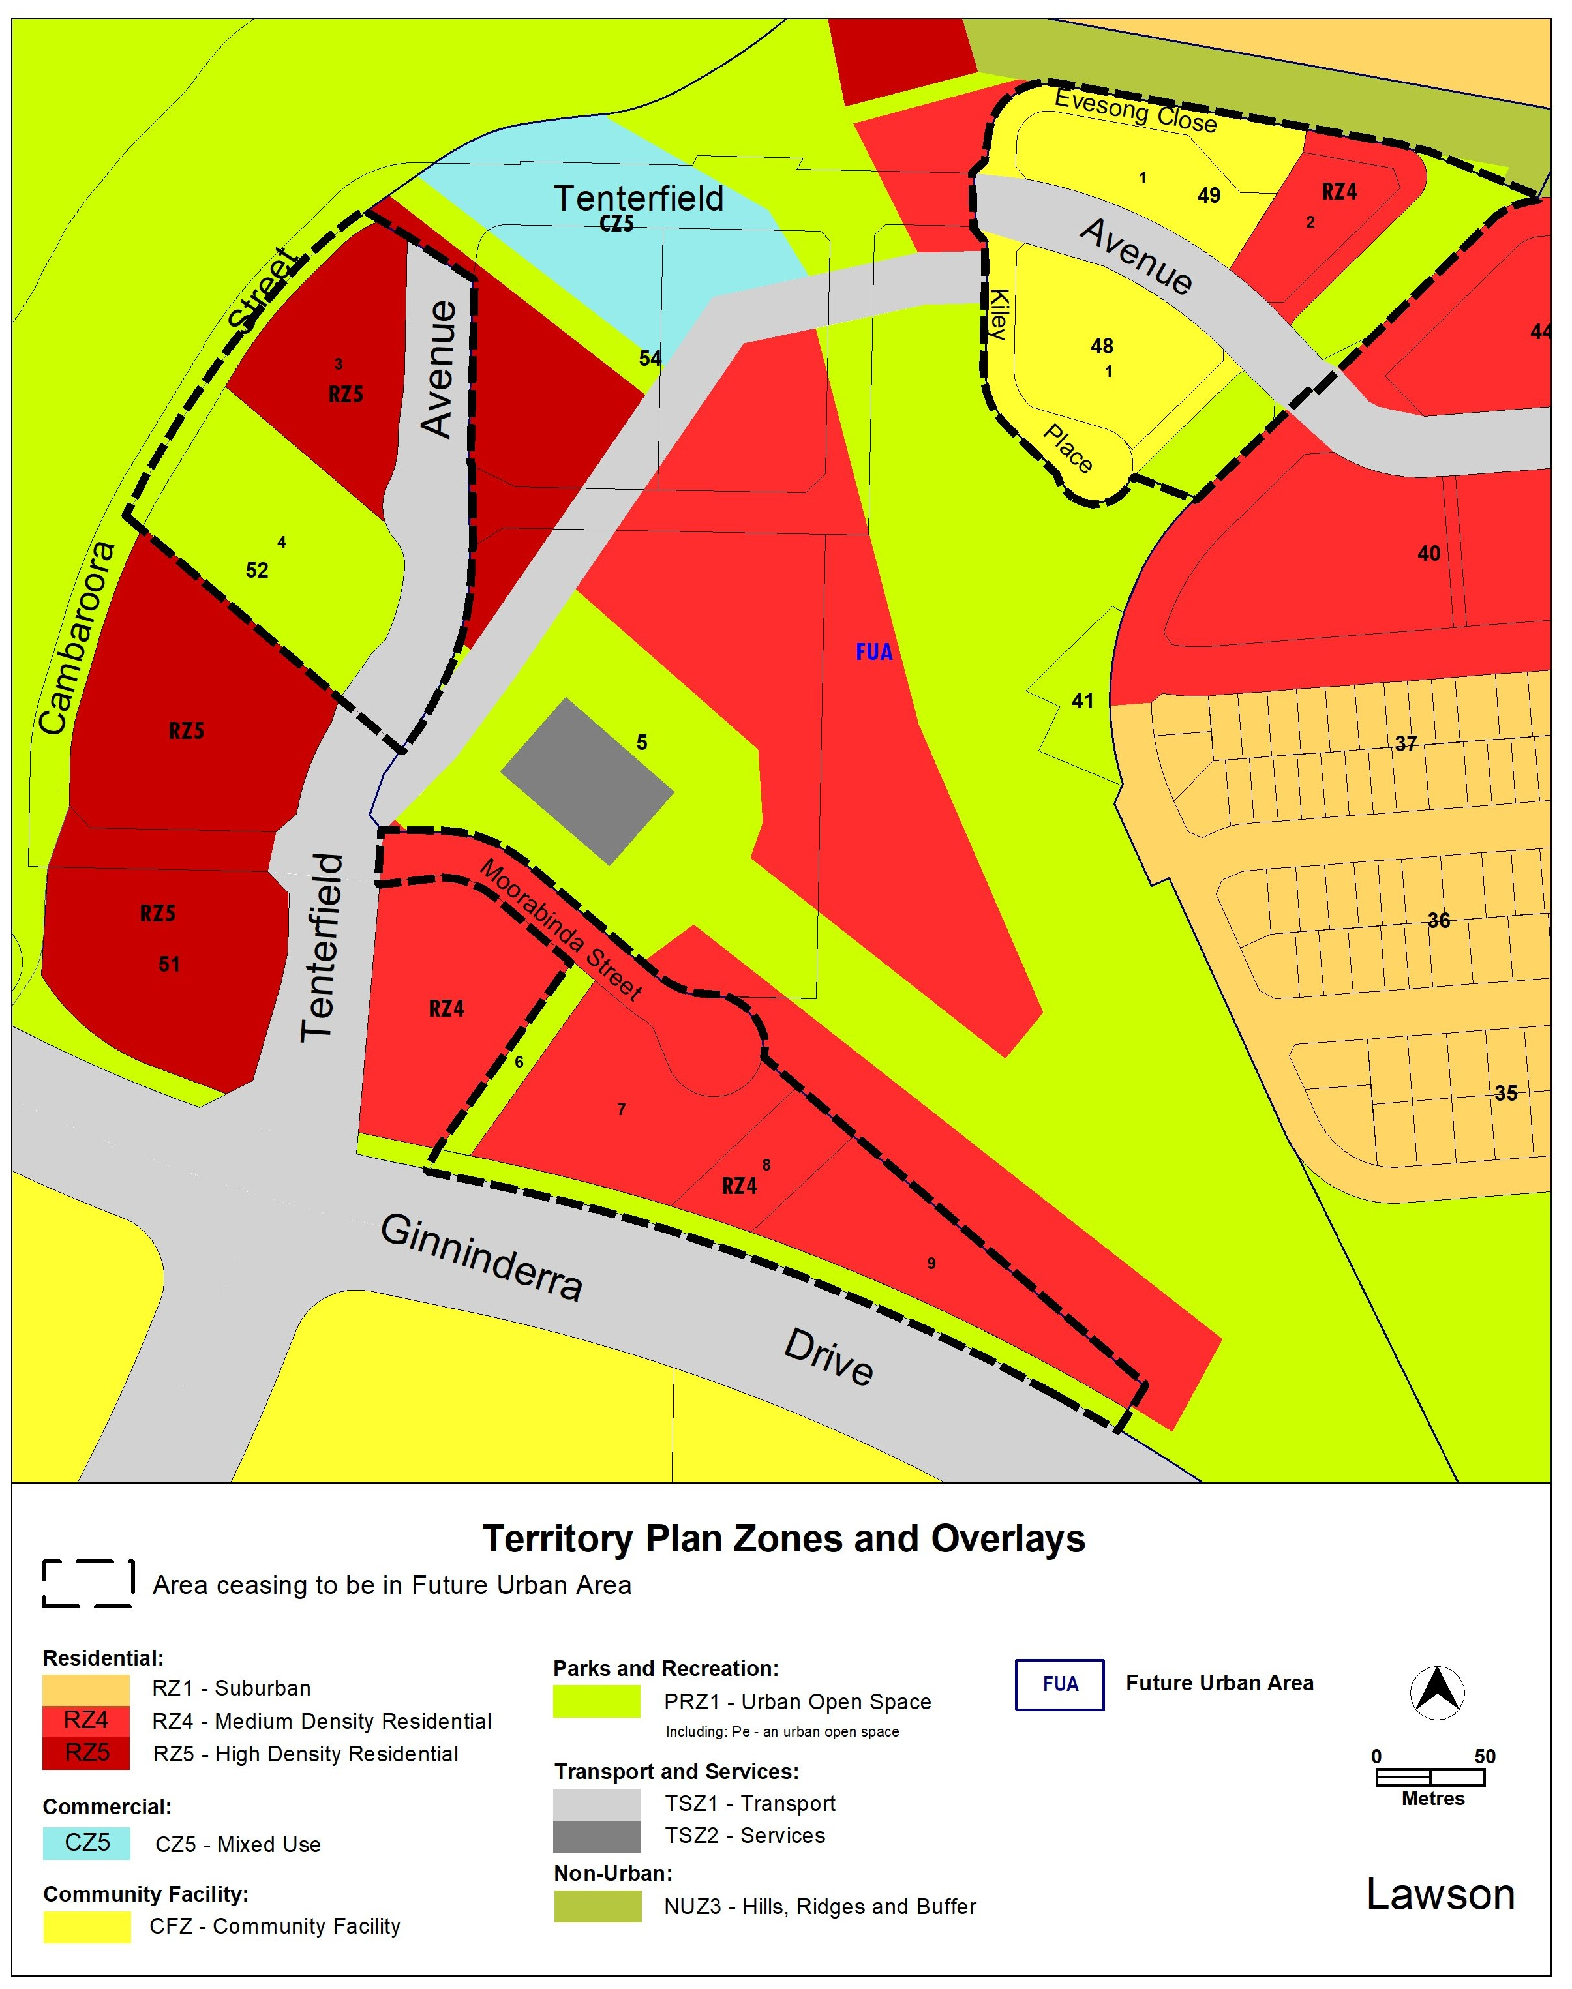

  - Part D – District Policies
The Belconnen District Policy will be varied to identify provisions that apply to land ceasing to be in a future urban area.

Belconnen District Policy – Assessment Requirements

Figure 13 Lawson - Building Heights and earthing requirements

- Amend the figure to include additional ongoing planning provisions in the division of Lawson in relation to building heights, earthworks, bushfire attack level, communal open space and noise attenuation.

- Amend the figure title to reflect the addition of ongoing planning provisions to Building Heights and other requirements.

Proposed Figure 13

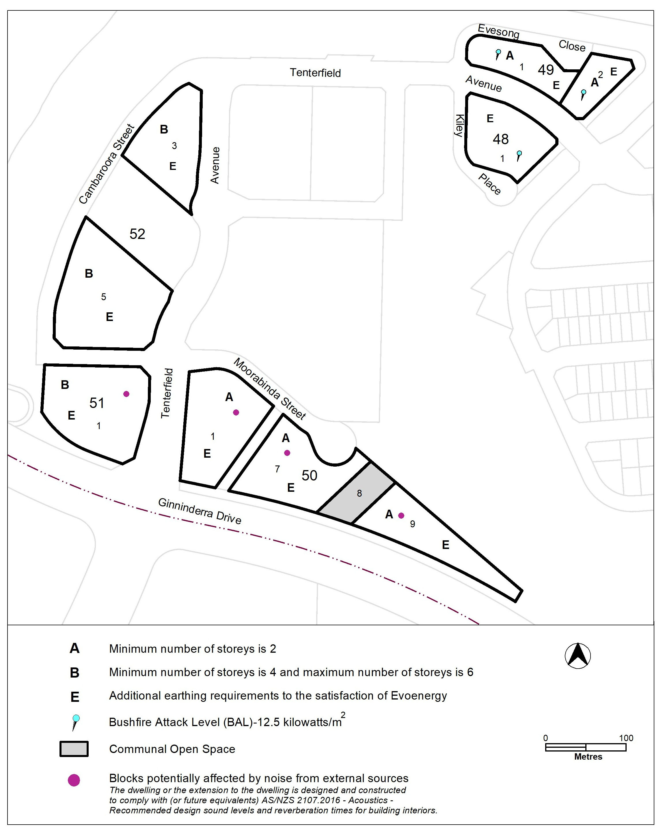

Assessment requirements

- Insert new Assessment requirement 51A for Bushfire Attack Levels to specify the standard which buildings are required to be constructed in accordance with.

- Insert new Assessment requirement 51B for Communal Open Space to show the block which is to be retained as communal open space while allowing for internal driveway access for the block.

- TERRITORY PLAN AMENDMENT INSTRUCTIONS
This section provides the legal instructions for how MA2026-13 amends the Territory Plan.
  - Part B – Territory Plan Map
The relevant part of the Territory Plan map is varied as indicated below.

Lawson

  - Part D: D02 – Belconnen District Policy

Assessment Requirement 51A and 51 B

Insert new Assessment requirement 51A and 51B after existing assessment requirement 51

Locality | Assessment requirement
Bushfire Attack Level | 51A. In accordance with Figure 13, all buildings are constructed in accordance with the relevant section of AS3959 or NASH Standard Steel Framed Construction in Bushfire Areas.
Communal Open Space | 51B. The following applies to the Communal Open Space land identified in Figure 13:  - The existing trees within the parcel are to be protected and maintained in accordance with the approved Tree Management Plan, unless approved otherwise in writing by the CED and the ACT Heritage Council.  - The parcel can be used by block 7 and 9 section 50 as Communal Open Space.  - Landscaping, lighting, permeable paving, fencing and associated gates, street furniture and other open space equipment are permitted, subject to compliance with a) above.  - A maximum of one internal driveway access and associated services may traverse the parcel, subject to compliance with a) above.  - Any other works proposed within the parcel (other than c) and d) above) require approval in writing from the CED and the ACT Heritage Council.

Hyperlink text referring to Figure 13 to the corresponding Figure 13.

Figure 13 – Lawson – Building heights and earthing requirements

Substitute Figure 13 and rename to Figure 13 – Building Heights and other requirements.

Substitute:

Figure 13 – Building Heights and other requirements

INTERPRETATION SERVICE
To speak to someone in a language other than English please telephone the Telephone Interpreter Service (TIS) 13 14 50
LANGUAGE | DETAILS
English | If you need an interpreter please call: 13 14 50
Mandarin (Simplified Chinese) / 简体中文 | 如果您需要翻译，请致电：13 14 50
Arabic / العربية | إذا كنت بحاجة إلى مترجم شفهي اتصل بالرقم: 50 14 13
Cantonese (Traditional Chinese) / 繁體中文 | 如果你需要傳譯員，請致電：13 14 50
Vietnamese /  Tiếng Việt | Nếu bạn cần thông dịch viên, xin gọi: 13 14 50
Korean / 한국어 | 통역사가 필요할 경우 다음 번호로 전화하시기 바랍니다: 13 14 50
Spanish / Español | Si necesita un intérprete, llame al 13 14 50
Persian (Farsi) / فارسی | اگر به مترجم نیاز دارید، لطفاً به این شماره تلفن کنید: 50 14 13
Dari / دری | اگر به یک ترجمان شفاهی نیاز دارید لطفاً به شمارۀ 131450 زنگ بزنید.
Punjabi / ਪੰਜਾਬੀ | ਜੇਕਰ ਤੁਹਾਨੂੰ ਕਿਸੇ ਦੁਭਾਸ਼ੀਏ ਦੀ ਲੋੜ ਹੈ ਤਾਂ ਕਿਰਪਾ ਕਰਕੇ ਫੋਨ ਕਰੋ: 13 14 50
Tamil / தமிழ் | உங்களுக்கு மொழிபெயர்த்துரைப்பாளர் ஒருவர் தேவைப்பட்டால் 13 14 50 என்ற எண்ணை அழைக்கவும்
Greek / Ελληνικά | Αν χρειάζεστε διερμηνέα, τηλεφωνήστε: 13 14 50
Italian / Italiano | Se hai bisogno di un interprete, chiama: 13 14 50
Hazaragi / هزاره گی | اگه ده ترجمان ضرورت ده رید، لطفاً ده شماره 50 14 13 تماس بگیرید.
Thai / ภาษาไทย | หากคุณต้องการล่าม กรุณาโทรไปที่ 13 14 50
Karen / ကညီကျိၥ် | ဖဲနမ့ၢ်လိၣ်ဘၣ်ပှၤကတိၤကျိးထံတၢ်တဂၤအခါ၀ံသးစူၤကိးဘၣ်-၁၃၁ ၄၅၀ တက့ၢ်.

Telephone and Interpreter Service 13 14 50 - Canberra and District - 24 hours a day, seven days a week

