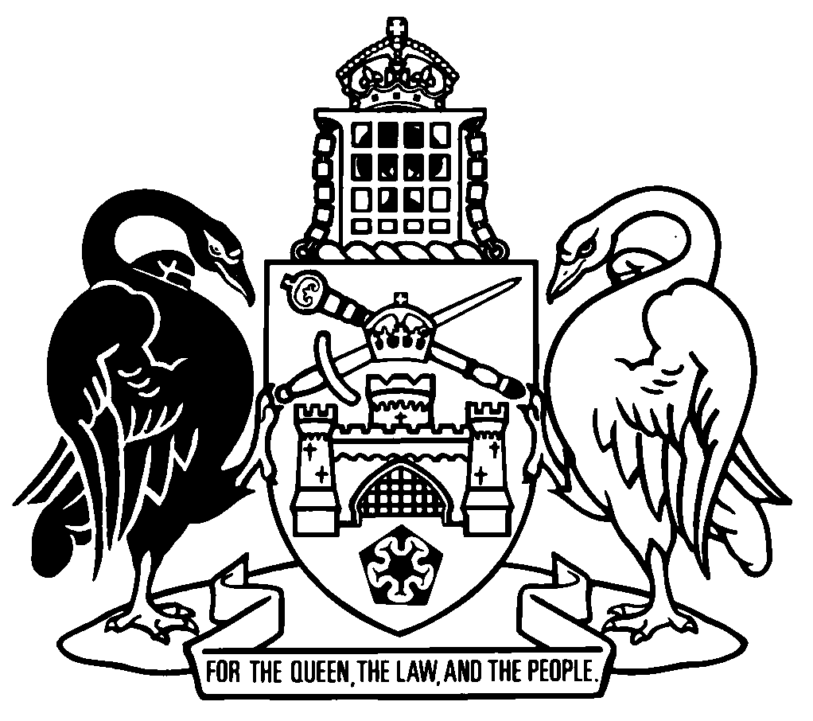
Australian Capital Territory
Smoke-Free Public Places Regulation 2005
SL2005-21
made under the
Smoke-Free Public Places Act 2003
Republication No 4
Effective: 27 November 2023 – 25 November 2025
Republication date: 27 November 2023
Last amendment made by A2023-36

About this republication
The republished law
This is a republication of the Smoke-Free Public Places Regulation 2005, made under the Smoke-Free Public Places Act 2003 (including any amendment made under the Legislation Act 2001, part 11.3 (Editorial changes)) as in force on 27 November 2023. It also includes any commencement, amendment, repeal or expiry affecting this republished law to 27 November 2023.
The legislation history and amendment history of the republished law are set out in endnotes 3 and 4.
Kinds of republications
The Parliamentary Counsel’s Office prepares 2 kinds of republications of ACT laws (see the ACT legislation register at www.legislation.act.gov.au):
- authorised republications to which the Legislation Act 2001 applies
- unauthorised republications.
The status of this republication appears on the bottom of each page.
Editorial changes
The Legislation Act 2001, part 11.3 authorises the Parliamentary Counsel to make editorial amendments and other changes of a formal nature when preparing a law for republication. Editorial changes do not change the effect of the law, but have effect as if they had been made by an Act commencing on the republication date (see Legislation Act 2001, s 115 and s 117). The changes are made if the Parliamentary Counsel considers they are desirable to bring the law into line, or more closely into line, with current legislative drafting practice.
This republication includes amendments made under part 11.3 (see endnote 1).
Uncommenced provisions and amendments
If a provision of the republished law has not commenced, the symbol U appears immediately before the provision heading. Any uncommenced amendments that affect this republished law are accessible on the ACT legislation register (www.legislation.act.gov.au). For more information, see the home page for this law on the register.
Modifications
If a provision of the republished law is affected by a current modification, the symbol M appears immediately before the provision heading. The text of the modifying provision appears in the endnotes. For the legal status of modifications, see the Legislation Act 2001, section 95.
Penalties
At the republication date, the value of a penalty unit for an offence against this law is $160 for an individual and $810 for a corporation (see Legislation Act 2001, s 133).

Australian Capital Territory
Smoke-Free Public Places Regulation 2005
made under the
Smoke-Free Public Places Act 2003

Contents
Page
Part 1 Preliminary
1 Name of regulation 2
3 Dictionary 2
4 Notes 2
Part 2 Enclosed public places
5 Purpose of pt 2 3
6 The basic rule—covered and 75% or more enclosed 3
7 Meaning of covered 4
8 Meaning of 75% or more enclosed 4
9 How to work out the closed area—walls 4
10 How to work out the closed area—overhead cover 6
11 How to work out the open area—walls 6
12 How to work out the open area—overhead cover 7
Part 3 Outdoor eating or drinking places
13 Height of screen or wall buffer for designated outdoor smoking area—Act, s 9F (6) (a) 8
14 Requirements for smoking management plan—Act, s 9J (2) (e) 8
Dictionary 9
Endnotes
1 About the endnotes 11
2 Abbreviation key 11
3 Legislation history 12
4 Amendment history 13
5 Earlier republications 14

Australian Capital Territory
Smoke-Free Public Places Regulation 2005

made under the
Smoke-Free Public Places Act 2003

Part 1 Preliminary

1 Name of regulation
This regulation is the Smoke-Free Public Places Regulation 2005.

3 Dictionary
The dictionary at the end of this regulation is part of this regulation.
Note 1 The dictionary at the end of this regulation defines certain terms used in this regulation, and includes references (signpost definitions) to other terms defined elsewhere in this regulation.
For example, the signpost definition ‘covered—see section 7.’ means that the term ‘covered’ is defined in that section.
Note 2 A definition in the dictionary (including a signpost definition) applies to the entire regulation unless the definition, or another provision of the regulation, provides otherwise or the contrary intention otherwise appears (see Legislation Act, s 155 and s 156 (1)).

4 Notes
A note included in this regulation is explanatory and is not part of this regulation.
Note See the Legislation Act, s 127 (1), (4) and (5) for the legal status of notes.

Part 2 Enclosed public places

5 Purpose of pt 2

(1) The Act prohibits smoking in enclosed public places and creates offences that give effect to that prohibition.

(2) The object of the Act is to promote public health by minimising the exposure of people in enclosed public places to environmental smoke.

(3) Under the Act, an enclosed public place is a public place, or part of a public place, that is enclosed as prescribed by regulation (see the Act, dictionary).

(4) The purpose of this part is to set out what makes a place enclosed for that definition.

6 The basic rule—covered and 75% or more enclosed
A place is enclosed if—

(a) it is covered; and

(b) it is 75% or more enclosed.
Note 1 Under this definition, any part of a place that is not under cover is not enclosed. However, the Act requires an occupier of premises to take reasonable steps to prevent smoke from the premises entering an enclosed public place—see s 8A (Offence by occupier—permitting smoke into enclosed public place from another part of premises) and s 9 (Offence by neighbouring occupier).
Note 2 Place includes part of a place (see dict, def place).

7 Meaning of covered

(1) A place is covered if it is under a ceiling, roof or other structure or device (whether fixed or moveable) that prevents or impedes upward airflow (an overhead cover).
Examples of other structure or device
1 awning
2 skylight
3 umbrella

(2) If an overhead cover (or part of an overhead cover) is moveable, the area under the overhead cover (or the part of the overhead cover) is covered at a particular time only to the extent that the overhead cover is present at that time.
Example for s (2)
An awning attached to a wall can be extended to a point 2m from the wall or a point 4m from the wall. If the awning is extended to the 2m point, the area under it to that 2m point is covered. If the awning is extended to the 4m point, the area under it to that 4m point is covered.

8 Meaning of 75% or more enclosed
A place is 75% or more enclosed if the open area of the walls and overhead cover of the place that opens directly to the outside air is 25% or less of the sum of—

(a) the total closed area of the walls and overhead cover of the place; and

(b) the total open area of the walls and overhead cover of the place.

9 How to work out the closed area—walls

(1) This section sets out how to work out the closed area of the walls of a place.

(2) The closed area of the walls of a place is the surface area of the walls that form part of the boundary of the place.

(3) A wall includes any door, window or other structure or device (whether fixed or moveable) that prevents or impedes lateral airflow.
Examples of other structure or device
1 moveable panel
2 shutter
3 blind

(4) If a wall is moveable, the wall forms part of the boundary of a place at a particular time only to the extent that it forms part of the boundary of the place at that time.
Example
A café has retractable panels along one of its boundaries. If the panels are completely closed, their whole surface area is counted. However, if the panels are 3/4 open, only 1/4 of their surface area is counted.

(5) However, a door or window that forms part of the boundary of the place must be treated as part of the closed area of the walls of the place even if it is open.

(6) For subsection (2), the surface area of a wall is the actual surface area (inside the place) of the solid surface of the wall.
Example
A restaurant has a courtyard with a metal slatted screen forming part of its boundary wall. The actual surface area of that part of the boundary wall is the surface area (inside the place) of the slats. The area of the gaps between the slats is part of the open area of the wall (see s 11).

(7) For subsection (6), a wall made of flyscreen, shadecloth or canvas is taken to have a solid surface.

(8) In this section:
wall includes part of a wall.

10 How to work out the closed area—overhead cover

(1) This section sets out how to work out the closed area of the overhead cover of a place.

(2) The closed area of the overhead cover of a place is the area of the vertical projection (inside the place) of the overhead cover.
Examples
1 A bar has a sloping ceiling. The closed area of the ceiling is worked out as the area of the projection onto a horizontal plane (the ‘plan view’) of the ceiling, not the (larger) surface area of the ceiling itself.
2 A beer garden has a wooden lattice overhead cover. The closed area of the overhead cover is worked out as the area of the projection onto a horizontal plane (the ‘plan view’) of the wooden lattice itself. The area of the gaps in the lattice is part of the open area of the overhead cover (see s 12).

(3) For subsection (2), an overhead cover made of flyscreen, shadecloth or canvas is taken to have a solid surface.

(4) In this section:
overhead cover includes part of an overhead cover.

11 How to work out the open area—walls

(1) This section sets out how to work out the open area of the walls of a place.

(2) The open area of the walls of a place is the total of the minimum areas required to fill—

(a) each gap in any parts of the walls that do not have, or are not taken under section 9 (7) to have, solid surfaces; and

(b) each gap between parts of the walls; and

(c) each gap between the walls and the nearest point of the overhead cover; and

(d) each gap between the walls and the nearest point of the floor.
Example
See example to section 9 (6).

12 How to work out the open area—overhead cover

(1) This section sets out how to work out the open area of the overhead cover of a place.

(2) The open area of the overhead cover of a place is the minimum area required to fill any gaps in the vertical projection (inside the place) of the overhead cover.
Example
See example 2 to section 10 (2).

(3) For subsection (2), an overhead cover made of flyscreen, shadecloth or canvas is taken to have a solid surface.

Part 3 Outdoor eating or drinking places

13 Height of screen or wall buffer for designated outdoor smoking area—Act, s 9F (6) (a)

(1) The prescribed height is 2.1m above the highest point of the floor of the designated outdoor smoking area.

(2) However, if at any point of the buffer it is not possible to comply with subsection (1) because of an overhead cover, the prescribed height at that point is the height of the overhead cover.
Note 1 The presence of a screen or wall buffer may make an area an enclosed public place—see pt 2 (Enclosed public places).
Note 2 Other legislation may apply in relation to a proposed structure:
• the structure may require building approval—see the Building Act 2004, div 3.3;
• use of the structure may require development approval—see the Planning Act 2023, s 148;
• if the structure causes premises to not comply with certain requirements, the commissioner must decide that the premises are not suitable premises for a licence or permit—see the Liquor Act 2010, s 77.

14 Requirements for smoking management plan—Act, s 9J (2) (e)
The licensed premises plan under the Liquor Regulation 2010, section 6 is prescribed.

Dictionary
(see s 3)
Note 1 The Legislation Act contains definitions and other provisions relevant to this regulation.
Note 2 For example, the Legislation Act, dict, pt 1, defines the following terms:
• Act
• for.
Note 3 Terms used in this regulation have the same meaning that they have in the Smoke-Free Public Places Act 2003 (see Legislation Act, s 148). For example, the following terms are defined in the Smoke-Free Public Places Act 2003, dict:
• designated outdoor smoking area (see s 9F (2))
• public place.
75% or more enclosed—see section 8.
closed area—

(a) of a wall, means the closed area worked out for the wall under section 9; and

(b) of an overhead cover, means the closed area worked out for the overhead cover under section 10.
covered—see section 7.
enclosed—see section 6.
floor includes ground.
open area—

(a) of a wall, means the open area worked out for the wall under section 11; and

(b) of an overhead cover, means the open area worked out for the overhead cover under section 12.
overhead cover—see section 7 (1).
place includes part of a place.
wall—see section 9.

Endnotes
1 About the endnotes
Amending and modifying laws are annotated in the legislation history and the amendment history. Current modifications are not included in the republished law but are set out in the endnotes.
Not all editorial amendments made under the Legislation Act 2001, part 11.3 are annotated in the amendment history. Full details of any amendments can be obtained from the Parliamentary Counsel’s Office.
Uncommenced amending laws are not included in the republished law. The details of these laws are underlined in the legislation history. Uncommenced expiries are underlined in the legislation history and amendment history.
If all the provisions of the law have been renumbered, a table of renumbered provisions gives details of previous and current numbering.
The endnotes also include a table of earlier republications.
2 Abbreviation key

A = Act | NI = Notifiable instrument
AF = Approved form | o = order
am = amended | om = omitted/repealed
amdt = amendment | ord = ordinance
AR = Assembly resolution | orig = original
ch = chapter | par = paragraph/subparagraph
CN = Commencement notice | pres = present
def = definition | prev = previous
DI = Disallowable instrument | (prev...) = previously
dict = dictionary | pt = part
disallowed = disallowed by the Legislative | r = rule/subrule
Assembly | reloc = relocated
div = division | renum = renumbered
exp = expires/expired | R[X] = Republication No
Gaz = gazette | RI = reissue
hdg = heading | s = section/subsection
IA = Interpretation Act 1967 | sch = schedule
ins = inserted/added | sdiv = subdivision
LA = Legislation Act 2001 | SL = Subordinate law
LR = legislation register | sub = substituted
LRA = Legislation (Republication) Act 1996 | underlining = whole or part not commenced
mod = modified/modification | or to be expired

3 Legislation history
The Smoke-Free Public Places Regulation 2005 was originally the Smoking (Prohibition in Enclosed Public Places) Regulation 2005. It was renamed by the Smoking (Prohibition in Enclosed Public Places) Amendment Regulation 2010 (No 1) SL2010-44 (see s 4).
Smoke-Free Public Places Regulation 2005 SL2005-21
notified LR 8 September 2005
s 1, s 2 commenced 8 September 2005 (LA s 75 (1))
remainder commenced 1 December 2006 (s 2)
as amended by
Smoking (Prohibition in Enclosed Public Places) Amendment Regulation 2010 (No 1) SL2010-44
notified LR 10 November 2010
s 1, s 2 commenced 10 November 2010 (LA s 75 (1))
s 6 commenced 9 December 2011 (s 2 (2))
remainder commenced 9 December 2010 (s 2 (1) and see Smoking (Prohibition in Enclosed Public Places) Amendment Act 2009 A2009-51, s 2 and CN2010-4)
Planning (Consequential Amendments) Act 2023 A2023-36 sch 1 pt 1.60
notified LR 29 September 2023
s 1, s 2 commenced 29 September 2023 (LA s 75 (1))
sch 1 pt 1.60 commenced 27 November 2023 (s 2 (1) and see Planning Act 2023 A2023-18, s 2 (2) and CN2023-10)

4 Amendment history
Name of regulation
s 1 sub SL2010-44 s 4
Commencement
s 2 om LA s 89 (4)
Outdoor eating or drinking places
pt 3 hdg ins SL2010-44 s 5
Height of screen or wall buffer for designated outdoor smoking area—Act, s 9F (6) (a)
s 13 ins SL2010-44 s 5
am SL2010-44 s 6; A2023-36 amdt 1.338
Requirements for smoking management plan—Act, s 9J (2) (e)
s 14 ins SL2010-44 s 5
Dictionary
dict am SL2010-44 s 7

5 Earlier republications
Some earlier republications were not numbered. The number in column 1 refers to the publication order.
Since 12 September 2001 every authorised republication has been published in electronic pdf format on the ACT legislation register. A selection of authorised republications have also been published in printed format. These republications are marked with an asterisk (*) in column 1. Electronic and printed versions of an authorised republication are identical.

Republication No and date | Effective | Last amendment made by | Republication for
R1  1 Dec 2006 | 1 Dec 2006–  8 Dec 2010 | not amended | new regulation
R2  9 Dec 2010 | 9 Dec 2010–  8 Dec 2011 | SL2010-44 | renaming and other amendments by SL2010-44
R3  9 Dec 2011 | 9 Dec 2011–  26 Nov 2023 | SL2010-44 | amendments by SL2010-44

© Australian Capital Territory 2023

