Australian Capital Territory
Planning and Development (Community Consultation) Amendment Regulation 2020 (No 1)
Subordinate Law SL2020-35

The Australian Capital Territory Executive makes the following regulation under the Planning and Development Act 2007.
Dated 7 September 2020.
Mick Gentleman
Minister
Yvette Berry
Minister

Australian Capital Territory
Planning and Development (Community Consultation) Amendment Regulation 2020 (No 1)
Subordinate Law SL2020-35
made under the
Planning and Development Act 2007

1 Name of regulation
This regulation is the Planning and Development (Community Consultation) Amendment Regulation 2020 (No 1).

2 Commencement
This regulation commences on 1 January 2021.
Note The naming and commencement provisions automatically commence on the notification day (see Legislation Act, s 75 (1)).

3 Legislation amended
This regulation amends the Planning and Development Regulation 2008.

4 New section 20A (1) (f)
insert
(f) the development of an estate.

5 New section 20A (1A)
insert

(1A) Also, a development proposal on which the proponent is required to consult the design review panel under the Act, section 138AL (1) or (2) is prescribed.

6 Section 20A (2)
omit
subsection (1) does
substitute
subsections (1) and (1A) do

7 Schedule 1B
substitute
Schedule 1B Land not requiring community consultation for development proposal
(see s 20A (2) (b))
East Gungahlin
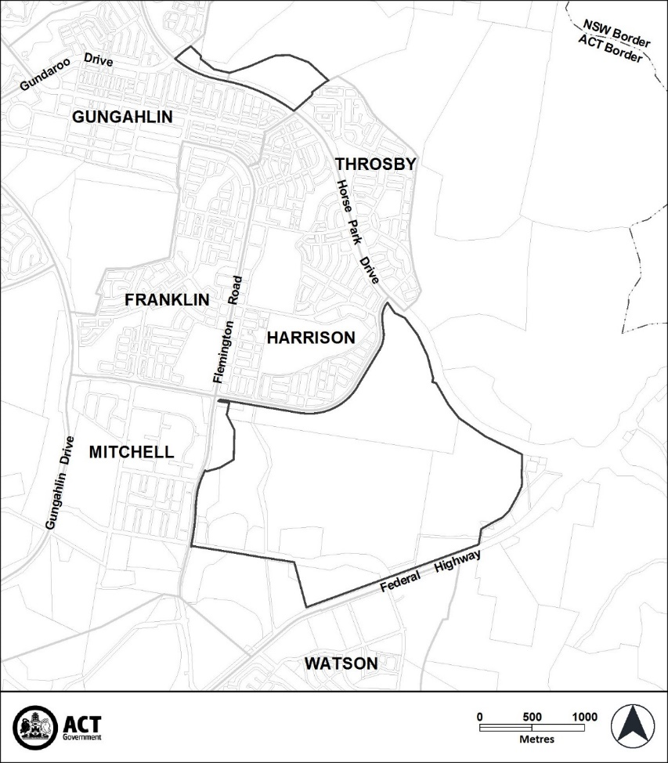
Lawson
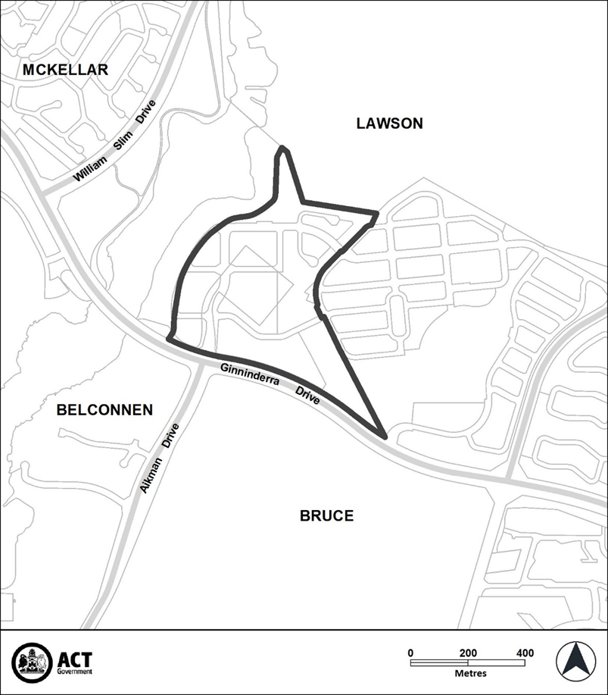
Molonglo Valley
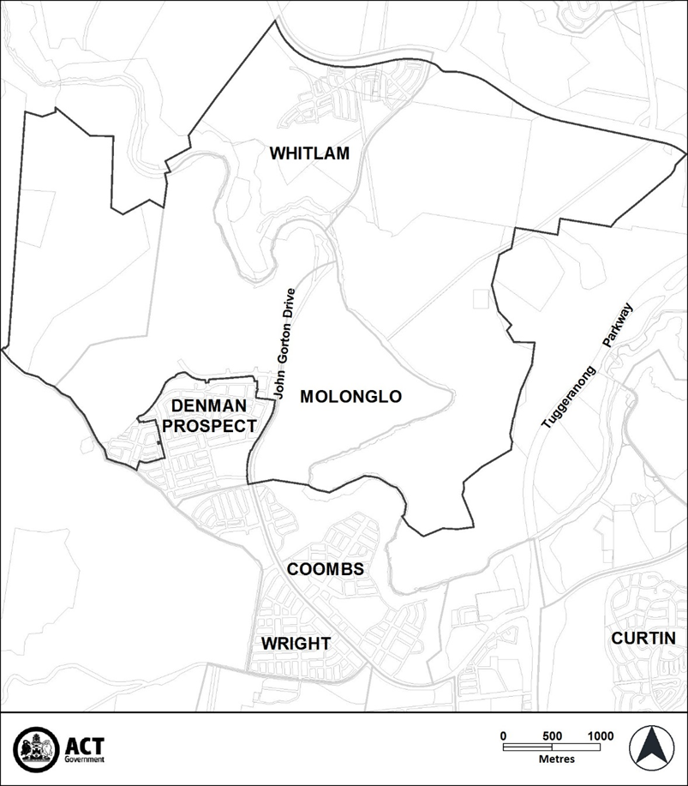
North Gungahlin
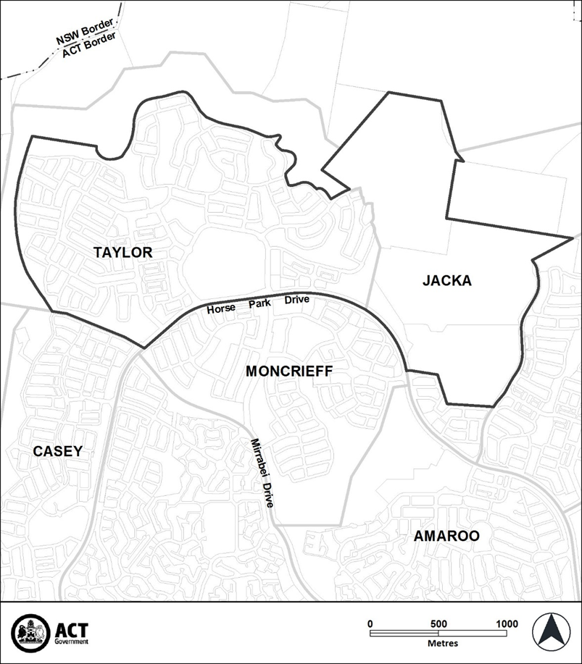
West Belconnen
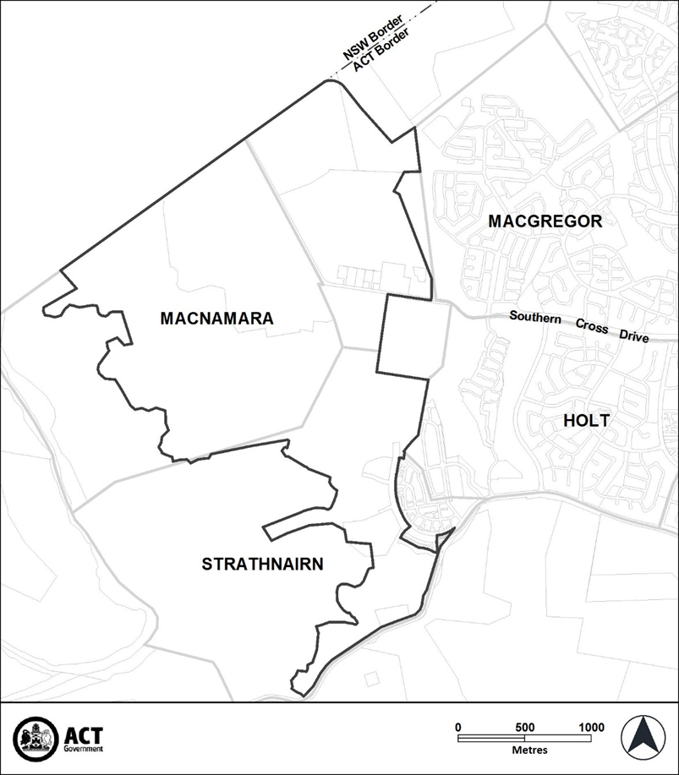

Endnotes
1 Notification
Notified under the Legislation Act on 10 September 2020.
2 Republications of amended laws
For the latest republication of amended laws, see www.legislation.act.gov.au.

© Australian Capital Territory 2020

