Australian Capital Territory
Work Health and Safety Amendment Regulation 2023 (No 1)
Subordinate Law SL2023-19

The Australian Capital Territory Executive makes the following regulation under the Work Health and Safety Act 2011.
Dated 24 August 2023.
Andrew Barr
Chief Minister
Mick Gentleman
Minister

Australian Capital Territory
Work Health and Safety Amendment Regulation 2023 (No 1)
Subordinate Law SL2023-19
made under the
Work Health and Safety Act 2011

Contents
Page
1 Name of regulation 1
2 Commencement 1
3 Legislation amended 1
4 New division 3.2.11 1
5 Section 144 (1), definition of electrical equipment, paragraph (a) (iv) and note 3
6 Section 163 3
7 Section 221 (2), definition of harness 4
8 Section 221 (2), note 4
9 Section 418A (1), new definition of engineered stone 4
10 Schedule 13, section 13.3 (3), definition of red and note 4
11 Schedule 13, section 13.5, figure 13.3 5
12 Dictionary, definition of boiler, paragraph (b) (iii) (C) and note 5
13 Dictionary, new definitions 6

1 Name of regulation
This regulation is the Work Health and Safety Amendment Regulation 2023 (No 1).

2 Commencement

(1) Sections 3 and 9 commence on the day after this regulation’s notification day.
Note The naming and commencement provisions automatically commence on the notification day (see Legislation Act, s 75 (1)).

(2) The remaining provisions commence on 27 November 2023.

3 Legislation amended
This regulation amends the Work Health and Safety Regulation 2011.

4 New division 3.2.11
insert
Division 3.2.11 Psychosocial risks
55A Meaning of psychosocial hazard—div 3.2.11
For this division, a psychosocial hazard is a hazard that—
(a) arises from, or relates to—
(i) the design or management of work; or
(ii) a work environment; or
(iii) plant at a workplace; or
(iv) workplace interactions or behaviours; and
(b) may cause psychological harm (whether or not it may also cause physical harm).
55B Meaning of psychosocial risk—div 3.2.11
For this division, a psychosocial risk is a risk to the health or safety of a worker or other person arising from a psychosocial hazard.
55C Duty to manage psychosocial risk
A person conducting a business or undertaking must manage psychosocial risks in accordance with part 3.1 (Managing risks to health and safety).
Note WHS Act—s 19 (see s 9).
55D Psychosocial risks—control measures

(1) A person conducting a business or undertaking must implement control measures to—
(a) eliminate psychosocial risks so far as is reasonably practicable; and
(b) if it is not reasonably practicable to eliminate psychosocial risks—minimise the risks so far as is reasonably practicable.

(2) In determining the control measures to implement, the person must have regard to all relevant matters, including—
(a) the duration, frequency or severity of the exposure of workers and other persons to any psychosocial hazards; and
(b) how the psychosocial hazards may interact or combine; and
(c) the design of work, including job demands and tasks; and
(d) the systems of work, including how work is managed, organised and supported; and
(e) the design and layout, and environmental conditions, of the workplace, including the provision of—
(i) safe means of entering and exiting the workplace; and
(ii) facilities for the welfare of workers; and
(f) the design and layout, and environmental conditions, of workers’ accommodation; and
(g) the plant, substances and structures at the workplace; and
(h) workplace interactions or behaviours; and
(i) the information, training, instruction and supervision provided to workers.

(3) In this section:
workers’ accommodation means premises to which the Act, section 19 (4) applies.
Note WHS Act—s 19 (see s 9).

5 Section 144 (1), definition of electrical equipment, paragraph (a) (iv) and note
omit
AS 2832.1:2004
substitute
AS 2832.1:2015

6 Section 163
omit
AS/NZS 3012:2010
substitute
AS/NZS 3012:2019

7 Section 221 (2), definition of harness
omit
AS/NZS 1891.1:2007 (Industrial fall-arrest systems and devices—Harnesses and ancillary equipment)
substitute
AS/NZS 1891.1:2020 (Personal equipment for work at height—Manufacturing requirements for full body combination and lower body harnesses)

8 Section 221 (2), note
omit
AS/NZS 1891.1:2007
substitute
AS/NZS 1891.1:2020

9 Section 418A (1), new definition of engineered stone
insert
engineered stone means a stone that is artificially produced by combining natural stone that contains crystalline silica with other materials such as resin and pigment.

10 Schedule 13, section 13.3 (3), definition of red and note
omit
AS 2700S-1996
substitute
AS 2700S-2011

11 Schedule 13, section 13.5, figure 13.3
substitute
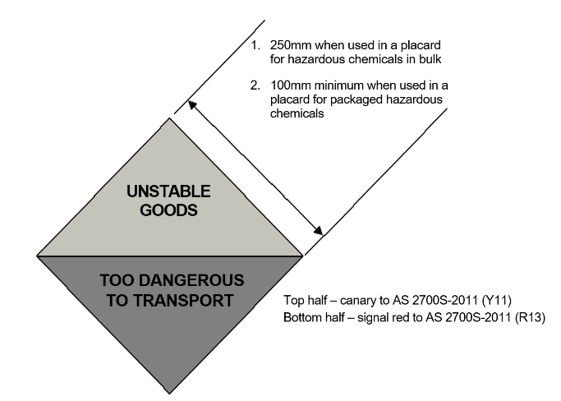
Figure 13.3 Label for unstable explosive, organic peroxide type A or self-reactive substance type A

12 Dictionary, definition of boiler, paragraph (b) (iii) (C) and note
omit
AS 2593:2004
substitute
AS 2593:2021

13 Dictionary, new definitions
insert
psychosocial hazard, for division 3.2.11 (Psychosocial risks)—see section 55A.
psychosocial risk, for division 3.2.11 (Psychosocial risks)—see section 55B.

Endnotes
1 Notification
Notified under the Legislation Act on 28 August 2023.
2 Republications of amended laws
For the latest republication of amended laws, see www.legislation.act.gov.au.

© Australian Capital Territory 2023

