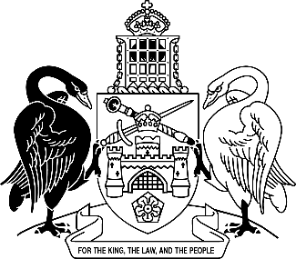
Australian Capital Territory
Rail Safety National Law (ACT) Amendment Regulation 2025 (No 1)
Subordinate Law SL2025-15

The Australian Capital Territory Executive makes the following regulation under the Rail Safety National Law (ACT) Act 2014.
Dated 22 July 2025.
Andrew Barr
Chief Minister
Tara Cheyne
Minister

Australian Capital Territory
Rail Safety National Law (ACT) Amendment Regulation 2025 (No 1)
Subordinate Law SL2025-15
made under the
Rail Safety National Law (ACT) Act 2014

1 Name of regulation
This regulation is the Rail Safety National Law (ACT) Amendment Regulation 2025 (No 1).

2 Commencement
This regulation commences on the day after its notification day.
Note The naming and commencement provisions automatically commence on the notification day (see Legislation Act, s 75 (1)).

3 Legislation amended
This regulation amends the Rail Safety National Law (ACT) Regulation 2014.

4 Section 4
substitute
4 Drug screening device—Act, s 10, def drug screening device, par (b)
The following devices are prescribed:
(a) Clonal Technologies Oral Fluid Drug Test 7;
(b) MedVet Oral7;
(c) Oranoxis ToxWipe Oral 7+.

Endnotes
1 Notification
Notified under the Legislation Act on 28 July 2025.
2 Republications of amended laws
For the latest republication of amended laws, see www.legislation.act.gov.au.

© Australian Capital Territory 2025

