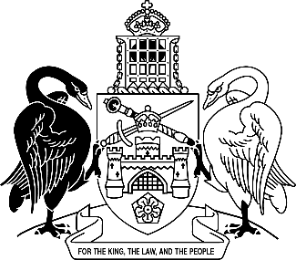
Australian Capital Territory
Ombudsman Amendment Regulation 2025 (No 1)
Subordinate Law SL2025-21

The Australian Capital Territory Executive makes the following regulation under the Ombudsman Act 1989.
Dated 15 October 2025.
Andrew Barr
Chief Minister
Tara Cheyne
Minister

Australian Capital Territory
Ombudsman Amendment Regulation 2025 (No 1)
Subordinate Law SL2025-21
made under the
Ombudsman Act 1989

1 Name of regulation
This regulation is the Ombudsman Amendment Regulation 2025 (No 1).

2 Commencement
This regulation commences on the day after its notification day.
Note The naming and commencement provisions automatically commence on the notification day (see Legislation Act, s 75 (1)).

3 Legislation amended
This regulation amends the Ombudsman Regulation 1989.

4 New section 3
insert
3 Ombudsman may disclose child safety information—prescribed entities—Act, s 34A (1) (j)
An entity that exercises a function under a law of a State or the Commonwealth corresponding, or substantially corresponding, to a function of the ombudsman under the Act, division 2.2A (Reportable conduct) is prescribed.
Note State includes the Northern Territory (see Legislation Act, dict, pt 1).

Endnotes
1 Notification
Notified under the Legislation Act on 23 October 2025.
2 Republications of amended laws
For the latest republication of amended laws, see www.legislation.act.gov.au.

© Australian Capital Territory 2025

