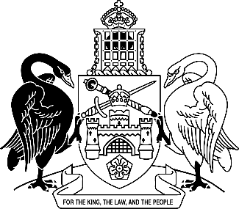
Australian Capital Territory
Magistrates Court (Environment Protection Infringement Notices) Amendment Regulation 2025 (No 1)
Subordinate Law SL2025-25

The Australian Capital Territory Executive makes the following regulation under the Magistrates Court Act 1930.
Dated 21 November 2025.
Andrew Barr
Chief Minister
Suzanne Orr
Minister
Tara Cheyne
Minister

Australian Capital Territory
Magistrates Court (Environment Protection Infringement Notices) Amendment Regulation 2025 (No 1)
Subordinate Law SL2025-25
made under the
Magistrates Court Act 1930

1 Name of regulation
This regulation is the Magistrates Court (Environment Protection Infringement Notices) Amendment Regulation 2025 (No 1).

2 Commencement
This regulation commences on the commencement of the Environment Protection (Industrial Chemicals) Amendment Regulation 2025 (No 1), section 3.
Note The naming and commencement provisions automatically commence on the notification day (see Legislation Act, s 75 (1)).

3 Legislation amended
This regulation amends the Magistrates Court (Environment Protection Infringement Notices) Regulation 2005.

4 Schedule 1, part 1.2, item 18
omit

5 Schedule 1, part 1.2, new item 26A
insert
26A | 52D (1)
26A.1 | • if IChEMS scheduling decision is in IChEMS register, sch 1, 2 or 3 | 5 | 160
26A.2 | • if IChEMS scheduling decision is in IChEMS register, sch 4 or 5 | 10 | 320
26A.3 | • if IChEMS scheduling decision is in IChEMS register, sch 6 or 7 | 20 | 640

6 Schedule 1, part 1.2, new item 40A
insert
40A | 58 (3) | 10 | 100

7 Schedule 1, part 1.2, item 47, column 2
after
66C
insert
(1)

Endnotes
1 Notification
Notified under the Legislation Act on 27 November 2025.
2 Republications of amended laws
For the latest republication of amended laws, see www.legislation.act.gov.au.

© Australian Capital Territory 2025

